Resume

Name of Teaching Staff | Mr. Waghmare Arun Ishwar |  |  |  | 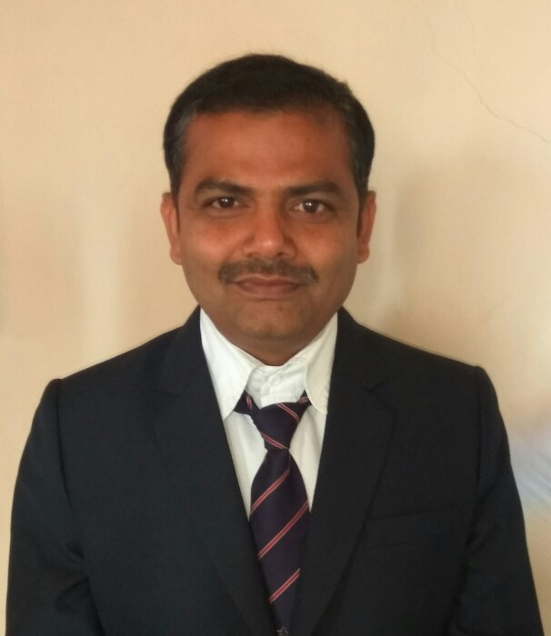
Institute Name | Aditya Engineering College,Beed.
Designation | Assistant Professor
Department | Information Technology
Area of Specialization | Software Testing
Date of Joining the Institute | 11/11/2022
Qualifications | UG |  | PG |  |  | Phd
Qualifications | BE( Information Technology) |  | ME(Computer) |  |  | ----
Total Experience in  Years | Teaching |  | Industry |  | Research
Total Experience in  Years | 14 Years |  | 00 |  | 00
Paper Published  ( Scopus and SCI) | National -00 |  | International - 01
Paper Published in Peer reviewed journal | National -00  -- |  | International - 00
Paper Presented in Conferences  /National  /International | National -02 |  | International -00
Books Published | --
IPRs | Patents | Copyrights
 | -- | --
Professional Memberships | ISTE.
Consultancy Activities | --
Awards | --
Grants fetched | --
Interaction with professional institutions | ISTE, CSI

