ODT Summative 2

Idea Brief :
This project focuses on creating an engaging, multi sensory experience through the interplay of light, motion, and user interaction. The booth is designed as an interactive, immersive space where light, motion, and user input come together to create a cinematic experience. A rotating setup with multiple arms decorated with CDs, powered by a DC motor and triggered via a push button, reflects and scatters light across the interior. Two Neopixel rings are placed on the angled side panels, directing light toward the rotating structure to enhance the reflections, while a web interface lets users choose colors and moods in real time.
To add interaction, there is a simple prop, a gun prop with a trigger that plays a short ‘pew pew’ sound using a buzzer. Together, these elements create a playful and visually dynamic environment inspired by Dhurandhar.
The initial concept faced challenges due to improper weight distribution and technical as well as mechanical failures in component integration. These limitations led to instability in the system, prompting a redesign. The final concept was therefore developed as a refined solution, focusing on improved structural balance, reliable component performance, and smoother overall functionality

Basic Idea Sketch :
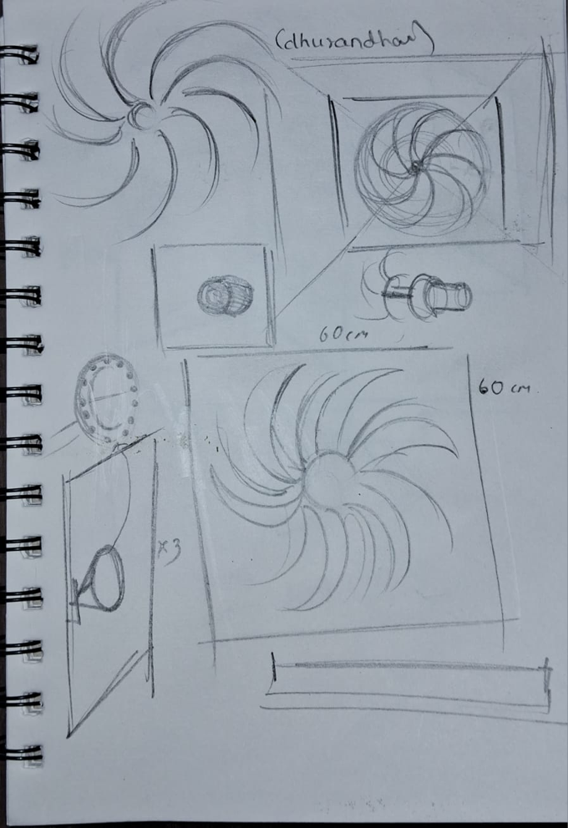
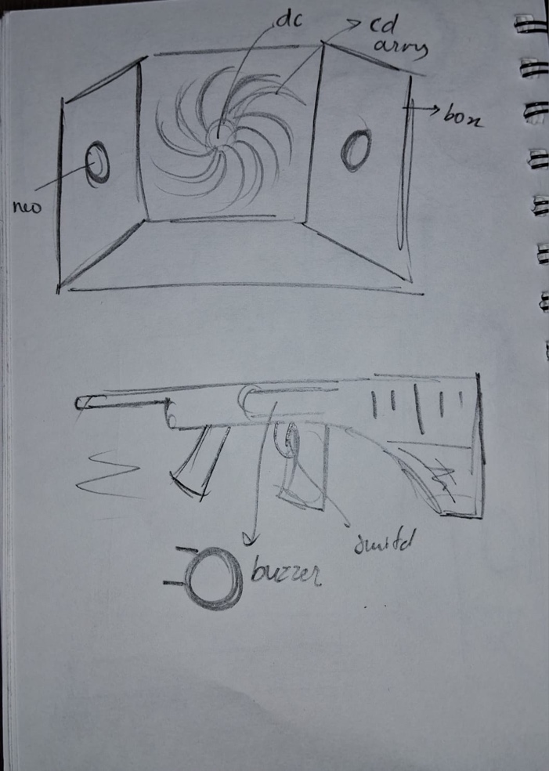

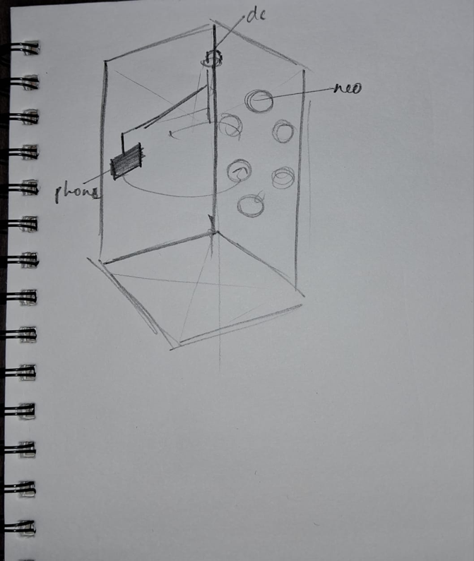

interactive photo booth humanintercative
Initial concept : human interactive photo booth with 360 revolving camera

