Describe different components of computer with a block diagram.

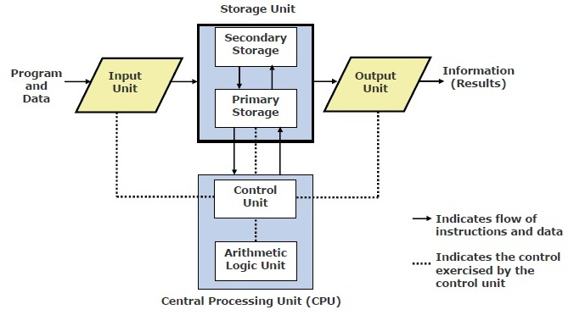

Block diagram of a computer

The computer system hardware comprises of three main components —

1. Input/Output (I/O) Unit,

2. Central Processing Unit (CPU),

3. Memory Unit.

Central Processing Unit - CPU controls, coordinates and supervises the operations of the computer. It is responsible for processing of the input data. CPU consists of Arithmetic Logic Unit (ALU) and Control Unit (CU).

ALU performs all the arithmetic and logic operations on the input data.

CU controls the overall operations of the computer i.e. it checks the sequence of execution of instructions, and, controls and coordinates the overall functioning of the units of computer.

Additionally, CPU also has a set of registers for temporary storage of data, instructions, addresses and intermediate results of calculation

Input and Output Unit -

Input unit: is used to enter data and information into a computer. The Input unit converts the data that it accepts from the user, into a form that is understandable by the computer. The devices like keyboard, mouse and scanner are commonly used input devices.

Output Unit : the Output unit provides the output in a form that is understandable by the user. Some of the commonly used output devices are monitor, printer and plotter.

Storage or Memory Unit : It is the unit where all the input data, instructions, intermediate results, final results and processed data are stored either temporarily or permanently.

Memory of a computer has two types:

a. Main Memory / Primary Memory units : This storage unit stores the data, instructions, intermediate results and output, temporarily, during the processing of data. This memory is called the main memory or primary memory of the computer. This memory can store data as long as the computer is on. All data get erased from primary memory once computer gets switched off.

b. Secondary Memory / Auxiliary Memory : this storage unit is also referred to as the secondary memory of the computer. The data, the programs and the output are stored permanently in the storage unit of the computer. Magnetic disks, optical disks and magnetic tapes are some examples of secondary memory.

BUS – Apart from these components there is another component called as Bus which is a collection of wires that carries data/Instructions and connects all the physical components of the computer.