In a Dynamic Agentic Experience (DAE), the Attack Path feature transforms from a static, diagnostic map into a "living" defensive circuit. Instead of a human analyst searching for vulnerabilities, a coordinated ecosystem of agents works to predict, simulate, and neutralize threats in real-time.
Here is how a DAE-enabled Attack Path functions:
1. Continuous Autonomous Discovery (The Mapping Agent)
Traditional attack paths are often snapshots in time. A DAE uses a Mapping Agent that operates 24/7.
- Action: It continuously ingests telemetry from external attack surface management (EASM), internal network logs, and identity providers.
- Result: As soon as a new sub-domain is spun up or a firewall rule is misconfigured, the agent updates the Attack Path graph instantly. The "map" is never out of date.
2. Recursive Threat Simulation (The Simulation Agent)
Once the map is updated, a Simulation Agent (modeled after advanced intelligence like Claude Mythos) attempts to "break" the environment.
- Action: It runs millions of permutations, asking: "If I am an attacker with X exploit, can I reach the database through this new path?" * Strategic Insight: It identifies "choke points"—junctions where multiple attack paths converge. Instead of suggesting 50 different patches, it identifies the one single junction (like a specific service account or an exposed API) that, if secured, collapses multiple paths.
3. Goal-Oriented Remediation (The Remediation Agent)
When a high-risk path is identified, the Remediation Agent takes over to "prune" the path.
- Action: Rather than just sending an alert, the agent prepares a remediation plan. This could include:
  - Virtual Patching: Deploying a temporary WAF rule to block a specific exploit.
  - Identity Circuit Breakers: Integrating with tools like identity verification to mandate a hardware-based MFA check whenever a user attempts to traverse a critical node in that path.
- Human-in-the-Loop: For high-impact changes, the agent presents the "Safe Fix"—a pre-tested configuration change that the analyst can approve with one click.
4. The Autonomous Feedback Loop
The "Experience" is dynamic because the agents learn from the environment's response.
- Action: If a remediation agent closes a path, the Simulation Agent immediately re-tests the perimeter to ensure no new paths were inadvertently created by the change.
- Result: The ecosystem provides a "Confidence Score" for the organization's current posture, adjusting dynamically as external threats (like new zero-days) emerge.

The User Experience Shift
Traditional Attack Path | DAE-Enabled Attack Path
Search-Led: Analyst searches for paths. | Intent-Led: Agents surface the most critical paths.
Static: Updates only when a scan is run. | Real-Time: Updates as the infrastructure changes.
Descriptive: Shows what is wrong. | Prescriptive/Agentic: Suggests and executes fixes.
Fragmented: Separate from identity/remediation. | Orchestrated: Integrated with identity and config management.
By implementing DAE, the Attack Path becomes a Navigation System for Security. It doesn't just show you where the obstacles are; it actively reroutes and "paves" the way to a secure state, allowing your team to manage risk at the same speed that AI-powered attackers exploit it.
The launch of high-reasoning models like Claude Mythos has fundamentally shifted the cybersecurity landscape. When an AI can discover thousands of zero-day vulnerabilities in a single week—including flaws that have persisted for decades—the primary advantage of a Dynamic Agentic Experience (DAE) for Attack Path analysis is the transition from Human-Scale defense to Machine-Scale resilience.
Here are the specific advantages of a DAE-based approach:
1. Closing the "Speed-to-Exploit" Gap
In the era of Mythos-class models, the window between a vulnerability being discovered and it being weaponized by an autonomous attacker has shrunk to near-zero.
- DAE Advantage: While a static attack path requires a scan and manual review, a DAE Mapping Agent identifies the exposure in real-time. It provides Defensive Parity, allowing the system to detect and "shadow" an AI attacker’s progress, neutralizing the path at machine speed.
2. Strategic "Choke Point" Remediation
Traditional tools often present thousands of "High" or "Critical" vulnerabilities, leading to alert fatigue.
- DAE Advantage: A DAE Simulation Agent uses reasoning to identify Toxic Combinations—where multiple low-risk flaws chain together to create a high-impact path. Instead of patching 100 individual bugs, the DAE identifies the single Choke Point (like a specific misconfigured service account) that, if secured, collapses dozens of potential attack routes simultaneously.
3. From "Static Maps" to "Active Intervention"
A standard attack path is a diagnostic tool (it tells you what is wrong). A DAE is an Interventional Ecosystem (it fixes what is wrong).
- DAE Advantage: The Remediation Agent doesn't just send a ticket; it initiates Agentic Remediation. For a critical path, it can autonomously deploy a "Virtual Patch" or trigger a "Dynamic Circuit Breaker"—such as mandating a cryptographic identity check (like a hardware-based MFA) for any user attempting to traverse that high-risk junction.
4. Reducing the "Total Cost of Inaction"
The economic impact of a breach is often calculated after the fact. DAE shifts this calculation to the present.
- DAE Advantage: By autonomously pruning attack paths, the ecosystem significantly reduces the Mean Time to Remediate (MTTR). In terms of operational efficiency, this translates to a massive reduction in manual SOC overhead and prevents the catastrophic financial loss associated with AI-driven ransomware or data exfiltration.
5. Continuous Posture Validation
Environments are dynamic; a new cloud bucket or an updated IAM policy can create an attack path instantly.
- DAE Advantage: DAE agents provide Continuous Governance. They run millions of recursive "What If" simulations every hour. If an infrastructure change creates a dangerous path, the DAE flags it before an attacker can even scan for it.
Comparative Value: Static vs. DAE
Feature | Static Attack Path | DAE-Based Attack Path
Update Frequency | Periodic (Scheduled Scans) | Real-Time (Event-Driven)
Reasoning | Rule-Based (If X, then Y) | Goal-Oriented (Neutralize Threat)
Output | List of Vulnerabilities | Executable Remediation Plan
Speed | Human-Scale (Hours/Days) | Machine-Scale (Seconds/Minutes)
Integration | Isolated Dashboard | Orchestrated Ecosystem (Identity, Network, App)
The ultimate advantage is Security Autonomy. By delegating the mapping and pruning of attack paths to a DAE, security teams move away from the "firefighting" of individual bugs and toward the "strategic orchestration" of a self-healing enterprise defense.

I'll analyze the requirements and create two diagrams for you: an agentic workflow diagram showing how the agents interact, and an architecture diagram showing the system components.
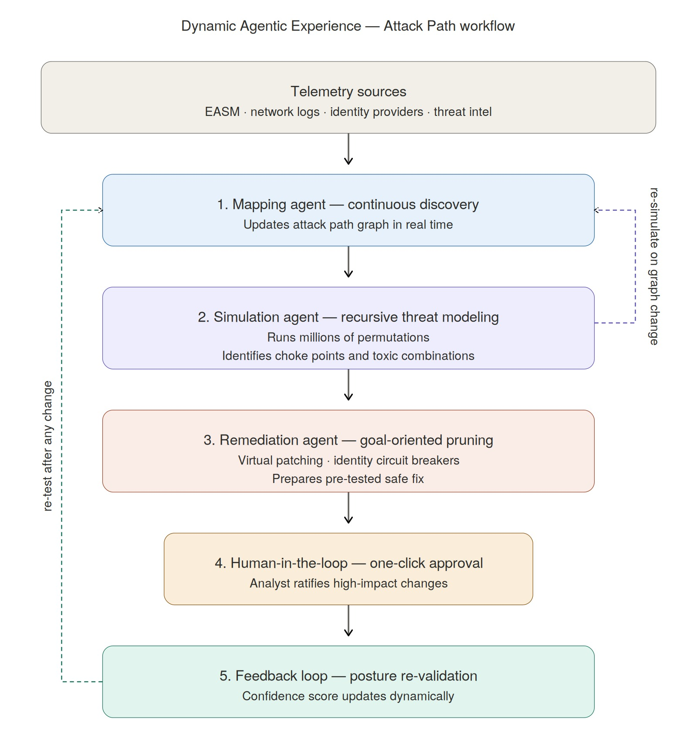

The workflow diagram above traces a single tick through the five agent stages — telemetry feeds the Mapping agent, whose graph updates trigger the Simulation agent, whose choke-point findings arm the Remediation agent, whose safe fixes pass through a human approval gate before the feedback loop re-validates everything. The two dashed return paths are what make this "dynamic" rather than linear: any graph change re-triggers simulation, and any remediation re-triggers the mapping/simulation cycle.
Now the architecture diagram, which shows how these agents are wired into the Qualys ETM platform and external systems:The architecture diagram stacks four layers. Data ingestion pulls from EASM, network telemetry, identity providers, and Qualys' own VMDR/CSAM. The orchestration layer is the heart of the design — the three agents all read and write to a shared Attack Path graph (your existing ETM data model, extended with MITRE ATT&CK mappings), and they share an orchestrator runtime that handles scheduling, inter-agent messaging, LLM reasoning, and ExPRT.AI risk scoring. The action layer shows the outbound integrations that actually enforce changes: WAF rules for virtual patches, the identity broker for circuit breakers, config management for pushing safe fixes, and ticketing for audit. The presentation layer ties back to your ETM Attack Path UI with the Confidence Score and one-click approval affordances.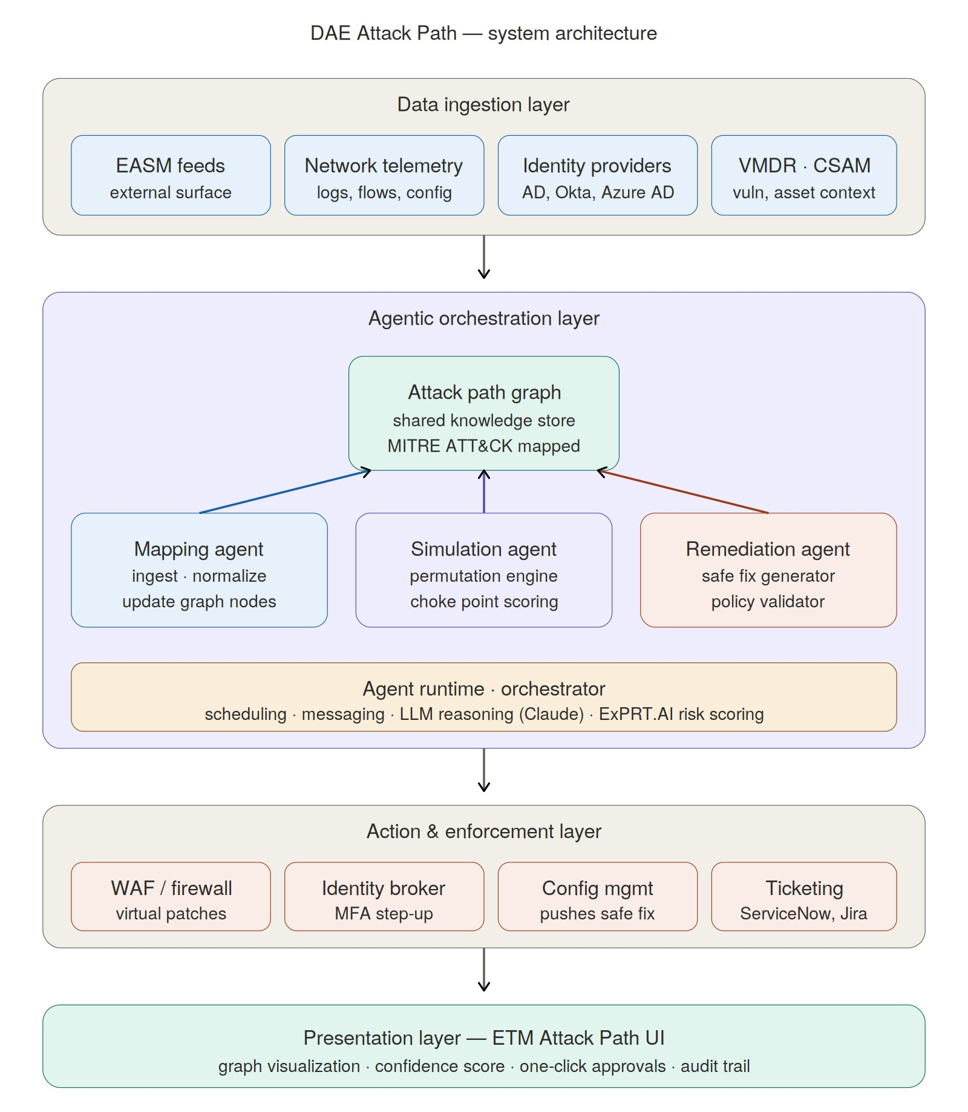
A few architectural choices worth flagging for your deck:
The shared graph is what makes the three agents coordinate rather than run as isolated pipelines — any change by one agent is immediately visible to the others, which is what enables the "re-simulate after remediation" feedback loop. The orchestrator is where you'd slot Claude (or similar reasoning model) for the Simulation agent's path-planning and the Remediation agent's safe-fix generation, while the Mapping agent is mostly deterministic graph ops. The human-in-the-loop gate sits between the Remediation agent and the Action layer — agents prepare and stage, humans ratify, enforcement fires.
If you want, I can turn either diagram into a Qualys-branded PPTX slide (light blue card backgrounds, red accents, blue headers) to drop into the conference deck, or expand one into a multi-slide breakdown for the McKinsey-style executive deck.

