1. Matrix-vector multiplication

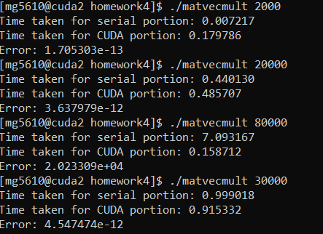

2.

Jacobi Serial version

Jacobi CUDA version

3. We have generated some training data on which we will run our Hogwild SGD on. Our next course of action is to write the CUDA code which will parallelize the SGD.