User Manual

*Project Tracking*

# Department of General Services Office of Public School Construction

June 2013

**USER MANUAL**

# TABLE OF CONTENTS

Page #

* 1. GENERAL INFORMATION 1-1
  2. System Overview 1-1
  3. Authorized Use Permission 1-1
  4. Points of Contact 1-1
  5. SYSTEM FEATURES 2-1
  6. Login 2-1
     1. Successful Login 2-2
     2. Invalid Password 2-2
     3. Account Locked 2-2
     4. Expired Password 2-3
     5. Invalid User Name 2-3
     6. User Name Not Approved 2-4
     7. Inactive User Name 2-4
  7. Change Your Password 2-5
     1. Valid Current Password 2-5
     2. Invalid Current Password 2-6
  8. Forgot Your Password 2-6
     1. Valid User Information 2-6
     2. Invalid User Information 2-7
  9. PTN Generator – Manage 2-8
     1. Edit PTN 2-8
     2. Add new PTN 2-8
     3. Search 2-9
  10. Project Tracking - Search 2-10
      1. Simple Search 2-10
      2. Advanced Search 2-10
  11. Project Tracking – Project Page 2-11
      1. Project Page - Details 2-12
      2. Project Page – Fund Releases 2-12
      3. Project Page – Budget Summary 2-12
      4. Project Page – Transaction Details 2-13
      5. Project Page – Modernization Eligibility 2-13
      6. Project Page – New Construction Eligibility 2-14
  12. Project Tracking – District Page 2-14
      1. District Page – Modernization Eligibility 2-14
      2. District Page – New Construction Eligibility 2-15
      3. District Page – Fund Release 2-15

# GENERAL INFORMATION

# System Overview

The Office of Public School Construction (OPSC) Project Tracking System is an application that allows you to access the project status information for school projects in the OPSC project tracking database. The information available includes various phases of the project and apportionment approval, fund release and category balances of the project.

Also, the collaborative efforts of the OPSC and the Division of the State Architect (DSA) have resulted in the creation of an interactive website that allows districts a point of entry to begin a school facilities project. Each project shall be identified by a project tracking number (PTN) that will join application data utilized by the above agencies. The goal is to provide school districts and other interested parties the ability to seamlessly access the status of a specific project during the approval processes of each office. Establishing a common numbering system is the first step in meeting this goal.

# Authorized Use Permission

The Project Tracking System is available to the general public. You do not need a password to view project tracking data with this "read only" application. Districts and charter schools can login to add or update information for their own Project Tracking Generator numbers.

# Points of Contact

For additional information, please contact your [OPSC project manager.](http://www.dgs.ca.gov/opsc/AboutUs/PMList.aspx)

# SYSTEM FEATURES

# Login

By logging in you will be allowed to create and modify existing records. Anyone can view all records in the database without logging in.

Open Internet Explorer, key the web address below and press **Enter**. <http://www.applications.opsc.dgs.ca.gov/PT>

The new OPSC Project Tracking page will display.

1. Hover over „PTN Generator‟ main menu.
2. Click on „Log in‟ submenu.

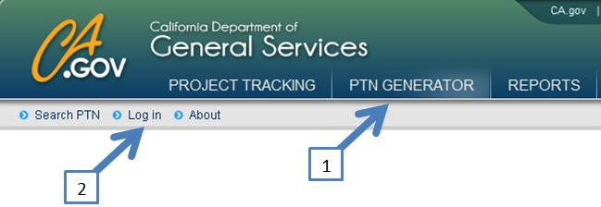

The login screen displays as shown below.

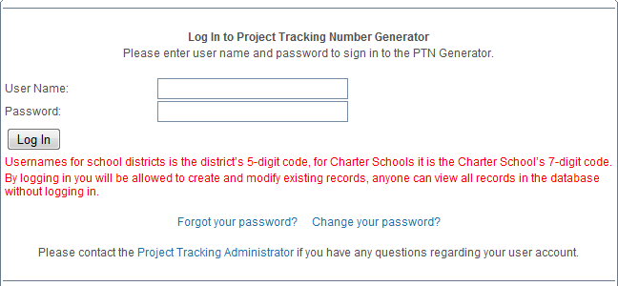

1. Type the **User Name** and **Password**.
   1. Username for school districts is the district‟s 5-digit code. For charter schools it is the charter school‟s 7-digit code.
   2. Password must be at least eight characters (at least one letter and one number).

*Note: Passwords are case sensitive.*

1. Click Log In button

## Successful Login

The welcome page is displayed.

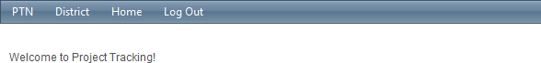

## Invalid Password

If user enters invalid password then the following error message will display: “The password you entered does not match our records.”

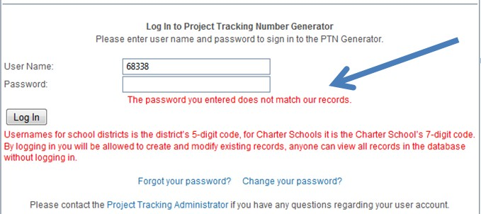

## Account Locked

If user enters an invalid password for 5 attempts then account is locked and the following error message will be displayed: “Your account has been locked out. Please contact the [Project Tracking Administrator](mailto:OPSCProjectTrackingAdmin@dgs.ca.gov) to unlock your account.”

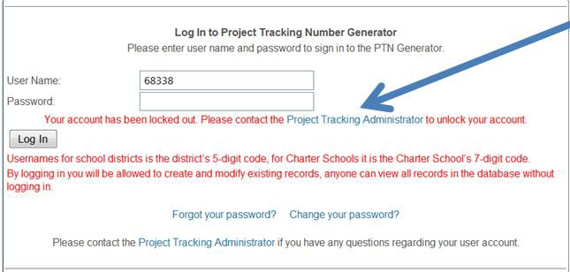

## Expired Password

Initially all passwords were set to expired status and the following error message is displayed: “Your password is expired. Please click 'Change your password?' link below to change your password.”

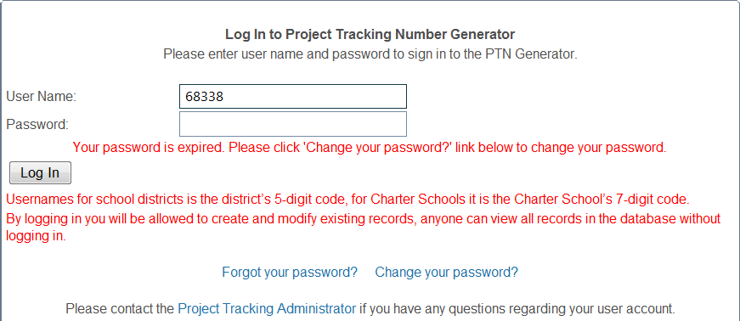

## Invalid User Name

If a district or charter school enters an invalid user name, then the following error message is displayed: “The username you entered does not match our records.”

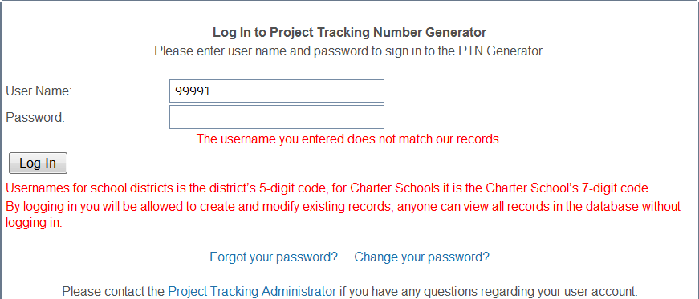

## User Name Not Approved

All previous district and charter usernames were approved when they were created by database administrators. The following error message is displayed if a username is not approved: “Your account has not been approved. Please contact the [Project Tracking Administrator](mailto:OPSCProjectTrackingAdmin@dgs.ca.gov) to approve your account.”

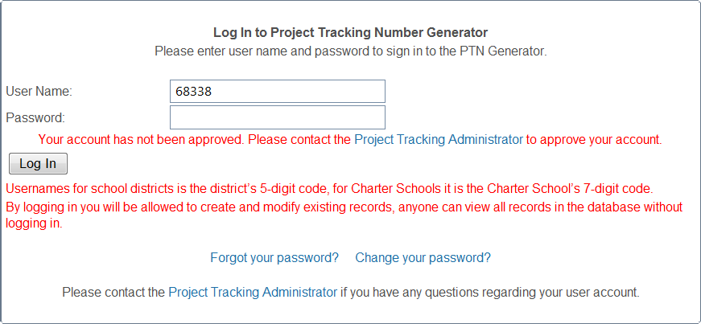

## Inactive User Name

The following error message is displayed if user name is inactive: “Your account has been inactivated. Please contact the [Project Tracking Administrator](mailto:OPSCProjectTrackingAdmin@dgs.ca.gov) to activate your account.”

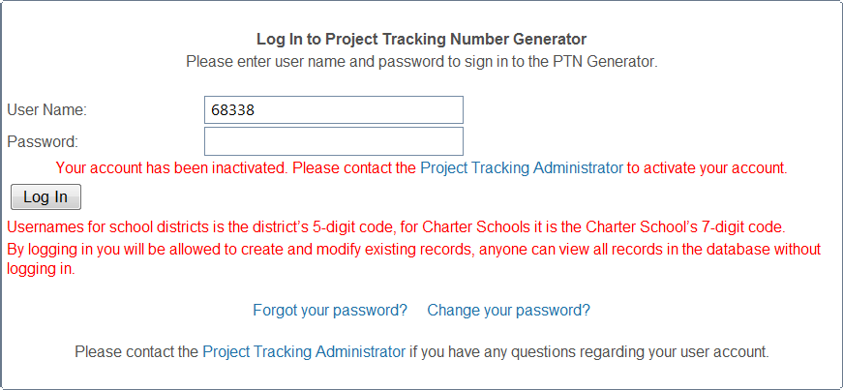

# Change Your Password

All users have an option to change their password.

Open Internet Explorer, key the web address below and press **Enter**. <http://www.applications.opsc.dgs.ca.gov/PT>

The new OPSC Project Tracking page will display.

1. Hover over „PTN Generator‟ main menu.
2. Click on „Log in‟ submenu.
3. Toward the bottom of the pages, click on “Change your password?” link.

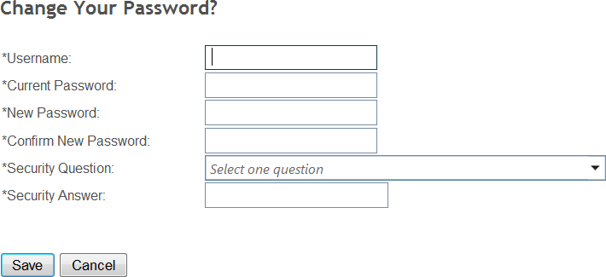

1. There are six fields and all of them are required. Please type and click on „Save‟ button. *Note: Passwords are case sensitive and must be at least eight characters in length (at least one letter and one number).*

## Valid Current Password

If user enters a valid current password, then the system will update the profile with a new password and the following message will be displayed.

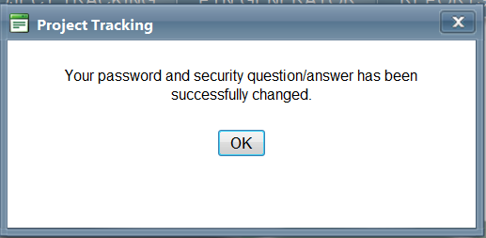

*Note: The system will NOT generate an email.*

## Invalid Current Password

* + - 1. If a user enters invalid current password the following error message will be displayed:

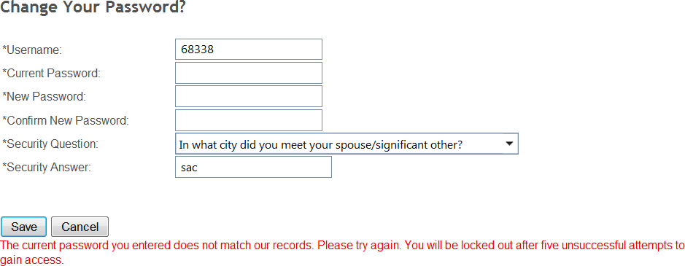

* + - 1. The user is locked out after five attempts and the following message is displayed:

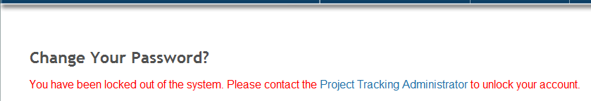

*Note: The user needs to send an email to Project Tracking Administrator and request to unlock the user profile.*

# Forgot Your Password

Open Internet Explorer, key the Web Address below and press **Enter**. <http://www.applications.opsc.dgs.ca.gov/PT>

The new OPSC Project Tracking page will display.

1. Hover over the „PTN Generator‟ main menu.
2. Click on the „Log in‟ submenu.
3. Toward the bottom of the pages, click on the “Forgot your password?” link.

## Valid User Information

* + - 1. On the first screen type in the user name and District Rep email address on file.

If the user name and email address match our system, then the second screen will be displayed.

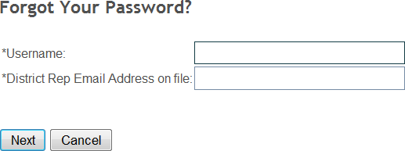

* + - 1. Type the security answer and click „Next.‟

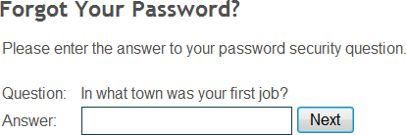

* + - 1. If the security answer matches to what is in the system then it will display the following message:

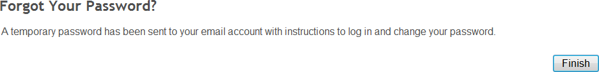

The system will generate an email with a new temporary password and send it to the Superintendent, as well as main and alternative district representatives on file with the OPSC.

*Note: Here is the email template*

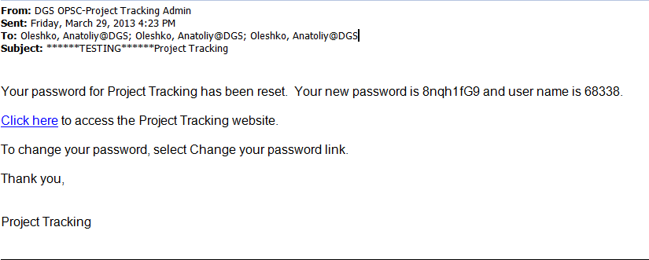

## Invalid User Information

* + - 1. If the user enters invalid User Name or Email Address on the first „Forgot your password?” screen , then the following messages is displayed and after five invalid attempts the user will be locked:

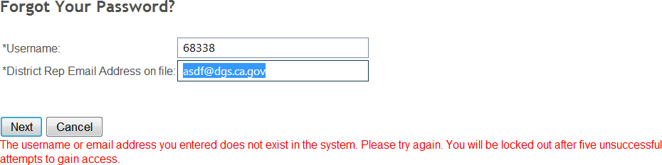

* + - 1. If the user enters invalid security answer on the second „Forgot your password?” screen, then after five attempts the user will be locked.

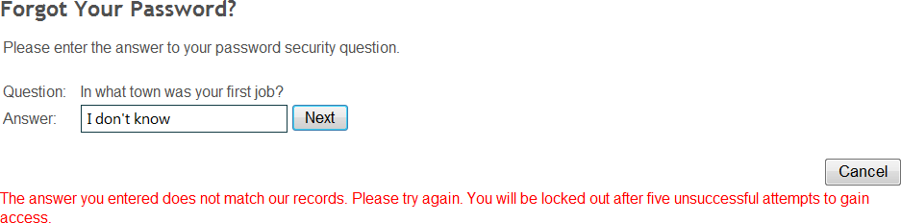

# PTN Generator

## Edit PTN

*Prerequisite: Login by following step 2.1*

* + - 1. 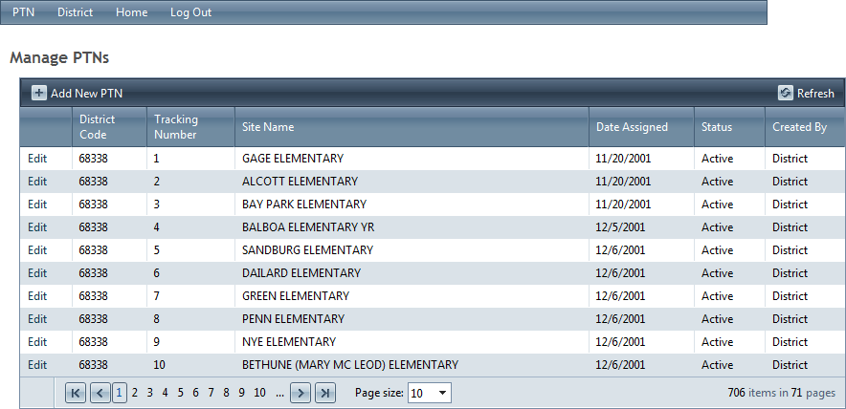Hover over „PTN‟ menu and click on „Manage PTN‟ submenu.
      2. Click „Edit‟ link next to the PTN you want to update and the edit form will be displayed.
      3. Click „Save‟ button to update the PTN record.

## Add new PTN

*Prerequisite: Login by following step 2.1*

* + - 1. Hover over „PTN‟ menu and click on „Manage PTN‟ submenu.
      2. Click „Add New PTN‟ button 
      3. Here is the Add PTN form:
         1. If a user selects „New School‟ for School name, then „Proposed School Name‟ is a required field.
         2. The „New Construction Type‟ is a required field if „New Construction‟ radio button is „Yes.‟
         3. School Type (High, Middle, and Elementary) is a required field.

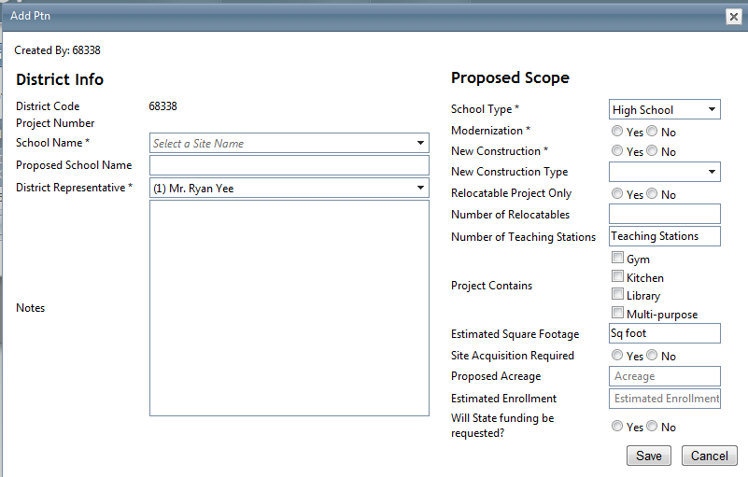

* + - 1. Click „Save‟ button to add new PTN record.

## Search

Open Internet Explorer, key the web address below and press **Enter**. <http://www.applications.opsc.dgs.ca.gov/PT>

The new OPSC Project Tracking page will display.

* + - 1. Click on „PTN Generator‟ main menu.
      2. Users can type District Code and number to search for specific PTN number.
      3. Click on „View‟ link in the first column to expand the nested form.

*Note: To view all PTNs for a district, enter only the 5-digit district code and click Search.*

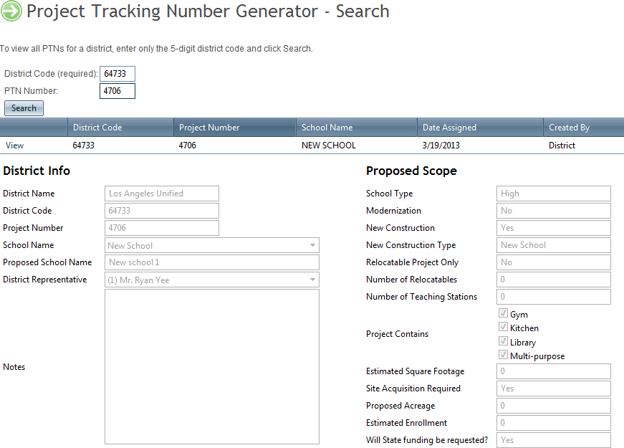

# Project Tracking - Search

Open Internet Explorer, key the web address below and press **Enter**. <http://www.applications.opsc.dgs.ca.gov/PT>

The new OPSC Project Tracking page will display.

## Simple Search

* + - 1. Hover over „Simple Search‟ tab.
      2. Users can choose one of the three search parameters:
         1. *Project Number* - OPSC project number is in the following format, two-digit program code, five-digit District Code, two-digit attendance area code, and finally three digit project number. Example: 50/64777-00-006 or 57/64777-00-006.
         2. *PTN Number* - Project Tracking Number as a two-part numerical identifier. The first part is the five-digit district code number; the second part is unique number assigned by OPSC PTN Generator web application. Example: 64733-0001.
         3. *DSA Number* - DSA Project Application Numbers are composed of two components. Example: 01-100000, where "01" represents the DSA San Francisco Bay Area Regional office and "100000" is the six-digit Application Number.
      3. Type the number and click Search button. The values for the project will be populated in the results table.

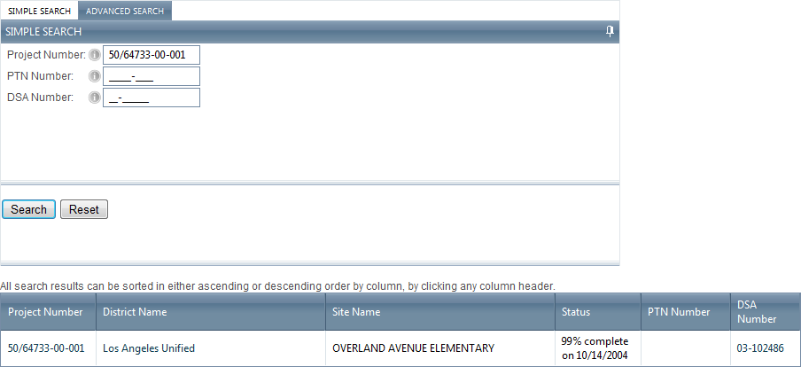

## Advanced Search

* + - 1. Hover over „Advanced Search‟ tab.
      2. Users can choose one or more of the five search parameters:
         1. *Program Type* –

School Facility Program (SFP) or

Lease-Purchase Program (LPP)

* + - * 1. *Project Type* – two-digit code

School Facility Program (SFP)

50 = SFP New Construction

51 = SFP Facility Hardship (New Construction)

52 = SFP Joint Use

53 = SFP Critically Overcrowded (Converted)

54 = SFP Charter (Converted)

55 = SFP Career Technical Education (New Construction)

56 = SFP Overcrowding Relief Grant

57 = SFP Modernization

58 = SFP Rehabilitation (Modernization)

59 = SFP Career Technical Education (Modernization)

Lease-Purchase Program (LPP) 22 = LPP New Construction 77 = LPP Modernization

* + - * 1. *County* – the state of California is divided into 58 counties
        2. *District*
        3. *Site*
      1. Click Search button. All projects that satisfy the search criteria will show in the results table. *All search results can be sorted in either ascending or descending order by column, by clicking any column header.*

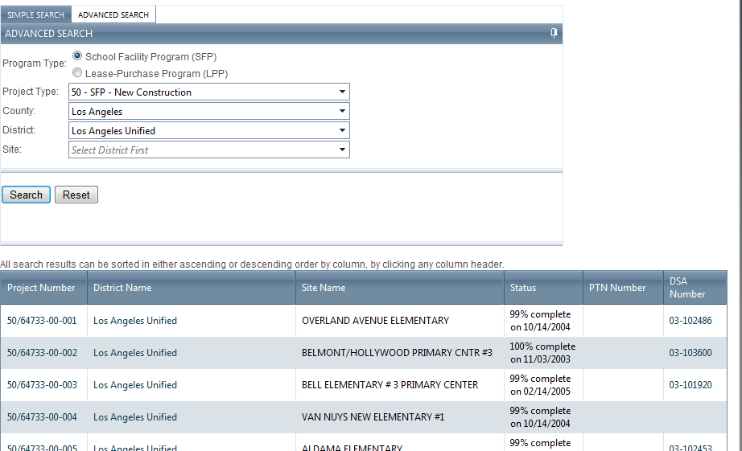

# Project Tracking – Project Page

*Prerequisite: Search for a project by using step 2.4.1 or 2.4.2*

1. Click on the Project Number link in the results table.
2. The Project Main page will display. This page is divided into six tabs. Click on the tab to see the details.

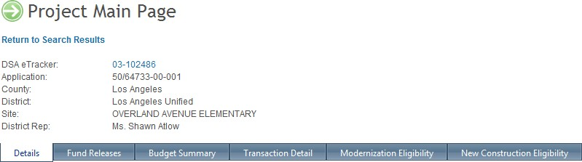

## Project Page - Details

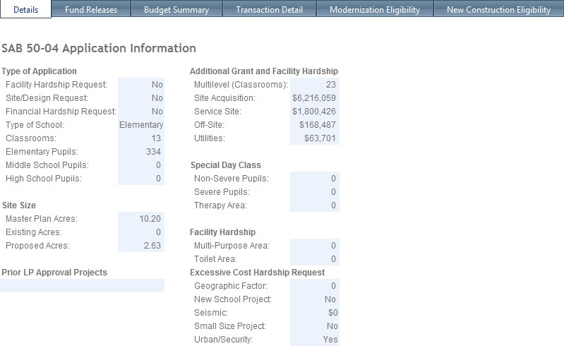*Details* - displays information that was entered onto the District's *Application for Funding* (Form SAB 50-04) submitted with the project. This will show information such as: classroom counts, number of pupil grants requested, funding amounts for site development and other project specifics.

## Project Page – Fund Releases

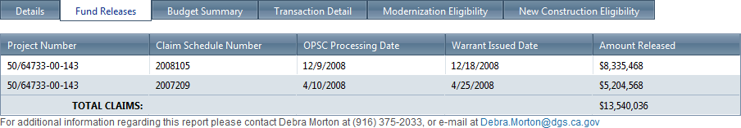*Fund Releases* - displays the date and type of each transaction related to the fund release for each phase of the project.

## Project Page – Budget Summary

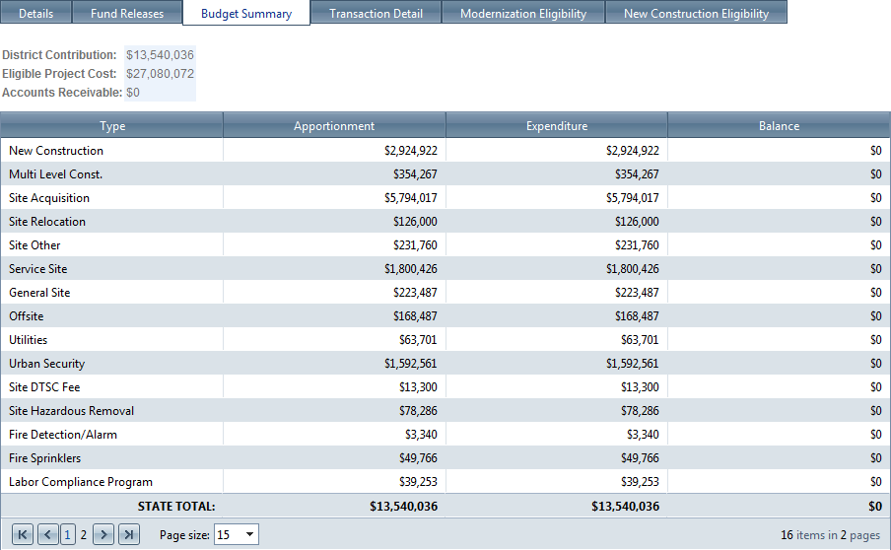*Budget Summary* - displays all of the various grants that the project qualified for and received. Instead of displaying a lump-sum grant amount, this screen shows a detailed breakdown of all grants associated with the project, by category.

## Project Page – Transaction Details

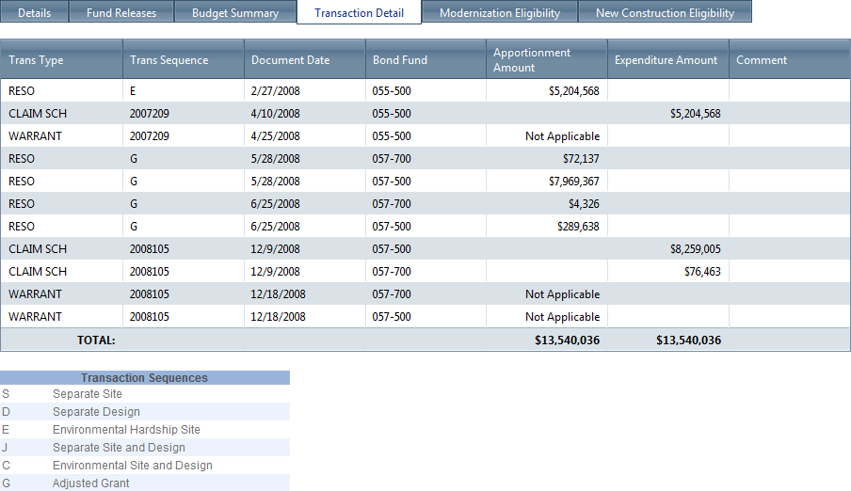*Transaction Detail* - The Transaction Detail screen displays the application's financial transaction history. This will include such things as: State Allocation Board approval dates, fund release requests and approval dates, project closeout dates, and dates of any other financial adjustments made to the project. The Transaction Detail also shows a tally of the funds apportioned and expended on the project.

## Project Page – Modernization Eligibility

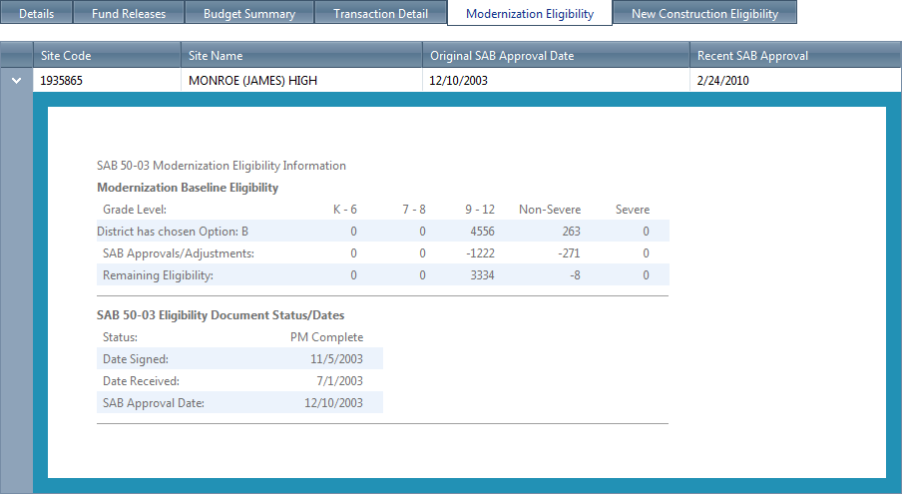*Modernization Eligibility* - displays the District's current remaining eligibility for a given school site as well as any and all adjustments made over time to the site's eligibility. *Click on the arrow to expand the nested table.*

## Project Page – New Construction Eligibility

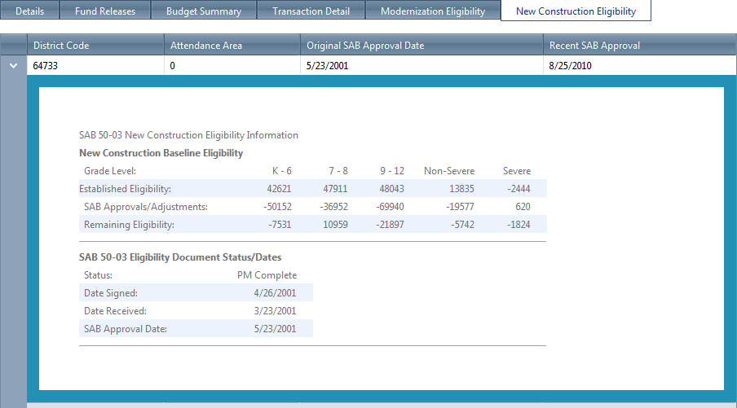*New Construction Eligibility* - displays the District's current remaining district-wide eligibility as well as any and all adjustments made over time to the District's eligibility. *Click on the arrow to expand the nested table.*

# Project Tracking – District Page

*Prerequisite: Search for a project by using step 2.4.1 or 2.4.2*

1. Click on the District Name link (second column) in the results table.
2. The District Main page will display. This page is divided into three tabs. Click on the tab to see the details.

## District Page – Modernization Eligibility

*Modernization Eligibility* - displays the District's current remaining eligibility for a given school site as well as any and all adjustments made over time to the site's eligibility. *Click on the arrow to expand the nested table.*

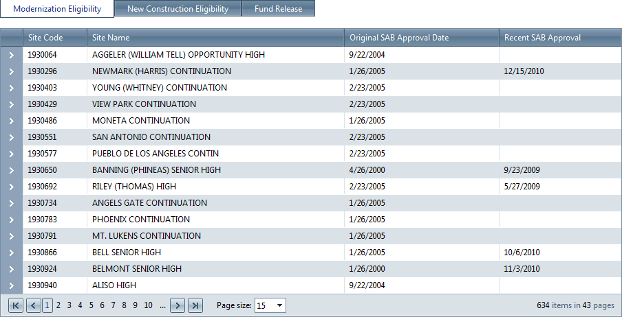

## District Page – New Construction Eligibility

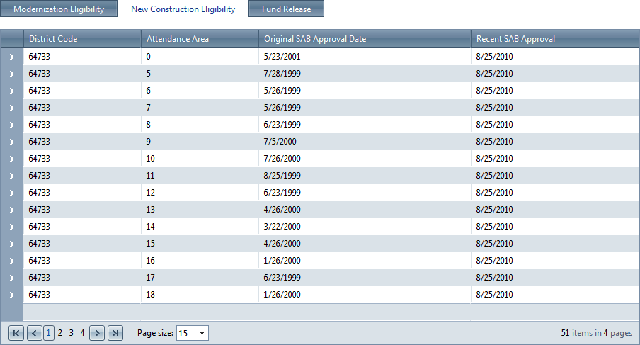*New Construction Eligibility* - displays the District's current remaining district-wide eligibility as well as any and all adjustments made over time to the District's eligibility. *Click on the arrow to expand the nested table.*

## District Page – Fund Release

*Fund Releases* - displays the date and type of each transaction related to the fund release for each phase of the project for all projects in a district.

