MAEER'S MIT ARTS, COMMERCE AND SCIENCE COLLEGE, ALANDI (D), PUNE
DEPARTMENT OF COMPUTER SCIENCE

M.Sc. COMPUTER SCIENCE
MACHINE LEARNING PROJECT REPORT

TEMPLE AND RELIGIOUS GATHERING
CROWD STAMPEDE PRESSURE INDEX
PREDICTION
A machine-learning based academic prototype for crowd pressure
prediction and risk-level classification
Student | Mr. Mayur Pawar
Roll No | SM1102
Subject Name | Machine Learning
Faculty/Guide | Prof. Ram Agrawal
Academic Year | 2026–202
Submitted in partial fulfillment of the academic requirements
for the M.Sc. Computer Science course
Submission Date: 29 September 2026
DECLARATION
This report presents the submitted project methodology, analysis, results,
and implementation details for academic evaluation.

TABLE OF CONTENTS
Sr. No. | Contents | Page No.
1 | Introduction | 3
2 | Problem Statement | 4
3 | Objectives | 5
4 | Currently Available Solutions and Their Limitations | 6
5 | Dataset Description | 7
6 | Exploratory Data Analysis | 8
7 | Proposed ML Algorithms | 9
8 | Algorithm Evaluation and Comparison | 10
9 | Results | 11
10 | Conclusions | 12
11 | Future Scope | 13
12 | References | 14

1. Introduction
Large temple festivals and religious gatherings attract thousands of devotees within a limited geographical area. During special occasions, festivals, holidays and important religious events, the number of people entering a temple or gathering area can increase rapidly. When the inflow of people becomes higher than the outflow, crowd density increases and movement becomes slower. In narrow corridors, entrances, exits, stairways and other restricted areas, this situation can create bottlenecks and increase crowd pressure. Therefore, monitoring and understanding crowd conditions is an important part of effective crowd management.
Traditional crowd-management methods generally depend on CCTV monitoring, security personnel, manual crowd counting, barricades and controlled entry or exit. These methods can provide useful information, but they may not always combine multiple crowd-related factors into a single measurable prediction. A machine-learning approach can analyze several parameters simultaneously and identify patterns within historical crowd-flow data.
The project “Temple and Religious Gathering Crowd Stampede Pressure Index Prediction” focuses on developing an academic machine-learning prototype for analyzing crowd conditions. The system uses parameters such as Crowd Count, Inflow Rate, Outflow Rate, Crowd Density, Corridor Width, Corridor Capacity, Flow Speed, Temperature, Weather and event-related information.
The project performs two major machine-learning tasks. The first task is regression, where the system predicts a numerical Crowd Pressure Index (CPI) on a scale of 0 to 100. The second task is classification, where the predicted crowd condition is categorized into three levels: Safe, Moderate and Critical.
The project follows a complete machine-learning workflow including data collection, dataset understanding, data cleaning, exploratory data analysis, feature engineering, feature and target preparation, train-test splitting, feature scaling, model development, model evaluation and comparison. Linear Regression and Random Forest Regression are used for the regression task, while Logistic Regression and Random Forest Classification are used for the classification task.
The performance of the models is evaluated using metrics such as MAE, RMSE and R² Score for regression, and Accuracy, Precision, Recall, F1 Score and Confusion Matrix for classification. A new crowd datapoint is also provided to demonstrate how the trained models generate a pressure index and risk level.
The main purpose of this project is to demonstrate how machine learning can be applied to structured crowd-flow data to support crowd analysis, risk identification and decision-making. The proposed system is an academic prototype, and its pressure-index formula and risk thresholds require validation using real-world data and domain experts before any operational safety use.

2. Problem Statement
Temple festivals, religious gatherings and other large public events can bring a very high number of people into a limited space. During peak hours, sudden increases in crowd inflow can cause congestion, particularly at temple entrances, exits, narrow corridors, stairways and other restricted areas. When the number of people entering an area is greater than the number leaving it, crowd accumulation can occur. Increased crowd density combined with reduced movement speed and limited corridor capacity can create potentially unsafe crowd conditions.
Traditional crowd-management techniques such as CCTV monitoring, manual counting, security personnel and physical barricades are useful for controlling crowds. However, these methods may depend heavily on continuous human observation and may not provide a numerical prediction of the overall crowd pressure. Different factors such as crowd count, inflow rate, outflow rate, density, corridor capacity and movement speed need to be considered together to understand the overall crowd condition.
Therefore, this project aims to develop a machine-learning based Crowd Pressure Index Prediction system. The system analyzes historical crowd-flow data and uses important crowd and environmental parameters to calculate and predict a numerical Crowd Pressure Index.
The project addresses two related problems:
- Regression: Predict the numerical Crowd Pressure Index from 0 to 100.
- Classification: Categorize the crowd condition into Safe, Moderate or Critical.
The proposed system provides a structured approach for analyzing crowd conditions and demonstrating how machine-learning techniques can be applied to crowd-management research. The system is intended as an academic prototype, and the pressure-index formula and risk thresholds used in the project require further validation with real-world data and domain experts.

3. Objectives
The main objective of this project is to develop a machine-learning based academic prototype for predicting crowd pressure during temple and religious gatherings.
The specific objectives are:
- To study crowd-flow conditions using a structured dataset containing crowd, corridor and environmental information.
- To understand the relationships between Crowd Count, Inflow Rate, Outflow Rate, Crowd Density and Flow Speed.
- To clean the dataset by handling missing values, incorrect data types and duplicate records.
- To perform Exploratory Data Analysis using statistical summaries, distributions and correlation analysis.
- To perform feature engineering by extracting useful time-related features such as Hour, Day, Month and Year.
- To calculate a project-defined Crowd Pressure Index using normalized pressure-related components.
- To use regression algorithms for predicting the numerical Crowd Pressure Index.
- To use classification algorithms for identifying Safe, Moderate and Critical conditions.
- To evaluate the models using appropriate regression and classification metrics.
- To compare the performance of the selected algorithms.
- To generate a confusion matrix for classification.
- To test the final workflow using a new crowd datapoint.

4. Currently Available Solutions and Limitations
Currently Available Solutions
- CCTV Monitoring – Used to monitor crowd movement and identify crowded areas.
- Manual Crowd Counting – Security personnel estimate the number of people in an area.
- Barricades – Used to control and organize the movement of people.
- Controlled Entry and Exit – Entry and exit points are managed to control crowd flow.
- Public Announcements – Used to guide people and provide instructions during crowded situations.
- Security Personnel – Police, volunteers, and security staff monitor and manage the crowd.
- Crowd Density Monitoring – Some systems estimate the number of people or density in a particular area.
Limitations
- CCTV monitoring requires continuous human observation.
- Manual counting is difficult for large crowds.
- Crowd conditions can change very quickly.
- Security personnel may not be able to monitor multiple locations simultaneously.
- Barricades and controlled entry control movement but do not predict future crowd pressure.
- Basic density monitoring may consider only the number of people.
- Important factors such as inflow, outflow, movement speed, and corridor capacity may not be considered together.
- Existing methods mainly focus on current crowd conditions rather than prediction.

5. Dataset Description
- Dataset Name: Temple_Crowd_Pressure_Dataset_20000.xlsx
- Number of Records: 12,009 records.
- Number of Original Columns: 15 columns.
- Duplicate Records: The dataset was checked for duplicate records, and no duplicate records were removed.
- Dataset Content: The dataset contains information about:
  - Crowd movement
  - Crowd density
  - Weather conditions
  - Temperature
  - Event and holiday information
  - Corridor characteristics
  - Crowd flow conditions
Dataset Columns
Column | Description
Date | Date of observation
Time | Time of observation
Location | Location where the observation was recorded
Crowd Count | Number of people present
Inflow Rate | Number of people entering the area
Outflow Rate | Number of people leaving the area
Crowd Density | Number of people per available area
Weather | Weather condition
Temperature | Temperature at the time of observation
Event Day | Indicates whether a special event is taking place
Holiday | Indicates whether the observation is on a holiday
Corridor Width | Width of the crowd movement corridor
Corridor Capacity | Estimated capacity of the corridor
Flow Speed | Speed of crowd movement
Bottleneck Indicator | Indicates whether a bottleneck condition exists

Data Preprocessing
- Numerical columns are converted into the appropriate numeric format.
- Missing numerical values are handled using the median.
- Missing categorical values are handled using the mode.
- Additional time-based features are extracted from the Date and Time columns:
  - Hour
  - Day
  - Month
  - Year
Target Variables
- The original dataset variables are used as input features for the machine-learning models.
- A Crowd Pressure Index is calculated using the selected crowd-related variables and is used as the regression target.
- The Risk Level is derived from the Crowd Pressure Index and is used as the classification target.
- The two outputs of the project are:
- Crowd Pressure Index → Regression output
- Risk Level (Safe, Moderate, Critical) → Classification output

6 Exploratory Data Analysis
1. Crowd Count
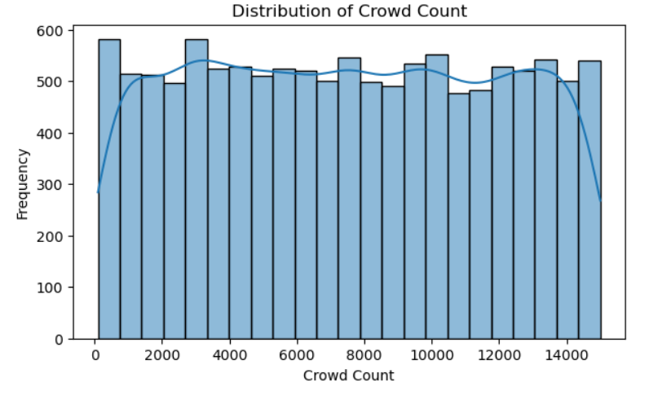
2. Crowd Density
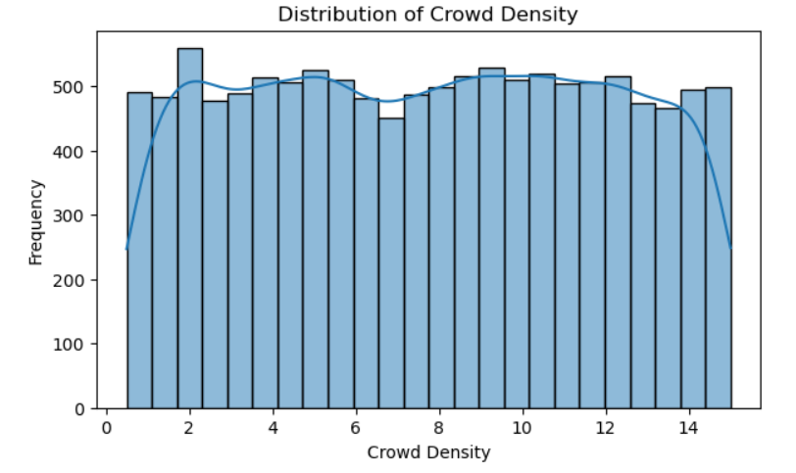
3.Inflow and Outflow
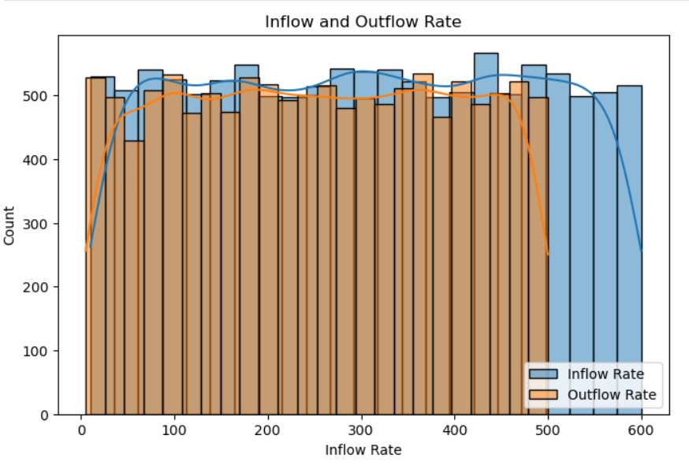
4. Correlation Matrix
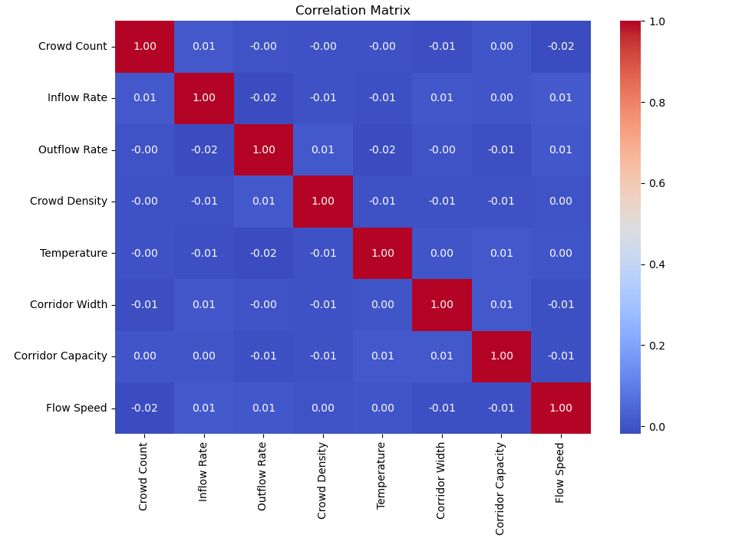

5. Risk Level Distribution
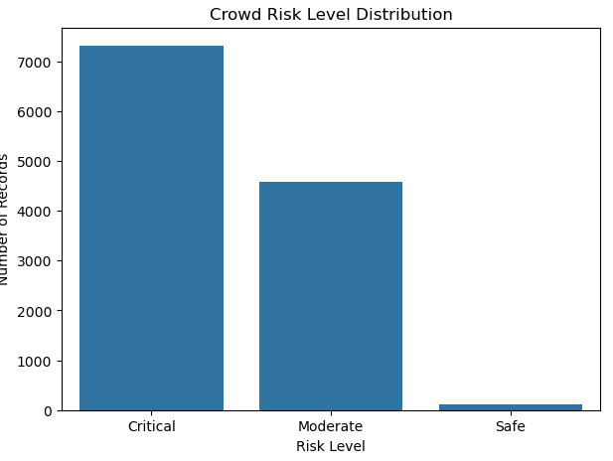
6. Crowd Pressure Index
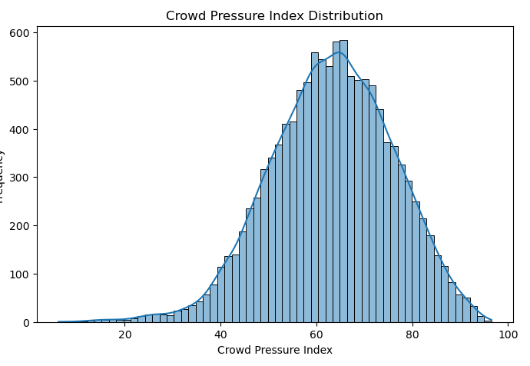

7. Proposed ML Algorithms
The project uses separate algorithms for regression and classification.
Regression Algorithms
1. Linear Regression
Linear Regression is used as a baseline regression algorithm. It is simple, fast and relatively easy to interpret. It is suitable for predicting a continuous numerical target such as the Crowd Pressure Index.
2. Random Forest Regression
Random Forest Regression is an ensemble machine-learning algorithm based on multiple decision trees. It can capture non-linear relationships and interactions between different crowd variables. It is suitable for structured/tabular data.
Classification Algorithms
1. Logistic Regression
Logistic Regression is used as a baseline classification algorithm to classify crowd conditions into Safe, Moderate and Critical categories.
2. Random Forest Classification
Random Forest Classification uses multiple decision trees and can model more complex relationships between the input features and risk categories.
The purpose of using these models is to compare a simple baseline approach with a more flexible tree-based approach. Model selection is based on the actual evaluation results rather than assuming beforehand that one algorithm will always perform better.

8. Algorithm Evaluation and Comparison
The dataset is divided into 80% training data and 20% testing data using train_test_split() with random_state=42. The training data is used to train the models, while the testing data is used to evaluate their performance on unseen records.
For regression, three evaluation metrics are used:
- MAE: Measures the average absolute difference between actual and predicted values. Lower values indicate smaller errors.
- RMSE: Measures prediction error while giving greater importance to larger errors. Lower values are preferred.
- R² Score: Indicates how well the model explains variation in the target variable. Higher values indicate better explanatory performance.
For classification, the following metrics are used:
- Accuracy: Percentage of correctly classified records.
- Precision: Measures the correctness of positive/class predictions.
- Recall: Measures how many actual class instances are correctly identified.
- F1 Score: Combines precision and recall.
- Confusion Matrix: Shows actual and predicted classes.
StandardScaler is applied to the appropriate models. Importantly, the scaler is fitted using only the training data and then applied to the testing data.
Both regression and classification models are compared using the same test dataset so that their performance can be evaluated consistently.
9. Results
The models were trained using the supplied dataset and the evaluation code described above.
Regression Results
Model | MAE | RMSE | R² Score
Linear Regression | 2.992 | 4.688 | 0.867
Random Forest Regression | 0.988 | 2.053 | 0.974
The Random Forest Regression produced lower MAE and RMSE and a higher R² score than Linear Regression on the test dataset.
Classification Results
Model | Accuracy | Precision | Recall | F1 Score
Logistic Regression | 0.921 | 0.922 | 0.921 | 0.920
Random Forest Classification | 0.964 | 0.964 | 0.964 | 0.963
The Random Forest Classification model achieved higher values across the reported classification metrics.
The Random Forest classification confusion matrix was:
Actual / Predicted | Safe | Moderate | Critical
Safe | 9 | 13 | 0
Moderate | 0 | 864 | 53
Critical | 0 | 20 | 1443
The results demonstrate that the Random Forest models captured the relationships in this dataset more effectively than the corresponding baseline models. These results apply specifically to the supplied dataset and project-defined target construction.
10. Conclusions
The project successfully demonstrates an end-to-end machine-learning workflow for Temple and Religious Gathering Crowd Stampede Pressure Index Prediction. The workflow begins with loading and understanding the dataset and continues through data cleaning, exploratory data analysis, feature engineering, target preparation, model training and evaluation.
A project-defined Crowd Pressure Index is calculated using Density Score, Inflow Score, Capacity Score and Speed Score. This index provides a numerical representation of the crowd condition on a 0–100 scale. The project also converts the index into three risk categories: Safe, Moderate and Critical.
For regression, Linear Regression and Random Forest Regression were compared. For classification, Logistic Regression and Random Forest Classification were compared. On the supplied dataset, Random Forest Regression produced an R² score of 0.974, while Random Forest Classification achieved an accuracy of approximately 96.42%.
The project demonstrates the usefulness of machine-learning techniques for structured crowd-flow analysis. However, the Crowd Pressure Index formula, weights and risk thresholds are project-defined academic assumptions. They have not been validated as official emergency-safety standards.
Therefore, the system should currently be considered a prototype for academic and research purposes.

11. Future Scope
- Real-Time CCTV Integration – Connect the system with CCTV cameras to automatically detect crowd count and crowd density.
- Computer Vision – Use object-detection and computer-vision techniques to identify and track crowd movement.
- IoT Integration – Use IoT sensors to collect real-time data such as inflow, outflow, movement speed, and environmental conditions.
- Real-Time Dashboard – Develop a web-based dashboard to display the Crowd Pressure Index, risk level, crowd density, and other important information.
- Real-Time Alerts – Add automatic alerts or notifications when the crowd pressure reaches a critical level.
- Advanced Machine Learning Models – Test models such as Gradient Boosting, XGBoost, Random Forest, and Neural Networks to improve prediction performance.
- Larger Dataset – Collect and use larger real-world datasets from different temples, festivals, and religious gatherings.
- GIS Integration – Use GIS and location-based information to identify crowded areas and possible bottleneck locations.
- Expert Validation – Validate the pressure-index formula and Safe, Moderate, and Critical thresholds with crowd-management experts.
- Field Testing – Test the system in real-world environments to evaluate its reliability and practical performance.
- Safety Validation – Conduct proper reliability and safety analysis before considering the system for actual emergency applications.
- Integrated System – In the future, machine learning, computer vision, IoT, GIS, dashboards, and alert systems can be combined into a single real-time crowd-management platform.

12. References
- Python Software Foundation. Python Documentation. Used as the primary programming language for data processing and machine-learning implementation.
- Pandas Documentation. Pandas Documentation. Used for data loading, cleaning, transformation, and analysis.
- NumPy Documentation. NumPy Documentation. Used for numerical calculations and feature processing.
- Matplotlib Documentation. Matplotlib Documentation. Used for creating graphs and visualizations during EDA.
- Seaborn Documentation. Seaborn Documentation. Used for statistical visualizations such as histograms and correlation heatmaps.
- Scikit-learn Documentation. Scikit-learn Documentation. Used for machine-learning algorithms, data preprocessing, train-test splitting, and model evaluation.
- Kaggle. India Crowd Flow Dataset. Used as a reference for crowd-flow-related data and project development.
https://www.kaggle.com/datasets/govindaramsriram/india-crowd-flow-dataset
- Project Dataset. Temple_Crowd_Pressure_Dataset_20000.xlsx – Dataset used for the implementation and analysis of the proposed project

