Vishwakarma Institute of Technology, Pune

Department: CSE-AI Semester: 5
Academic Year: 2026-27
Practical No: 2
Division: C Batch: 2
Roll no: 3090349 PRN No: 12410277
Name of Student: Mayuresh Kulal
Subject Name: Deep Learning
Problem Statement:
Design and implement a Multilayer Perceptron (MLP) for classification of the Iris or Wine dataset, and evaluate its performance using accuracy and a confusion matrix.
Algorithm:
Libraries Used:
1. Scikit-learn (sklearn)
- Used for loading the dataset, preprocessing, building the Multilayer Perceptron (MLP) classifier, training, and evaluation.
- Provides train_test_split, StandardScaler, MLPClassifier, and evaluation metrics such as accuracy_score, confusion_matrix, and classification_report.
2. Matplotlib (matplotlib.pyplot)
- Used for data visualisation.
- Displays the confusion matrix and the training loss curve of the MLP.
Dataset Description: Iris Dataset
The Iris dataset is a classic multivariate classification dataset containing measurements of iris flowers.
- It contains 150 samples.
- Each sample has 4 numeric features: sepal length, sepal width, petal length, and petal width.
- The dataset has 3 classes: Setosa, Versicolor, and Virginica (50 samples each).
Input: 4 numerical features (sepal length, sepal width, petal length, petal width)
Output: One of 3 iris species classes.
Steps:
Import Required Libraries
- Import scikit-learn modules for dataset loading, preprocessing, model building, and evaluation.
- Import Matplotlib for visualisation.
Load the Dataset
- Load the Iris dataset using load_iris() from sklearn.datasets.
- Split the data into training and testing sets (80% train, 20% test) using train_test_split.
Preprocess the Data
- Standardise the features using StandardScaler so that they have zero mean and unit variance.
- Fit the scaler on the training data and transform both the training and testing data.
Build the MLP Model
- Create an MLPClassifier with two hidden layers of 10 neurons each.
- Use the ReLU activation function and the Adam optimiser.
- Set max_iter to 1000 to allow sufficient training iterations for convergence.
Train the Model
- Train the MLP classifier using the fit() method on the scaled training data.
Evaluate the Model
- Predict class labels for the test data using predict().
- Calculate the accuracy using accuracy_score().
- Generate the confusion matrix using confusion_matrix().
- Generate the classification report using classification_report().
Visualise the Results
- Plot the confusion matrix using ConfusionMatrixDisplay.
- Plot the training loss curve using mlp.loss_curve_.
Code:
from sklearn.datasets import load_iris
from sklearn.model_selection import train_test_split
from sklearn.preprocessing import StandardScaler
from sklearn.neural_network import MLPClassifier
from sklearn.metrics import accuracy_score, confusion_matrix, classification_report

import matplotlib.pyplot as plt
from sklearn.metrics import ConfusionMatrixDisplay

iris = load_iris()
X, y = iris.data, iris.target
X_train, X_test, y_train, y_test = train_test_split(X, y, test_size=0.2, random_state=42)
scaler = StandardScaler()
X_train = scaler.fit_transform(X_train)
X_test = scaler.transform(X_test)
mlp = MLPClassifier(hidden_layer_sizes=(10, 10), activation='relu', solver='adam', max_iter=1000, random_state=42)
mlp.fit(X_train, y_train)
y_pred = mlp.predict(X_test)
print("Accuracy:", accuracy_score(y_test, y_pred))
print("Confusion Matrix:\n", confusion_matrix(y_test, y_pred))
print("\nClassification Report:\n", classification_report(y_test, y_pred))

fig, axes = plt.subplots(1, 2, figsize=(10, 4))

# 1. Confusion Matrix
cm = confusion_matrix(y_test, y_pred)
disp = ConfusionMatrixDisplay(
confusion_matrix=cm, display_labels=iris.target_names
)
disp.plot(cmap='viridis', values_format='d', ax=axes[0])
axes[0].set_title("MLP Confusion Matrix")

# 2. Loss Curve
axes[1].plot(mlp.loss_curve_)
axes[1].set_title("MLP Loss Curve")
axes[1].set_xlabel("Iterations")
axes[1].set_ylabel("Cost")

plt.tight_layout()
plt.show()
Output:
Accuracy and Classification Report:
Accuracy: 0.9666666666666667
Confusion Matrix:
[[10 0 0]
[ 0 8 1]
[ 0 0 11]]

Classification Report:
precision recall f1-score support

0 1.00 1.00 1.00 10
1 1.00 0.89 0.94 9
2 0.92 1.00 0.96 11

accuracy 0.97 30
macro avg 0.97 0.96 0.97 30
weighted avg 0.97 0.97 0.97 30

Confusion Matrix and Loss Curve:
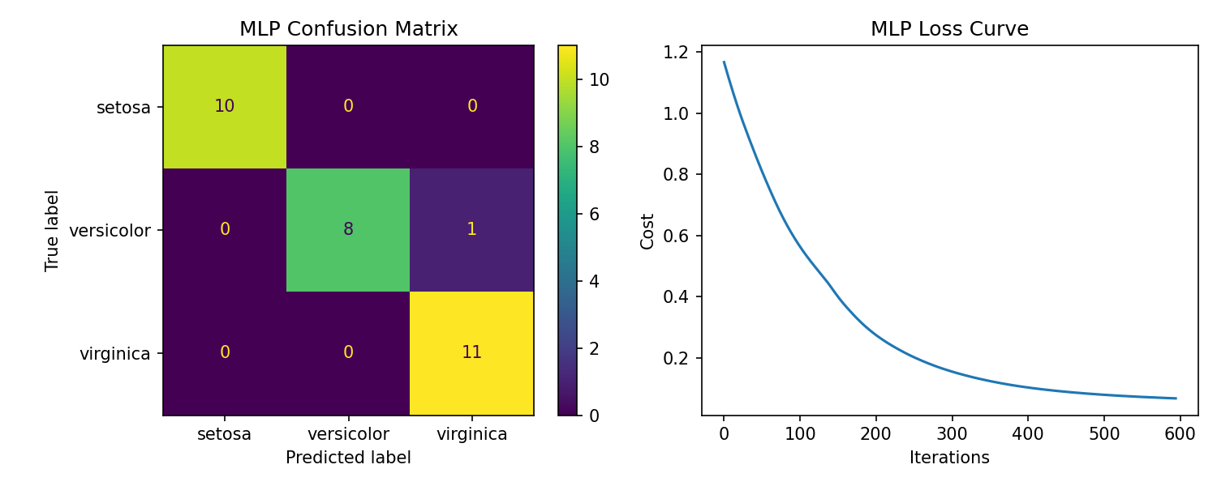
Conclusion:
The Multilayer Perceptron successfully classified the Iris dataset with high accuracy. The confusion matrix shows that most samples were correctly classified, with only minor misclassification between the Versicolor and Virginica classes, which are known to have overlapping feature values. The loss curve shows a steady decrease in training loss, indicating that the model converged well during training.

