BRACT’s
Vishwakarma Institute of Technology, Pune
Practical Implementation Sheet
Department: CSE-AI Semester: 5 Academic Year: 2026-27
Division: C Batch: 2 Practical No: 3
Roll no: 49 PRN No: 12410277 Name of Student: Mayuresh Kulal
Subject Name : Deep Learning

Problem Statement : Implement forward propagation and backpropagation using TensorFlow/Keras. Analyze the effect of different learning rates and the number of epochs on model performance.

Algorithm :
• Start
• Import the required libraries (TensorFlow, Keras, NumPy, Pandas, Scikit-learn, Matplotlib).
• Load the Iris dataset.
• Separate the dataset into input features (X) and target labels (y).
• Convert the target labels into one-hot encoded format.
• Split the dataset into training and testing sets.
• Normalize the input features using StandardScaler.
• Create a Sequential Neural Network consisting of:
- Input layer with 4 input features.
- Hidden Layer 1 with 16 neurons and ReLU activation.
- Hidden Layer 2 with 8 neurons and ReLU activation.
- Output layer with 3 neurons and Softmax activation.
• Compile the model using:
- Adam Optimizer
- Categorical Cross-Entropy Loss
- Accuracy as the evaluation metric.
• Train the model using model.fit().
• During training, TensorFlow performs:
- Forward Propagation: Computes predictions by passing inputs through the network.
- Loss Calculation: Computes the prediction error using categorical cross-entropy.
- Backpropagation: Computes gradients of the loss with respect to all trainable weights.
- Weight Update: Updates weights using the Adam optimizer and the selected learning rate.
• Repeat the training process for the specified number of epochs.
• Evaluate the trained model using the test dataset.
• Record the test loss and accuracy.
• Repeat the experiment using different learning rates (e.g., 0.1, 0.01, 0.001).
• Repeat the experiment using different numbers of epochs (e.g., 10, 50, 100).
• Compare the accuracy and loss obtained for different learning rates and epochs.
• Plot graphs for:
- Accuracy vs. Epochs
- Loss vs. Epochs
- Learning Rate vs. Accuracy
• Analyze the effect of learning rate and epochs on model performance.
• Stop

Code :
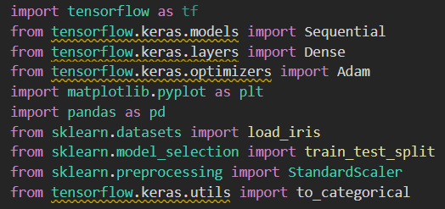
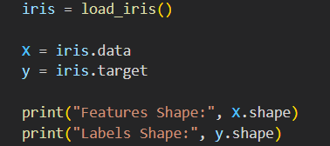
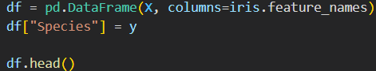
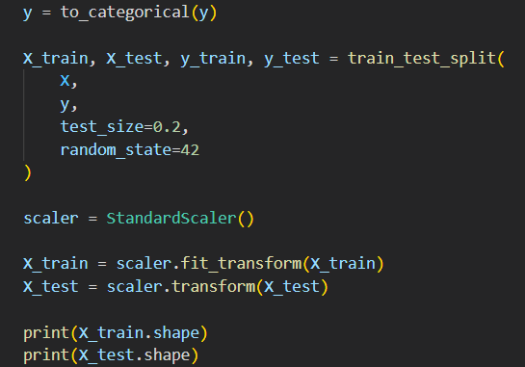
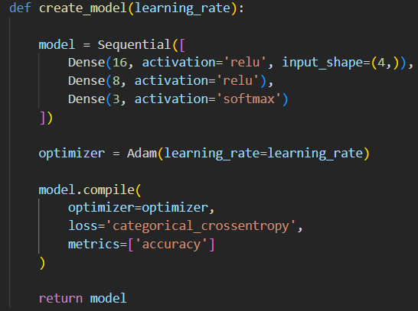
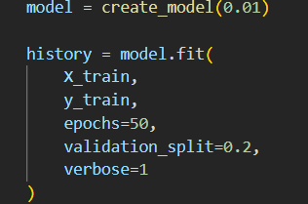
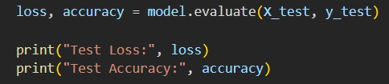
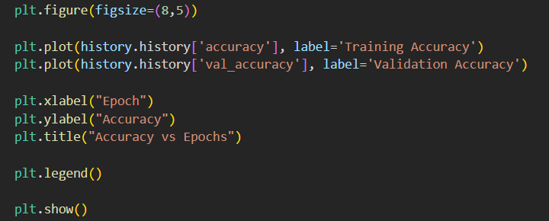
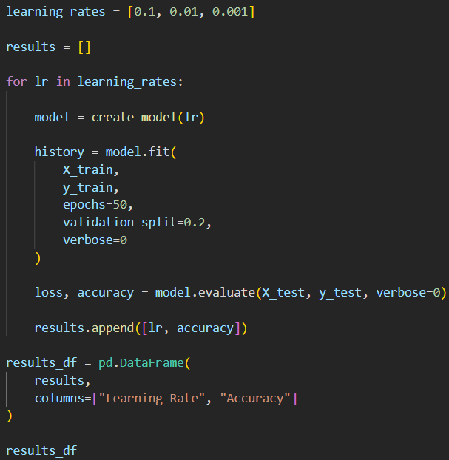
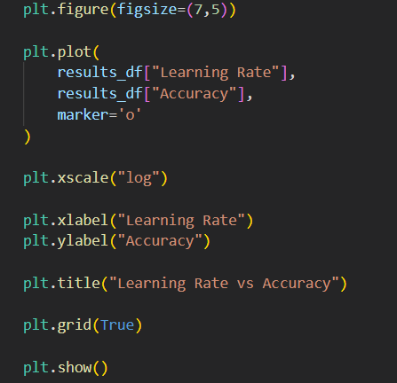
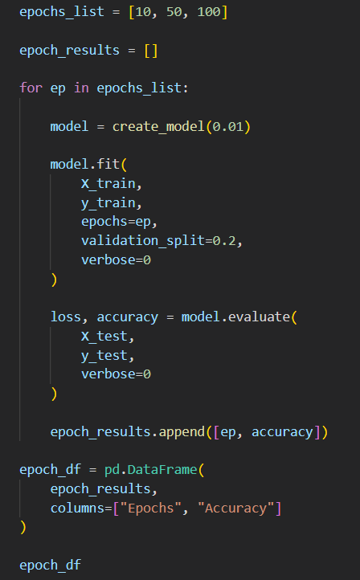
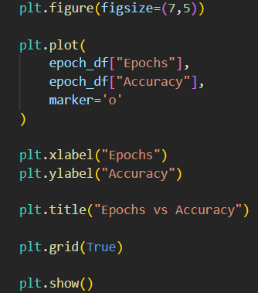
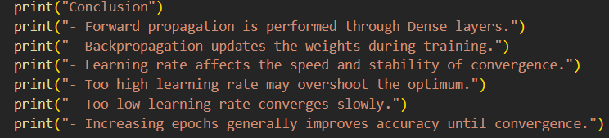

Output :
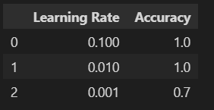

- Learning rate vs Accuracy visualization:
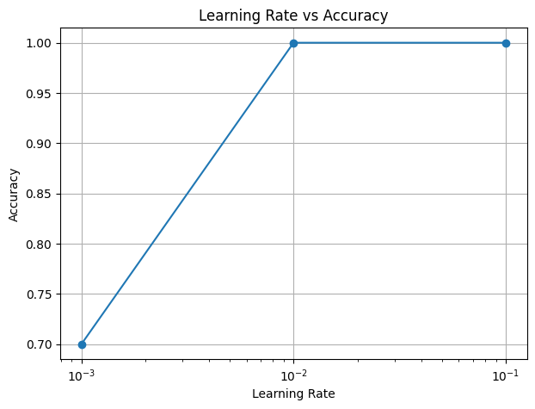

- Epoch vs Accuracy
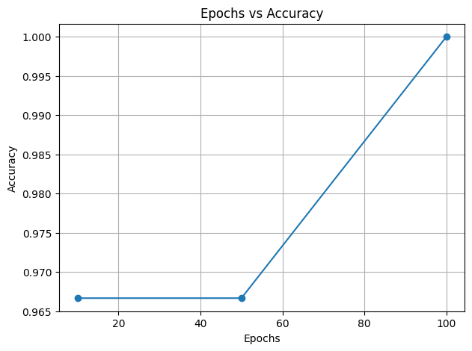

- Training Accuracy Visualization
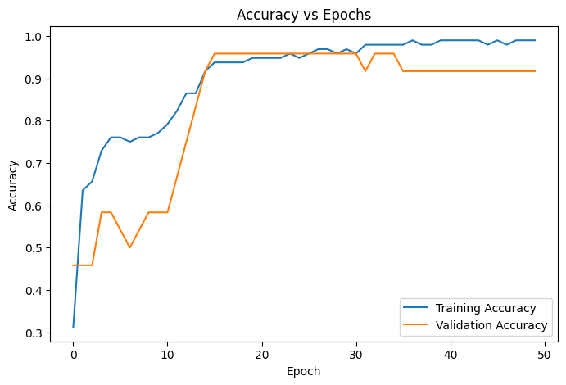
Conclusion:
- Forward propagation is performed through Dense layers.
- Backpropagation updates the weights during training.
- Learning rate affects the speed and stability of convergence.
- Too high learning rate may overshoot the optimum.
- Too low learning rate converges slowly.
- Increasing epochs generally improves accuracy until convergence.

