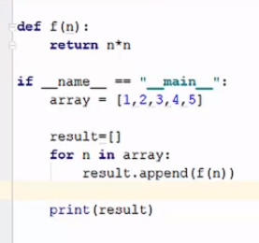
Let’s see how above code is executed by python internally using cpu on the computer
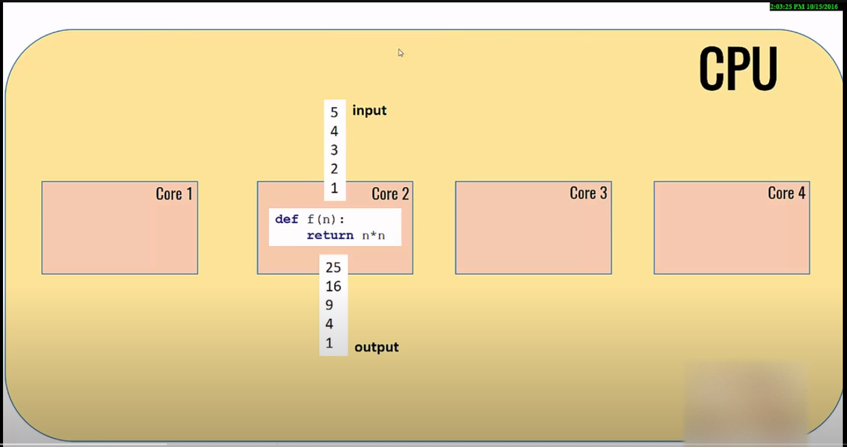

Here big yellow block is CPU and there are 4 cores. These cores are nothing but processing units present on your CPU or central processing unit.
nowadays most of the computers comes with multiple cores so it is very likely you will have multiple cores you might have two cores or four cores based on the kind of configuration you have but let's assume you have four cores here when you execute that program your OS is going to select one of the cores and this core will execute the entire program now the problem here is that you have three other cores sitting idle.
Above code was very small and simple and it was not computationally heavy. So, when we are doing heavy image processing or heavy computation then giving workload to one core is not good idea.
So for utilizing all the cores, we will parallelize our work, we will try to deploy our code on all the cores and then divide the input between all the cores.

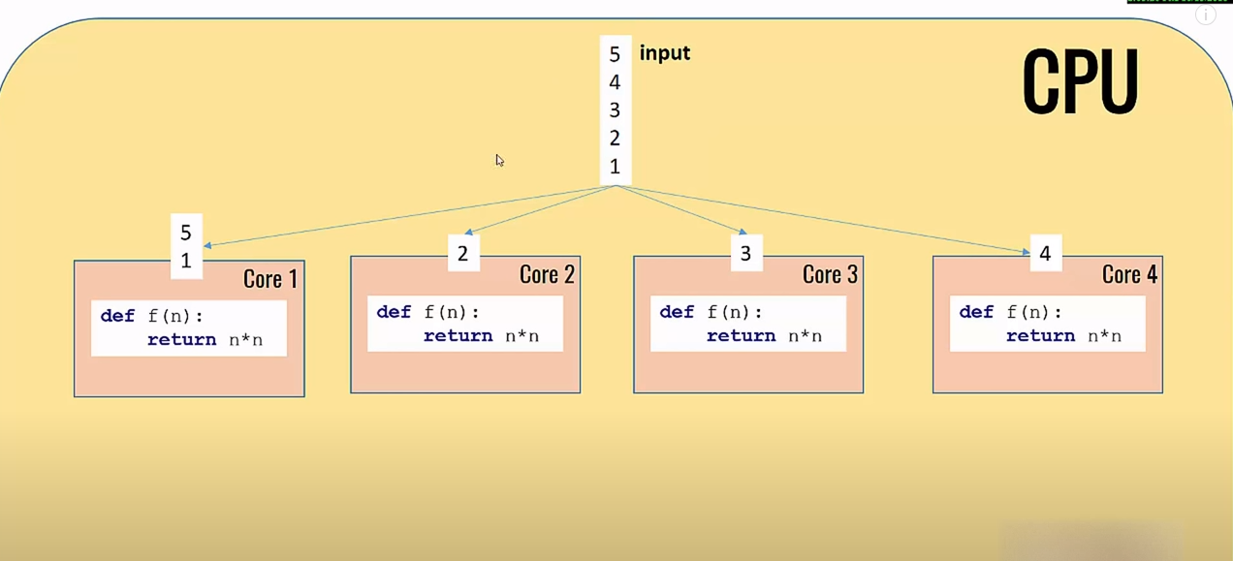
let's say they calculate the results in the end you aggregate those results back into one output
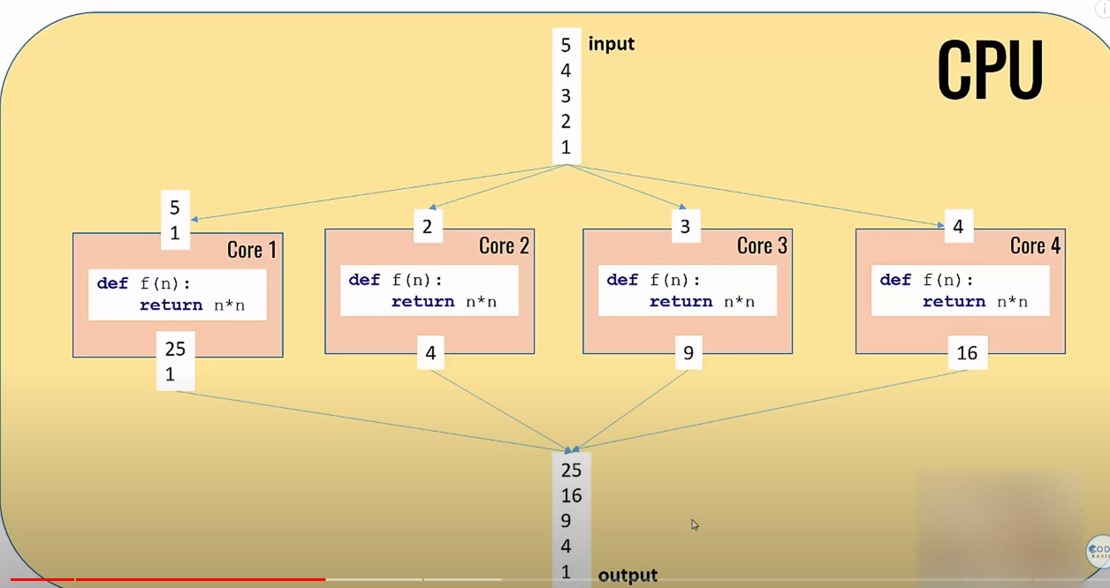
now difference between this approach and the previous approaches that here you are utilizing all the cores. Of course you have to do some division of work and then aggregation but you are utilizing all the processing power that you have any computer. this is called parallel processing and this process of dividing the numbers, input between multiple cores is called ‘map’ versus the process of aggregating these results back is called ‘reduce’.
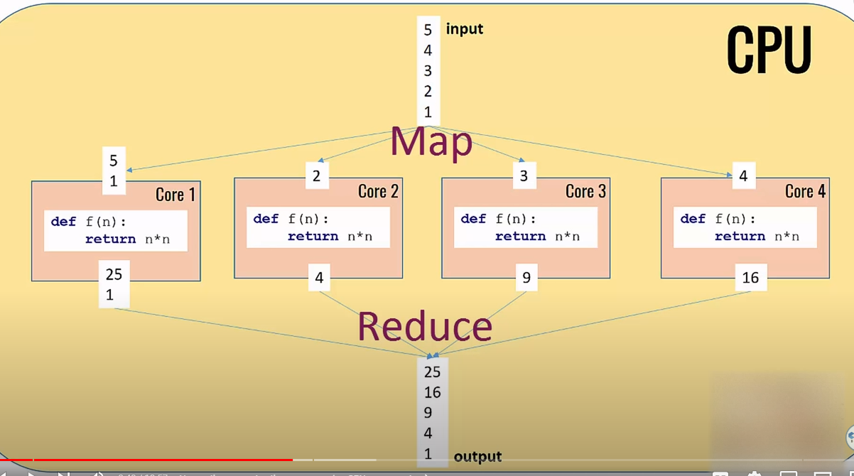
We will do the same thing using multiprocessing pool.

