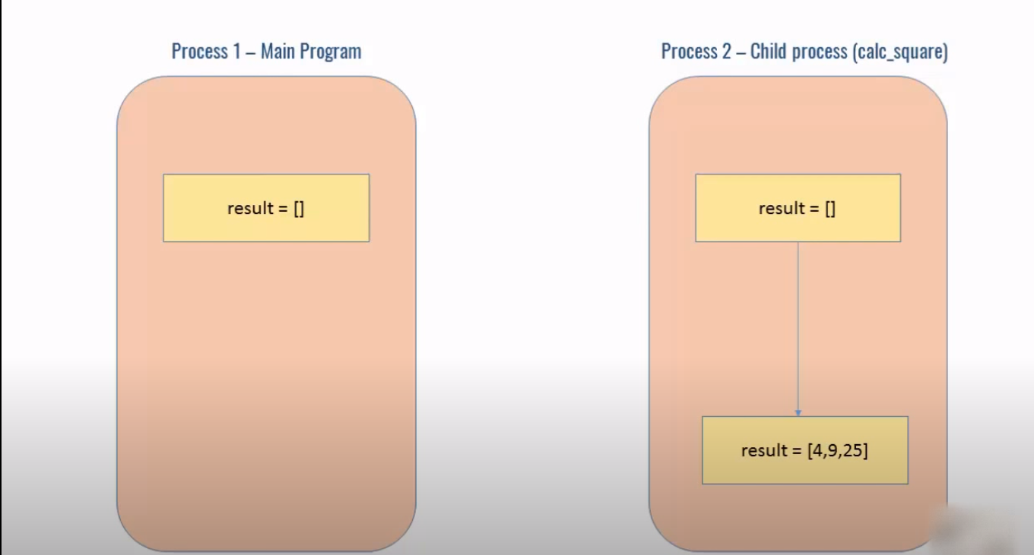
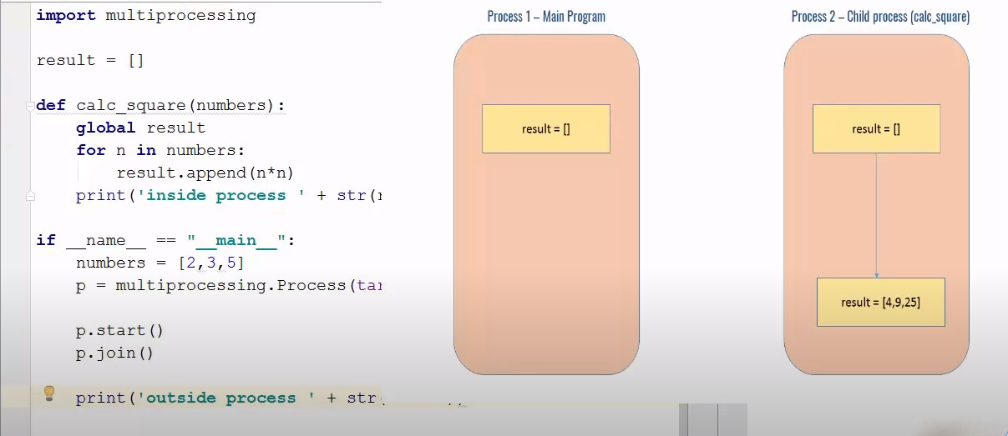
I have a parent process which has a “result” global variable but when you create a child process which is shown on the right hand side the memory for this global variable will be copied so now I have a separate copy of “result” variable hence when you when you run your calculated square function it is only updating the copy in the child process okay so this is the problem now how to solve this issue by sharing data between two resources.
This can be solved by using Shared Memory
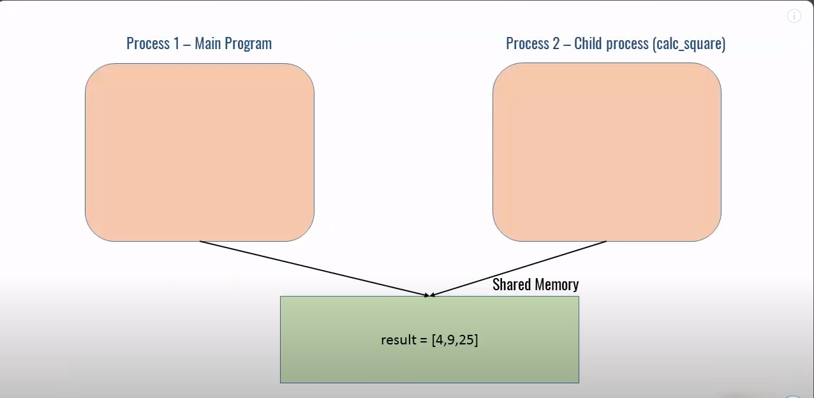
Shared memory lives outside the processes hence we can access it. There’s two way of using shared memory. First one is value and other is array.

