Other than “shared memory” there are two more ways to share data between process.
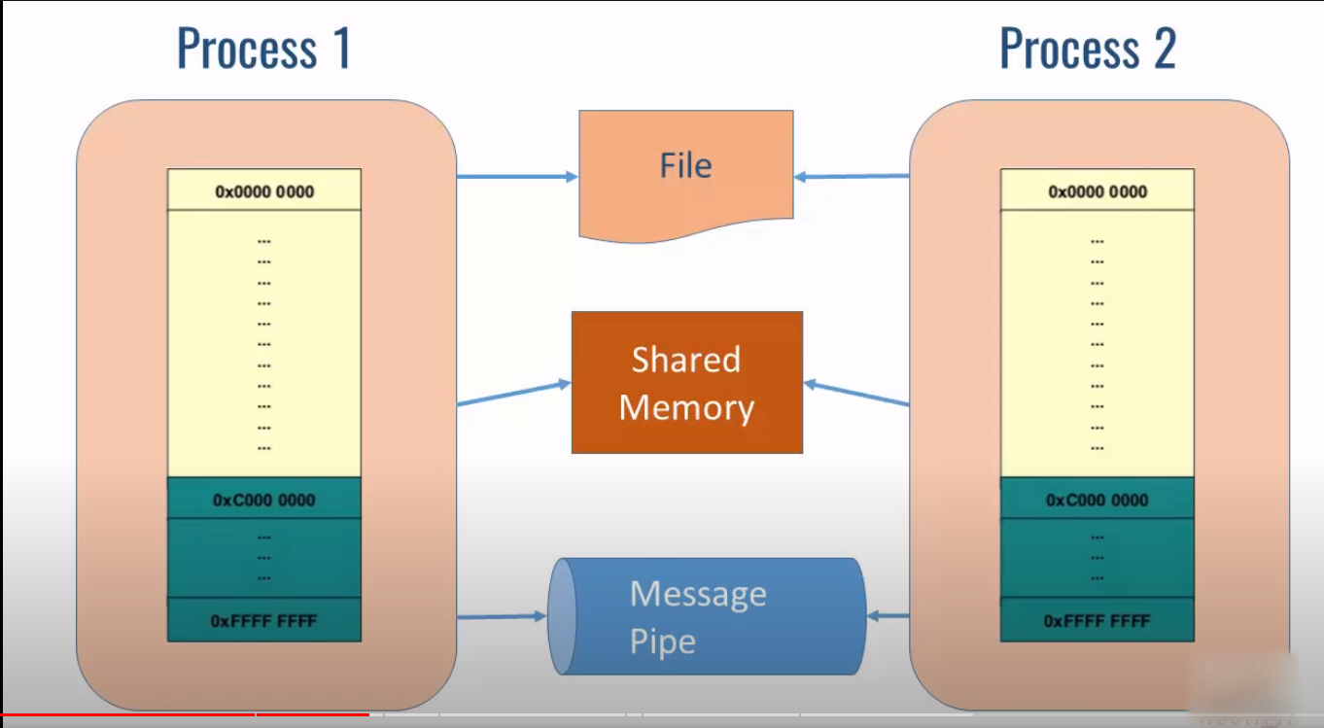
As we can see in the diagram , process 1 and 2 have their own address spaces. Whenever they want to exchange data they can use either common file or shared memory or message pipe.
Queue is basically shared memory.
Difference between Queue module and multiprocessing queue
