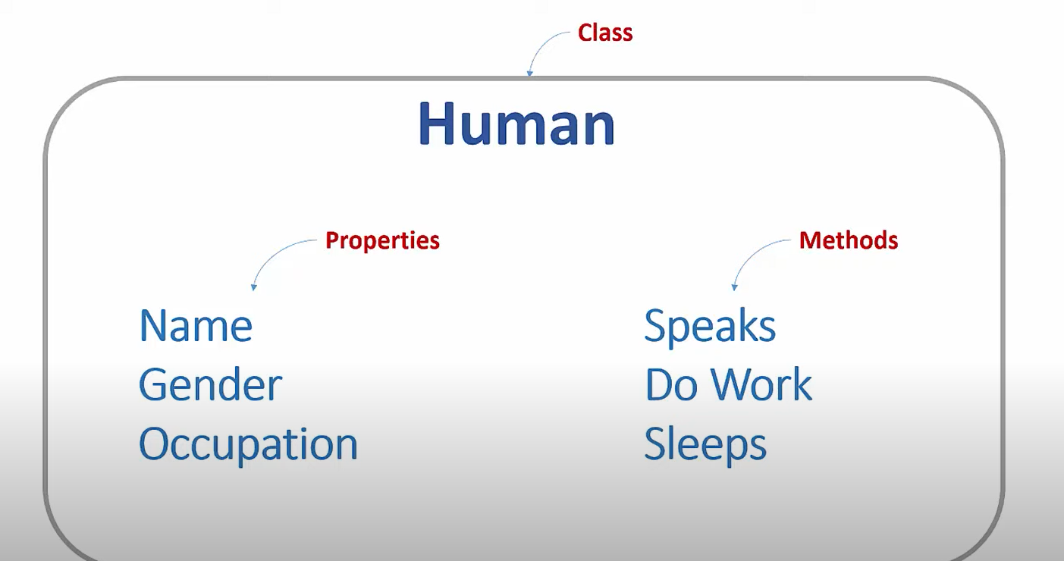

Properties and Methods form a central entity called as class.
In above example Human is a class, which has two central components Properties and Methods.
Class is nothing but abstraction of some entity which contains common set of properties and Methods.

What is an Object?
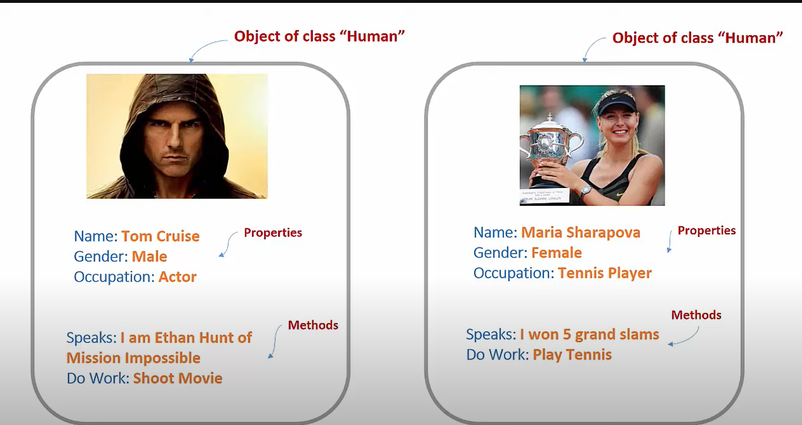
Object is nothing but a specific instance of a class.

