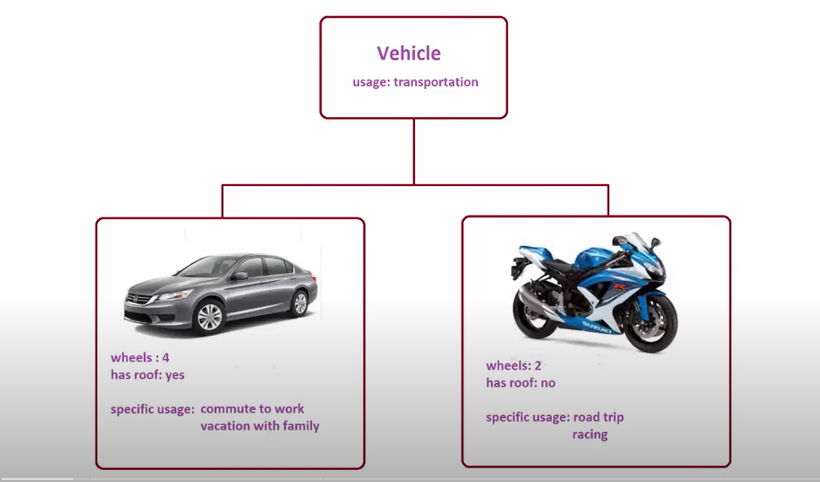
Car and Bike can be thought of as subclasses of base class Vehicle.
i.e. Car and Bike are classes that inherit from Vehicle class.

