**COLLEGE ENQUIRY CHATBOT**

END TERM REPORT

*By*

Mayur (K18NZ-A13)

Rounik Saha (K18NZ-A14)

Kunga Topgyal (K18NZ-A15)



Department of Intelligent System

School of Computer Science Engineering

Lovely Professional University, Jalandhar

April-2020

**Student Declaration**

This is to declare that this report has been written by us. No part of the report is copied from other sources. All information included from other sources have been duly acknowledged. We aware that if any part of the report is found to be copied, We are shall take full responsibility for it.

Mayur

Roll no. 13

Rounik Saha

Roll no. 14

Kunga Topgyal

Roll no. 15

Date:- 04 April 2020

**Introduction**

**What is a chatbot?**

A Chatbot, or Chatterbot is a computer program aiming at simulating a written conversation with a human user.

**Why making one?**

Well, first… because it’s fun! Since Alan Turing, chatbot programming has been a way to test computer’s ability to pretend like they are human.

Also, chatbots can be have very useful applications, such as helping users on a website, teaching a language, etc.

**HOW?**

**In this Chatbot we are using the modules tkinter.**

The [tkinter](https://docs.python.org/3/library/tkinter.html" \l "module-tkinter" \o "tkinter: Interface to Tcl/Tk for graphical user interfaces) package (“Tk interface”) is the standard Python interface to the Tk GUI toolkit. Both Tk and [tkinter](https://docs.python.org/3/library/tkinter.html" \l "module-tkinter" \o "tkinter: Interface to Tcl/Tk for graphical user interfaces) are available on most Unix platforms, as well as on Windows systems.

**Goals**

**Our main aim of making this chatbot is giving the expected result that the**

**User may ask to it about the college enquires like sports day, annual day**

**And user also add the data.**

**Background**

Chatbots has emerged as a hot topic in the latest years, and it is used by numerous companies in various areas - help desk tools, automatic telephone answering systems, e-commerce and so on. Even though the technology has been around since the 60’s (Atwell & Shawar, 2007). Why are we suddenly so interested in this technology now? This can likely be explained by the recent year's advancements in messaging applications and AI technology (Brandtzaeg & Følstad, 2017). In the article Chatbots: Are they really useful? Atwell and Shawar provide real-life examples of different chatbots in different contexts. One of the examples is Sophia, a robot that was developed to assist in mathematics at Harvard by answering students' questions. This turned out to be applicable in many other contexts.

**DISPLAYING SOME PARTS OF CODE**

Here we will display some of the parts of the code

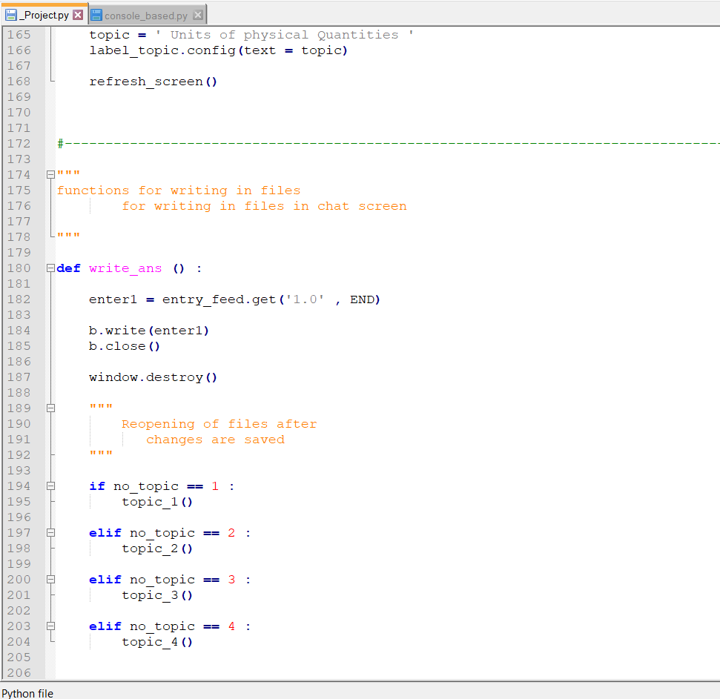

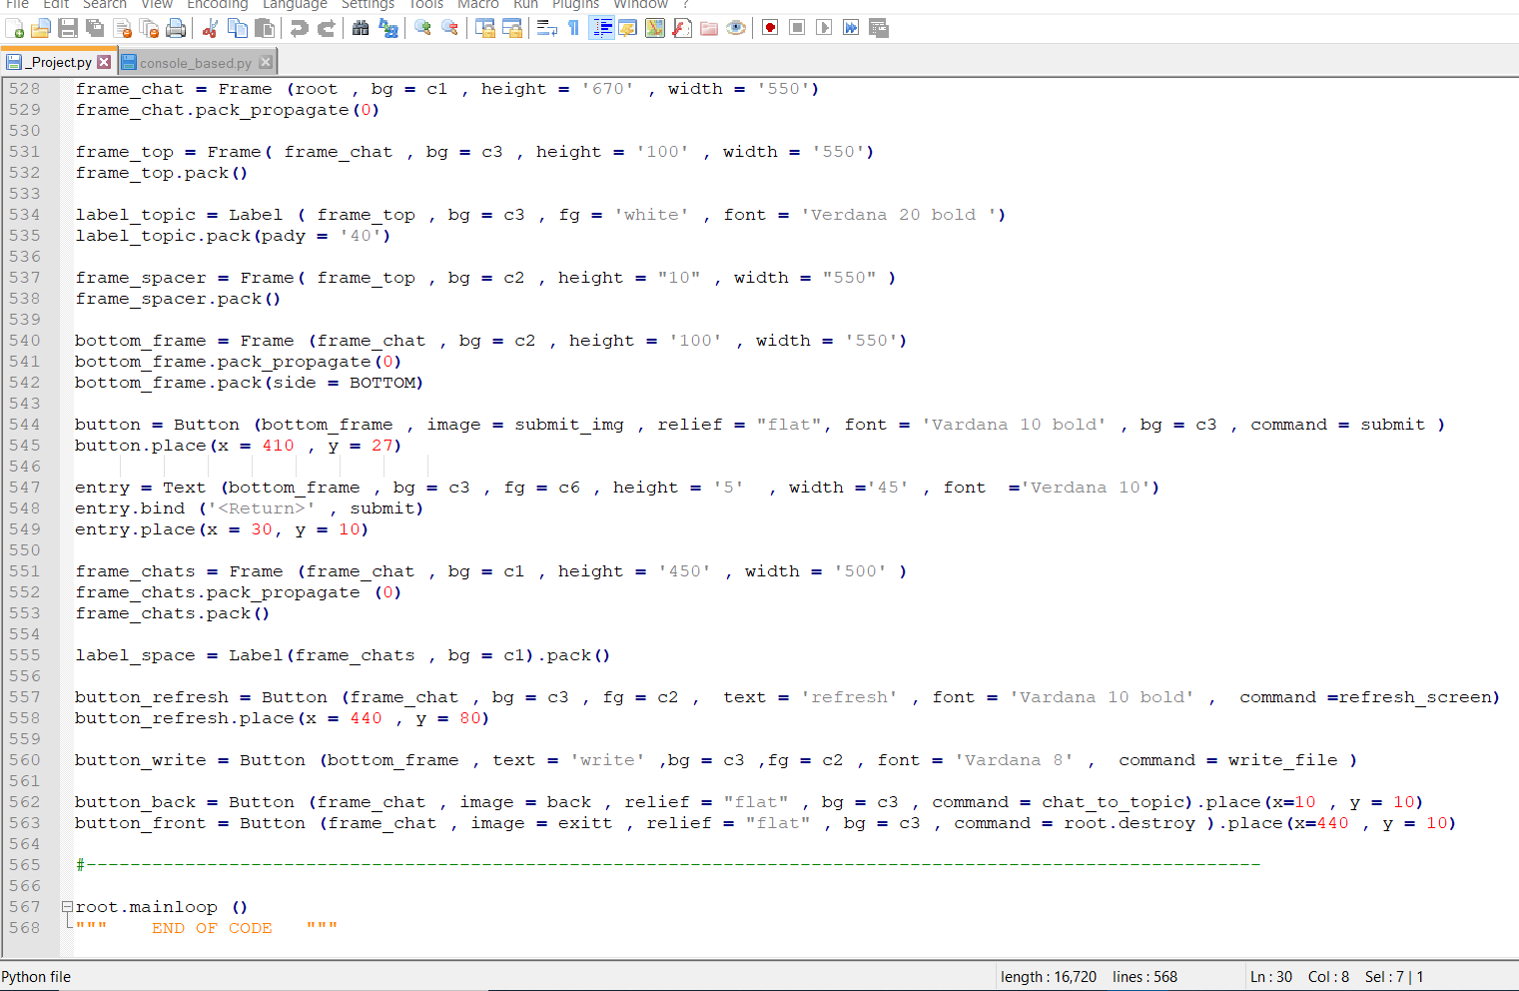

**INTERACTING WITH THE USER, OUTPUT**

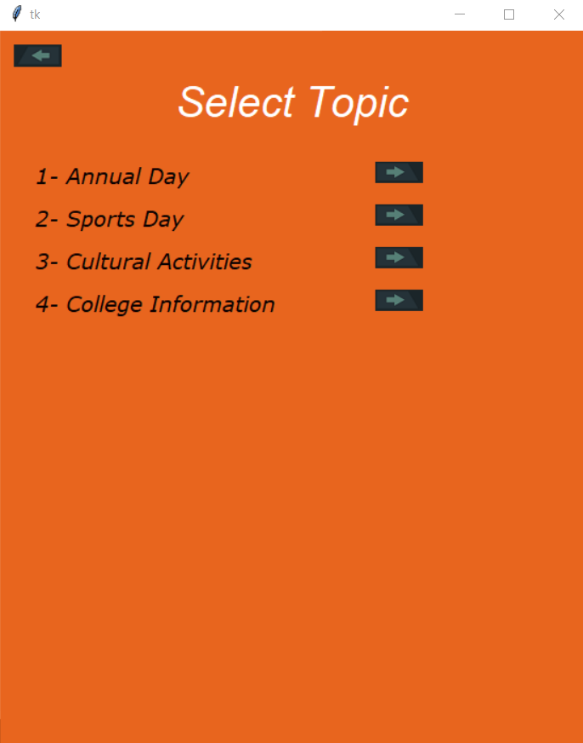

**Here user can select what kind of information he want**

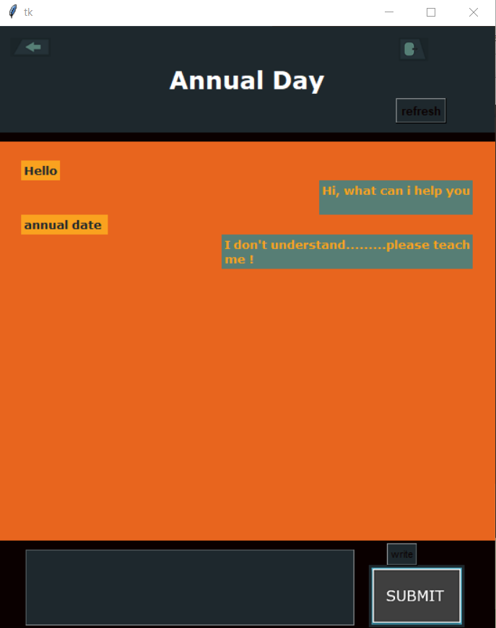

**If chatbot don’t now anything he will reply**

**“ I don’t understand……….please teach me.”**

**Problems:**

**-> It can not answer any question which is not present in the file which is fed into it.**

**-> It would give u an error if u will write the last line of the file as question.**