# Azure Basic Services

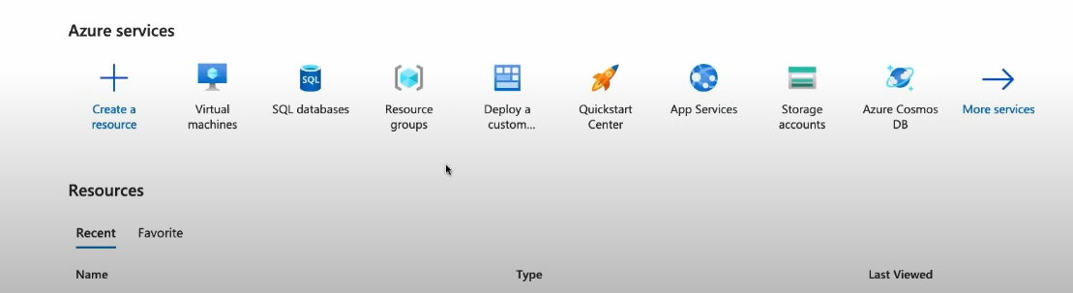

# Azure Resource Manager Workflow



