Topics: Descriptive Statistics and Probability

- Look at the data given below. Plot the data, find the outliers and find out $μ, σ, σ^{2}$

Name of company | Measure X
Allied Signal | 24.23%
Bankers Trust | 25.53%
General Mills | 25.41%
ITT Industries | 24.14%
J.P.Morgan & Co. | 29.62%
Lehman Brothers | 28.25%
Marriott | 25.81%
MCI | 24.39%
Merrill Lynch | 40.26%
Microsoft | 32.95%
Morgan Stanley | 91.36%
Sun Microsystems | 25.99%
Travelers | 39.42%
US Airways | 26.71%
Warner-Lambert | 35.00%
- This data has one outlier = Morgan Stanley having 91.36%

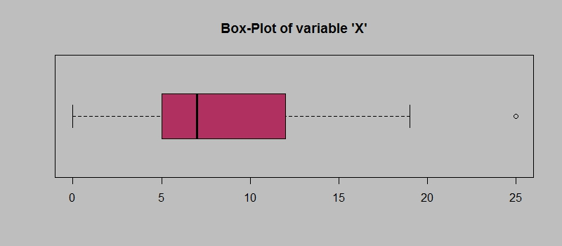
Answer the following three questions based on the box-plot above.
- What is inter-quartile range of this dataset? (please approximate the numbers) In one line, explain what this value implies.
- What can we say about the skewness of this dataset?
- If it was found that the data point with the value 25 is actually 2.5, how would the new box-plot be affected?

Q1 = 5, this implies First Quantile Range
Q3 (Third Quantile Range) = 12,
Median (Second Quartile Range) = 7,
IQR (Inter-Quartile Range) = Q3 – Q1 = 12 – 5 = 7,
Second Quartile Range is the Median Value
This data have one outlier of value 25.

As the Median is on the left side or say that closer to the bottom of the box, then it is Right-Skewed.

If the data pont having value 25 is actually 2.5, then there would be no outliers.
The new box plot will still Right Skewed, but with no outliers.

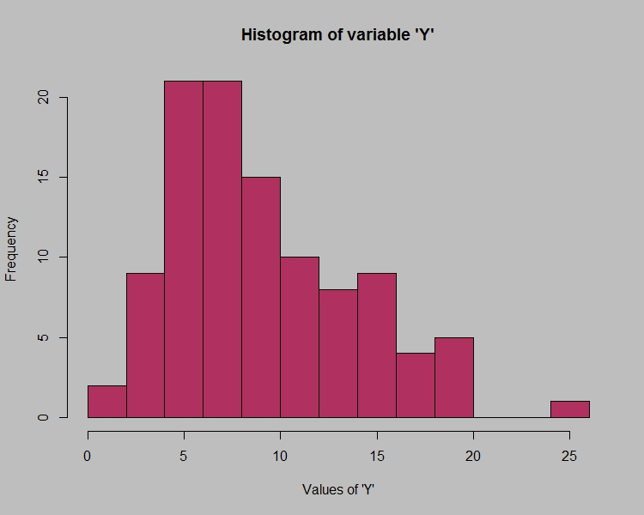

Answer the following three questions based on the histogram above.
- Where would the mode of this dataset lie?
- Comment on the skewness of the dataset.
- Suppose that the above histogram and the box-plot in question 2 are plotted for the same dataset. Explain how these graphs complement each other in providing information about any dataset.
- The mode will be between 4 to 10.
- Right Skewed.
- In Box Plot, Median is easier to find, while in Histogram, Mode is easier to find.
Both, Box plot and Histogram are Right Skewed. And have one outlier. (if data point having value 25 is considered in Box Plot)

- AT&T was running commercials in 1990 aimed at luring back customers who had switched to one of the other long-distance phone service providers. One such commercial shows a businessman trying to reach Phoenix and mistakenly getting Fiji, where a half-naked native on a beach responds incomprehensibly in Polynesian. When asked about this advertisement, AT&T admitted that the portrayed incident did not actually take place but added that this was an enactment of something that “could happen.” Suppose that one in 200 long-distance telephone calls is misdirected. What is the probability that at least one in five attempted telephone calls reaches the wrong number? (Assume independence of attempts.)

- Returns on a certain business venture, to the nearest $1,000, are known to follow the following probability distribution
x | P(x)
-2,000 | 0.1
-1,000 | 0.1
0 | 0.2
1000 | 0.2
2000 | 0.3
3000 | 0.1

- What is the most likely monetary outcome of the business venture?
- Is the venture likely to be successful? Explain
- What is the long-term average earning of business ventures of this kind? Explain
- What is the good measure of the risk involved in a venture of this kind? Compute this measure
- Most likely monetary outcome of the business venture is 2000$ as it has the highest probability, that is 0.3
- The Sum of all the Probabilities of all the Positive Return monetary value, = 0.2 + 0.3 + 0.1 = 0.6. So there is 60% of chance of making profit for this business venture.
- The Long-term average earning of this kind of business is Sum of all Monetary outcomes multiplies by their respective probabilities, i.e.
Expected Value = ∑ (x * P(x))
= [(-2000*0.1) + (-1000*0.1) + (0*0.2) + (1000*0.2) + (2000*0.3) + (3000*0.1)]
= $800.
That means, on an average, the returns will be $820.
- Variance or say Variability in the monetary outcome is a good measure of the risk involved in a venture of this kind. Hifger the variance, more will be the risk and vice-versa.

