CampusFlow LMS — Executive Summary
Oct 13, 2026 · @Mayur

Summary
CampusFlow is a learning management system built for our engineering programmes that runs a course end to end, from the university syllabus to the final grade and CO attainment. It is built and tested. The decision requested is approval for a one-semester pilot in one department, run alongside the existing ERP so nothing is at risk.
This note is the pre-read for a 15-minute presentation and live demo.

The problem today
A teacher's semester is spread across tools that do not talk to each other, so the same course data is typed again at every step and plans drift from what is actually taught.
Task | Where it lives today | The cost
Lesson plan | Word file, submitted at term start | Actual dates and coverage filled in by hand later
Attendance | ERP, class by class | A growing list of pending classes
ISE / MSE marks | Excel per assessment | Bucket conversions done manually
CO attainment | Computed after the semester | Assembled for NBA after the fact
Holidays, lost classes, re-exams | Handled ad hoc | Plans fall behind with no warning

What CampusFlow does
One connected flow, from the syllabus to the final result.
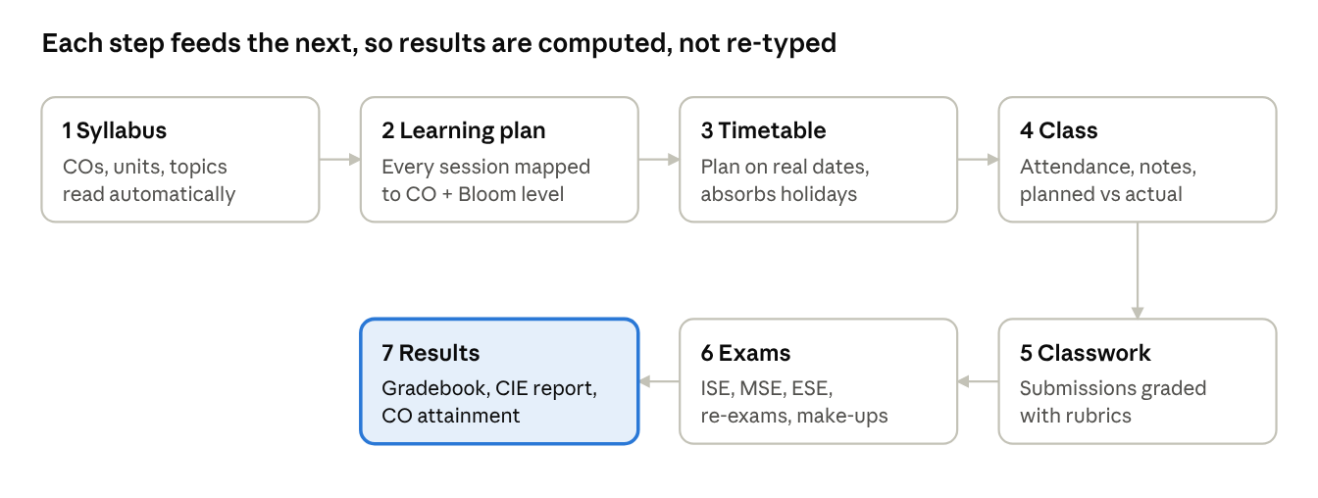
CampusFlow course flow · 7 steps
The syllabus defines the outcomes and units; every later step is tied to them, which is what makes the results automatic.
- Course setup: upload the syllabus (PDF, Word or text) and the course is built: session plan, ISE/MSE/TW/ESE scheme, rubrics, question bank, draft assignments and draft MSE/ESE papers.
- Existing lesson plans: the departmental Word lesson plan imports as-is and exports back in the same format with actual dates and Covered / Not covered filled in.
- Teaching methods by year: demonstrations for first years through to case studies and project work for final years, with suggested tools (Colab, MATLAB, Tinkercad, Virtual Labs).
- Schedule changes: sudden holidays, supplementary teaching days and rescheduled classes shift the plan automatically, with a warning when the syllabus no longer fits.
- Attendance: marked vs pending per class, one-tap marking, student self check-in by code, alerts below 75%.
- Assessment: weighted ISE/MSE/TW/ESE scheme, papers generated by blueprint, re-exams and make-up assessments folded into the final grade.
- Academic terms: odd, even, re-exam and special-exam terms, as in the ERP.

What it changes
Information is entered once; marks, attendance percentages and outcome attainment are computed rather than re-typed.
- Teachers: a course is set up from the syllabus in minutes; existing departmental lesson plans import as they are and export back in the same format with actual dates filled in; attendance takes one tap; rubric grading adds up automatically.
- Students: one place for assignments, feedback, attendance, class notes and a running grade, much like Google Classroom. Draft marks and unreleased exam marks stay private.
- Institution: CO attainment is available continuously for NBA and outcome-based education, not assembled after the semester. Consolidated CIE and attendance reports match the ERP's layout and export to CSV. Holidays declared once update every course in the term.
- Control: it can run on the college's own server, so student data stays with the institution.

Where it stands
Everything described here is built and working; it is not yet installed on a college server.
Done
- All features above implemented, with 37 automated checks that run on every change.
- A full teacher-and-student walkthrough tested in a real browser: course creation, timetable, holiday, supplementary day, attendance, submission, rubric grading, reports and the student view — 17 of 17 steps passed.
- A real departmental lesson plan (MEC702, Word .doc) imported correctly: 17 rows became 50 sessions in 7 units, with 6 COs and the holiday, MSE and ESE dates.
Needed before a pilot
- A college server (or approved hosting) with a production database and backups.
- Import of student lists from the current ERP.
- A data-privacy and access review.
- A short training session for pilot faculty.

Proposed pilot and the ask
Start small: one department, one semester, in parallel with the ERP, then decide on evidence.
Phase | When | What happens
1. Set up | [month] | Install on a college server, import students, train [__] volunteer faculty
2. Pilot | One semester | [__] courses in [department] run fully on CampusFlow alongside the ERP
3. Review | End of semester | Compare teacher time on lesson plans, attendance and marks, and the completeness of CO data; decide on rollout
Requested: approval for the pilot, a college server or approved hosting, [__] faculty volunteers, and access to student lists for the pilot classes.

