Topic name: tiny tails…

Because each tail has a tale.

Description: tiny tail is a shelter home based in a small town in badlapur, we work to recuse and provide shelter to injured, abandoned and lost animals.

We have a dedicated team of doctors and staff that work their best to save each and every possible soul.

Our dedicated team tries not only to help save lives but also try to help get them a permanent home.

Anyone who wishes to spend his time with these tiny souls are always welcome.

**Entity Relationship Diagram**

cause table

1.cause_id(PK)

2.common causes

reporter table

1.reporter_id(PK)

2.name

3.surname

4.address

5.contact

6.email

doctor table

1.doctor_id(PK)

2.dr_name

3.speciality

4.contact

details table

1.type_id(PK)

2.animal

3.gender

4.type

shelter table

1.animal_id(PK)

2. name

3. age

4.admit_date

5.type_id(FK)

6.cause_id(FK)

7.medicine_id(FK)

8.reporter_id(FK)

9.doctor_id(FK)

10.location

medicine table

1.medicine_id(PK)

2.medicine name

3.type

4.dose

4. dose

4.type

**Our database tables;**

**1.Shelter table;**

Shelter table consists of all the entries of animals who were reported to the centre. It tells us about animal, his age, date he got admitted, cause of accident, medicine and doctor assigned to that case and the person who reported that case.

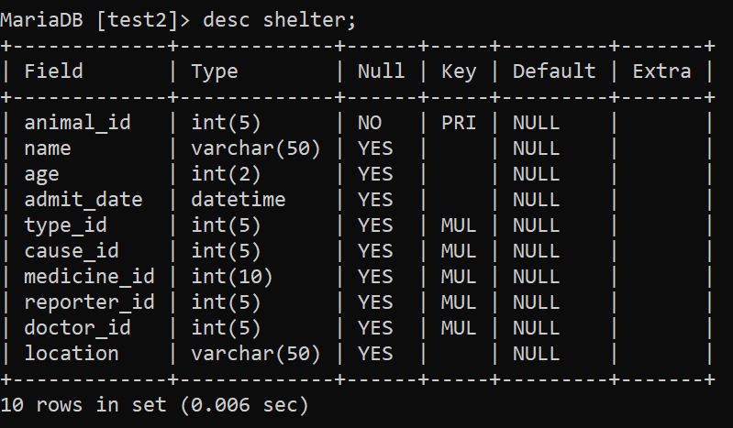

And here are the entries….

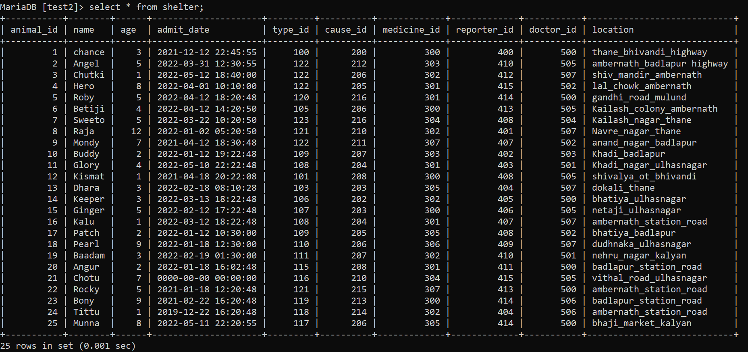

**2.Details table;**

Details table is linked to shelter table, it tells us about which animal got admitted, gender and type. This helps us to identify the process of medicine to be followed.

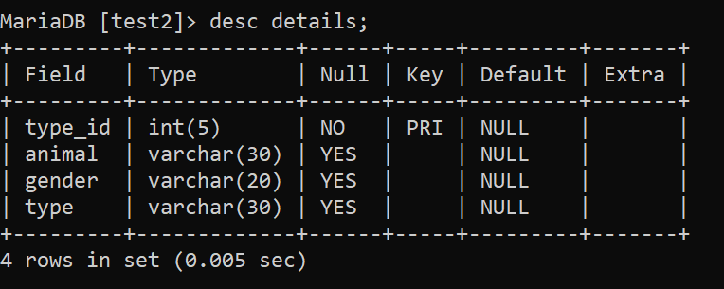

And here are the entries…

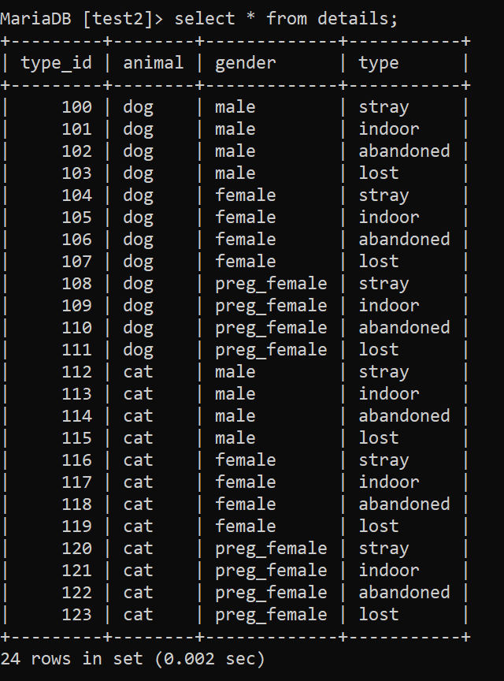

**3.Doctor table;**

Doctor table tells us about the doctor assigned to that case. This helps to maintain a record of which doctor is available and when, and who’s handling which case.

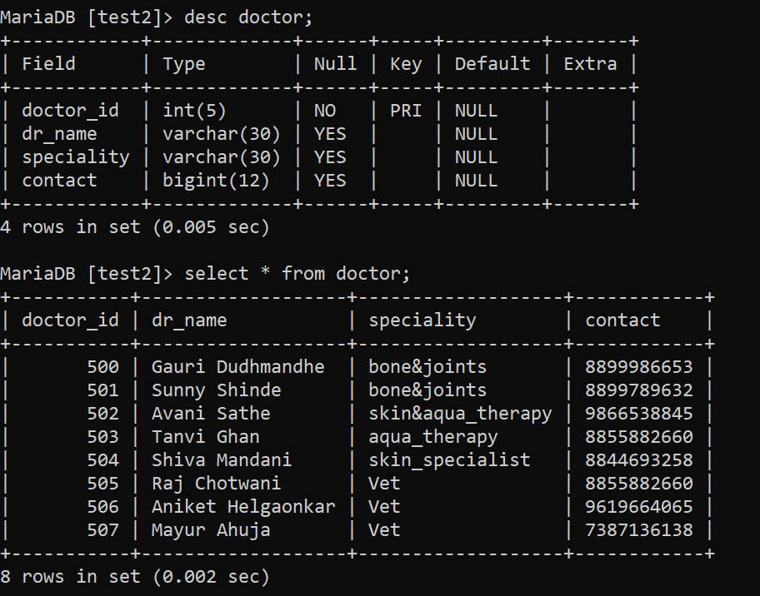

**4.Medicine table;**

Medicine table tells us about the medicines that are been allotted to the case, if in case there is a change in procedure or if we want to shift animal to another centre this helps us to trace back medicines assigned.

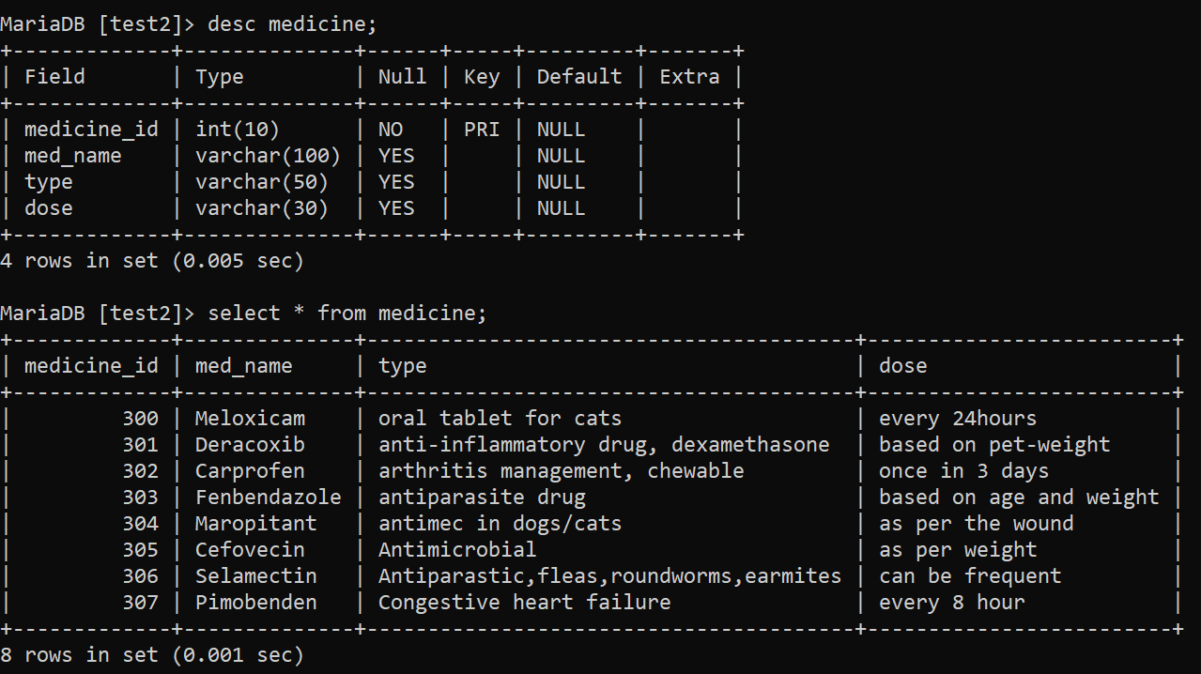

**5.Reporter table;**

Reporter table tells us about the person who reported the case to us, this helps us to trace back cases and to assist in locating back the animal.

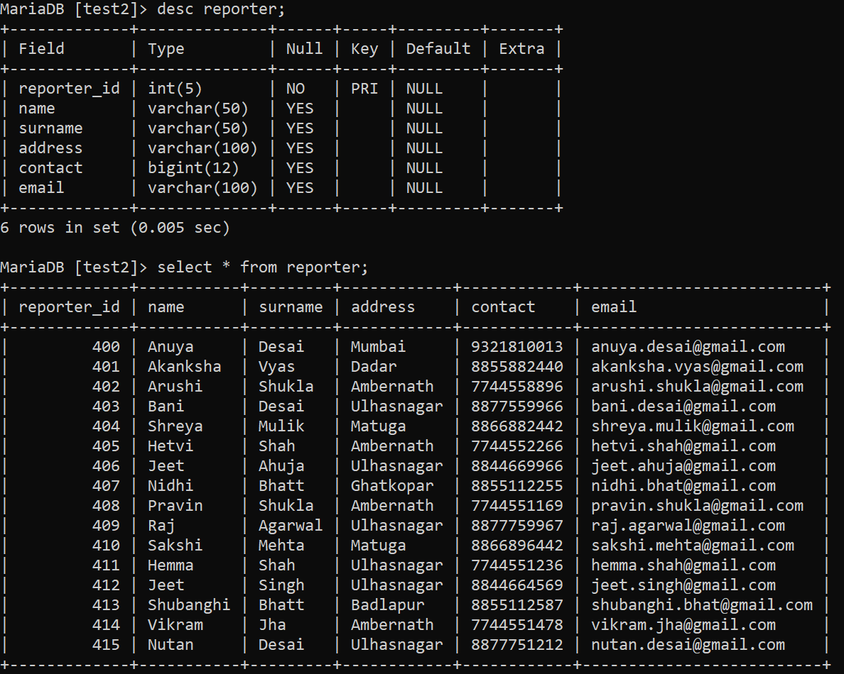

**6.Cause table;**

Animals that come at our centre usually have common cause of accident and have common animal reporters reporting about the case.

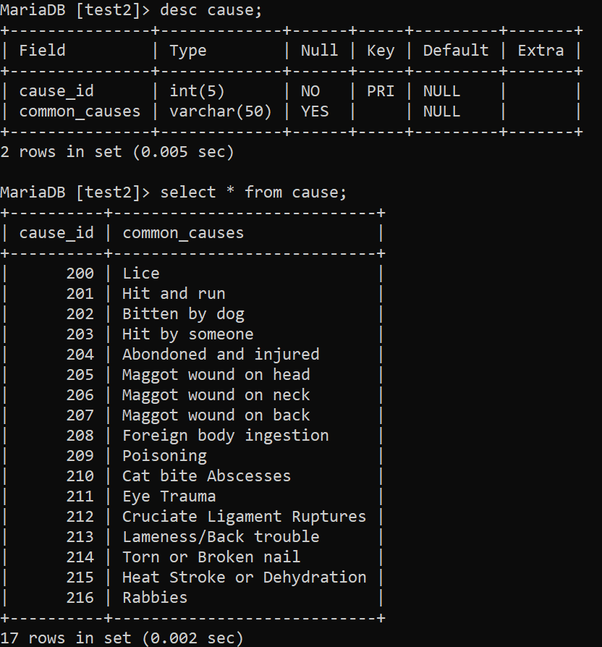

**Let us go through some of subquerys;**

1. To find all the animal’s name, admit date and reporter who have maggot wound.

select name,admit_date,location from shelter where cause_id in( select cause_id from cause where common_causes like 'magg%');

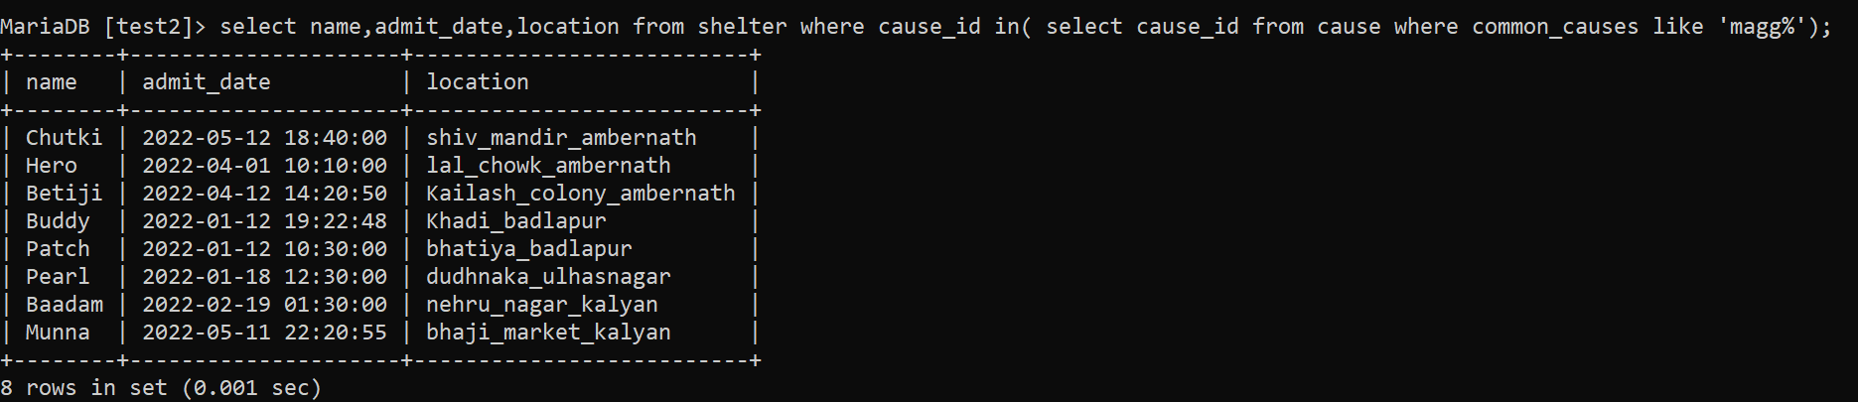

1. To find name, age, admit date of animals who have been assigned under ‘Avani Sathe’.

select name from shelter where doctor_id in(select doctor_id from doctor where dr_name='Avani Sathe');

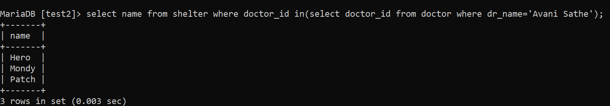

1. To find all the cases whose case reporter are from the city ‘ulhasnagar’.

select name,age,location,reporter_id from shelter where reporter_id in( select reporter_id from reporter where address='ulhasnagar');

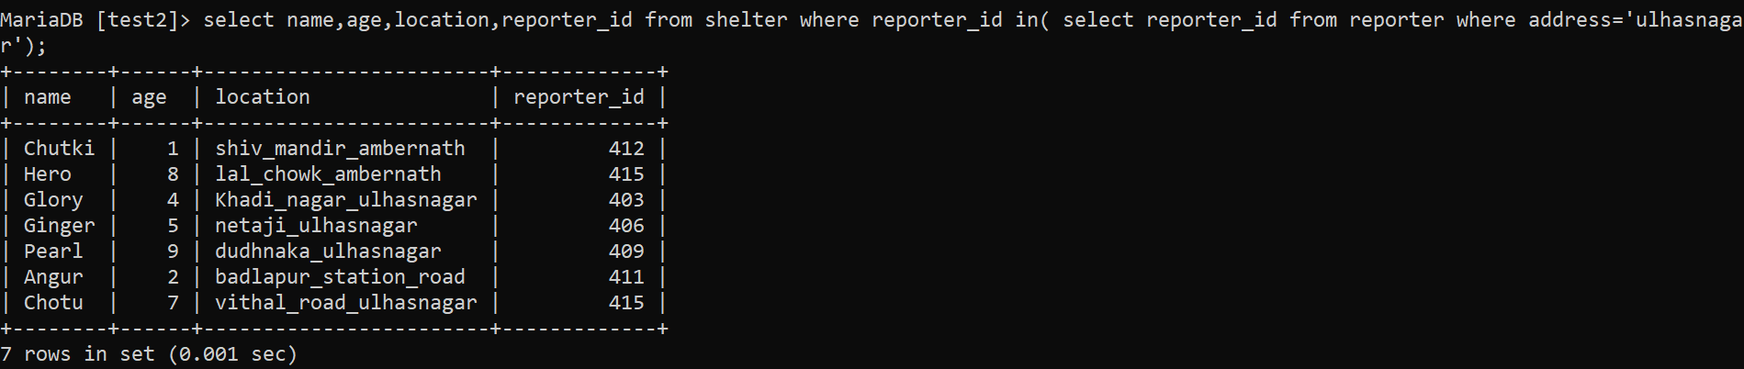

1. To find name, age of animal whose age is greater than 3, and doctor assigned is, ‘Raj Chotwani’.

select name,age from shelter where age>5 and doctor_id =(select doctor_id from doctor where dr_name='Raj Chotwani');

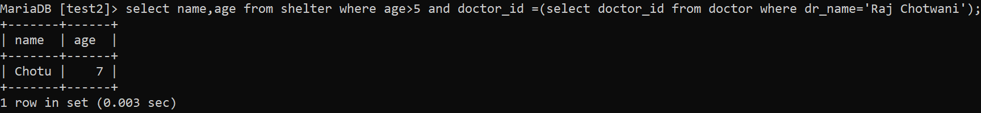

**Let us go through some of joins;**

1. To find which animal is assigned to which doctor. (Left Join)

select shelter.name,doctor.dr_name from shelter left join doctor on shelter.doctor_id = doctor.doctor_id order by dr_name;

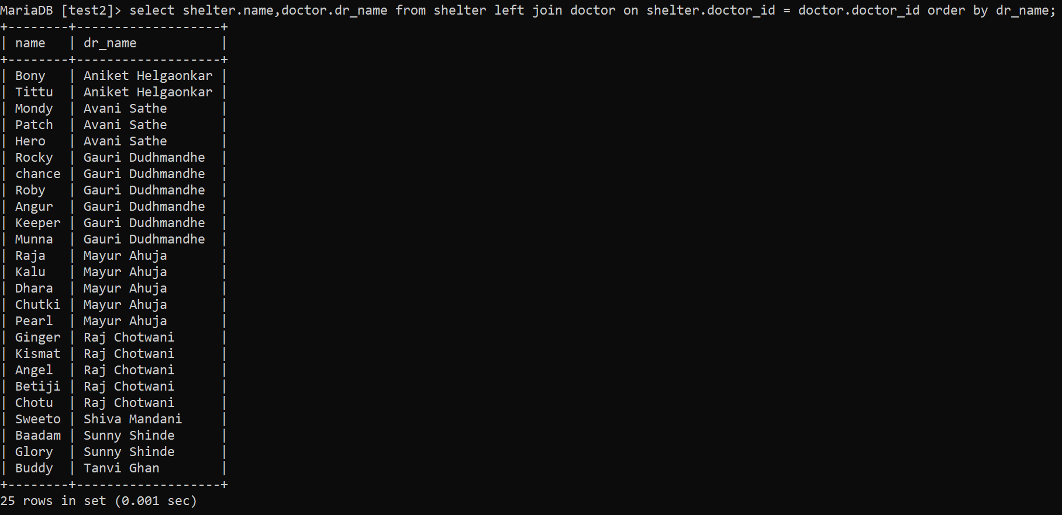

1. To find out which animal has been assigned which medicine. (Inner join).

select shelter.name,medicine.med_name from shelter inner join medicine on shelter.medicine_id = medicine.medicine_id order by med_name;

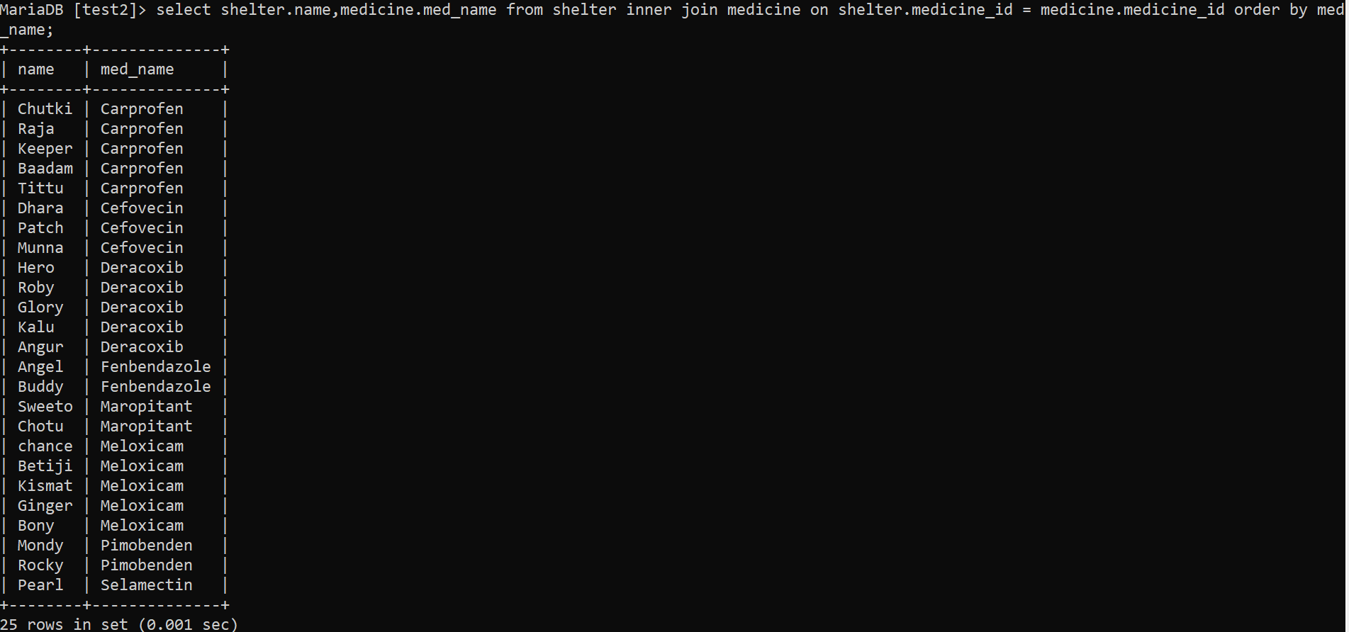

1. To find out name, category, type and gender of animal. (Right join)

select shelter.name, details.animal, details.gender, details.type from details right join shelter on details.type_id = shelter.type_id;

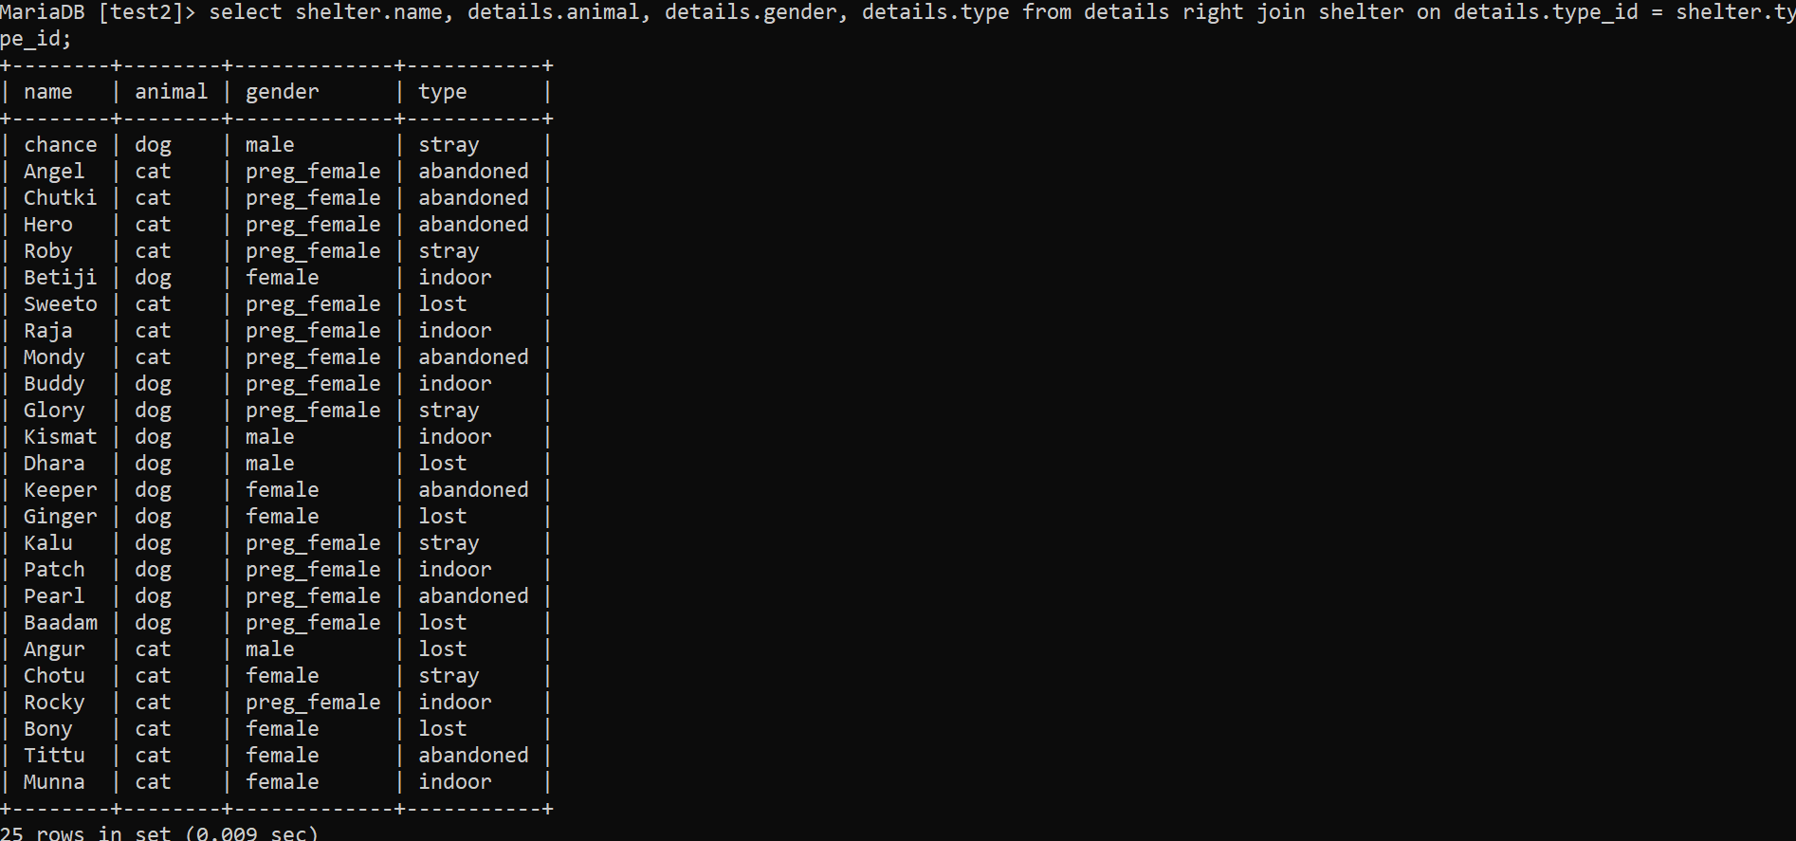

**Let us go through some of views;**

1. This view show name and age of animals who are younger than 3 year old.

create view young as select name,age from shelter where age<3;

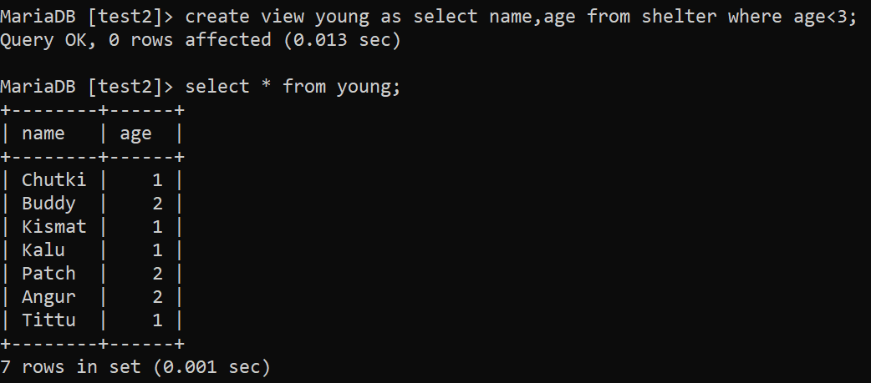

1. This view shows animal’s name, animal’s location and reporter’s location respectively.

create view address as select shelter.name as animal_name ,shelter.location as animals_location ,reporter.address as reporters_address from shelter,reporter where shelter.reporter_id=reporter.reporter_id;

