**Problem Statement**

In the fast paced and tech. driven world often times emotions are not openly shared or discussed - Never even take the time to ask - How your child/student are filling ? - Are you happy today ? - What would make tomorrow a better day for you ? Those questions which should be asked on a regular basis and the happiness of your child/student should be constantly monitored. and that's we come up with solution like

**Solution:**

Devlopment of happiness index for schools with self-assessment facilities Features: Daily Mood tracking of student History of mood (Weekly/Monthly/yearly) overall happiness index of student/class/school Activity Tracking and predicting of Future Mood Visual Stats

**IDEA:**

Base Page (Home)

-School, Teacher and Student login options (/)

-our features listed on home page

Login (Teacher)(/teacher)

Teachers Page:

- List of Rooms available created by teacher

- add Room button

- Overall room avg. happiness index (/teacher/over-all-happiness-index)

- individual student happiness index

Login (Student)(/student)

Student Page:

- username and password provide by teacher

- Monthly Happiness survey (questions)

- daily mood traking (/student/mood-tracking)

- results of previous surveys (/student/over-all-happiness-index)

- Chart and Graphs Of daily mood and Activities

- Over All happiness index using Monthly survey and Daily mood tracking

Main

- Algorithem To Calculate

- Security of data

----------------------------------------------------------------------

Extra

----------------------------------------------------------------------

Login (School)(/school)

School Page:

- List of Rooms created by class teacher

- Over All School Happiness Index (/school/over-all-happiness-index)

- suggestion for teachers how to improve thier class's happiness index

School Student and Teachers Daily Mood Diary/Post related to Thier daily school Experiance

- All student Post are anonymous

- if any student wants to revel thier identity for particular post he/she allowed to do that

- Also AI use their posts for sentimental analysis and provide score(index) it also use to

measure overall happiness index

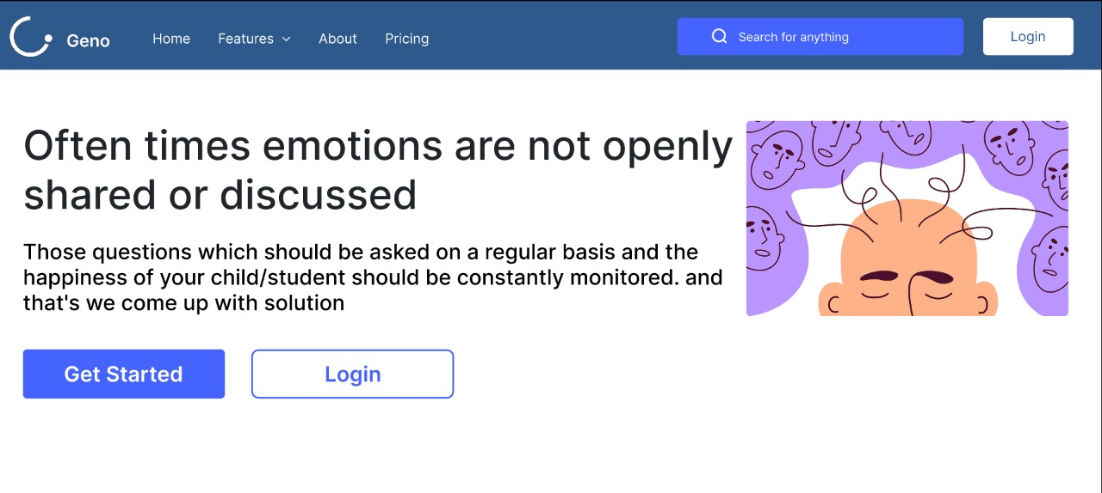

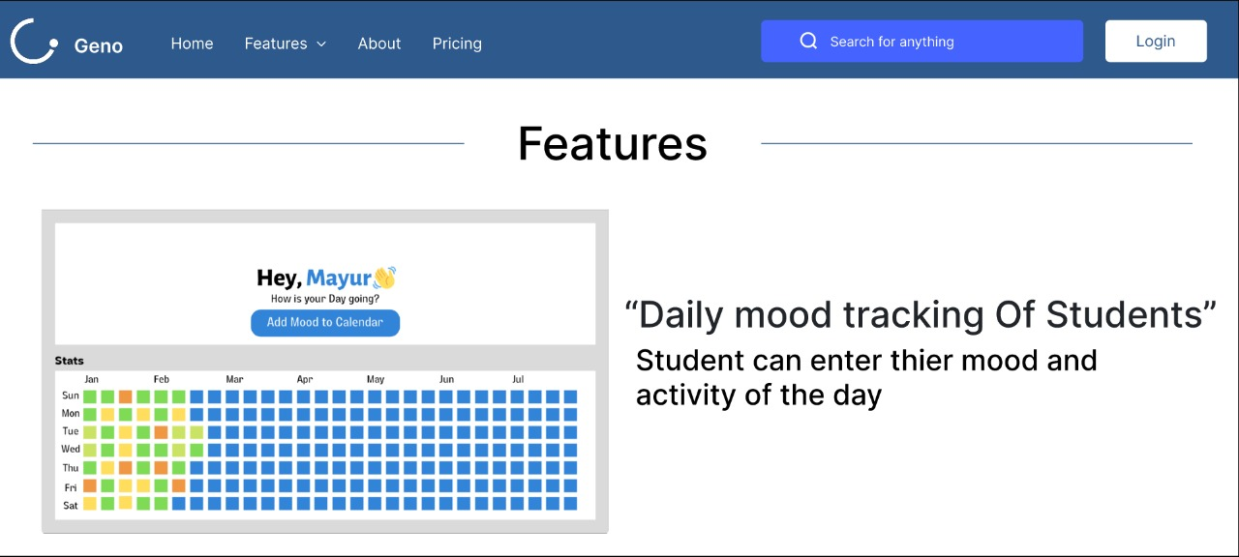

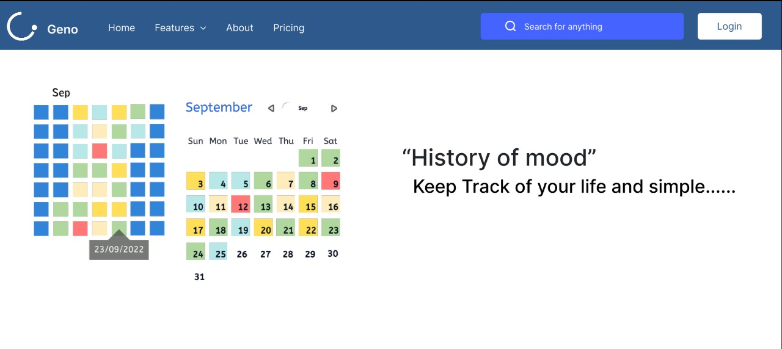

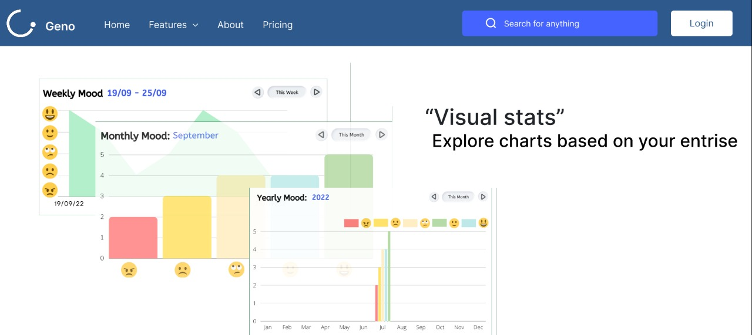

* 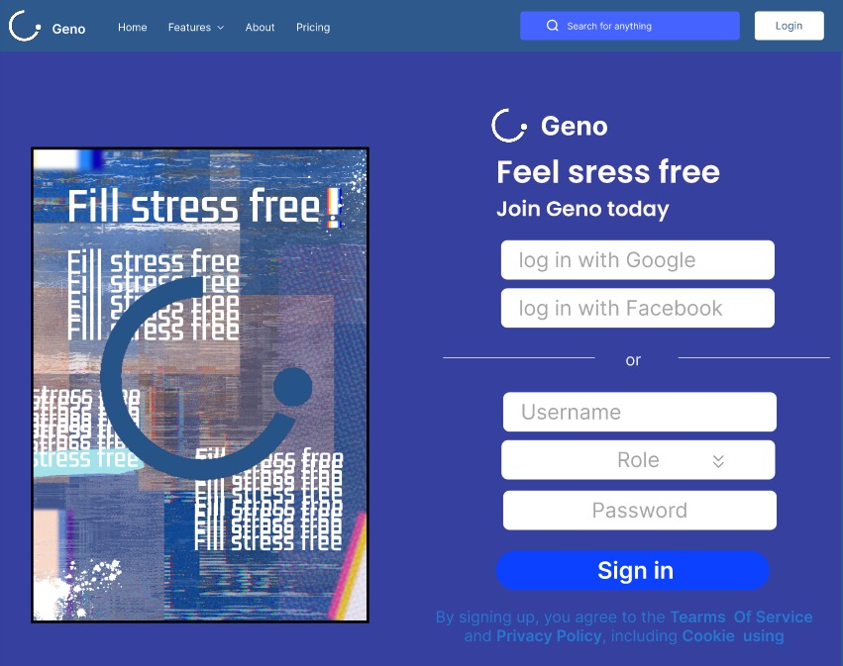

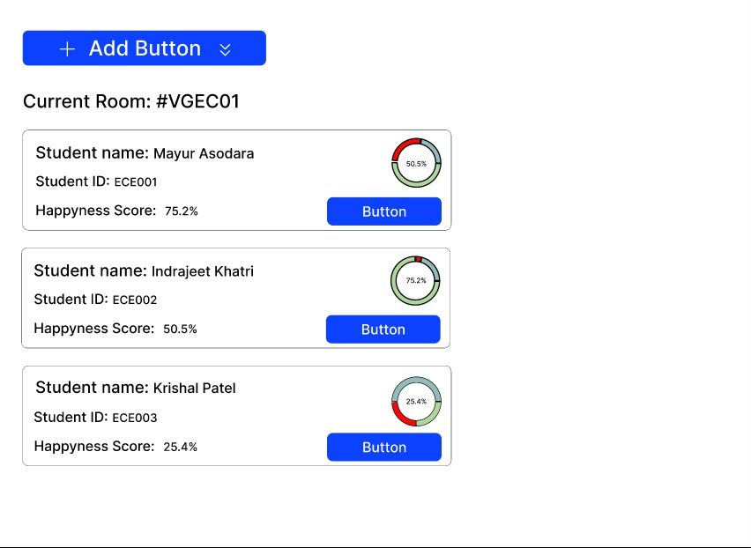

**Index.html :**

<!DOCTYPE html>

<html lang="en">

  <head>

    <meta charset="UTF-8" />

    <meta http-equiv="X-UA-Compatible" content="IE=edge" />

    <meta name="viewport" content="width=device-width, initial-scale=1.0" />

    <title>Home</title>

    <link rel="stylesheet" href="../static/css/style.css" />

    <link

      href="https://cdn.jsdelivr.net/npm/bootstrap@5.2.0/dist/css/bootstrap.min.css"

      rel="stylesheet"

      integrity="sha384-gH2yIJqKdNHPEq0n4Mqa/HGKIhSkIHeL5AyhkYV8i59U5AR6csBvApHHNl/vI1Bx"

      crossorigin="anonymous"

    />

  </head>

  <body>

    <nav class="navbar bg-light fixed-top">

      <div class="container-fluid">

        <a class="navbar-brand" href="#">Geno</a>

        <button

          class="navbar-toggler"

          type="button"

          data-bs-toggle="offcanvas"

          data-bs-target="#offcanvasNavbar"

          aria-controls="offcanvasNavbar"

        >

          <span class="navbar-toggler-icon"></span>

        </button>

        <div

          class="offcanvas offcanvas-end"

          tabindex="-1"

          id="offcanvasNavbar"

          aria-labelledby="offcanvasNavbarLabel"

          style="background-color: #e3f2fd"

        >

          <div class="offcanvas-header">

            <h5 class="offcanvas-title" id="offcanvasNavbarLabel">Geno</h5>

            <button

              type="button"

              class="btn-close"

              data-bs-dismiss="offcanvas"

              aria-label="Close"

            ></button>

          </div>

          <div class="offcanvas-body">

            <ul class="navbar-nav justify-content-end flex-grow-1 pe-3">

              <li class="nav-item">

                <a class="nav-link active" aria-current="page" href="index.html"

                  >Home</a

                >

              </li>

              <li class="nav-item">

                <a class="nav-link active" aria-current="page" href=""

                  >Fetures</a

                >

              </li>

              <li class="nav-item dropdown">

                <a

                  class="nav-link dropdown-toggle"

                  href="index.html"

                  role="button"

                  data-bs-toggle="dropdown"

                  aria-expanded="false"

                >

                  Role

                </a>

                <ul class="dropdown-menu">

                  <li>

                    <a class="dropdown-item" href="teachers.html">Teacher</a>

                  </li>

                  <li><a class="dropdown-item" href="#">Student</a></li>

                </ul>

              </li>

            </ul>

          </div>

        </div>

      </div>

    </nav>

    <section>

      <div class="container">

        <div class="row align-items-center reverse">

          <div class="col-lg-6">

            <h2>Often times emotions are not openly shared or discussed</h2>

            <p>

              Those questions which should be asked on a regular basis and the

              happiness of your child/student should be constantly monitored.

              and that's we come up with solution

            </p>

            <div class="first-section_buttons">

              <button type="button" class="btn btn-primary">Get started</button>

              <button

                type="button"

                class="btn btn-outline-primary"

                onclick="window.location.href='login.html'"

              >

                Log in

              </button>

            </div>

          </div>

          <div class="col-lg-6">

            <img

              class="que-img"

              src="https://thumbs.dreamstime.com/b/school-mental-health-word-cloud-wordcloud-made-text-school-mental-health-word-cloud-126516313.jpg"

            />

          </div>

        </div>

      </div>

    </section>

    <section>

      <div class="container">

        <div class="row align-items-center">

          <div class="col-lg-6">

            <img

              src="https://static.happify.com/static/img/wellness_landing/break_old_patterns.svg?cb095b75929a52bb4da75e8e9ad32a6da3e89c9d"

              style="margin-right: 400px"

            />

          </div>

          <div class="col-lg-6">

            <h2>

              Break old patterns,<br />

              form new habits

            </h2>

            <p>

              Lorem ipsum, dolor sit amet consectetur adipisicing elit.

              Assumenda aspernatur commodi neque nobis? Tempore ullam quo

              repellendus dolorum expedita perferendis dolore? Similique ipsum

              quidem corporis, rerum quibusdam obcaecati odio dicta? Odio illum

              tempore, harum deleniti libero magni aspernatur sed pariatur?

            </p>

          </div>

        </div>

      </div>

    </section>

    <section>

      <div class="container mb-5">

        <div class="row align-items-center reverse">

          <div class="col-lg-6">

            <h2>

              Simple & effective solutions <br />for your mental health &

              well‑being

            </h2>

            <p>

              Lorem ipsum dolor sit amet, consectetur adipisicing elit. Illo, ad

              quo fugiat veniam unde labore aliquam architecto odit ratione

              perferendis, tempore maxime hic eos in quam dolorum omnis porro

              est.

            </p>

          </div>

          <div class="col-lg-6">

            <img

              class="que-img"

              src="https://static.happify.com/static/img/wellness_landing/simple_effective2x.png?cb095b75929a52bb4da75e8e9ad32a6da3e89c9d"

            />

          </div>

        </div>

      </div>

    </section>

    <script

      src="https://cdn.jsdelivr.net/npm/bootstrap@5.2.0/dist/js/bootstrap.bundle.min.js"

      integrity="sha384-A3rJD856KowSb7dwlZdYEkO39Gagi7vIsF0jrRAoQmDKKtQBHUuLZ9AsSv4jD4Xa"

      crossorigin="anonymous"

    ></script>

  </body>

</html>

**Style.css:**

.container {

  margin-top: 5rem !important;

  margin-left: 0.5rem !important;

  margin-right: 26rem !important;

  font-family: Arial, Helvetica, sans-serif;

}

.btn-outline-success {

  --bs-btn-border-color: #0d6efd;

}

.que-img {

  width: 600px;

}

.btn-primary {

  height: 40px;

  width: 150px;

  margin-top: 20px;

  margin-right: 5px;

  border-radius: 0px;

}

.btn-outline-primary {

  height: 40px;

  width: 150px;

  margin-top: 20px;

  margin-right: 5px;

  border-radius: 0px;

}

.vl {

  border-left: 1px solid white;

  height: 100vh;

  position: absolute;

  left: 50%;

  margin-left: -3px;

  top: 0;

}

.card {

  margin-top: 10px;

  margin-left: 10px;

  height: 165px !important;

  width: 895px !important;

}

.roomid {

  margin-top: 30px;

  margin-left: 10px;

}

**Login.html:**

<!DOCTYPE html>

<html lang="en">

  <head>

    <meta charset="UTF-8" />

    <meta http-equiv="X-UA-Compatible" content="IE=edge" />

    <meta name="viewport" content="width=device-width, initial-scale=1.0" />

    <link

      href="https://cdn.jsdelivr.net/npm/bootstrap@5.2.0/dist/css/bootstrap.min.css"

      rel="stylesheet"

      integrity="sha384-gH2yIJqKdNHPEq0n4Mqa/HGKIhSkIHeL5AyhkYV8i59U5AR6csBvApHHNl/vI1Bx"

      crossorigin="anonymous"

    />

    <link rel="stylesheet" href="../static/css/style.css">

    <title>Login</title>

  </head>

  <body>

    <div style="height: 100vh; display: flex">

      <div

        class="container-l"

        style="

          width: 50%;

          max-width: 50%;

          background-position: center;

          display: flex;

          background-size: cover;

          align-items: center;

          justify-content: center;

          background-color: #304991;

        "

      >

       <img src="../static/images/lgbg.png" alt="" style="height: 90vh;">

      </div>

      <div class="vl"></div>

      <div

        class="container-r"

        style="

          width: 50%;

          max-width: 50%;

          background-color: #304991;

          display: flex;

          border-color: #ffffff;

        "

      >

        <div style="padding-left: 30px">

          <img src="../static/images/genologo.png" alt="" style="height: 80px;

          width:80px

          ">

          <h1

            style="

              font-family: system-ui, -apple-system, BlinkMacSystemFont,

                'Segoe UI', Roboto, Oxygen, Ubuntu, Cantarell, 'Open Sans',

                'Helvetica Neue', sans-serif;

              font-size: 44px;

              font-weight: 600;

              margin-top: 10px;

              color: #ffffff;

            "

          >

            Fill stress free

          </h1>

          <h2

            style="

              font-size: 22px;

              font-weight: 400;

              margin-top: 20px;

              color: #ffffff;

            "

          >

            Join Geno today.

          </h2>

          <div style="font-weight: 900 !important; margin-top: 30px">

            <div class="input-group mb-3">

  <input type="text" class="form-control" placeholder="Username" aria-label="Username" aria-describedby="basic-addon1">

</div>

          </div>

          <div style="font-weight: 900 !important; margin-top: 10px">

            <div class="input-group mb-3">

  <input type="password" class="form-control" id="inputPassword" placeholder="Password" aria-describedby="basic-addon1">

</div>

          </div>

            <div style="display: flex; align-items: center; margin-top: 10px">

              <div

                style="height: 1px; background-color: gray; width: 135px"

              ></div>

              <div

                style="

                  margin-left: 5px;

                  margin-right: 5px;

                  font-size: 15px;

                  color: white;

                "

              >

                or

              </div>

              <div

                style="height: 1px; background-color: gray; width: 135px"

              ></div>

            </div>

             <div style="font-weight: 900 !important; margin-top: 10px">

            <div class="input-group mb-3">

  <input type="text" class="form-control" placeholder="Username" aria-label="Username" aria-describedby="basic-addon1">

</div>

          </div>

<div style="font-weight: 900 !important; margin-top: 10px">

            <div class="input-group mb-3">

<select class="form-select form-select-sm" aria-label=".form-select-sm example">

  <option selected>Role</option>

  <option value="1">Teacher</option>

  <option value="2">Student</option>

</select>

</div>

</div>

 <div style="font-weight: 900 !important; margin-top: 10px">

            <div class="input-group mb-3">

  <input type="password" class="form-control" id="inputPassword" placeholder="Password" aria-describedby="basic-addon1">

</div>

          </div>

            <button

              type="button"

              class="btn btn-info"

              style="

                width: 300px;

                background-color: #1d9bf0;

                color: white;

                font-family: system-ui, -apple-system, BlinkMacSystemFont,

                  'Segoe UI', Roboto, Oxygen, Ubuntu, Cantarell, 'Open Sans',

                  'Helvetica Neue', sans-serif;

                font-size: 14px;

                font-weight: 600;

                border-radius: 20px;

                margin-top: 10px;

              "

            >

              Sign in

            </button>

            <div

              style="

                font-weight: 200;

                color: gray;

                font-size: 12px;

                margin-top: 5px;

              "

            >

              By signing up, you agree to the

              <a style="color: #1d9bf0">Terms of Service</a> and

              <a style="color: #1d9bf0"

                >Privacy <br />

                Policy</a

              >

              , including <a style="color: #1d9bf0">Cookie Use</a>.

            </div>

      <script

        src="https://cdn.jsdelivr.net/npm/bootstrap@5.2.0-beta1/dist/js/bootstrap.bundle.min.js"

        integrity="sha384-pprn3073KE6tl6bjs2QrFaJGz5/SUsLqktiwsUTF55Jfv3qYSDhgCecCxMW52nD2"

        crossorigin="anonymous"

      ></script>

    </div>

  </body>

</html>

**Teachers.html:**

<!DOCTYPE html>

<html lang="en">

  <head>

    <meta charset="UTF-8" />

    <meta http-equiv="X-UA-Compatible" content="IE=edge" />

    <meta name="viewport" content="width=device-width, initial-scale=1.0" />

    <link rel="stylesheet" href="../static/css/style.css" />

    <link

      href="https://cdn.jsdelivr.net/npm/bootstrap@5.2.0/dist/css/bootstrap.min.css"

      rel="stylesheet"

      integrity="sha384-gH2yIJqKdNHPEq0n4Mqa/HGKIhSkIHeL5AyhkYV8i59U5AR6csBvApHHNl/vI1Bx"

      crossorigin="anonymous"

    />

    <title>Teacher</title>

  </head>

  <body>

   <nav class="navbar bg-light fixed-top">

      <div class="container-fluid">

        <a class="navbar-brand" href="#">Geno</a>

        <button

          class="navbar-toggler"

          type="button"

          data-bs-toggle="offcanvas"

          data-bs-target="#offcanvasNavbar"

          aria-controls="offcanvasNavbar"

        >

          <span class="navbar-toggler-icon"></span>

        </button>

        <div

          class="offcanvas offcanvas-end"

          tabindex="-1"

          id="offcanvasNavbar"

          aria-labelledby="offcanvasNavbarLabel"

          style="background-color: #e3f2fd"

        >

          <div class="offcanvas-header">

            <h5 class="offcanvas-title" id="offcanvasNavbarLabel">Geno</h5>

            <button

              type="button"

              class="btn-close"

              data-bs-dismiss="offcanvas"

              aria-label="Close"

            ></button>

          </div>

          <div class="offcanvas-body">

            <ul class="navbar-nav justify-content-end flex-grow-1 pe-3">

              <li class="nav-item">

                <a class="nav-link active" aria-current="page" href="index.html">Home</a>

              </li>

              <li class="nav-item">

                <a class="nav-link active" aria-current="page" href=""

                  >Fetures</a

                >

              </li>

              <li class="nav-item dropdown">

                <a

                  class="nav-link dropdown-toggle"

                  role="button"

                  data-bs-toggle="dropdown"

                  aria-expanded="false"

                >

                  Role

                </a>

                <ul class="dropdown-menu">

                  <li>

                    <a class="dropdown-item" href="teachers.html">Teacher</a>

                  </li>

                  <li><a class="dropdown-item" href="#">Student</a></li>

                </ul>

              </li>

            </ul>

          </div>

        </div>

      </div>

    </nav>

    <div class="dropdown">

  <button type="button" class="btn btn-primary dropdown-toggle" data-bs-toggle="dropdown" aria-expanded="false" data-bs-auto-close="outside" style="margin-top: 70px; margin-left: 10px; width: 200px; height: 40px"

    >

    + Add Room

  </button>

  <form class="dropdown-menu p-4">

    <div class="mb-3">

      <label for="exampleDropdownFormEmail2" class="form-label">Room id</label>

      <input type="email" class="form-control" id="exampleDropdownFormEmail2" placeholder="#VGEC001">

    </div>

    <div class="mb-3">

      <label for="exampleDropdownFormPassword2" class="form-label">Create Password</label>

      <input type="password" class="form-control" id="exampleDropdownFormPassword2" placeholder="Password">

    </div>

    <div class="mb-3">

      <div class="form-check">

        <input type="checkbox" class="form-check-input" id="dropdownCheck2">

        <label class="form-check-label" for="dropdownCheck2">

          Remember me

        </label>

      </div>

    </div>

    <button type="submit" class="btn btn-primary">Add Room</button>

  </form>

</div>

    <div class="roomid">

      <h2>Current Room: #VGEC01</h2>

    </div>

    <div>

      <div class="card">

        <div class="card-body">

          <h5 class="card-title">Student name: Mayur Asodara</h5>

          <p>Student id: ECE001<br>

          Happiness Score: 70.2%<br>

            <a href="#" class="btn btn-primary" style="margin-left: 720px"

              >Button</a

            >

          </p>

        </div>

      </div>

      <div>

      <div class="card">

        <div class="card-body">

          <h5 class="card-title ">Student name: Indrajeet Khatri</h5>

          <p>Student id: ECE002<br>

          Happiness Score: 70.2%<br>

            <a href="#" class="btn btn-primary" style="margin-left: 720px"

              >Button</a

            >

          </p>

        </div>

      </div>

    <div>

      <div class="card">

        <div class="card-body">

          <h5 class="card-title">Student name: Raj Rajput</h5>

<p>Student id: ECE003<br>

          Happiness Score: 70.2%<br>

            <a href="#" class="btn btn-primary" style="margin-left: 720px"

              >Button</a

            >

          </p>

        </div>

      </div></div>

      <div>

      <div class="card">

        <div class="card-body">

          <h5 class="card-title">Student name: Krishal Patel</h5>

          <p>Student id: ECE004<br>

          Happiness Score: 70.2%<br>

            <a href="#" class="btn btn-primary" style="margin-left: 720px"

              >Button</a

            >

          </p>

        </div>

      </div>

      <div>

      <div class="card">

        <div class="card-body">

          <h5 class="card-title">Student name: Akshit Kachhadiya</h5>

          <p>Student id: ECE005<br>

          Happiness Score: 70.2%<br>

            <a href="#" class="btn btn-primary" style="margin-left: 720px"

              >Button</a

            >

          </p>

        </div>

      </div>

      <div>

      <div class="card">

        <div class="card-body">

          <h5 class="card-title">Student name: Viral Parmar</h5>

          <p>Student id: ECE006<br>

          Happiness Score: 70.2%<br>

            <a href="#" class="btn btn-primary" style="margin-left: 720px"

              >Button</a

            >

          </p>

        </div>

      </div>

      <div>

      <div class="card">

        <div class="card-body">

          <h5 class="card-title">Student name: Karan Diwan</h5>

          <p>Student id: ECE007<br>

          Happiness Score: 70.2%<br>

            <a href="#" class="btn btn-primary" style="margin-left: 720px"

              >Button</a

            >

          </p>

        </div>

      </div>

      <div>

      <div class="card">

        <div class="card-body">

          <h5 class="card-title">Student name: Deven Desai</h5>

          <p>Student id: ECE008<br>

          Happiness Score: 70.2%<br>

            <a href="#" class="btn btn-primary" style="margin-left: 720px"

              >Button</a

            >

          </p>

        </div>

      </div>

      <div>

      <div class="card">

        <div class="card-body">

          <h5 class="card-title">Student name: Smit Gajera</h5>

          <p>Student id: ECE009<br>

          Happiness Score: 70.2%<br>

            <a href="#" class="btn btn-primary" style="margin-left: 720px"

              >Button</a

            >

          </p>

        </div>

      </div>

    <script

      src="https://cdn.jsdelivr.net/npm/bootstrap@5.2.0/dist/js/bootstrap.bundle.min.js"

      integrity="sha384-A3rJD856KowSb7dwlZdYEkO39Gagi7vIsF0jrRAoQmDKKtQBHUuLZ9AsSv4jD4Xa"

      crossorigin="anonymous"

    ></script>

  </body>

</html>

**app.py**

from flask import Flask

from flask import render_template

app = Flask(__name__)

@app.route("/")

@app.route("/home")

def home():

  return render_template('index.html')

@app.route("/login")

def about():

  return render_template('login.html')

@app.route("/students")

def contact():

  return render_template('student.html')

@app.route("/teachers")

def projects():

  return render_template('teachers.html')

*#----------------------------------Algo for calculate happiness index------------------------------------*

def monthsresult(answere):

*# 1 = happy*

*# 2 = neutral*

*# 3 = sad*

*# 4 = very sad*

    marks = 0

    if answere ==1:

            marks= marks + 1

    elif answere == 2:

            marks = marks + 0.5

    elif answere == 3:

            marks = marks - 0.5

    elif answere == 4:

            marks = marks - 1

    return marks

def OptionsResult():

    correct= 0

    incorrect = 0

*#quetion1*

*#correct answere is option1*

    if (answere==option1):

        correct = correct +1

    else:

        incorrect = incorrect +1

*#quetion2*

*#correct answere is option1*

    if (answere==option1):

        correct = correct +1

    else:

        incorrect = incorrect +1

*#quetion3*

*#correct answere is option1*

    if (answere==option1):

        correct = correct +1

    else:

        incorrect = incorrect +1

*# total quetions = 10*

    avg_marks= (correct - incorrect)*5

    return avg_marks

marks = 0

for i in range(1,31):

    answere = int(input("choice an option "))

    y = monthsresult(answere)

    marks = y + marks

    avg_marks = marks * 1.6666667

avg_marks = int(avg_marks)

print(avg_marks)

*#optionalMarks=OptionsResult()*

total_marks = avg_marks *#+ optionalMarks*

if total_marks >= 90:

    print("your this month was great")

elif total_marks>= 60 and total_marks < 90:

    print("this month was an average ")

elif total_marks>= 40 and total_marks< 60 :

    print("this month was moderate")

else :

    print("you can have a great month ahead")

if __name__ == "__main__":

  app.run(debug=True ,port=3000)