Run FeeReport class

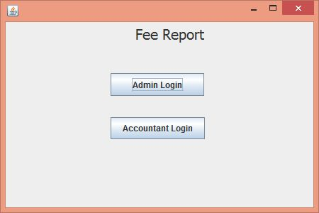

Click on Admin Login

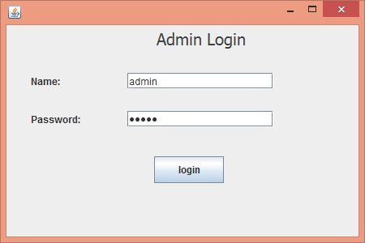

Name is: admin

Password is: admin123

click on login button, it will open Admin Section

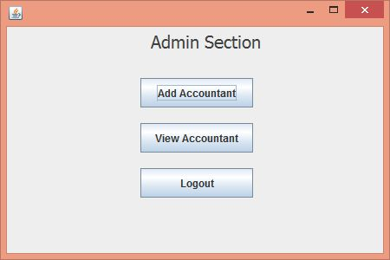

Click on Add Accountant

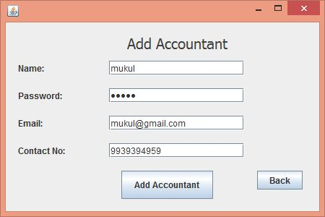

After adding accountant, click on back button.

Now click on View Accountant.

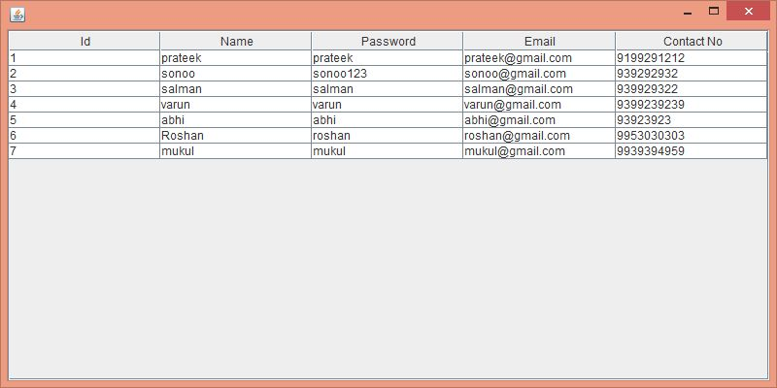

Now click on logout

Click on Accountant Login

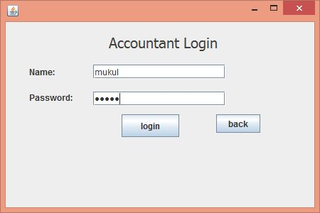

Use the name and password which you stored in database.

Click on login button.

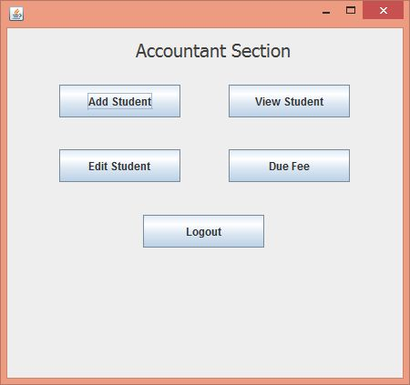

Click on Add Student

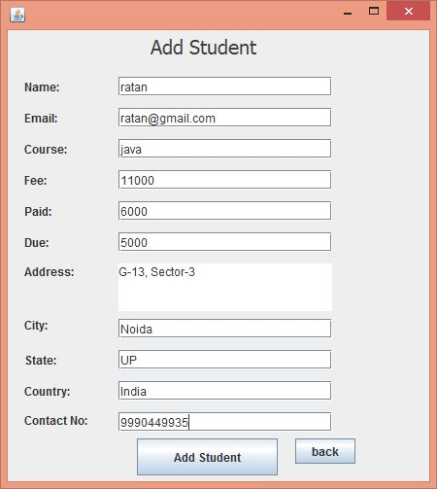

Fill information and click on Add Student

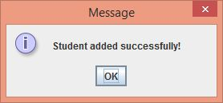

Click on ok. Now View Student.

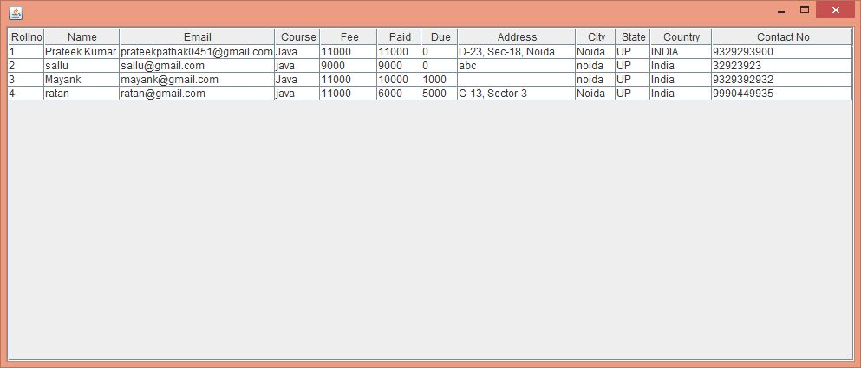

Now, click on edit button.

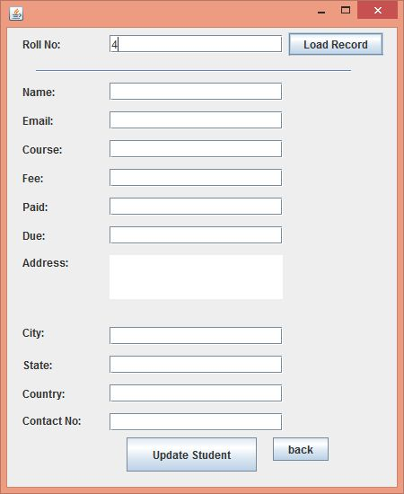

Enter rollno and click on load record.

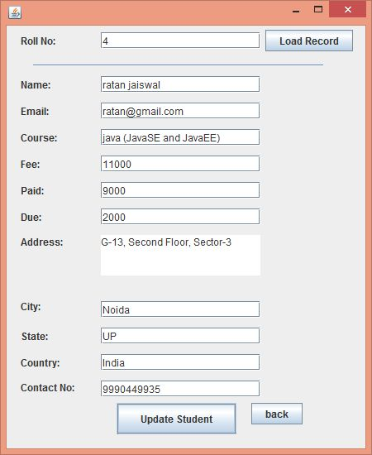

Update information and click on Update Student.

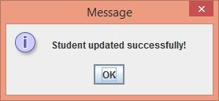

Click on ok button. Now View due fee.

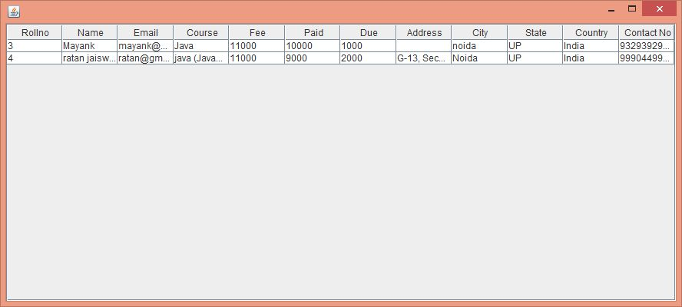

Now logout.

Thanks and Regards,

Mayur AVachat.