Q. 1 ) Write an AngularJS script for addition of two numbers using ng-init, ng-model & ng-bind. And also demonstrate ng-show, ng-disabled, ng-click directives on button component.
<!DOCTYPE html>
<html lang="en" ng-app>
<head>
<meta charset="UTF-8">
<meta name="viewport" content="width=device-width, initial scale=1.0">
<title>AngularJS Addition Example</title>
<script src="https://ajax.googleapis.com/ajax/libs/angularjs/1.8.2/angular.min.js">
</script>
</head>
<body ng-init="num1=0; num2=0; sum=0; allowCalc=false; showResult=false">
<h2>AngularJS Addition with Checkbox Control</h2>
<p> Enter First Number: <input type="number" ng-model="num1"></p> <p> Enter Second Number: <input type="number" ng-model="num2"> </p>
<p> <input type="checkbox" ng-model="allowCalc"> Allow Addition </p>
<p> <button ng-click="sum = num1 + num2; showResult = true" ng- disabled="!allowCalc"> Add Numbers </button>
</p>
<div ng-show="allowCalc && showResult">
<h3>Result: <span ng-bind="sum"></span></h3>
<p>◻ Calculation completed successfully!</p>
</div>

</body>
</html>

Output:

Q. 2 ) Create a Node.js application that reads data from multiple files asynchronously using promises and async/await.
const fs = require('fs').promises;
const files = ['file1.txt', 'file2.txt', 'file3.txt']; function readFileAsync(fileName) {
return fs.readFile(fileName, 'utf8');
}
async function readMultipleFiles() { try {
const readPromises = files.map(file => readFileAsync(file)); const contents = await Promise.all(readPromises); contents.forEach((content, index) => {
console.log(`--- Content of ${files[index]} ---`); console.log(content);
console.log(' \n');
});
} catch (err) {
console.error('Error reading files:', err);
}
}

readMultipleFiles();

Output:

Q. 3 ) Write an AngularJS script to print details of bank (bank name, MICR code, IFC code, address etc.) in tabular form using ng-repeat.
<!DOCTYPE html>
<html lang="en" ng-app="bankApp">
<head>
<meta charset="UTF-8">
<meta name="viewport" content="width=device-width, initial-scale=1.0">
<title>Bank Details</title>
<script src="https://ajax.googleapis.com/ajax/libs/angularjs/1.8.2/angular.min.js"></scr ipt>
<style> table {
border-collapse: collapse; width: 80%;
margin: 20px auto;
}
th, td {
border: 1px solid #333; padding: 8px 12px; text-align: left;

}
th {
background-color: #f2f2f2;
}
h2 {
text-align: center;
}
</style>
</head>
<body ng-controller="bankCtrl">
<h2>Bank Details</h2>
<table>
<tr>
<th>Bank Name</th>
<th>MICR Code</th>
<th>IFSC Code</th>
<th>Address</th>
</tr>
<tr ng-repeat="bank in banks">
<td>{{ bank.name }}</td>
<td>{{ bank.micr }}</td>
<td>{{ bank.ifsc }}</td>
<td>{{ bank.address }}</td>
</tr>

</table>
<script>
var app = angular.module('bankApp', []); app.controller('bankCtrl', function($scope) {
$scope.banks = [
{
name: 'State Bank of India', micr: '1100023',
ifsc: 'SBIN0001234',
address: '123 MG Road, Mumbai'
},
{
name: 'HDFC Bank', micr: '4000123',
ifsc: 'HDFC0005678',
address: '45 Park Street, Kolkata'
},
{
name: 'ICICI Bank', micr: '5000456', ifsc: 'ICIC0009876',
address: '78 Brigade Road, Bangalore'
},
{

}
];
});
name: 'Axis Bank', micr: '6000789', ifsc: 'UTIB0004321',
address: '90 Marine Drive, Mumbai'

</script>
</body>
</html>

Output:

Roll No :- 08 Remark:-
Name :- Bhalerao Mayur Abasaheb
Subject :- Full Stack Development-II
Class :- M.sc (Computer Science) SEM-III

Q. 4 ) Create a simple Angular application that fetches data from an API using HttpClient. Implement an Observable to fetch data from an API endpoint.
app.components.ts
import { Component, OnInit } from '@angular/core'; import { ApiService } from './api.service'; @Component({
selector: 'app-root',
templateUrl: './app.component.html'
})
export class AppComponent implements OnInit { posts: any[] = [];
constructor(private apiService: ApiService) {} ngOnInit(): void {
// Subscribe to the Observable this.apiService.getPosts().subscribe((data) => { this.posts = data;
});
}
}

app.module.ts
import { NgModule } from '@angular/core';
import { BrowserModule } from '@angular/platform-browser'; import { HttpClientModule } from '@angular/common/http'; import { AppComponent } from './app.component'; @NgModule({
declarations: [AppComponent], imports: [
BrowserModule, HttpClientModule
],
providers: [],
bootstrap: [AppComponent]
})
export class AppModule {}

app.component.html
<div class="container">
<h1>Posts from API</h1>
<ul>
<li *ngFor="let post of posts">
<strong>{{ post.title }}</strong>
<p>{{ post.body }}</p>
</li>
</ul>

</div>

api.service.ts
import { Injectable } from '@angular/core';
import { HttpClient } from '@angular/common/http'; import { Observable } from 'rxjs';
@Injectable({ providedIn: 'root'
})
export class ApiService {
private apiUrl = 'https://jsonplaceholder.typicode.com/posts'; constructor(private http: HttpClient) {}
getPosts(): Observable<any> {
return this.http.get<any>(this.apiUrl);
}
}

Output:

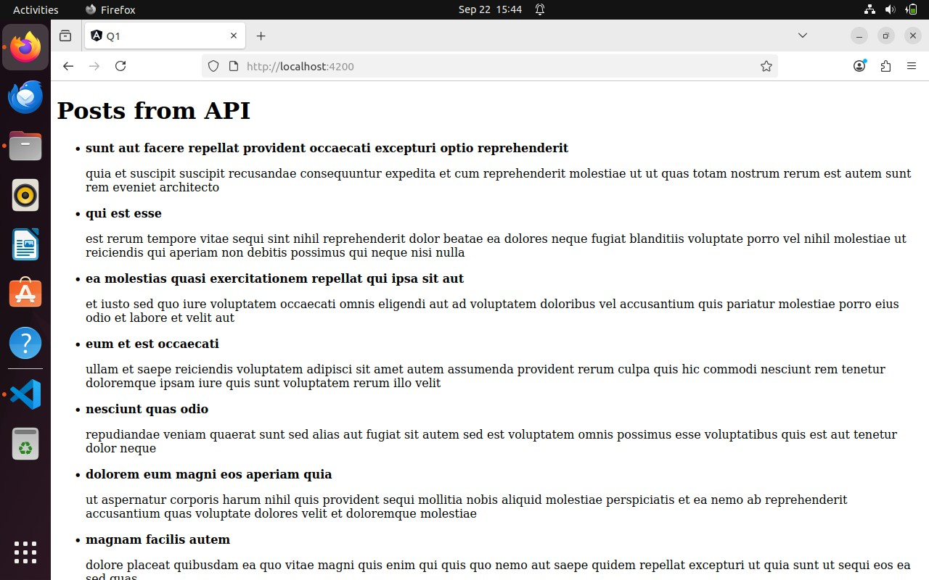

Q. 5 ) Write an AngularJS script to display list of games stored in an array on click of button using ng-click and also demonstrate ng-init, ng-bind directive of AngularJS.
<!DOCTYPE html>
<html lang="en" ng-app>
<head>
<meta charset="UTF-8">
<meta name="viewport" content="width=device-width, initial-scale=1.0">
<title>AngularJS Games List</title>
<script src="https://ajax.googleapis.com/ajax/libs/angularjs/1.8.2/angular.min.js"></scr ipt>
<style> ul {
list-style-type: square; margin: 10px 0; padding-left: 20px;
}
button {
padding: 6px 12px; margin-top: 10px;

}
</style>
</head>
<body ng-init="games=['Cricket','Football','Tennis','Hockey','Badminton']; showGames=false; message=''">
<h2>Games List Example</h2>
<button ng-click="showGames=true; message='List of Games:'">Show Games</button>
<h3 ng-bind="message"></h3>
<ul ng-show="showGames">
<li ng-repeat="game in games">{{ game }}</li>
</ul>
</body>
</html>

Output:

Q. 6 ) Find a company with a workforce greater than 30 in the array (use find by id method).
company.service.ts
import { Injectable } from '@angular/core'; import { Observable, of } from 'rxjs'; export interface Company {
id: number; name: string;
workforce: number;
}
@Injectable({ providedIn: 'root'
})
export class CompanyService { private companies: Company[] = [
{ id: 1, name: 'TechCorp', workforce: 25 },
{ id: 2, name: 'InnoSoft', workforce: 40 },
{ id: 3, name: 'WebSolutions', workforce: 15 },
{ id: 4, name: 'AlphaSystems', workforce: 50 },
{ id: 5, name: 'MegaTech', workforce: 60 }

];
constructor() { }
getCompanies(): Observable<Company[]> { return of(this.companies);
}
}

app.component.ts
import { Component, OnInit } from '@angular/core';
import { CompanyService, Company } from './services/company.service'; @Component({
selector: 'app-root',
templateUrl: './app.component.html', styleUrls: ['./app.component.css']
})
export class AppComponent implements OnInit { companies: Company[] = [];
filteredCompanies: Company[] = [];
constructor(private companyService: CompanyService) { } ngOnInit(): void { this.companyService.getCompanies().subscribe(data => {
this.companies = data;
});
}
findCompanies(): void {

this.filteredCompanies = this.companies.filter(company => company.workforce > 30);
}
}

app.component.html
<div style="text-align:center; margin:20px;">
<h1>Companies with Workforce Greater Than 30</h1>
<button (click)="findCompanies()">Show Companies</button>
<table *ngIf="filteredCompanies.length > 0" border="1" cellpadding="5" cellspacing="0" style="margin:auto; margin-top:20px; width:70%;">
<tr>
<th>ID</th>
<th>Name</th>
<th>Workforce</th>
</tr>
<tr *ngFor="let company of filteredCompanies">
<td>{{ company.id }}</td>
<td>{{ company.name }}</td>
<td>{{ company.workforce }}</td>
</tr>
</table>
<p *ngIf="filteredCompanies.length === 0 && companies.length > 0" style="color:red; margin-top:20px;">
No company found with workforce greater than 30.
</p> </div>

Output:

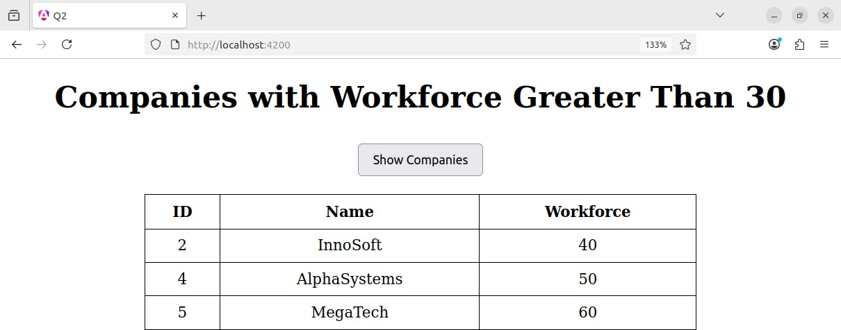

Q. 7 ) Fetch the details using ng-repeat in AngularJS.
<!DOCTYPE html>
<html ng-app="myApp">
<head>
<meta charset="UTF-8">
<title>AngularJS ng-repeat Example</title>
<script src="https://ajax.googleapis.com/ajax/libs/angularjs/1.8.3/angular.min.js">
</script>
<style>
table {
border-collapse: collapse; width: 60%;
margin: 20px auto;
}
th, td {
border: 1px solid #333; padding: 8px;
text-align: left;

}
th {
background-color: #f2f2f2;
}
</style>
</head>
<body ng-controller="MainController">
<h2 style="text-align:center;">Company Details</h2>
<table>
<tr>
<th>ID</th>
<th>Name</th>
<th>Workforce</th>
</tr>
<tr ng-repeat="company in companies">
<td>{{ company.id }}</td>
<td>{{ company.name }}</td>
<td>{{ company.workforce }}</td>
</tr>
</table>
<script>
var app = angular.module('myApp', []); app.controller('MainController', ['$scope', function($scope) {

$scope.companies = [
{ id: 1, name: 'TechSoft', workforce: 25 },
{ id: 2, name: 'Green Energy', workforce: 40 },
{ id: 3, name: 'Blue Ocean', workforce: 32 },
{ id: 4, name: 'SkyNet', workforce: 28 }
];
}]);
</script>
</body>
</html>

Output:

Q. 8 ) Create Express.js application to include middleware for parsing request bodies (e.g., JSON, form data) and validating input data. Send appropriate JSON responses for success and error cases.
const express = require('express'); const mongoose = require('mongoose'); const app = express();
const port = 3000; mongoose.connect('mongodb://localhost:27017/testdb', { useNewUrlParser: true,
useUnifiedTopology: true,
})
.then(() => console.log('MongoDB connected'))
.catch((err) => {
console.error('MongoDB connection error:', err); process.exit(1);
});
app.use(express.json()); app.use(express.urlencoded({ extended: true })); const userSchema = new mongoose.Schema({ username: {

type: String,
required: [true, 'Username is required'],
minlength: [3, 'Username must be at least 3 characters long'], trim: true,
},
email: { type: String,
required: [true, 'Email is required'], trim: true,
lowercase: true, validate: {
validator: function (v) {
// Basic email regex
return /^[^\s@]+@[^\s@]+\.[^\s@]+$/.test(v);
},
message: props => `${props.value} is not a valid email!`,
},
},
});
const User = mongoose.model('User', userSchema); app.post('/register', async (req, res) => {
try {
const user = new User(req.body); await user.save();

res.status(201).json({ success: true,
message: 'User registered successfully', data: {
username: user.username, email: user.email,
},
});
} catch (err) {
if (err.name === 'ValidationError') {
const errors = Object.values(err.errors).map(e => e.message); return res.status(400).json({ success: false, errors });
}
console.error(err);
res.status(500).json({ success: false, message: 'Server error' });
}
});
app.listen(port, () => {
console.log(`Server listening on http://localhost:${port}`);
});

Output:

Q. 9 ) Create a simple Angular component that takes input data and displays it.
student.component.ts
import { Component } from '@angular/core'; @Component({
selector: 'app-student',
templateUrl: './student.component.html', styleUrls: ['./student.component.css']
})
export class StudentComponent { studentName: string = ''; studentAge: number | null = null; submitted = false;
onSubmit() { this.submitted = true;
}
}

Student.component.html
<div style="margin:20px;">
<h2>Enter Student Details</h2>

<label for="name">Name: </label>
<input id="name" [(ngModel)]="studentName" placeholder="Enter name"
/><br><br>
<label for="age">Age: </label>
<input id="age" type="number" [(ngModel)]="studentAge" placeholder="Enter age" /><br><br>
<button (click)="onSubmit()">Submit</button>
<div *ngIf="submitted" style="margin-top:20px;">
<h3>Student Information</h3>
<p><strong>Name:</strong> {{ studentName }}</p>
<p><strong>Age:</strong> {{ studentAge }}</p>
</div>
</div>

App.component.html
<app-student></app-student>

Output:

Q. 10 ) Implement a simple server using Node.js.
const http = require('http'); const PORT = 3000;
const server = http.createServer((req, res) => { res.writeHead(200, { 'Content-Type': 'text/plain' }); res.end('Hello! This is a simple Node.js server.\n');
});
server.listen(PORT, () => {
console.log(`Server is running at http://localhost:${PORT}`);
});

Output:
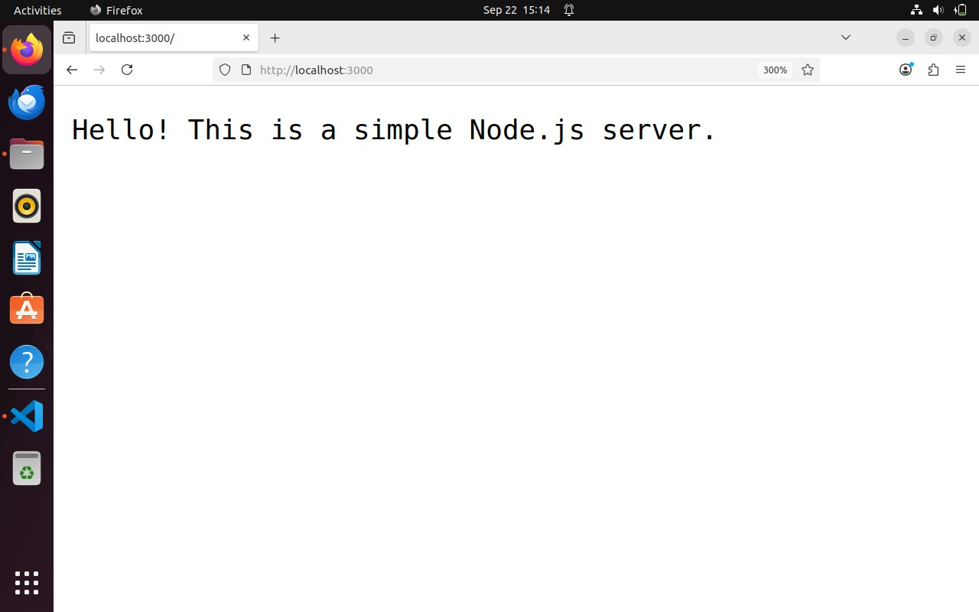

Q. 11 ) Create Angular application that print the name of students who play basketball using filter and map method.
app.component.ts
import { Component, OnInit } from '@angular/core'; @Component({
selector: 'app-root',
templateUrl: './app.component.html'
})
export class AppComponent implements OnInit { students = [
{ id: 1, name: Sanket, sport: 'Basketball' },
{ id: 2, name: 'Sham', sport: 'Football' },
{ id: 3, name: mayur, sport: 'Basketball' },
{ id: 4, name: 'Krushna', sport: ' Basketball ' }
];
basketballPlayers: string[] = []; ngOnInit(): void {
// ◻ filter + map this.basketballPlayers = this.students
.filter(student => student.sport === 'Basketball')

.map(student => student.name);
}

App.component.html
<div style="padding:20px;">
<h1>Basketball Players</h1>
<ul>
<li *ngFor="let player of basketballPlayers">{{ player }}</li>
</ul>
</div>

Output:
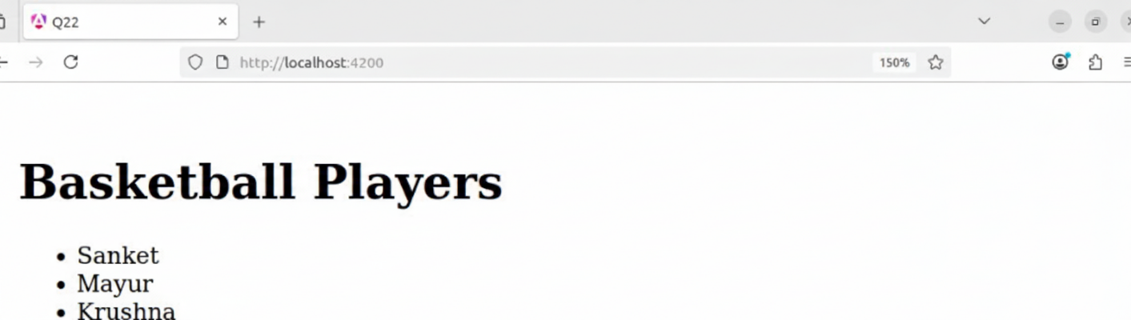

Q. 12 ) Write an AngularJS script to print details of Employee (employee name, employee Id,Pin code, address etc.) in tabular form using ng-repeat.
<!DOCTYPE html>
<html lang="en" ng-app="employeeApp">
<head>
<meta charset="UTF-8">
<title>Employee Details</title>
<script src="https://ajax.googleapis.com/ajax/libs/angularjs/1.8.2/angular.min.js"></scr ipt>
<style> body {
font-family: Arial, sans-serif;
}
table {
border-collapse: collapse; width: 75%;
margin: 20px auto;
}
th, td {
border: 1px solid #444;

padding: 8px; text-align: center;
}
th {
background: #f2f2f2;
}
h1 {
text-align: center; margin-top: 20px;
}
</style>
</head>
<body ng-controller="employeeController">
<h1>Employee Details</h1>
<table>
<tr>
<th>Employee ID</th>
<th>Name</th>
<th>Pin Code</th>
<th>Address</th>
</tr>
<tr ng-repeat="emp in employees">
<td>{{ emp.id }}</td>
<td>{{ emp.name }}</td>

<td>{{ emp.pincode }}</td>
<td>{{ emp.address }}</td>
</tr>
</table>
<script>
var app = angular.module("employeeApp", []); app.controller("employeeController", function($scope) {
$scope.employees = [
{ id: 101, name: "Rahul", pincode: "560001", address: "MG Road, Bangalore, Karnataka" },
{ id: 102, name: "Mayur", pincode: "380001", address: "Ashram Road, Ahmedabad, Gujarat" },
{ id: 103, name: "Om", pincode: "112233", address: "Connaught Place, New Delhi" },
{ id: 104, name: "Sham", pincode: "445566", address: "T Nagar, Chennai, Tamil Nadu" },
{ id: 105, name: "Krushna", pincode: "778899", address: "Shivaji Nagar, Pune, Maharashtra" }
];
});
</script>
</body>
</html>

Output:

Q. 13 ) Create Angular application that print the name of students who got 85% using filter and map method.
students.component.ts
import { Component, OnInit } from '@angular/core'; @Component({
selector: 'app-students',
templateUrl: './students.component.html', styleUrls: ['./students.component.css']
})
export class StudentsComponent implements OnInit { students = [
{ name: 'Rahul', percentage: 85 },
{ name: 'Om', percentage: 90 },
{ name: 'Ram', percentage: 70 },
{ name: 'Mayur', percentage: 85 },
{ name: 'Krushna', percentage: 85 }
];
topperNames: string[] = []; ngOnInit(): void {
// Filter and Map

this.topperNames = this.students
.filter(student => student.percentage === 85)
.map(student => student.name);
}
}

students.component.html
<div style="margin:20px;">
<h2>Students with 85%</h2>
<ul>
<li *ngFor="let name of topperNames">{{ name }}</li>
</ul>
</div>

app.component.html
<app-students></app-students>

Output:

Q. 14 ) Find an emp with a Salary greater than 25000 in the array. (Using find by id method).
const employees = [
{ id: 1, name: "Mayur", salary: 20000 },
{ id: 2, name: "Suyash", salary: 28000 },
{ id: 3, name: "Sanket", salary: 25000 },
{ id: 4, name: "Uddhav", salary: 30000 },
];
const highSalaryEmps = employees.find(e => e.salary >= 25000); if (highSalaryEmps.length > 0) {
console.log("Employees with salary >= 25000:"); console.log(highSalaryEmps);
} else {
console.log("No employees found with salary >= 25000");
}

Output:

Q. 15 a ) Develop an Express.js application that defines routes for Create and Read operations on a resource (products).
const express = require('express'); const mongoose = require('mongoose'); const app = express();
const PORT = 3000; app.use(express.json());
mongoose.connect('mongodb://localhost:27017/productsdb', { useNewUrlParser: true,
useUnifiedTopology: true
})
.then(() => console.log('◻ Connected to MongoDB'))
.catch((err) => console.error('◻ MongoDB connection error:', err)); const productSchema = new mongoose.Schema({
name: { type: String, required: true }, price: { type: Number, required: true }, description: String
}, { timestamps: true });
const Product = mongoose.model('Product', productSchema); app.post('/product', async (req, res) => {

try {
const product = new Product(req.body); const saved = await product.save(); res.status(201).json(saved);
} catch (err) {
res.status(400).json({ error: err.message });
}
});
app.get('/product', async (req, res) => { try {
const products = await Product.find(); res.json(products);
} catch (err) {
res.status(500).json({ error: err.message });
}
});
app.listen(PORT, () => {
console.log(`◻ Server running on http://localhost:${PORT}`);
});

Output:

Q. 15 b ) Develop an Express.js application that defines routes for Create and Read operations on a resource (User).
const express = require('express'); const mongoose = require('mongoose'); const app = express();
const PORT = 3000; app.use(express.json());
mongoose.connect('mongodb://localhost:27017/userdb', { useNewUrlParser: true,
useUnifiedTopology: true
})
.then(() => console.log('◻ Connected to MongoDB'))
.catch(err => console.error('◻ Connection error:', err)); const userSchema = new mongoose.Schema({
name: { type: String, required: true },
email: { type: String, required: true, unique: true }, age: { type: Number, required: true }
}, { timestamps: true });
const User = mongoose.model('User', userSchema); app.post('/users', async (req, res) => {

try {
const user = new User(req.body); const saved = await user.save(); res.status(201).json(saved);
} catch (err) {
res.status(400).json({ error: err.message });
}
});
app.get('/users', async (req, res) => { try {
const users = await User.find(); res.json(users);
} catch (err) {
res.status(500).json({ error: err.message });
}
});
app.listen(PORT, () => {
console.log(`◻ Server running at http://localhost:${PORT}`);
});

Output:

Q. 15 c ) Develop an Express.js application that defines routes for Create, Update operations on a resource (Employee).
const express = require('express'); const mongoose = require('mongoose');
mongoose.connect('mongodb://localhost:27017/employeedb', { useNewUrlParser: true,
useUnifiedTopology: true
}).then(() => console.log('Connected to MongoDB'))
.catch(err => console.error('MongoDB connection error:', err)); const employeeSchema = new mongoose.Schema({
name: { type: String, required: true }, position: { type: String, required: true }, salary: { type: Number, required: true }
}, { timestamps: true });
const Employee = mongoose.model('Employee', employeeSchema); const app = express();
const PORT = 3000; app.use(express.json()); app.post('/employees', async (req, res) => { try {

const emp = new Employee(req.body); const savedEmp = await emp.save(); res.status(201).json(savedEmp);
} catch (error) {
res.status(400).json({ error: error.message });
}
});
app.put('/employees/:id', async (req, res) => { try {
const updatedEmp = await Employee.findByIdAndUpdate( req.params.id,
req.body,
{ new: true, runValidators: true }
);
if (!updatedEmp) {
return res.status(404).json({ error: 'Employee not found' });
}
res.json(updatedEmp);
} catch (error) {
res.status(400).json({ error: error.message });
}
});
app.listen(PORT, () => {
console.log(`Server running on http://localhost:${PORT}`);

});

Output:

Q. 15 d ) Develop an Express.js application that defines routes for Create operations on a resource (Movie).
const express = require('express'); const mongoose = require('mongoose'); const app = express(); app.use(express.json());
mongoose.connect('mongodb://localhost:27017/moviedb', { useNewUrlParser: true,
useUnifiedTopology: true,
})
.then(() => console.log('◻ Connected toMongoDB'))
.catch((err) => console.error('◻ MongoDB connection error:', err)); const movieSchema = new mongoose.Schema({
title: { type: String, required: true }, director: String,
releaseYear: Number, genre: String,
});
const Movie = mongoose.model('Movie', movieSchema); app.post('/movies', async (req, res) => {

try {
const movie = new Movie(req.body); const savedMovie = await movie.save(); res.status(201).json({
message: '◻ Movie created successfully!', data: savedMovie,
});
} catch (error) { res.status(400).json({
message: '◻ Failed to create movie', error: error.message,
});
}
});
const PORT = 3000; app.listen(PORT, () => {
console.log(`◻ Server is running on http://localhost:${PORT}`);
});

Output:

