
A PROJECT REPORT
ON

Footware

SUBMITTED BY

Ms. NANDA ANCHAL VIMAL Mr. KENIL BHANDERI
ACADEMIC YEAR 2025-26
M.S.C IT SEM 3

UNDER THE GUIDANCE OF

Mr. Shaunak Purohit

SMT.C.Z.M. GOSRANI BCA & M.SC. (IT & CA)
College JAMNAGAR SUBMITTEDTO

SAURASHTRAUNIVERSITY-RAJKOT

A PROJECTREPORT ON

Footware

SUBMITTEDBY

Ms. NANDA ANCHAL VIMAL Mr. KENIL BHANDERI

ACADEMIC YEAR 2025-26
M.S.C IT SEM 3

UNDERTHEGUIDANCEOF

Mr. Shaunak Purohit

SMT.C.Z.M.GOSRANIBCA & M.SC. (IT & CA)COLLEGE JAMNAGAR

SUBMITTED TO


SAURASHTRAUNIVERSITY-RAJKOT



ABSTRACT

The Footwear E-commerce System is a modern, web-based application designed to simplify the online purchasing of footwear products. With the increasing demand for digital shopping, this platform offers customers a convenient way to explore various shoe categories, compare styles, and make secure purchases from the comfort of their homes. The system provides a user-friendly interface featuring detailed product descriptions, high-quality images, size charts, and advanced search filters to ensure an effortless shopping experience.
This platform is built with a strong backend architecture that enables administrators to manage inventory, update product listings, track orders, and handle customer queries efficiently. It supports secure authentication, smooth navigation, and optimized performance across all devices. By incorporating responsive designs, intuitive layouts, and efficient order- processing workflows, the system ensures reliability and scalability, making it suitable for both growing businesses and large-scale footwear retailers.
Overall, the Footwear E-commerce System bridges the gap between traditional retail and digital shopping by offering a faster, safer, and more engaging way to shop for footwear. While it focuses on meeting current consumer needs, the system also provides a foundation for future enhancements such as AI-based recommendations, mobile app integration, loyalty programs, and real-time inventory updates. This ensures continued relevance and adaptability in the rapidly evolving e-commerce landscape.

ACKNOWLEDGEMENT

We feel great pleasure in submitting this project report as a part of Our
M.S.C Semester 3 curriculum. A practical study plays an important role.
For the successful completion of Our project, We would especially like to thank my parents for their support and unconditional help. We would also like to thank Our Project Guide Khushal Rajani for their constant support and help in implementation of this project.
We are also thankful to our Principal Mam, Ms. Hetal G. Savla for all the facilities they provided throughout our semester and for encouraging we to take up this activity.
Lastly, We would also like to thank the faculties and staff members of Smt. C.Z.M. Gosrani B.C.A. College, Jamnagar.

PROJECT PROFILE

STUDENTINFORMATION
Name  NANDA ANCHAL VIMAL KENIL BHANDERI | Enrollment Numbers  24CS032PG00105  24CS032PG00094
PROJECTDETAILS
Project Title | Footware
Duration | 4 Months
Name of Project | Footware
Platform | Angular
Team Size | 2
GUIDEINFORMATION
Name of Guide | Mr. Shaunak Purohit

INDEX

Chapter | Title | PageNo.
1 | Overview of the accepted SDLC Model | 01
2 | Requirement Gathering and Analysis | 02
 | 2.1OrganizationDetails | 02
 | 2.2Meetings | 02
 | 2.3TypeofProject | 03
 | 2.4Methodofcollectingrequirements | 03
3 | System Requirement Specification | 04
 | 3.1Introduction | 04
 | 3.1.1Purpose | 04
 | 3.1.2Scope | 05
 | 3.1.3OperatingEnvironment | 06
 | 3.1.4Userclasses | 07
 | 3.2SystemModules | 08
 | 3.3ExternalInterfaceRequirements | 10
 | 3.3.1HardwareInterfaceRequirements | 10
 | 3.3.2SoftwareInterfaceRequirements | 10
 | 3.3.3UserInterfaceRequirements | 10
 | 3.4Non-functionalRequirements | 11
 | 3.4.1PerformanceRequirements | 11
 | 3.4.2SecurityRequirements | 11
 | 3.5FeasibilityStudy | 12

 | 3.5.1OperationalFeasibilityStudy | 12
 | 3.5.2TechnicalFeasibilityStudy | 12
 | 3.5.3EconomicFeasibilityStudy | 12
 | 3.5.4ScheduleFeasibilityStudy | 13
4 | System Analysis and Modelling | 14
 | 4.1Normalization | 14
 | 4.2DataDictionary | 19
 | 4.3DataFlowDiagram | 24
 | 4.4E-RDiagram | 27
 | 4.5Use-caseDiagram | 28
 | 4.6GanttChart | 30
5 | Test Cases | 31
6 | Screenshots | 34
7 | Limitations and Future Enhancements | 45
8 | Conclusion | 46
9 | References and Bibliography | 47

CHAPTER1 OVERVIEWOFTHEACCCEPTEDSDLCMODEL

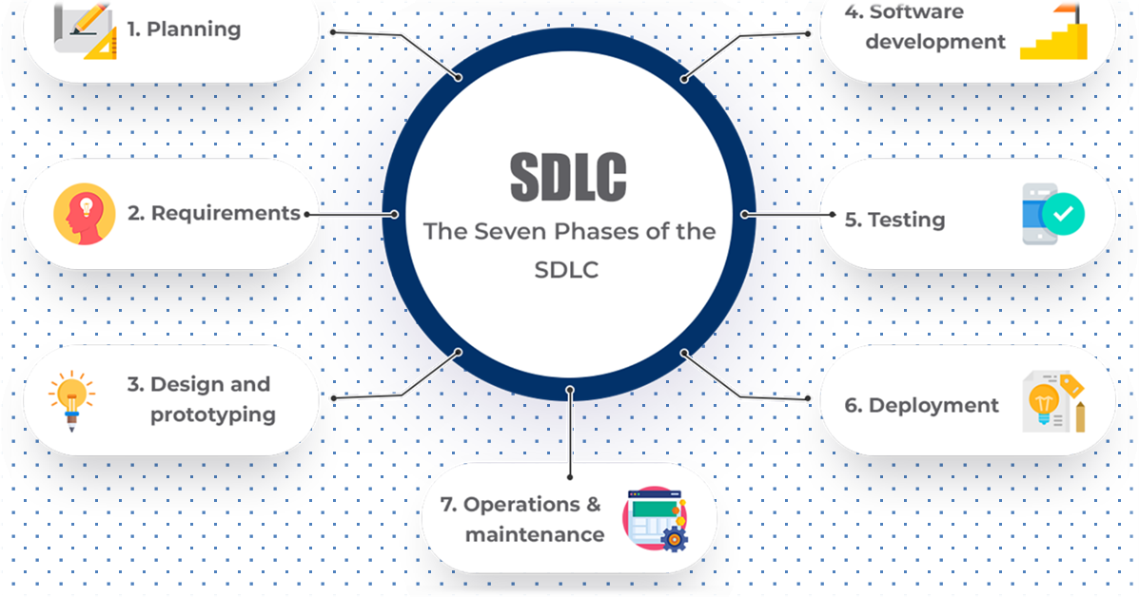

The Software Development Life Cycle(SDLC)involves the following key phases:
- Planning and requirement: Define project goals, requirements, and timelines.
- Design: Create system architecture, database schema, and UI designs.
- Development: Write code, implement features, and integrate technologies.
- Testing: Thoroughly test the system for bugs and functionality.
- Deployment: Prepare and deploy the PMS on a web server.
- Maintenance: Provide on going support and address feedback for improvements.

CHAPTER 2 REQUIREMENT GATHERING AND ANALYSIS

Organization details
    - Name of organization:
      - Footware

Brief details of the organization:
      - Our organization is an online footwear retail platform dedicated to offering a wide range of stylish and comfortable footwear with a seamless, fast, and convenient online shopping experience.

Meetings
    - Meeting with an Owner:

Name of the Owner:
        - Harshil

Requirements of the Owner in their own words:
        - User-friendly e-commerce website with intuitive navigation.
        - High-quality product images and detailed descriptions.
        - Mobile-responsive design for a seamless shopping experience across devices.

Type of project
    - Web-Based Ecommerce Project

Method of collecting requirements
    - Meeting
    - Interviews

CHAPTER3 SYSTEMREQUIREMENTSPECIFICATION

Introduction
- The rise of e-commerce has significantly transformed the retail industry, offering customers the convenience of shopping from anywhere at any time. The Footwear E-commerce System is developed to meet the growing demand for online footwear shopping by providing a user-friendly, responsive, and secure platform. Customers can easily browse through different footwear categories, compare styles, check availability, and place orders without the need to visit a physical store.

Purpose
      - 1. Client Management: Efficiently manage client information and relationships.
      - 2.User-Friendly Platform: Create accessible interface for easy browsing and shopping
      - 3. Wide Range: Offer a diverse selection of high-quality Shoes Products with clear descriptions and images.
      - 4.Mobile Compatibility: Ensure the website is mobile-friendly.
      - 5.Customer Engagement :Improve customer interaction through personalized recommendations and reviews.

      - 6.DeploymentEase: Simplify project deployment on web servers.
      - 7.Maintenanceand Scalability: Support on going maintenance and future scalability.

Scope
      - Scalability: The website will be scalable to accommodate future growth sales volume.
      - Product Management:
        - Categories: Organization of product into distinct categories for easier navigation and filtering.
        - Products: Detailed records of products, including attributes such as Name, description, price, and image.
      - Mobile Compatibility: Fully responsive design ensuring the website functions are less on mobile and tablet devices.
      - Security: On going enhancements to ensure data security and privacy.
      - User Management: Manage user authentication and authorizations on improving usability and user interface.

Operating Environment
      - WebServer: A webserver, such as Apache or Nginx, is required to host and serve the application.
      - Project Languages: The software is developed using a combination of Angular, JavaScript, HTML and CSS ensuring compatibility across most web browsers and devices.
      - Operating System: The choice of the operating system for the server (e.g., Linux, Windows) should be compatible with the selected software components.
      - Browser Compatibility: Ensure that it is compatible with common web browsers like Chrome, Firefox and Safari.
      - Hardware Resources: Hardware resources such as CPU, RARE, and storage should meet the system’s performance.
      - Network Connectivity: The server should have a stable internet connection for client access and data synchronization.
      - Database Server: A database server (e.g., MySQL, MariaDB) is necessary to store and manage project data and user information.

User Classes

Owner
        - The owner can view a user.
        - The owner can add, update, delete and view a category.
        - The owner can add, update, delete and view a product.
        - The owner can view payments.
        - The owner can add, update, delete and view admin.

Clients
        - The client can add, and view product.
        - The client can add order.
        - The client can send feedback.
        - The client can view cart.
        - The client can checkout.

System Modules

Admin
  - Add admin.
  - Update admin.
  - View admin.
  - Delete admin.

User
  - Add user.
  - Update user.
  - View user.
  - Delete user.

Category
  - Add category.
  - Update category.
  - Delete category.
  - View category.

Payment
  - View payment.

Order
  - Update order.
  - View order.

Product
  - View product.
  - Add product.
  - Update product.
  - Delete product.

External Interface Requirements

    - HardwareInterfaceRequirements
    - Server Hardware: Adequate CPU, RARE, and storage for the website and database.
    - Network Connectivity: Reliable internet connection for user- server communication.
      - Storage: Sufficient space for data storage and backups.

      - User Devices: Compatible hardware for accessing the website.

SoftwareInterfaceRequirements

      - Operating System: Compatibility with common server operating systems.

      - Database: Integration with a database management system.
      - Programing Language: Support for project-related language.
      - Browser Compatibility: Ensure usability on popular web browser.
      - Web Server: Support for hosting on web server.

User Interface Requirements

      - The user interface must be clean, intuitive, and fully responsive, providing a seamless browsing experience across all devices. It should feature easy navigation, high-quality product images with zoom capabilities, and clear calls-to-action. The design will focus on simplicity and accessibility, ensuring users can quickly find products, apply filters, and complete purchases effortlessly, all while maintaining a visually appealing layout.

Non-functional Requirements

    - Performance Requirements
- Responsive user interface with minimal latency.
- Efficient database queries and indexing.
- Fast and accurate search functionality.
- Cross-browser and mobile compatibility.
- Minimal page load times.
- Efficient back up and recovery processes.

Security Requirements
- Encryption for data in transit and at rest.
- Secure session management.
- User privacy and data protection compliance.
- Robust user authentication and authorization.

Feasibility Study

    - Operational Feasibility Study
      - Operational feasibility is the measure of how well a proposed system solves the problems and takes advantage of the opportunities identified during scope definition and how it satisfies the requirements identified in the requirements analysis phase of system development.

Technical Feasibility Study
      - Technical feasibility study assesses if the RMS project can be effectively developed and implemented with available technology, resources, and expertise.

Economic Feasibility Study
      - Economic feasibility study evaluates if the RMS project makes financial sense by comparing costs to expected benefits and returns on investment (ROI). It guides decisions on project funding and sustainability.

Schedule Feasibility Study
      - Schedule feasibility evaluates if the RMS project can realistically meet its proposed timelines, considering available resources and constraints. Itensures effective project planning and management.

CHAPTER4
SYSTEM ANALYSIS AND MODELING

  - Normalization

    - Un-Normalization

Id | Admin | User | Cart | Category | Product
1 | Yash | Pisyuh | 2 | Slippers | Crocs
2 | Harshil | Chirag | 5 | Shoes | Sport Shoes

    - 1stNormal Form:

- Table Name: Admin
Primary Key: Id (Auto Increment)

Id | Name | Email | Password
1 | Yash | yash@gmail.com | yash@123

- Table Name: User
Primary Key: Id ( Auto Increment )

Id | Name | Email | Password
1 | Pisyuh | puiyu@gmail.com | piyuuuuuu

- Table Name: Category

Primary Key: Id (Auto Increment)

Id | Name
1 | Shoes
2 | Slippers

2ndNormalForm:

      - Table Name: Products
Primary Key: Id (Auto Increment)
Foreign Key: CategoryId

Id(AI) | Name | Description | Price | CategoryId | IsDelete
1 | Crocks | an American footwear company based in Broomfield,  Colorado | 500 | 2 | 1
2 | Sport Shoes | A shoe is an item of footwear intended to protect and comfort the  human foot. | 2000 | 3 | 1

      - Table Name: Cart
Primary Key: Id(Auto Increment)
Foreign Key: ClientId, ProductId

Id(AI) | ClientId | ProductId | Quantity | IsDelete
1 | 5 | 1 | 1 | 1
2 | 8 | 3 | 2 | 0

      - Table Name: Orders
Primary Key: Id(Auto Increment)
Foreign Key: CartId

Id(AI) | CartId | Status
1 | 5 | Pending
2 | 8 | Done

      - Table Name : Payments Primary Key: Id Foreign Key: OrderId

Id(AI) | OrderId | Status
1 | 5 | Pending
2 | 8 | Done

Data Dictionary

          - Admin

Sr.No. | Column | Data Type | AllowNulls | Constraints
1 | Id | Int(11) | NOTNULL | Primarykey,Auto- Increment
2 | Name | Varchar(200) | NOTNULL
3 | Email | Varchar(200) | NOTNULL
4 | Password | Varchar(200) | NOTNULL

            - Users

Sr.No. | Column | Data Type | AllowNulls | Constraints
1 | Id | Int(11) | NOTNULL | Primarykey,Auto- Increment
2 | Name | Varchar(200) | NOTNULL
3 | Email | Varchar(200) | NOTNULL
4 | Password | Varchar(200) | NOTNULL

          - Category

Sr.No. | Column | Data Type | Allow Nulls | Constraints
1 | Id | Int(11) | NOTNULL | Primary key, Auto-Increment
2 | Name | Varchar(200) | NOT NULL
            - Product

Sr.No. | Column | Data Type | Allow Nulls | Constraints
1 | Id | Int(11) | NOTNULL | Primary key, to-Increment
2 | Name | INT | NOT NULL
3 | Description | Varchar(200) | NOT NULL
4 | Price | INT | NOT NULL
5 | CategoryId | INT | NOT NULL | Foreign Key(Category)
6 | IsDelete | INT | NOT NULL
7 | ImageFileName | Varchar(200) | NOT NULL

          - Cart

Sr.No. | Column | Data Type | AllowNulls | Constraints
1 | Id | Int(11) | NOTNULL | Primarykey,Auto- Increment
2 | ClientId | INT | NOTNULL | Foreign_Key(Client)
3 | ProductId | INT | NOTNULL | Foreign Key( Product )
4 | Quantity | Varchar(200) | NOTNULL
5 | IsDeleted | Varchar(200) | NOT NULL
- Checkout

Sr.No. | Column | Data Type | AllowNulls | Constraints
1 | Id | Int(11) | NOTNULL | Primarykey,Auto- Increment
2 | Name | Varchar(200) | NOTNULL
3 | Email | Varchar200) | NOTNULL
4 | Phone | INT | NOT NULL
5 | Address | Varchar(200) | NOTNULL
6 | City | Varchar(200) | NOT NULL
7 | State | Varhchar(200) | NOT NULL
8 | Zip | Varchar(200) | NOT NULL
9 | Total | Varchar(200) | NOT NULL
10 | ClientId | Varchar(200) | NOT NULL | Foreign Key( Client )

- Orders

Sr.No. | Column | Data Type | AllowNulls | Constraints
1 | Id | Int(11) | NOTNULL | Primarykey,Auto- Increment
2 | CartId | INT | NOTNULL | Foreign Key(Cart)
3 | Status | Varchar(200) | NOTNULL
- Payments

Sr.No. | Column | Data Type | AllowNulls | Constraints
1 | Id | Int(11) | NOTNULL | Primarykey,Auto- Increment
2 | OrderId | INT | NOTNULL | Foreign Key(Order)
3 | Status | Varchar(200) | NOTNULL

DataFlowDiagram

ContextLevel


FirstLevel

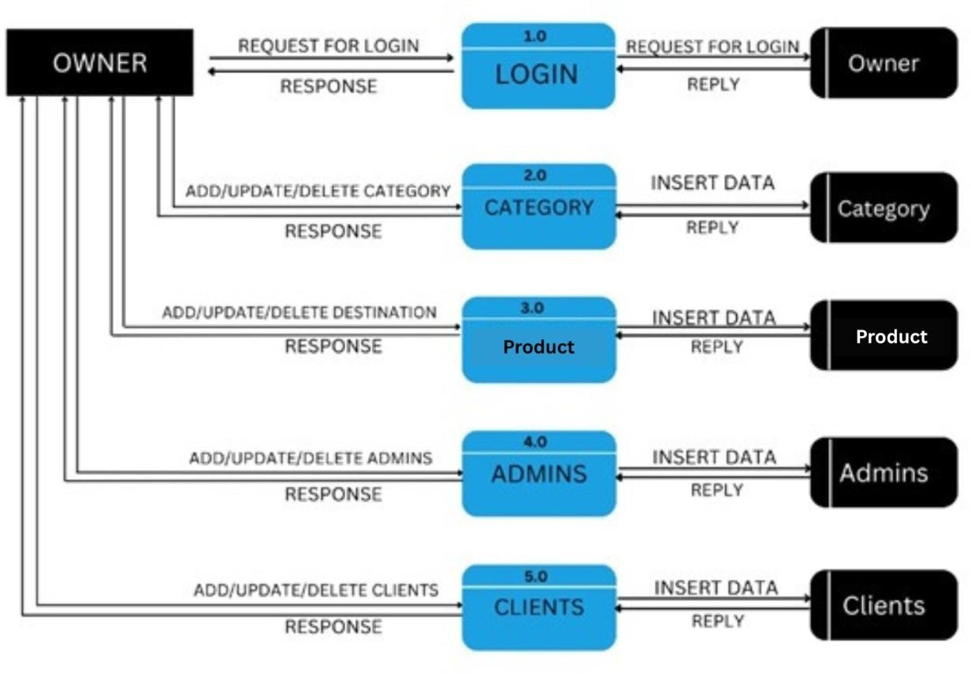

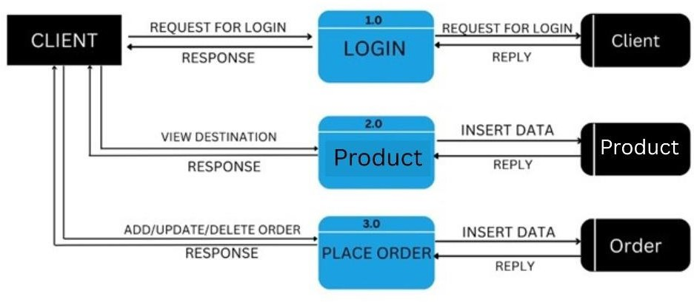

SecondLevel
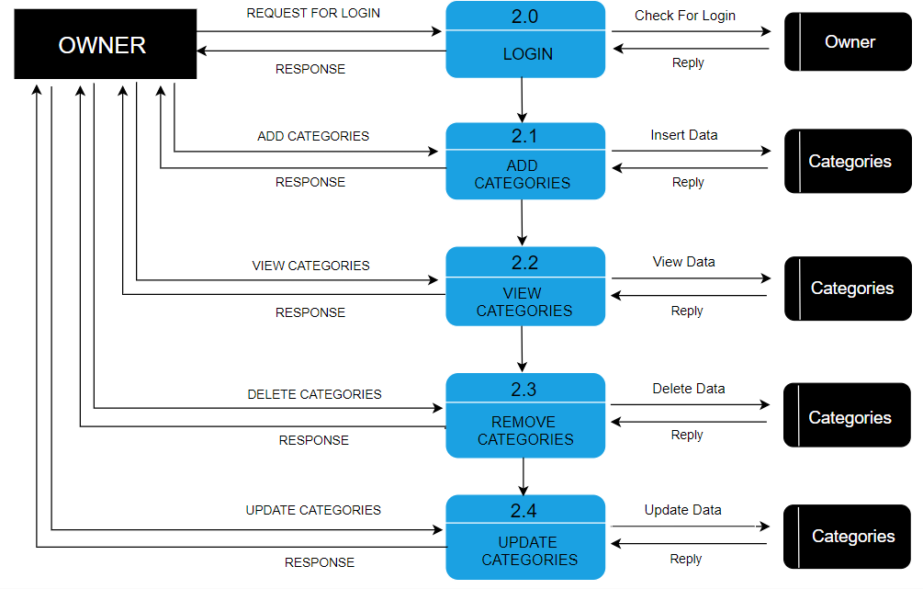

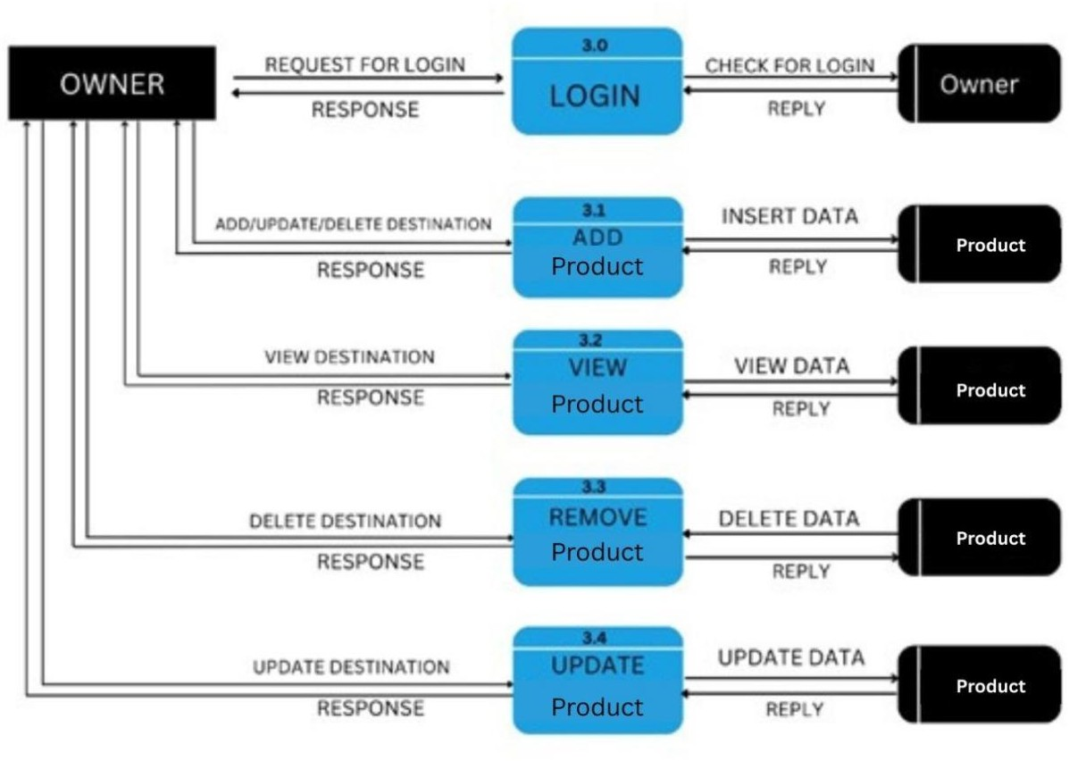

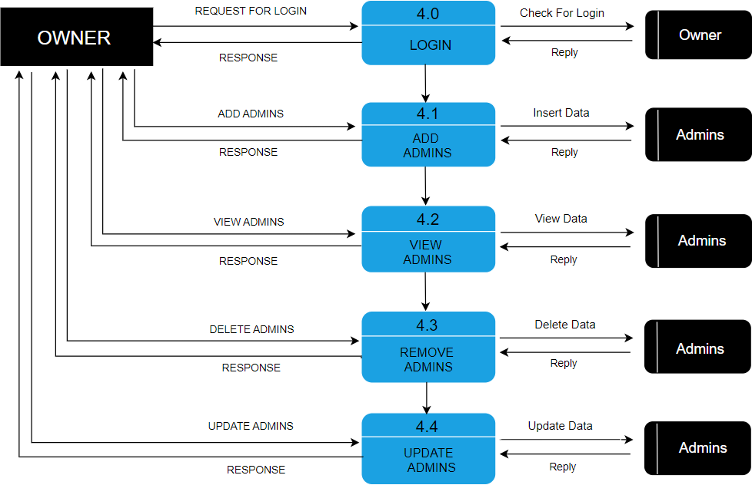

        - ER Diagram
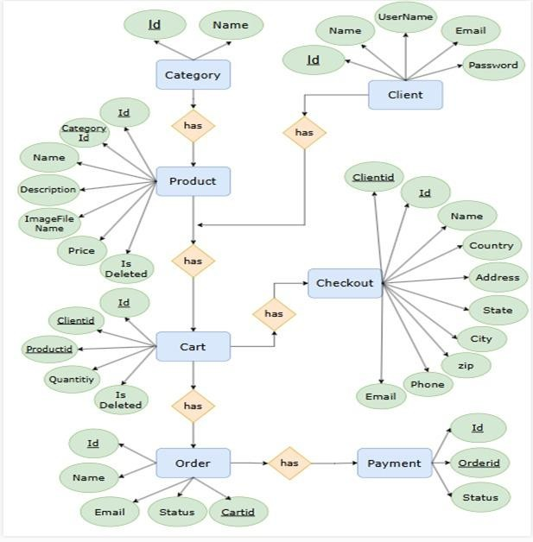

        - UseCaseDiagram

- Owner

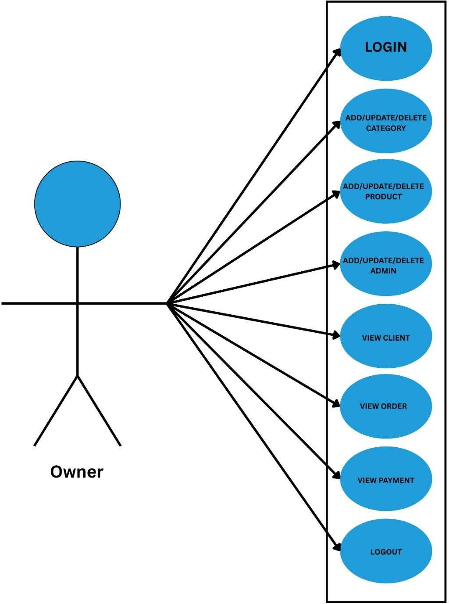

- User

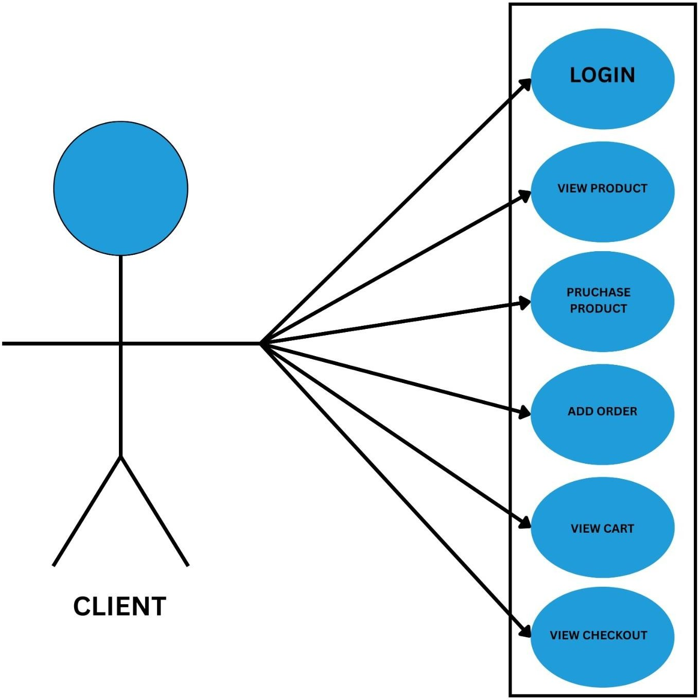

        - GanttChart
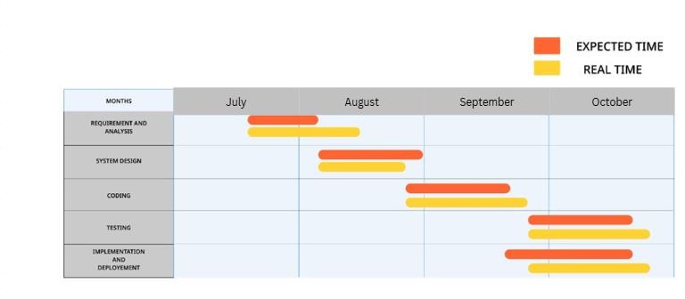

CHAPTER5
Test Cases

TESTCASENo.1 |  |  | TESTCASEDESIGNDATE:1/Sep/2025
TESTTITLE: Login Module Test |  |  | TESTCASEEXECUTIONDATE: 1/Sep/2025
DESCRIPTION: In this test case Login module would be tested
PRECONDITION: Login Activity must be working
STEP  No. | TESTSTEP | TESTDATA | EXPECTED RESULT | ACTUAL RESULT | STATUS
1 | Navigate to login page | /Login | Login page is visible | Same As Expected | PASS
2 | Enter Email | Admin@gma il.com | Email is  expected | Same As Expected | PASS
3 | Enter Password | Admin | Password is expected | Same As Expected | PASS
4 | Submit Button | Button click | Check credentials | Same As Expected | PASS

TESTCASENo.2 | TESTCASEDESIGNDATE:3/Sep/2025
TESTTITLE:order Product | TESTCASEEXECUTIONDATE: 3/Sep/2025
DESCRIPTION :In this test case add destination would be tested
PRECONDITION :page shop must be working

STEP  No. | TESTSTEP | TESTDATA | EXPECTED RESULT | ACTUAL RESULT | STATUS
1 | Navigate to page | /Shop | Page is visible | Same As Expected | PASS
2 | Click on the destination  u want | /Single | page is visible | Same As Expected | PASS
3 | Make the order | Click on the Add To  Cart Button | Clicked are expected | Same As Expected | PASS

CHAPTER6

Screenshots
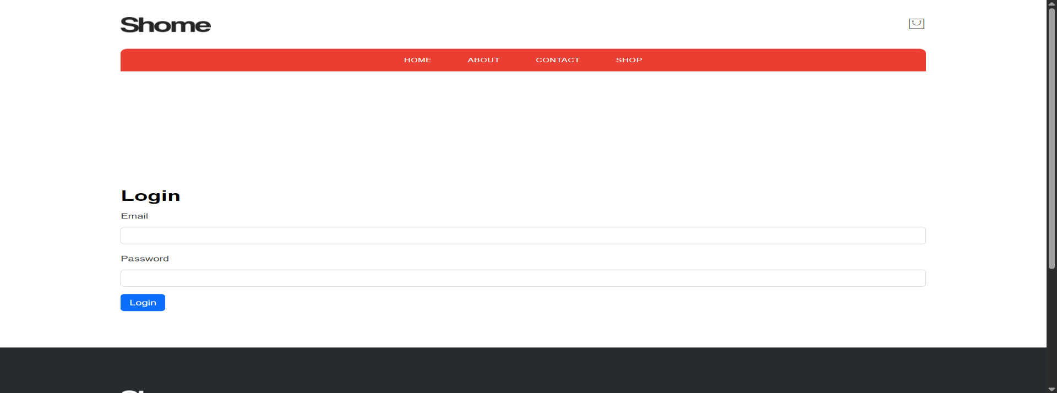
File Name: Login.php Description: User can login

File:Register.php
Description: This page will allow user to Register
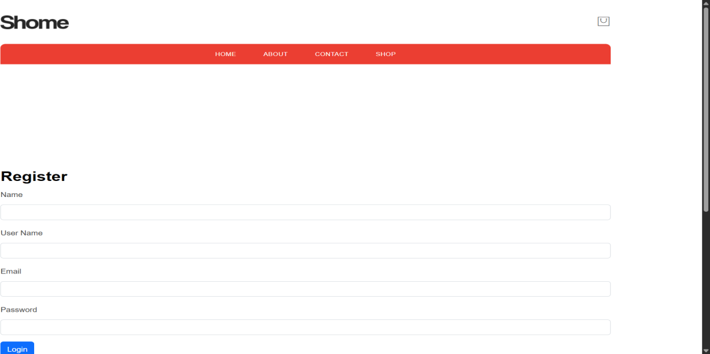

File: index
Description: This page will allow user to view index

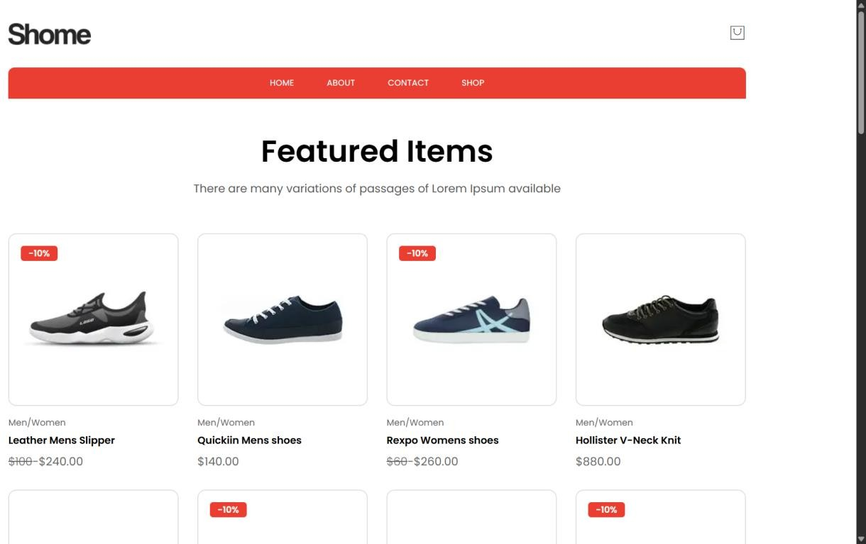

File: about
Description: This page will allow user to view about page
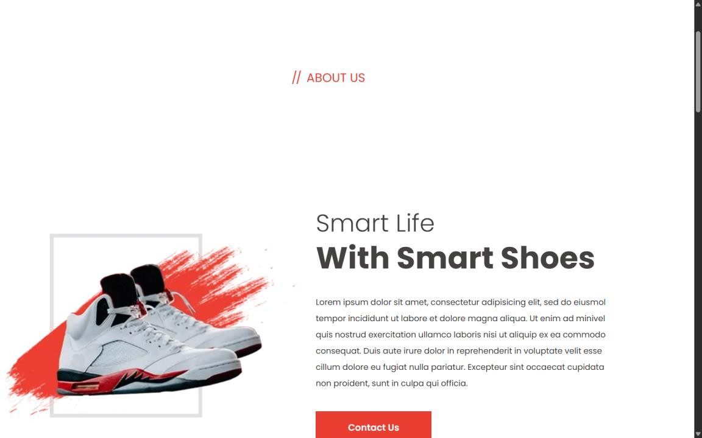

Description: This page will allow user to view shop
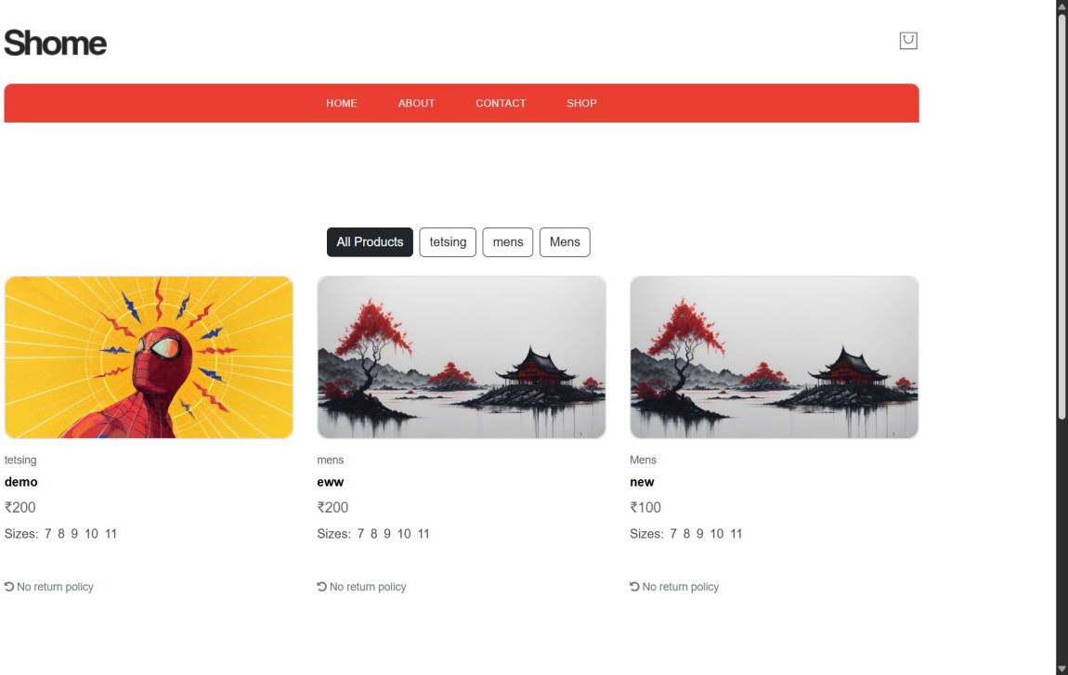

File: contact
Description: This page will allow user to share feedback

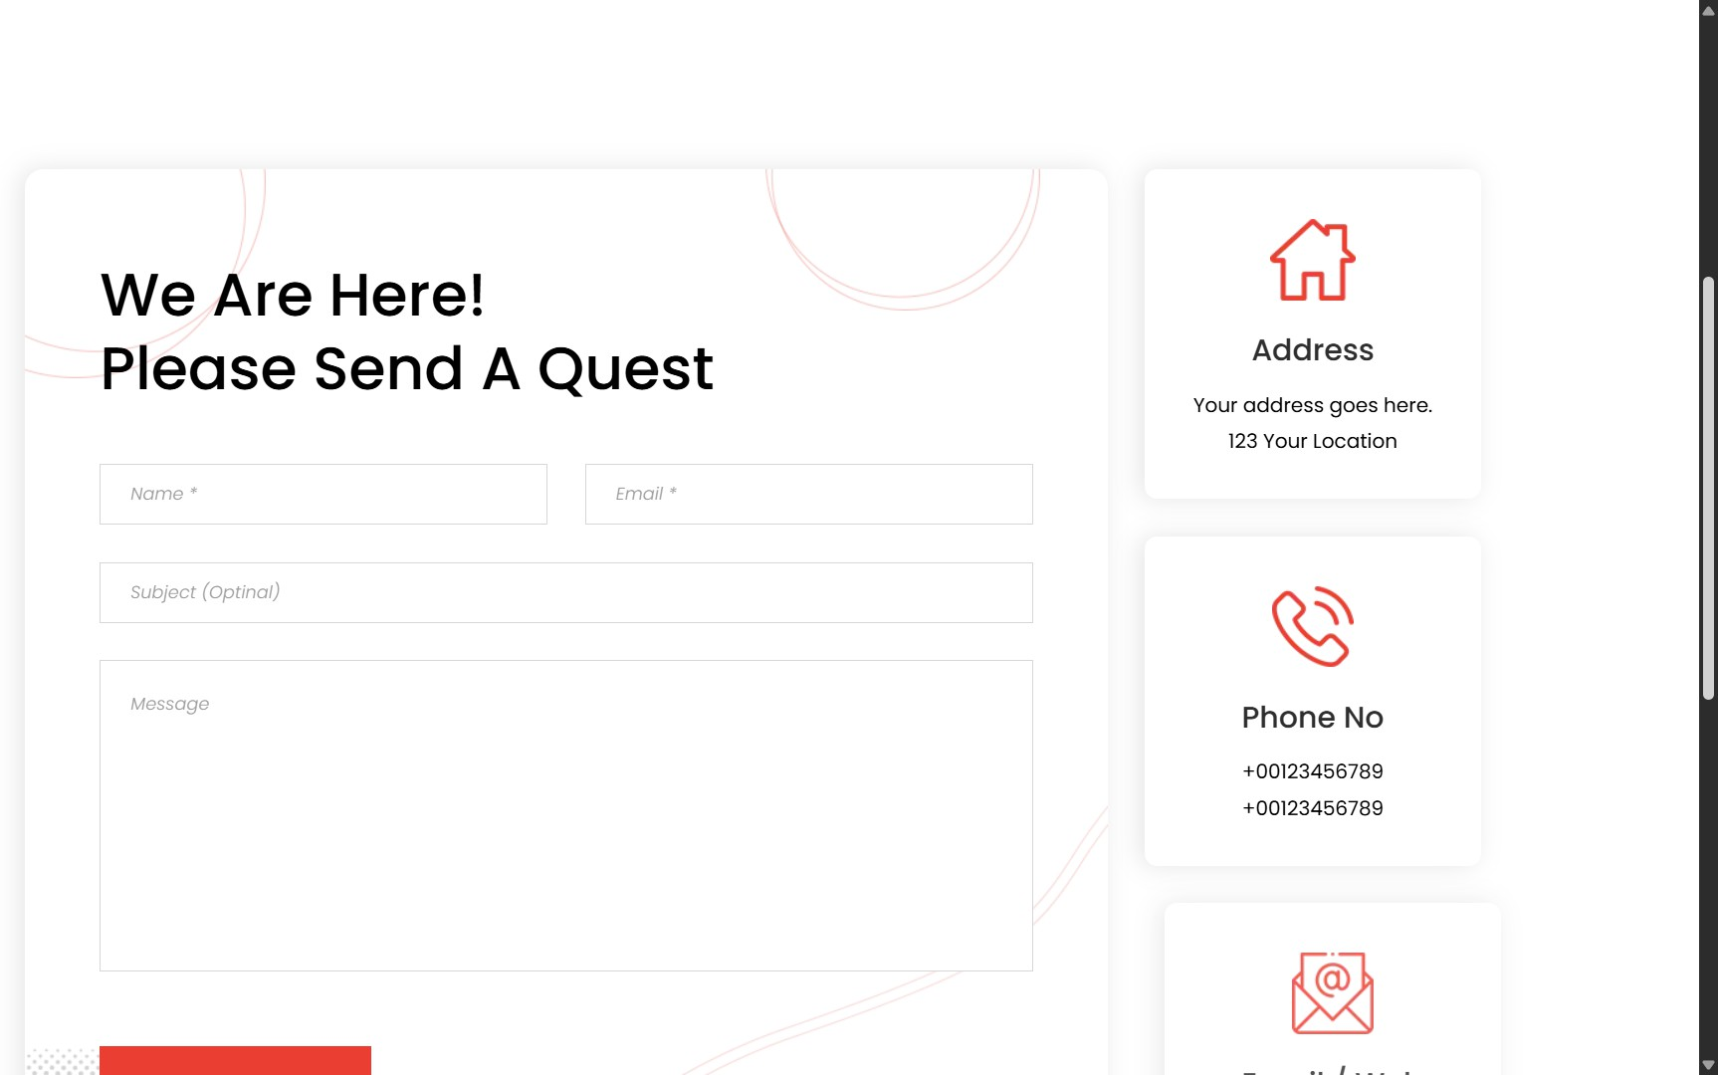

File:Admins
Description:This page will allow owner to view admin
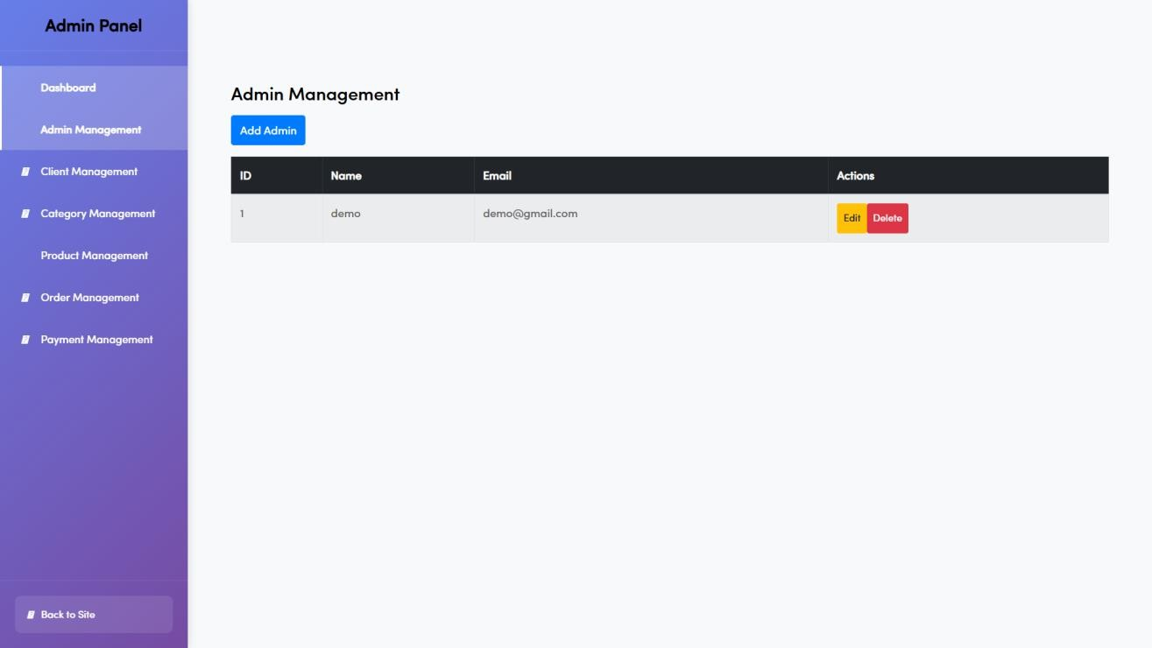

File:Admin Client
Description:This page will allow owner to view Clients
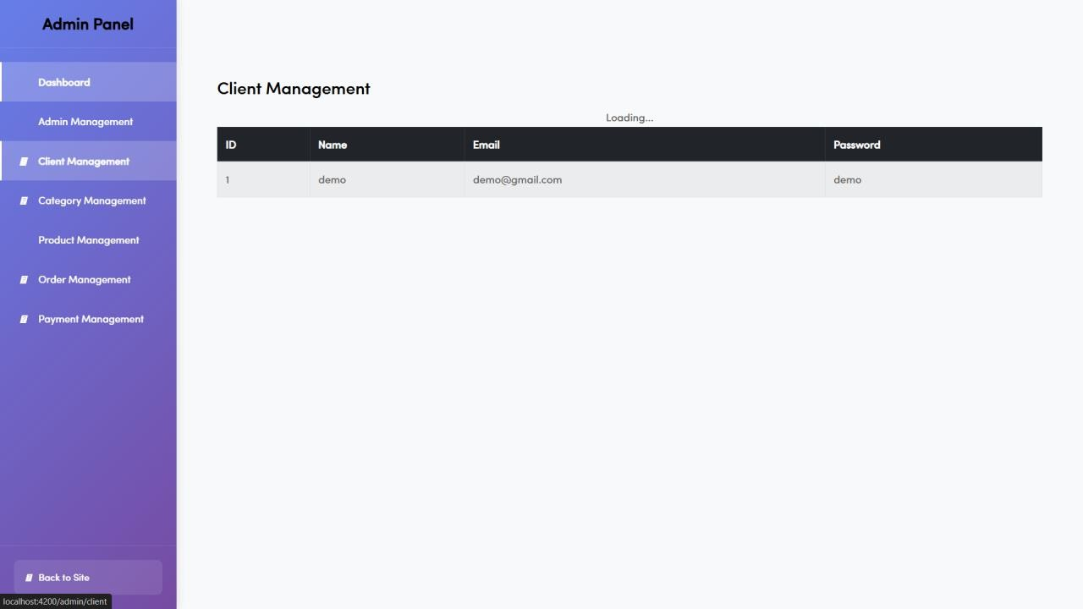

File:admin Product Description:This page will all user to view Products.
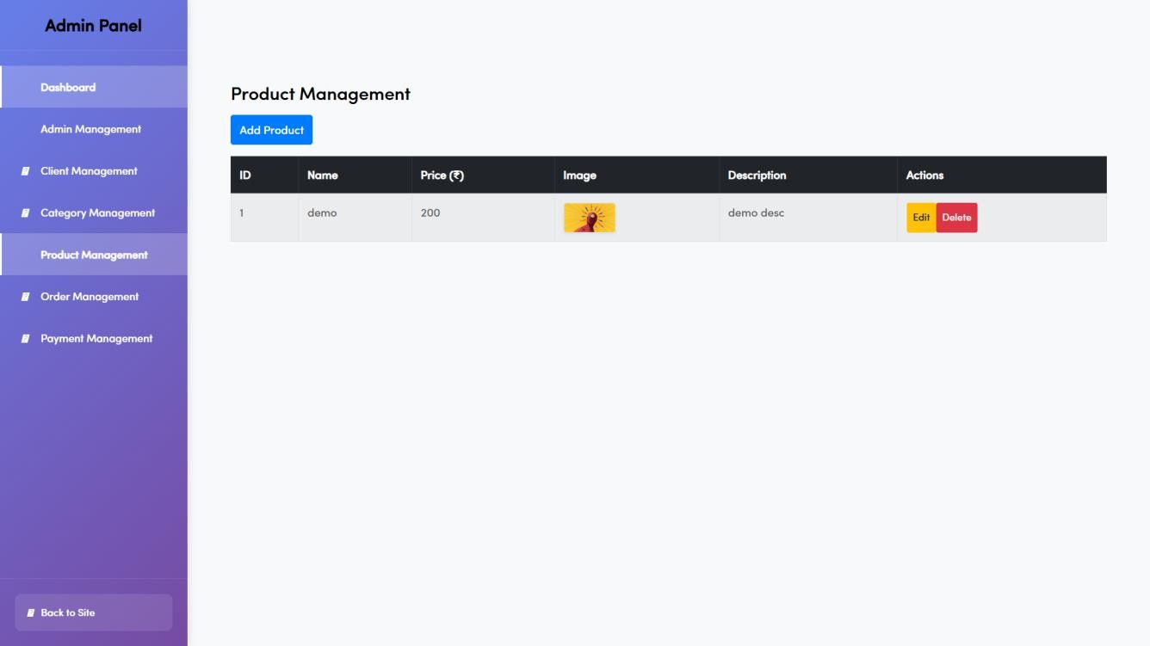

File: Admin Category
Description: This page will allow owner to add categories
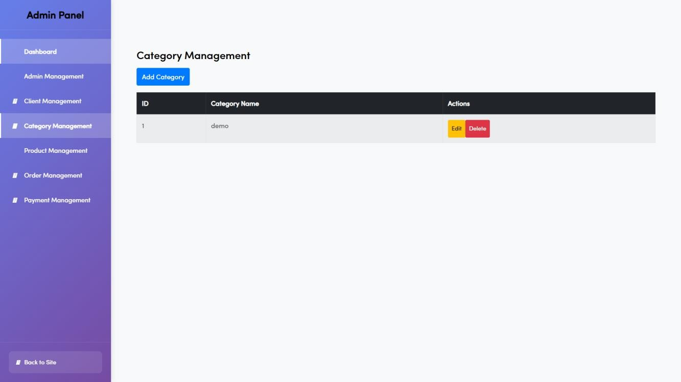

File:Admin Order
Description:This page will allow admin to view orders.
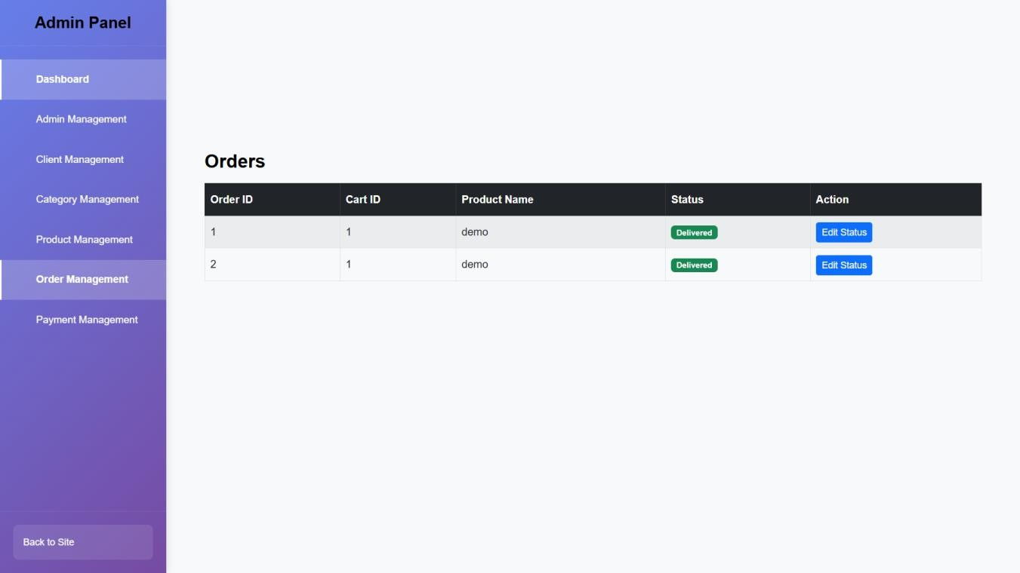
File:admin Payment
Description:This page will allow admin to view payment.
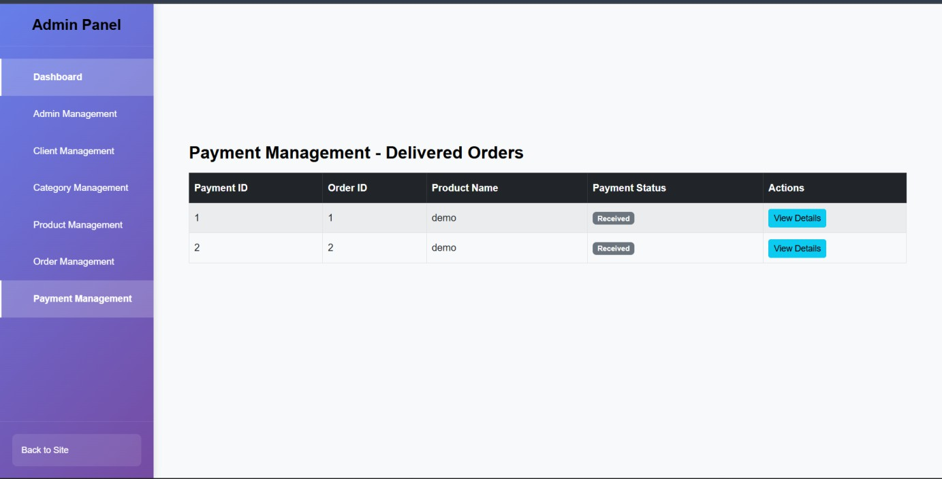

Limitations and Future Enhancements

Limitations:
  - Despite offering a strong digital solution for footwear shopping, the system has a few limitations. The platform relies heavily on internet connectivity, making access difficult in low- network areas. High server loads during festive sales or peak seasons may require advanced optimization to maintain performance. Integration with third-party delivery partners or advanced AI-based recommendation engines is limited in the current version. The platform also requires regular security updates to prevent data breaches and maintain customer trust. Additionally, real-time inventory updates can be challenging without automated stock management tools. These limitations can be addressed in future upgrades to enhance system performance and flexibility.

Future Enhancements:
  - Future enhancements will focus on improving user experience, automation, and scalability. Integration of AI-driven recommendation systems can help customers find products based on preferences, trends, and purchase history. A dedicated mobile app for Android and iOS will enhance accessibility and increase user engagement. Real-time inventory management, integration with premium courier APIs, and automated shipping updates will further streamline operations. Additional payment options such as UPI, QR-based payments, and EMI will expand convenience. Introducing a loyalty program, virtual try-on feature, and advanced analytics dashboard for admin can significantly boost customer satisfaction and business growth. Cloud deployment will offer improved scalability, security, and performance for high-traffic scenarios.

CHAPTER8

Conclusion

The Footwear E-commerce System provides a comprehensive and efficient platform for purchasing footwear online. It simplifies the shopping process by offering a wide product range, secure payment options, and user-friendly navigation. For administrators, it ensures smooth management of products, orders, and customers through a centralized dashboard. While the system currently has some limitations, planned future enhancements will significantly improve functionality, automation, and user experience. Overall, this project successfully demonstrates an effective and scalable solution for digital footwear retailing and aligns with modern e-commerce standards.

CHAPTER9

References and Bibliography

All the references listed below were used to develop and design this website and were also used for documentation. Weare thankful to each and every person who helped us and supported us for this project completion.

- Books:-
  - Chaffey, Dave

  - Krug, Steve

Libraries and Server:-

  - Angular

Websites:-
  - https://angular.dev/

  - https://developer.mozilla.org/en-US/

