A
PROJECT REPORT
ON
Hospital Management System
SUBMITTED BY
Ms. NANDA ANCHAL VIMAL
Mr. KENIL BHANDERI
ACADEMIC YEAR 2025-26
M.S.C IT SEM 3
UNDER THE GUIDANCE OF
Mr. Shaunak Purohit
SMT. C.Z.M. GOSRANI BCA & M.SC. (IT & CA)
COLLEGE JAMNAGAR
SUBMITTED TO
SAURASHTRA UNIVERSITY - RAJKOT

ABSTRACT
The Hospital Management System (Health-Connect) is a modern, web-based application designed to simplify hospital operations. With increasing demand for digital health solutions, this platform offers a convenient way for patients to book appointments, doctors to manage their schedules, and pharmacies to handle medicine requests.
The system provides a user-friendly interface featuring detailed doctor profiles, pharmacy listings with medicine catalogs, and a comprehensive admin dashboard. It ensures an effortless experience for all user roles: Patients, Doctors, and Admin.
This platform is built with a strong backend architecture (Node.js/Express) and a responsive frontend (React), connected by a reliable PostgreSQL database. It features secure authentication, real-time data updates, and efficient workflow management.
Overall, Health-Connect bridges the gap between traditional healthcare services and digital accessibility, offering a faster, safer way to manage health needs. It provides a foundation for future enhancements such as AI diagnosis and mobile app integration.

ACKNOWLEDGEMENT
We feel great pleasure in submitting this project report as a part of Our M.S.C Semester 3 curriculum. A practical study plays an important role.
For the successful completion of Our project, We would especially like to thank my parents for their support and unconditional help. We would also like to thank Our Project Guide Khushal Rajani for their constant support and help in implementation of this project.
We are also thankful to our Principal Mam, Ms. Hetal G. Savla for all the facilities they provided throughout our semester.
Lastly, We would also like to thank the faculties and staff members of Smt. C.Z.M. Gosrani B.C.A. College, Jamnagar.

PROJECT PROFILE

STUDENT INFORMATION
Name | Enrollment Numbers
Ms. NANDA ANCHAL VIMAL | 24CS032PG00105
Mr. KENIL BHANDERI | 24CS032PG00094

PROJECT DETAILS
Project Title | Hospital Management System
Duration | 4 Months
Name of Project | Health-Connect

INDEX
1. Introduction
2. System Analysis
2.1 Problem Statement
2.2 Proposed Solution
2.3 Scope of the System
3. System Design
3.1 Use Case Diagram
3.2 Data Flow Diagrams (DFD)
3.3 ER Diagram
3.4 Gantt Chart
4. Implementation
4.1 Tech Stack
4.2 Database Schema
5. Test Cases
6. Screenshots
7. Limitations and Future Enhancements
8. Conclusion
9. References

CHAPTER 1: INTRODUCTION
The healthcare industry relies heavily on efficient information management. Health-Connect is a comprehensive web application designed to manage the complexities of hospital administration, doctor scheduling, and pharmacy operations.
Traditionally, these systems operate in silos. This project integrates them into a single platform where patients can access all services remotely. It ensures data consistency, reduces manual errors, and improves the overall patient experience.

CHAPTER 2: SYSTEM ANALYSIS

2.1 Problem Statement
- Manual record keeping is prone to errors.
- Patients face long waiting times for appointments.
- Pharmacy stock is often not visible to patients online.

2.2 Proposed Solution
- A centralized web portal for all hospital needs.
- Real-time appointment booking and status tracking.
- Integrated pharmacy module for medicine requests.

2.3 Scope of the System
- User Authentication (Patient, Doctor, Admin).
- Doctor Management & Appointment Scheduling.
- Pharmacy Inventory & Request Management.

CHAPTER 3: SYSTEM DESIGN

3.1 Use Case Diagram
[Use Case Diagram Placeholder]
Actors: Patient, Doctor, Admin
- Patient: Login, Book Appointment, Order Medicine.
- Doctor: View Appointments, Update Profile.
- Admin: Manage Doctors, Pharmacies, Requests.

3.2 Data Flow Diagrams (DFD)
Context Level (Level 0):
User -> [Health-Connect] -> Database
Level 1:
User -> Auth Process -> Dashboard
Dashboard -> Appointment Process -> Database

3.3 ER Diagram
[ER Diagram Description]
Entities: Users, Doctors, Appointments, Pharmacies, Medicines, Requests
Relationships: Users 1:1 Doctors, Doctors 1:N Appointments, Pharmacies 1:N Medicines

3.4 Gantt Chart
Month 1: Requirement Analysis & Database Design
Month 2: Backend API Development (Auth, Doctors)
Month 3: Frontend Development & Pharmacy Module
Month 4: Integration, Testing & Documentation

CHAPTER 4: IMPLEMENTATION

4.1 Tech Stack
- Frontend: React.js, Tailwind CSS
- Backend: Node.js, Express.js
- Database: PostgreSQL (Drizzle ORM)

4.2 Database Schema
Table: Users
ID | Int(11) PK
Username | Varchar(255)
Password | Varchar(255)
Role | Varchar(50)

Table: Doctors
ID | Int(11) PK
UserId | Int FK
Specialization | Varchar(255)

CHAPTER 5: TEST CASES

Test Case 1: Login Module
Step | Test Data | Expected Result | Status
1 | Enter valid admin creds | Login Success | PASS
2 | Enter invalid creds | Show Error | PASS

Test Case 2: Medicine Request
Step | Test Data | Expected Result | Status
1 | Select Medicine 'Paracetamol' | Form Opens | PASS
2 | Submit Request | Admin receives request | PASS

CHAPTER 6: SCREENSHOTS

Home Page
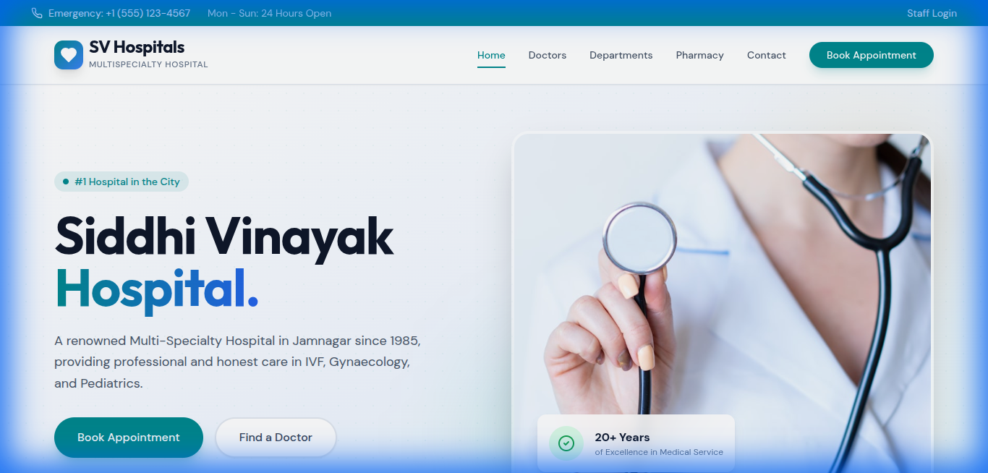
Description: The landing page allowing users to access services.

Admin Login
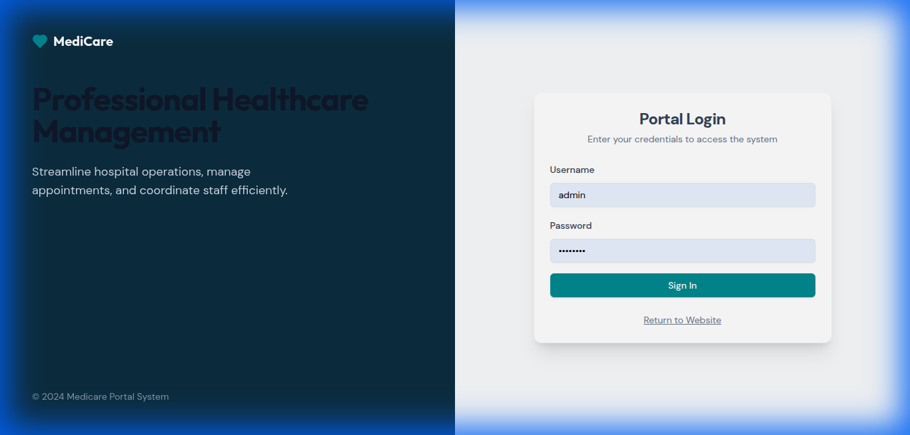
Description: Secure login page for administrators.

Admin Dashboard
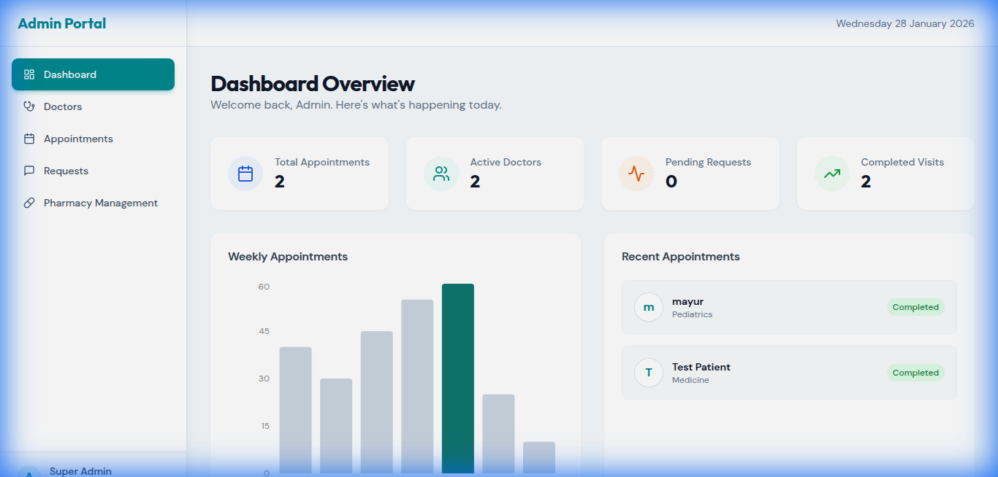
Description: Dashboard showing hospital overview.

Pharmacy List
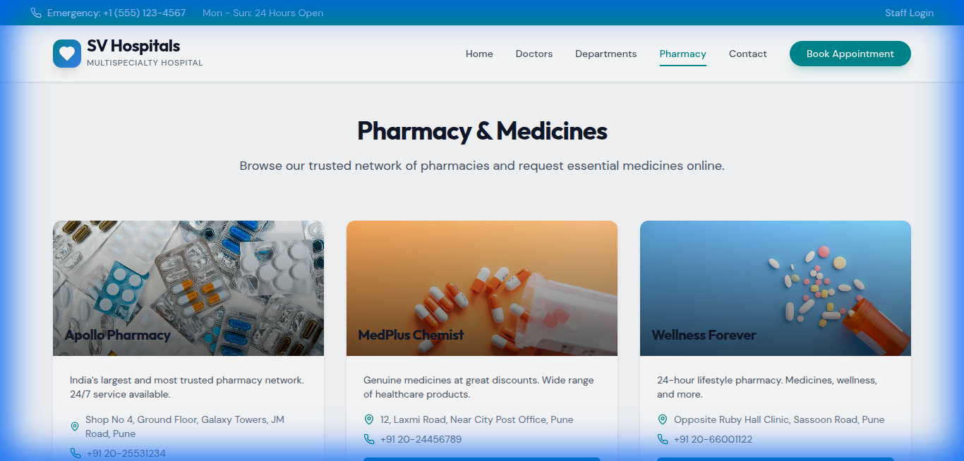
Description: Users can browse available pharmacies.

Pharmacy Details
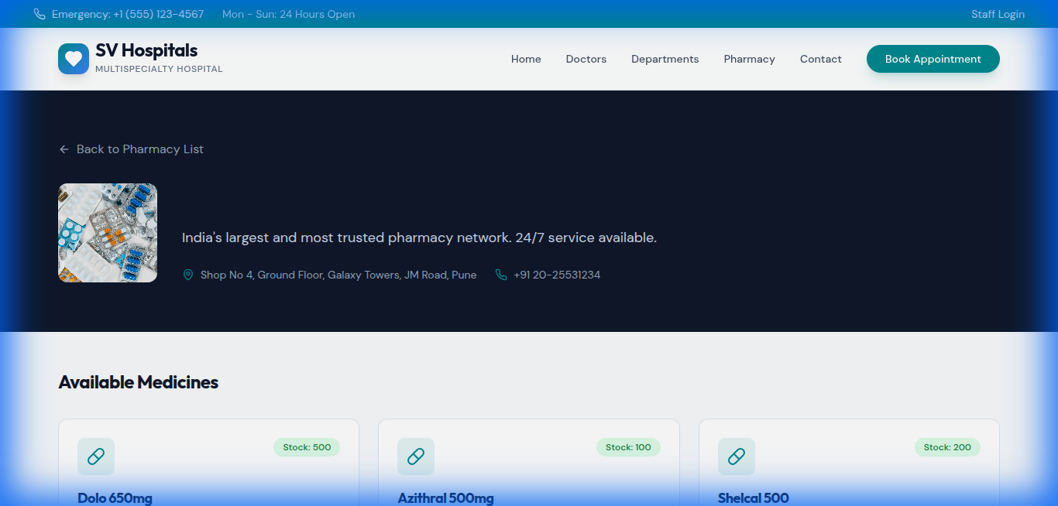
Description: Viewing medicines stocked by a specific pharmacy.

Admin Pharmacy Management
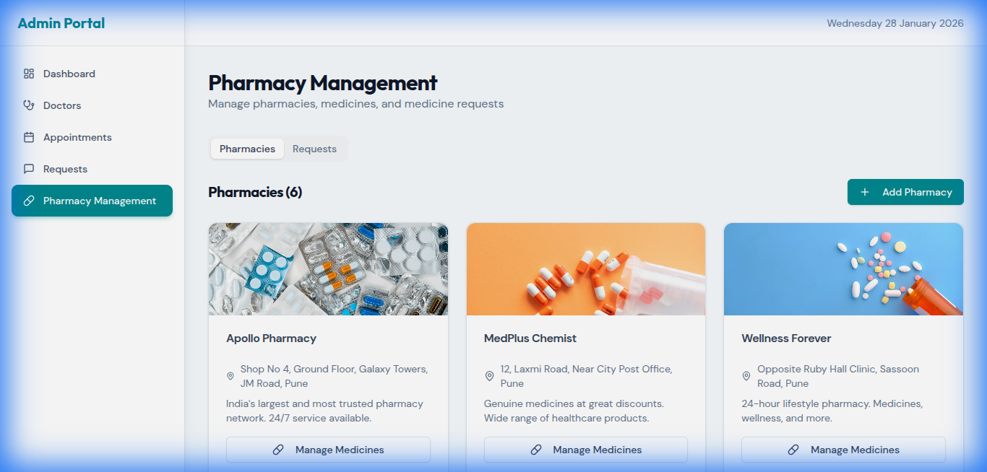
Description: Admin interface to manage inventory and requests.

CHAPTER 7: LIMITATIONS AND FUTURE ENHANCEMENTS

Limitations:
- Requires active internet connection.
- No online payment gateway implemented yet.

Future Enhancements:
- Mobile Application for Android/iOS.
- AI-based Symptom Checker.
- Integration with Insurance Providers.

CHAPTER 8: CONCLUSION
The Health-Connect Hospital Management System provides a comprehensive and efficient platform for managing healthcare services online. It simplifies the appointment and pharmacy process for patients while offering robust tools for administrators. Overall, this project demonstrates an effective solution for digital healthcare.

CHAPTER 9: REFERENCES AND BIBLIOGRAPHY
1. React Documentation - https://react.dev/
2. Express.js Guide - https://expressjs.com/
3. PostgreSQL Documentation - https://www.postgresql.org/
4. Tailwind CSS - https://tailwindcss.com/

