Why you are using **MarXI-archive cloning** from github instead ,you can **store** files and folders required for project in **MarXI folder** and then **copy it to the project folder**:

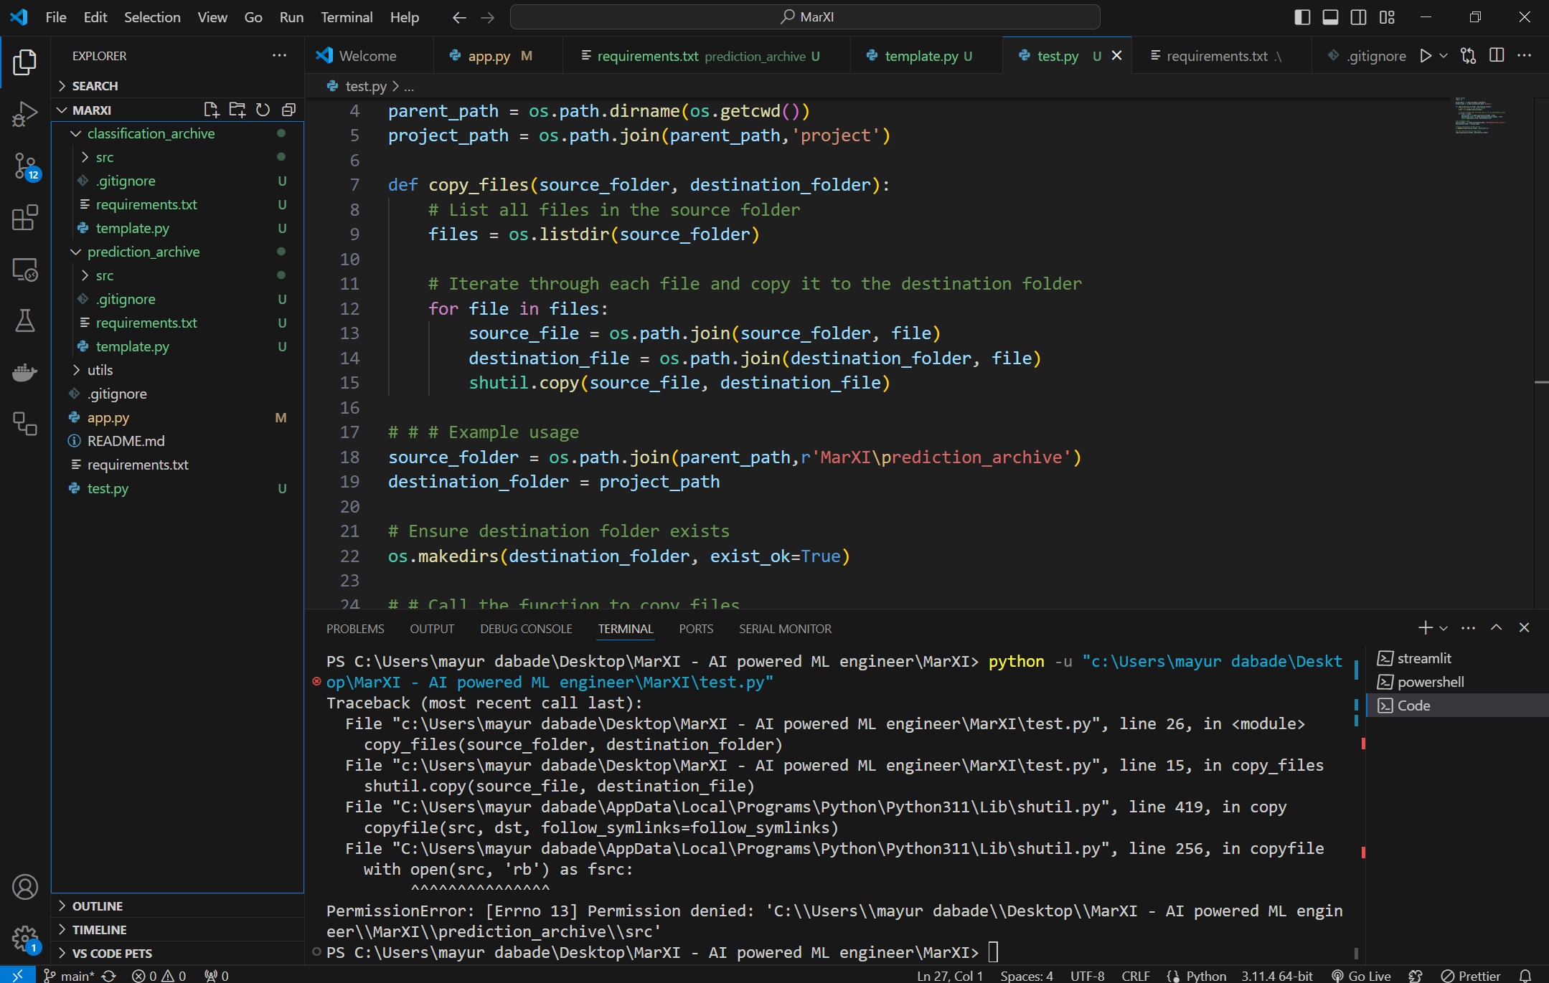

By storing files and folder in MarXI and copy got problem related to “**PermissionError**”. As user will need to clone my MarXI wali repo to their own machine. And every pc/machines will have different permission related problem so in order to solve this issue I am cloning required files from my github repo to **project** folder