Pre-checks for using autoupgrade
- Make sure you have java 8 on the system
- There is at least 15GB space free on the file system and FRA should have enough free space
- Download the latest version of autoupgrade.jar from MOS note ID 2485457.1
- Database should be in archivelog mode

My Current/ Source database is 12c : 12.1.0.2.0 , that I will be upgrading to 19c using autoupgrade method .
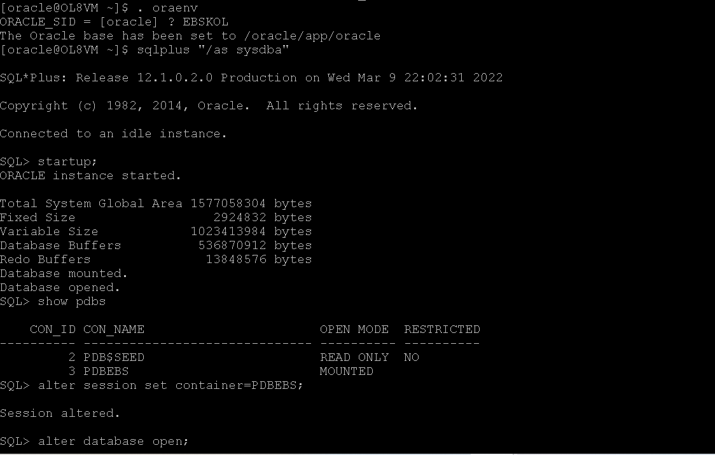
Step 1- Install the 19c Database software
mkdir /oracle/app/oracle/product/19.0.0/dbhome_1
-> Copy the database setup into the location /oracle/app/oracle/product/19.0.0/dbhome_1
-> Unzip the file

-> As root user run : yum install -y oracle-database-preinstall-19c
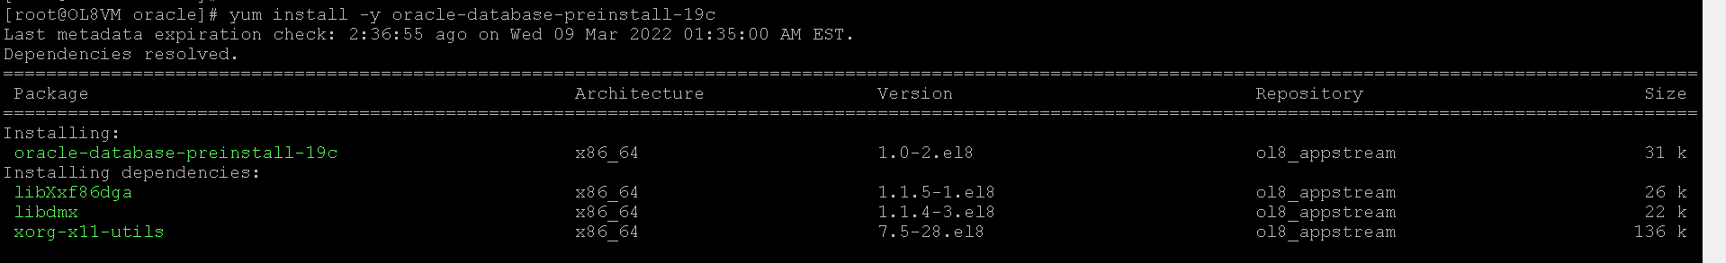

Once the installation is completed
Unzip the 19c software in the oracle home directory. It will take some time to complete the unzip
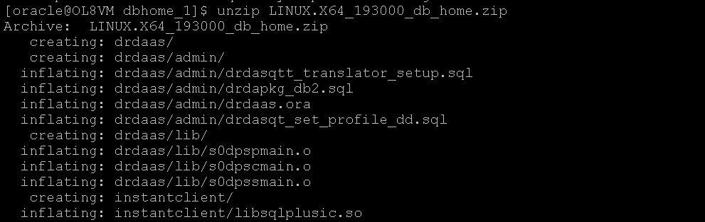
Edit the response file for installation in silent mode , the location of the response file will be under oracle_home->install->response folder
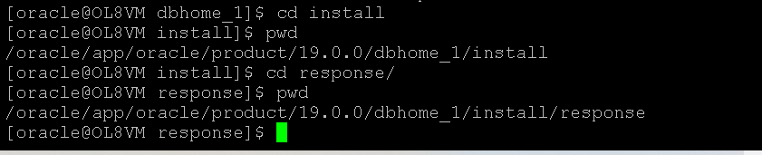
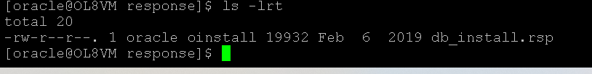
Take a backup of this file before editing it
Edit the response file and add the below compoents in the response file :This is just an example , all the entries should be of 19c database , ie 19c database home etc
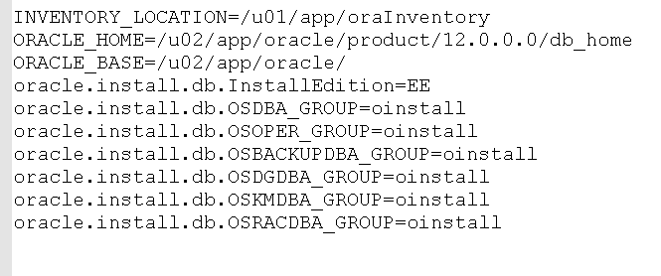
Install 19c in silent mode
./runInstaller -ignorePrereq -silent -responseFile /oracle/app/oracle/product/19.0.0/dbhome_1/install/response/db_install.rsp
In case you are getting error like unsupported os version you can export the variable like below before starting the installation
Error :
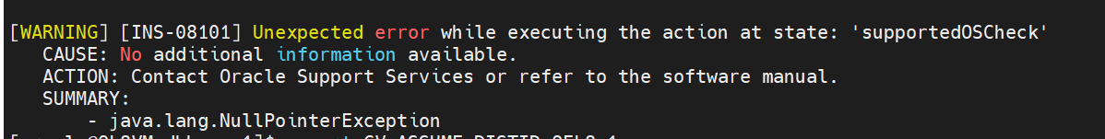
export CV_ASSUME_DISTID=OEL8.1
Warnings can be ignored , if anything FATAL is there , then only action is required
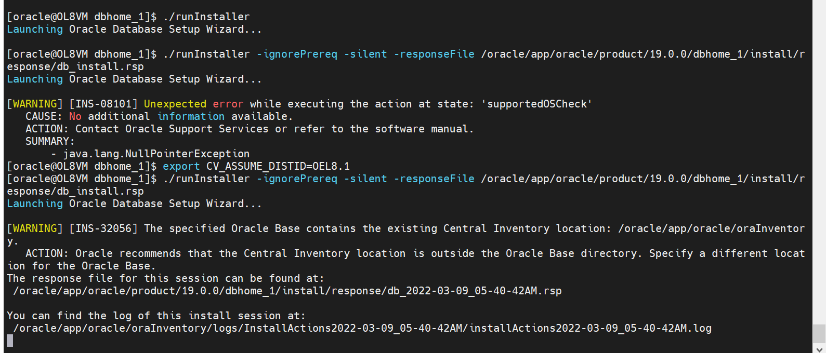
Installation Completed, now run the root.sh manually
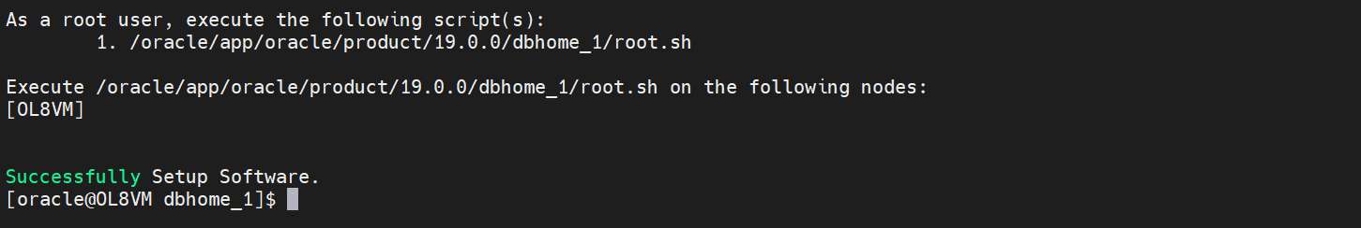
Installation of 19c is now successful
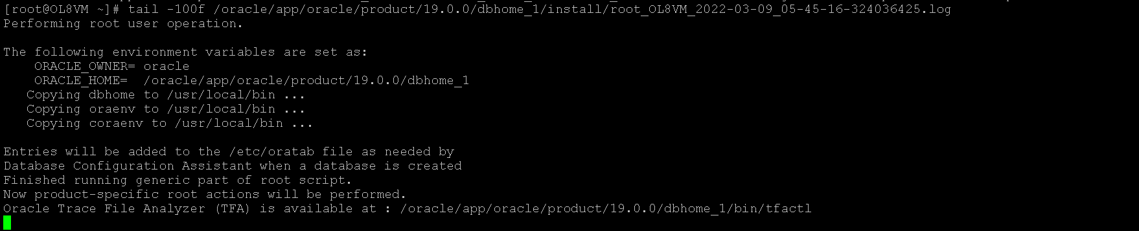

Step 2- Make the environment ready and download the latest version of autoupgrade and do the prechecks
Download the latest version of autoupgrade.jar file from the below link :
https://support.oracle.com/epmos/faces/DocumentDisplay?_afrLoop=260103973740217&id=2485457.1&_afrWindowMode=0&_adf.ctrl-state=11mdgr1r8_61#aref_section12
MOS note : Doc ID 2485457.1
Once the file is downloaded , go to the directory 19cOraclehome/ rdbms/admin/ and remove the old autoupgrade.jar file and replace it with latest downloaded one

Create the sample autoupgrade config file :
Use the below command
java -jar /oracle/app/oracle/product/19.0.0/dbhome_1/rdbms/admin/autoupgrade.jar -create_sample_file config

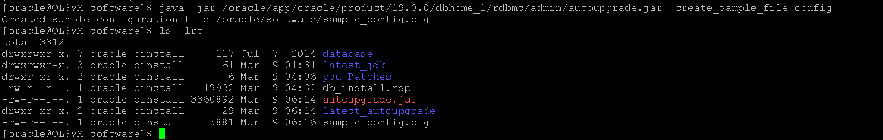

First step is to edit the content of the config file and make sure change the name of file to some other name that sample_config.cfg , below are the entries added in the config file .

upg1.log_dir=/oracle/software/upgrade_logs # Pat
upg1.sid=EBSKOL
upg1.source_home=/oracle/app/oracle/product/12.0.0/dbhome_1
upg1.target_home=/oracle/app/oracle/product/19.0.0/dbhome_1
upg1.start_time=NOW #
upg1.upgrade_node=OL8VM # Opt

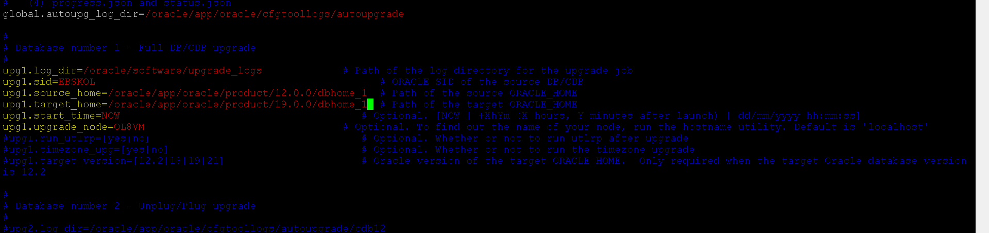

Getting error : Since autoupgrade requires only java 8 , I have higher version and hence getting error

Will update the java using the link below :
https://www.youtube.com/watch?v=u-6s7osqRvY
After upgrading the java , run the autoupgrade again
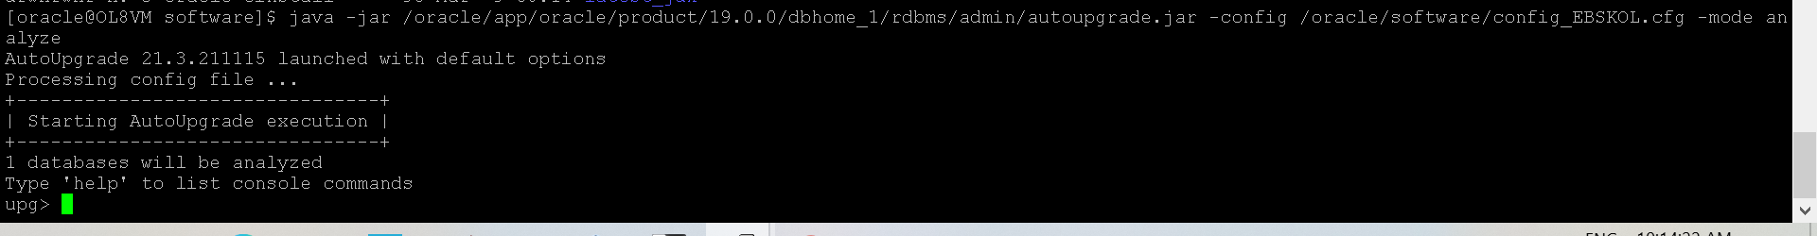
Monitor the job using lsj command
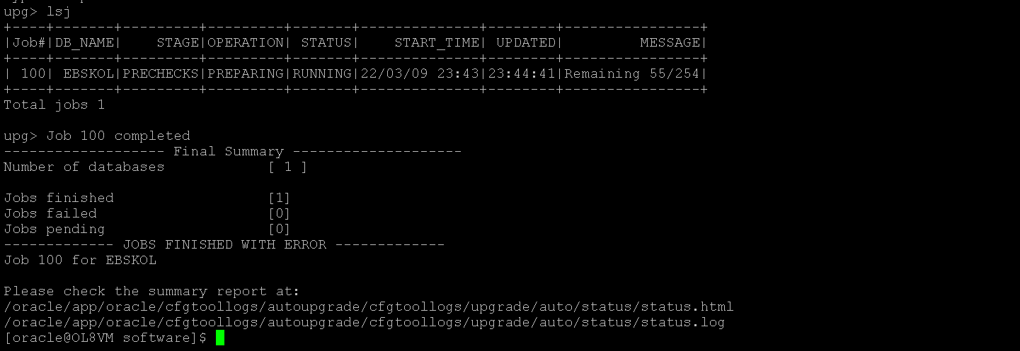

We got the error that the database archive log should be enabled after checking the logs
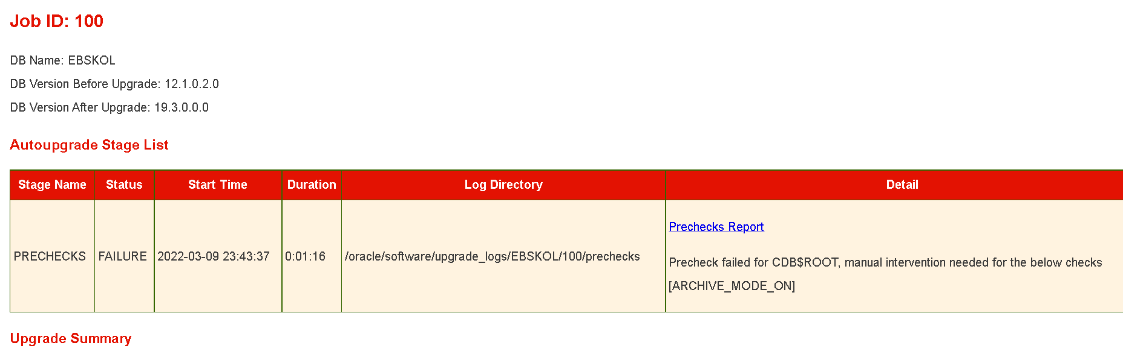
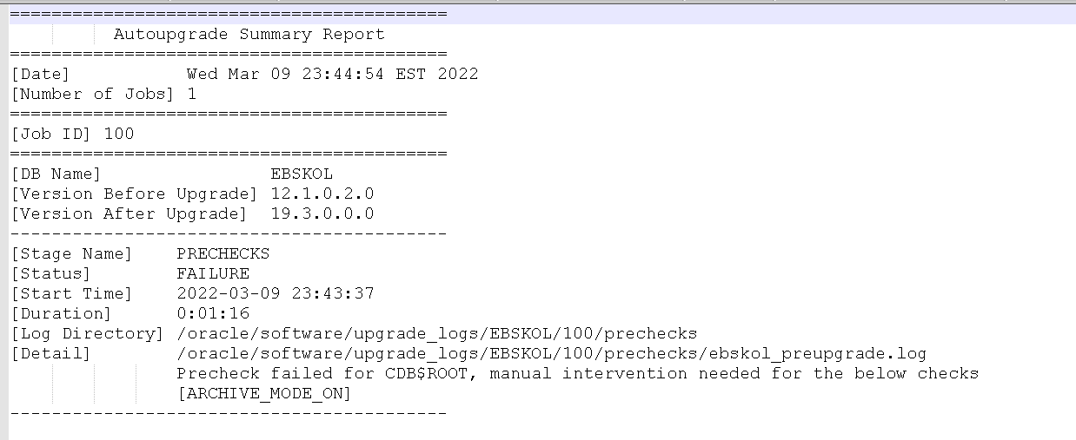

SO we missed to enable archivelog of the database, enable the archivelog mode for the database
And re run the auoupgrade analyze
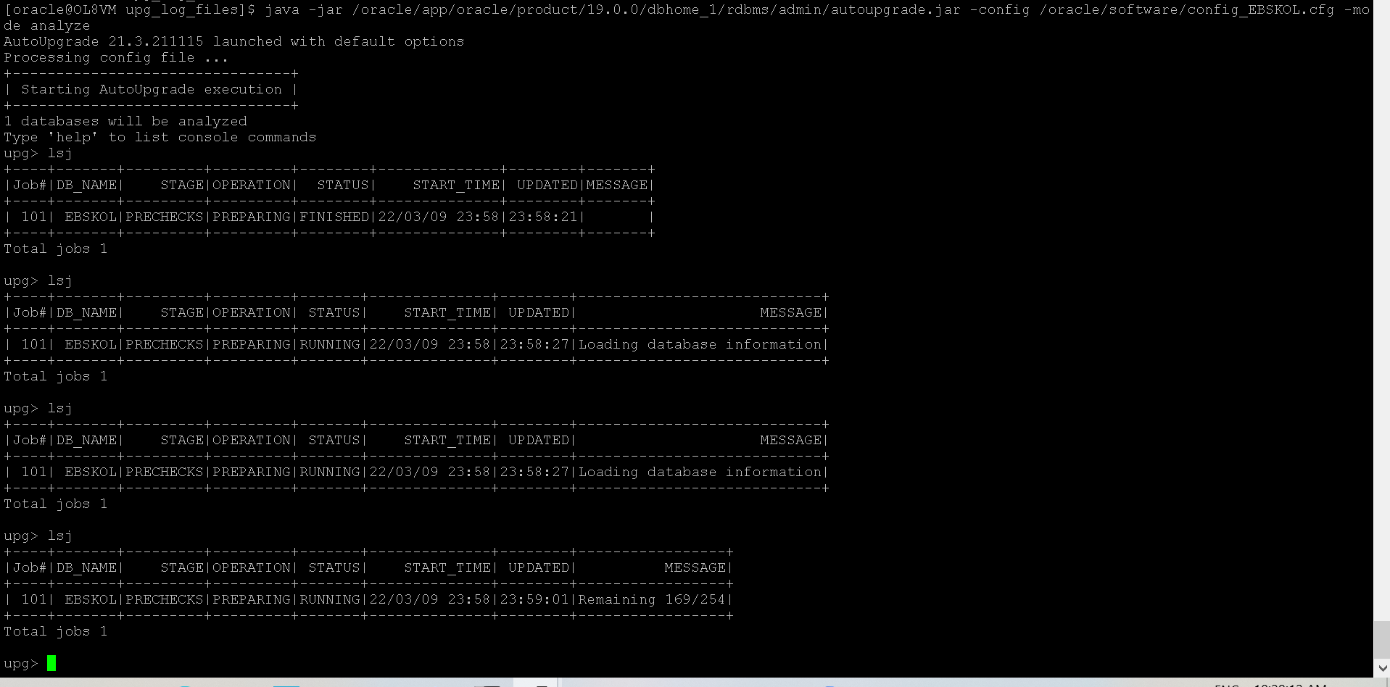
After 5 mins job is completed as it’s a small database
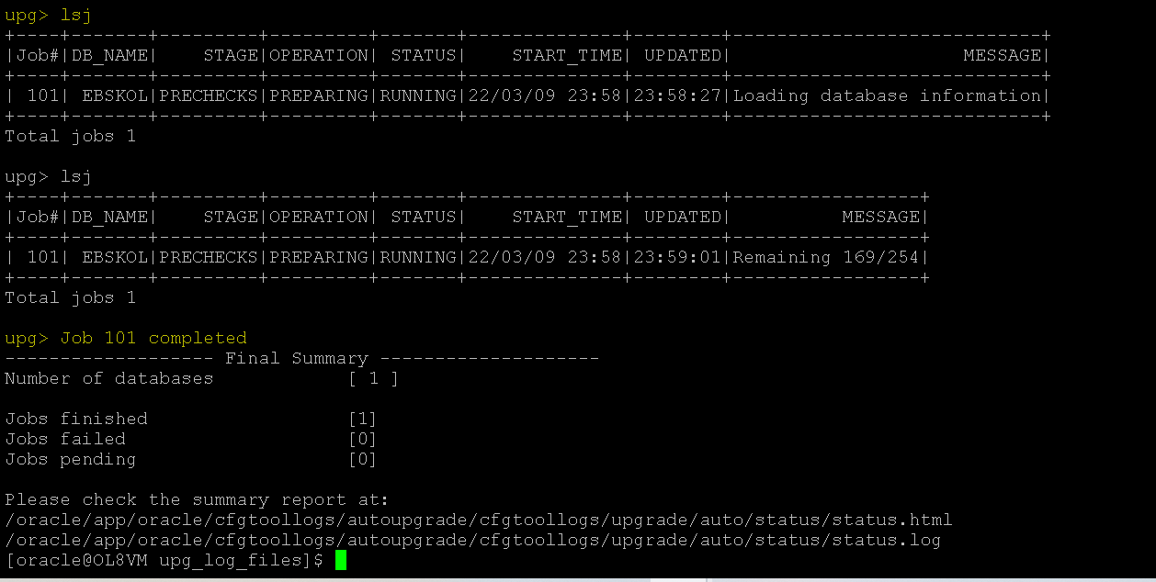

Check the logs for any issues.
On checking the logs, it shows no manual intervention is needed and prechecks are successful
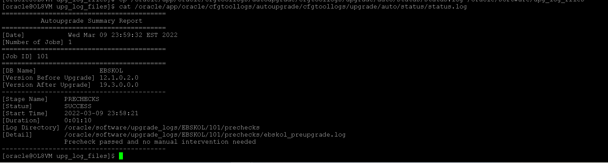
No we are ready to deploy the autoupgrade to do the actual upgrade of the database
java -jar /oracle/app/oracle/product/19.0.0/dbhome_1/rdbms/admin/autoupgrade.jar -config /oracle/software/config_EBSKOL.cfg -mode deploy
Upgrade started
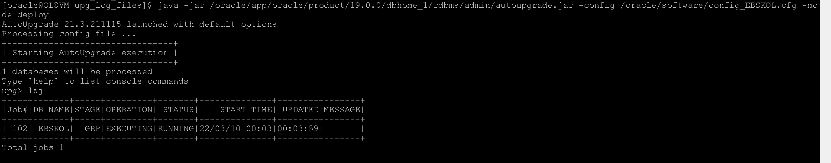
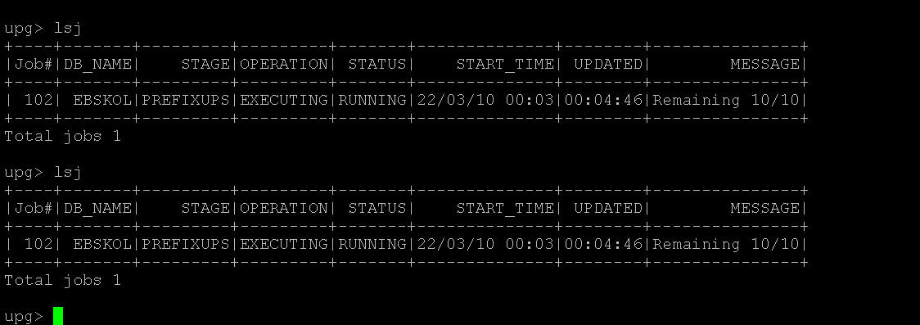

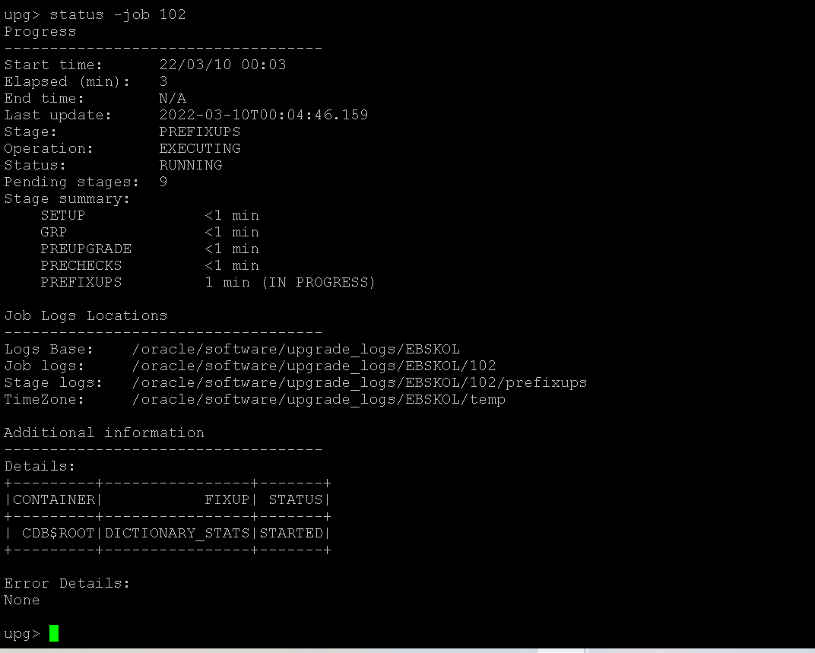
Monitor the status on the upg prompt using below commands like
upg>lsj

upg> status -job 101 -> show status of the jobs

upg> logs --> shows the status of the logs

IT failed with error :
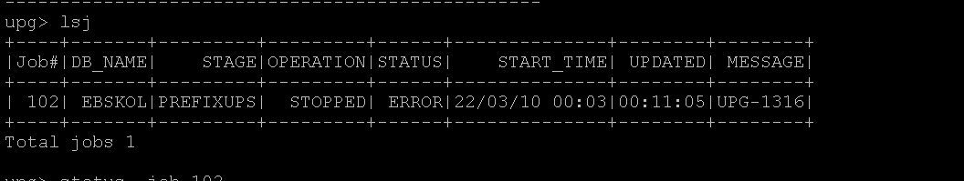
We analyzed the logs and found the error , that the archive log space requires atleast 13GB free for autoupgrade

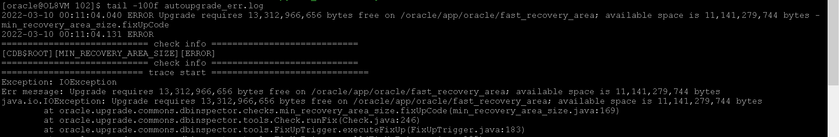

Started again at 10:54 after increasing FRA Size
There was space issue and we freed some space from the server and envoked the autouprade again
Started at 11:00AM
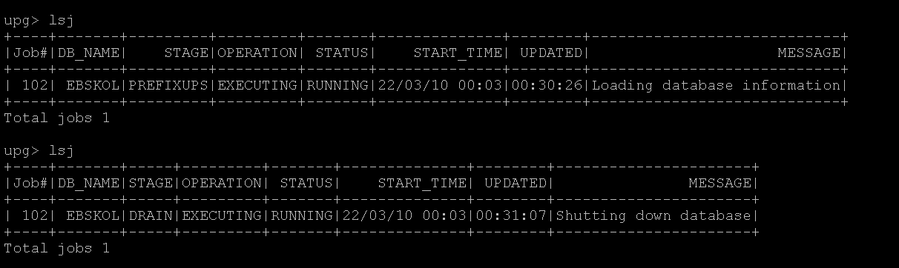
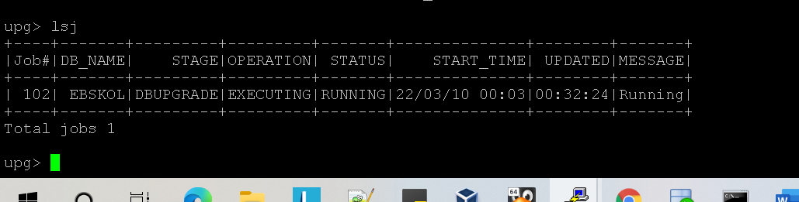
Database upgrade is running
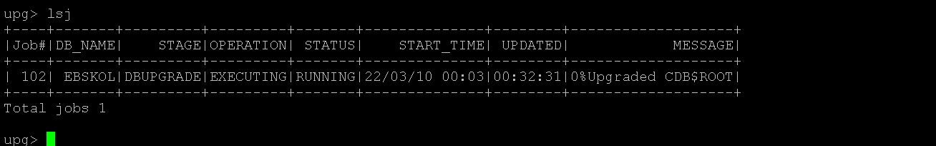

You can monitor the logs as well , check the log location like below :
Tail the log file and check the progress on a new window :
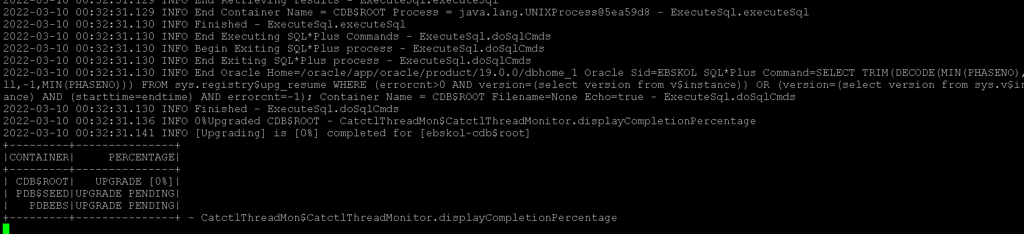

Status of the job :
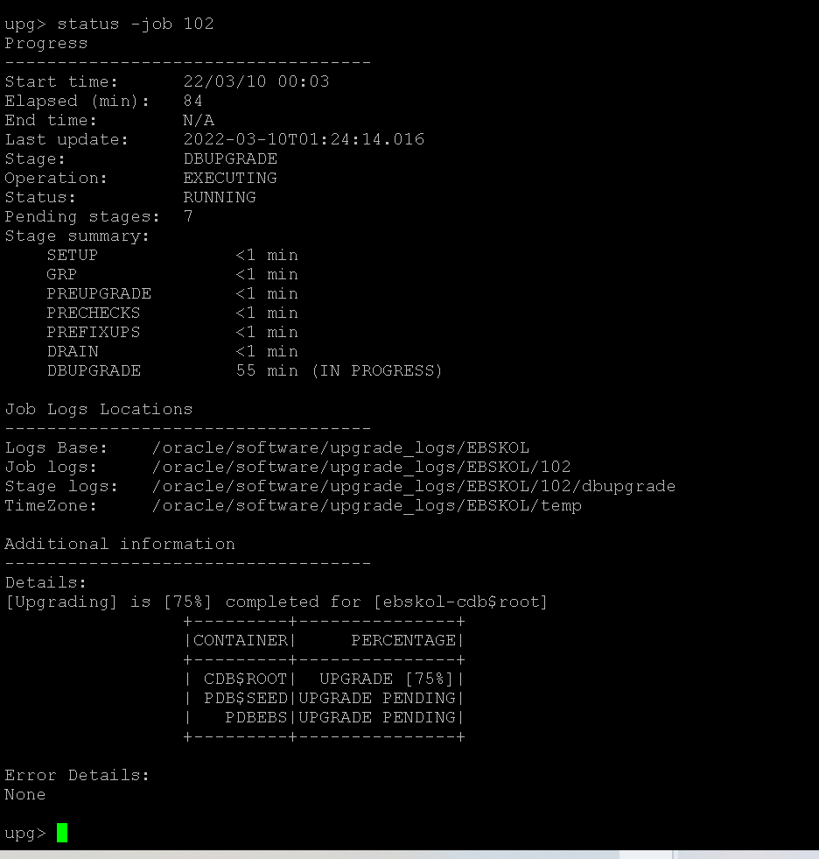
Upgrade progress after 1 hour ;
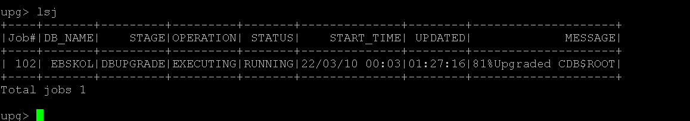

After an hour the container database is upgraded,now the pdb is getting upgraded

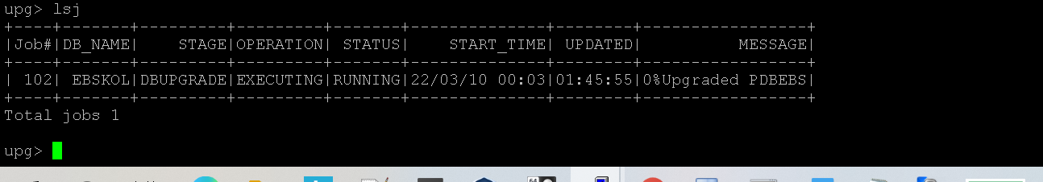

At 95% when we check the status of the job it shows :
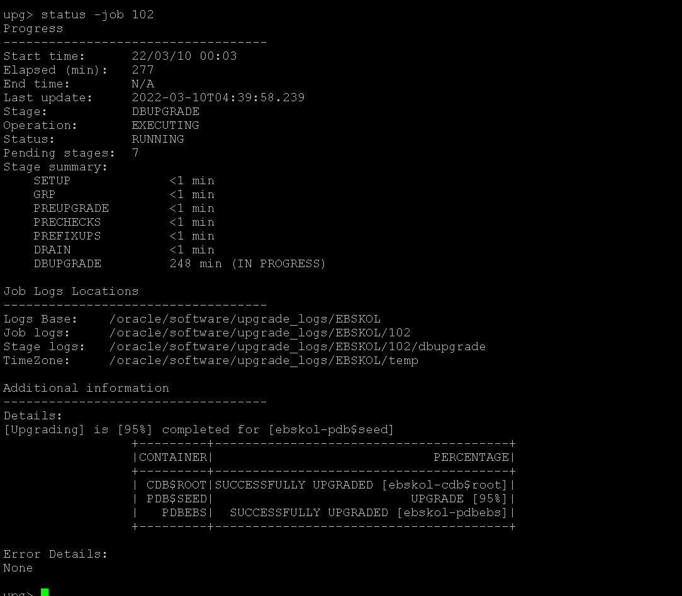

Total time take was more than 260 mins , below is the final confirmation that job is finished , it will show the below prompt on completion :
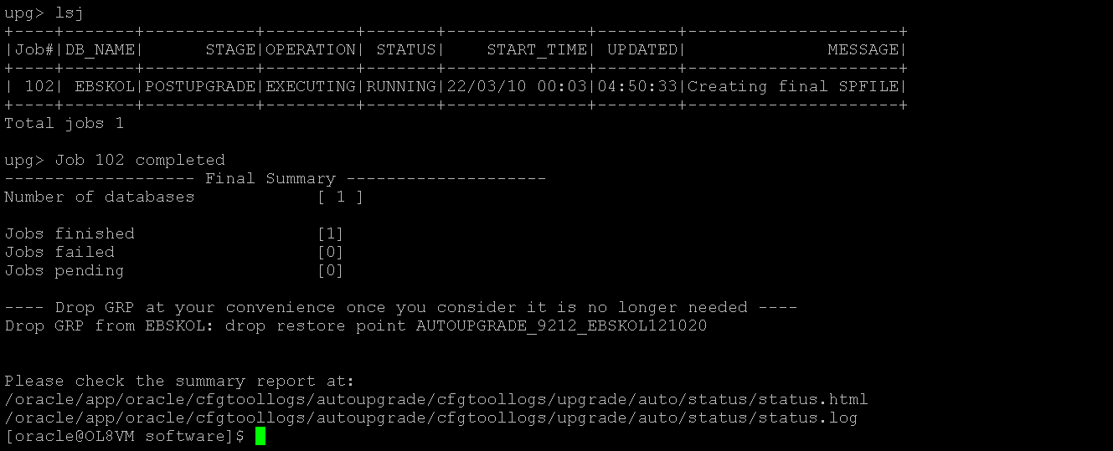

Now lets analyze the output files for the results
HTML report is attached for the status .
Tail the log file to see the upgrade summary , the upgrade summary will look like below :

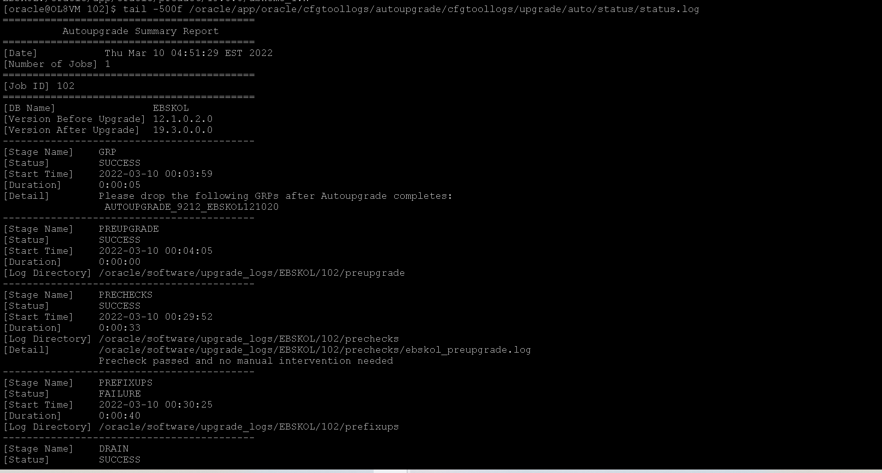

Note that the autoupgrade will replace the correct oracle home in oratab file as well , we don’t need to do anything manually , just verify the components if upgraded correctly .
Once we connect to the database , we see that its 19c
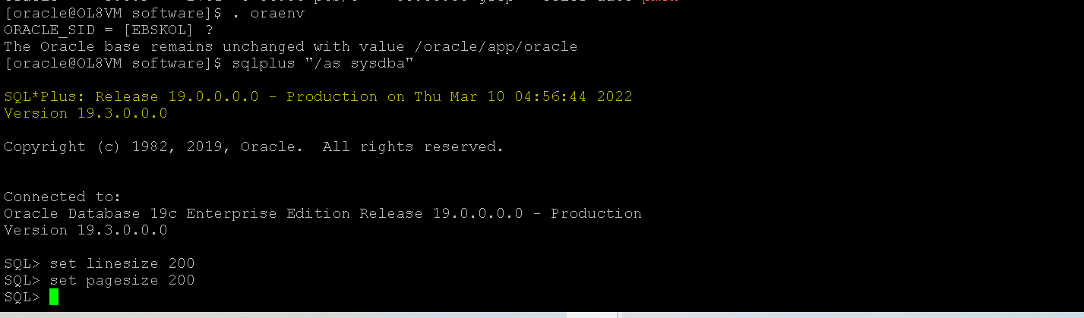
Step 3: Post upgrade steps
Verify if all the components of the databases are upgraded to 19c and also they should be in valid state .
select COMP_NAME ,VERSION ,STATUS from dba_registry;
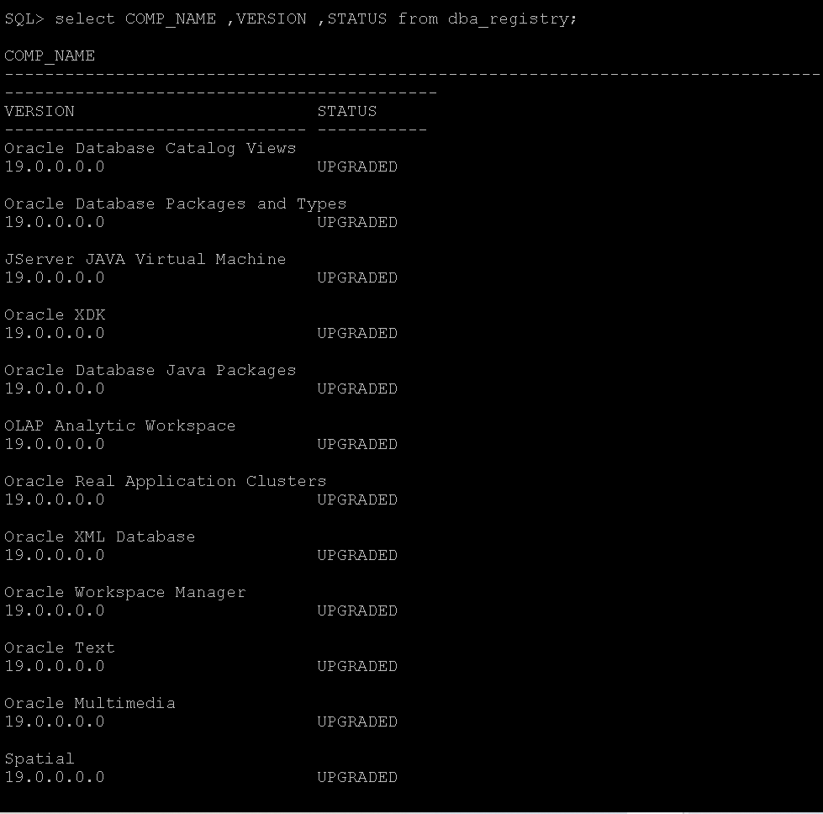
There are some objects invalid, we will run the utlrp once to see if it resolves it
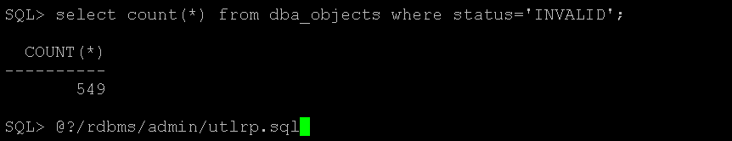
It complied successfully
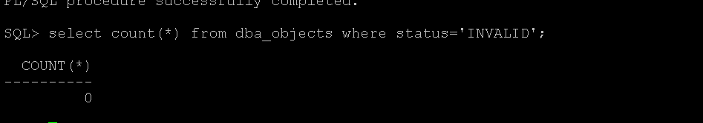
Do the same thing on the pdb as well
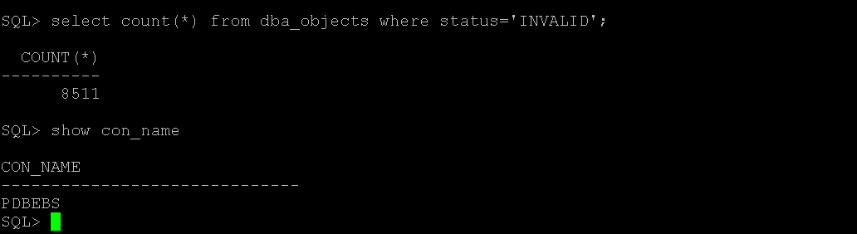

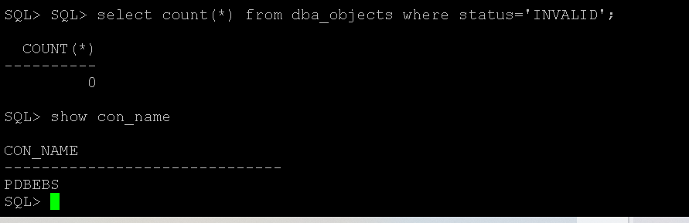

Drop the restore point created during the upgrade process. Autoupgrade creates a guaranteed restore point during the process, make sure you drop it, once upgrade completed. (Verified that flashback is off after the upgrade, so need to worry about flashback)
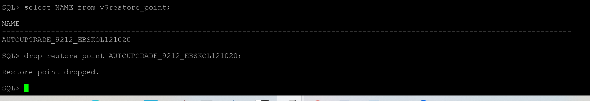
The autoupgrade tool automatically adds the entry into the oratab file and also listener is started automatically, nothing to do manually
Please stop the running the listener and start it once again and on database issue the command: alter system register to make sure listener is running from 19c home and supports the correct service. Do this in case the user is facing connectivity issues.

*****DB Upgrade is Successful ****
Note:
- Ideally autoupgrade runs the utlrp as well, but in our case, we had to recompile the invalid objects manually
- It’s a good practice to gather the fixed object stats and data dictionary stats before starting the autoupgrade, it saves time.

Few Important Commands Used during the process
TO check the jobs
upg> lsj
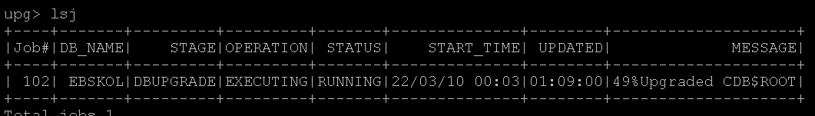
To check the status of the job (In case there are multiple database upgrade running, there will be multiple job i’d's and you can check status of each job id)
upg> status -job 102 (here 102 is the job id)
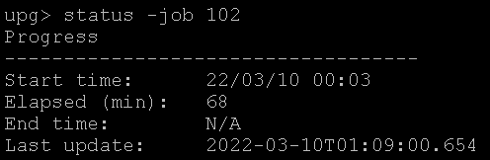
To verify if autoupgrade session is running
ps -ef | grep autoupgrade
To run autoupgrade in nohup mode: To let it run in background
nohup java -jar /oracle/app/oracle/product/19.0.0/dbhome_1/rdbms/admin/autoupgrade.jar -config /oracle/software/config_EBSKOL.cfg -mode deploy -noconsole &
To speed up the autoupgrade process you can always
Add the below entries in the config file
upg1.catctl_options=-n 64 -N 8
n -> total number of parallel process , minimum 4 , maximum unlimited , default is CPU_COUNT
N -> number of parallel process per pdb minimum 1 , maximum 8 , default 2

Other way of running autoupgrade in one line without creating a configuration file
java -jar autoupgrade.jar \ -config_values "sid=EBSKOL,source_home=/oracle/app/oracle/product/12.0.0/dbhome_1,target_home=/oracle/app/oracle/product/19.0.0/dbhome_1" \ -mode analyze

For running the one line command in deploy mode

java -jar autoupgrade.jar \ -config_values "sid=EBSKOL,source_home=/oracle/app/oracle/product/12.0.0/dbhome_1,target_home=/oracle/app/oracle/product/19.0.0/dbhome_1" \ -mode deploy

Running one liner command using environment variable
export ORACLE_HOME=EBSKOL
export ORACLE_HOME=/oracle/app/oracle/product/12.0.0/dbhome_1
export ORACLE_TARGET_HOME=/oracle/app/oracle/product/19.0.0/dbhome_1

java -jar autoupgrade.jar -config_values -mode analyze

java -jar autoupgrade.jar -config_values -mode deploy

