Week 5

Mayuree

2022-06-25

##Importing the csv file from github  
url <- "https://raw.githubusercontent.com/fivethirtyeight/data/master/hate-crimes/hate_crimes.csv"  
data <- read.csv(url)

library(tidyverse)

## -- Attaching packages --------------------------------------- tidyverse 1.3.1 --

## v ggplot2 3.3.5 v purrr 0.3.4  
## v tibble 3.1.6 v dplyr 1.0.9  
## v tidyr 1.2.0 v stringr 1.4.0  
## v readr 2.1.2 v forcats 0.5.1

## -- Conflicts ------------------------------------------ tidyverse_conflicts() --  
## x dplyr::filter() masks stats::filter()  
## x dplyr::lag() masks stats::lag()

data %>% select(median_household_income, hate_crimes_per_100k_splc) %>%   
 filter(if_all(c(median_household_income, hate_crimes_per_100k_splc), ~!is.na(.x))) %>%   
 ggplot(aes(x=median_household_income, y=hate_crimes_per_100k_splc)) +   
 geom_point() +  
 geom_smooth(method = "lm", se=TRUE, fullrange=FALSE, level=0.95)+  
 ggtitle("Hate Crime vs Income Inequality") +  
 xlab("Median household income") +   
 ylab("Hate crimes per 100K people(Southern Poverty Law Center)")

## `geom_smooth()` using formula 'y ~ x'

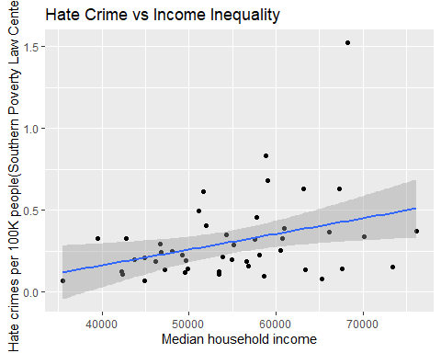

## This shows a scatterplot with respect to Income Inequality. This scatter plot shows that as the Income Inequality increases , the hate crimes also increases.

#This bar graph shows the top states ranked according to hate_crimes_per_100k_splc.  
##This shows that District of Columbia(DC) has the highest Hatecrime & colorado has the lowesr rate of hate crime.  
library(ggplot2)  
# Basic barplot  
p<-ggplot(data = filter(data,dense_rank(desc(hate_crimes_per_100k_splc))<=10), aes(x= reorder(state,(hate_crimes_per_100k_splc)), y= hate_crimes_per_100k_splc)) +  
 geom_bar(stat="identity")   
p

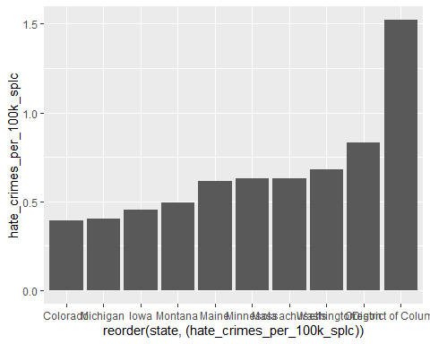

p + coord_flip()

