


INSTITUTE FOR ADVANCED COMPUTING AND SOFTWARE DEVELOPMENT, AKURDI, PUNE

BookNest

PG-DAC August 2024

Submitted By:

Group No: 101

Roll No. Name of Student
248009 Akash Vispute
248049 Mayuresh Suryavanshi

Mr. Prithviraj Shinde Mr. Rohit Puranik
Project Guide Centre Coordinator

ABSTRACT

BookNest is a web-based application designed to facilitate the browsing, searching, and purchasing of books online. It provides an intuitive interface for customers to explore the bookstore’s catalog, add books to their cart, and securely complete transactions. The system also includes administrative capabilities for
managing inventory, processing orders, and Monitoring sales.
Built using the Spring Boot framework, this system ensures efficient bookstore management by automating key processes such as inventory tracking, customer transactions, and administrative tasks. Security features are integrated using Spring Security for authentication and authorization.
This project aims to provide a scalable and robust solution for bookstore owners, enabling them to streamline operations and improve user experience. The system’s architecture is designed for efficiency, ensuring real-time updates and seamless interaction between users and administrators.

ACKNOWLEDGEMENT

We would like to express our sincere gratitude to our project guide, Mr. Prithviraj Shinde Sir, for their invaluable guidance, continuous support, and insightful suggestions throughout the development of this project. Their expertise and encouragement have been instrumental in shaping our understanding and improving our work. We are also deeply thankful to our coordinator, Mr. Rohit Puranik Sir, for providing us with the necessary resources, motivation, and a conducive environment to complete this project successfully. Their assistance and leadership have played a crucial role in the smooth execution of our research and implementation. We extend our appreciation to all faculty members, peers, and everyone who directly or indirectly contributed to the successful completion of this project.

Akash Vispute (240841220015)
Mayuresh Suryavanshi (240841220096)

IACSD

Table of Contents

Sr.No | Description | Page No.
1 | Introduction | 1
2 | SRS | 4
3 | Diagrams | 6
3.1 | ER Diagram | 6
3.2 | Use Case Diagram | 7
3.3 | Data Flow Diagram | 8
3.4 | Activity Diagram | 9
3.5 | Class Diagram | 10
3.6 | Sequence Diagram | 11
4 | Database Design | 12
5 | Snapshots | 15
6 | Conclusion | 18
7 | References | 19

- INTRODUCTION

.
BookNest is a web-based application that allows users to browse, search, and purchase books online. It provides a user-friendly interface for customers to explore the bookstore's catalog, add items to their cart, and complete transactions securely. Additionally, the system offers administrative capabilities for managing inventory, processing orders, and monitoring sales.

The primary purpose of this project is to develop a robust and scalable web application using Spring Boot framework that facilitates the management of a book store. The system aims to streamline various processes involved in operating a bookstore, including inventory management, customer transactions, and administrative tasks.

Objective :-

Develop a responsive and intuitive web application for managing bookstore operations Implement secure authentication and authorization mechanisms to protect sensitive data. Provide an extensive catalog of books with robust search and filtering capabilities.Enable customers to add items to their shopping cart, proceed to checkout, and make payments securely. Empower administrators with tools for managing inventory, processing orders, and generating reports. Ensure scalability and maintainability of the system to accommodate future growth and enhancements.

In the BookNest, both User and Admin roles play crucial roles in the management and operation of the platform. Each role comes with specific responsibilities, permissions, and access levels to ensure that the system operates smoothly and securely.
The system offers an intuitive platform for book lovers to explore, purchase, and review books. It also streamlines operations for book vendors by automating essential tasks like inventory tracking, order processing, and customer interactions. With the increasing demand for digital transformation in the e-commerce sector, an efficient and user-friendly online bookstore management system has become a necessity for businesses seeking growth and sustainability.

Key Features of the System
An BookNest includes multiple essential features to optimize user experience and business operations. The key features typically include:

a) User Module
- User Registration & Login – Customers and administrators have secure login credentials.

b) Book Management
- Categorization & Search – Books are categorized based on genre, author, price, and ratings.
- Book Details – Each book has a description, author information, pricing, and availability status.
- ISBN & Metadata Integration – Proper book identification and metadata ensure easy discoverability.

c) Shopping & Payment Module
- Shopping Cart – Users can add multiple books before proceeding to checkout.
- Order Confirmation – Users receive updates on their order.

d) Admin
- Inventory Management – Admin can add, update, and remove books from the catalog.
- Sales Analytics – Reports on best-selling books, revenue, and customer behavior.
- Order Management –Admin can view overall orders.

Benefits to Stakeholders
A well-designed BookNest provides benefits to various stakeholders, including customers, vendors, and administrators.

a) For Customers
- Convenience – Shop for books anytime, anywhere.
- Variety – Access a broader collection compared to local bookstores.
- Discounts & Offers – Avail promotional discounts and deals.

c) For Administrators
- Simplified System Management – Oversee operations efficiently.
- Enhanced Security – Protects user data and transaction details.

5. Challenges & Considerations
While an BookNest provides numerous benefits, it also presents challenges that must be addressed for successful implementation:
- Cybersecurity Threats – Ensuring robust security against data breaches and fraud.
- Technical Issues – Regular maintenance and updates to prevent system crashes.
- Competition – Competing with established players like Amazon and Barnes & Noble.
- Legal & Copyright Concerns – Ensuring compliance with book distribution laws and copyright regulations.

SOFTWARE REQUIREMENT SPECIFICATION

- Requirements:

Hardware and Network Interfaces:

Server:

Processor: Intel Core i5 or equivalent AMD processor.
RAM: Minimum 8GB RAM.
Storage: SSD storage for improved performance.
Network: Ethernet or Wi-Fi connectivity.
Operating System:Windows Operating System

Client Devices:

Processor: Intel Core i5 or equivalent AMD processor
RAM: Minimum 8GB RAM.
Storage: Sufficient storage for caching and local data. (min 256 GB SSD)
Network: Ethernet or Wi-Fi connectivity.
Browser: Compatible with latest versions of popular browsers like Google Chrome,
Mozilla Firefox, and Brave.

Software Interfaces:

- Spring Boot
- Spring MVC
- Spring Data JPA
- Thymeleaf (for front-end templating)
- MySQL Database
- Maven (for dependency management)
- Git (version control)

Software configuration for back-end Services:
- Java EE 11
- Spring Boot 2.5.6
- Spring JPA
- Spring Authentication 5.6.2
- MySQL 8.0
- STS 4.0.0

Software configuration for front-end Services:
- HTML, CSS
- Thymeleaf

DIAGRAMS

Entity Relationship Diagram:

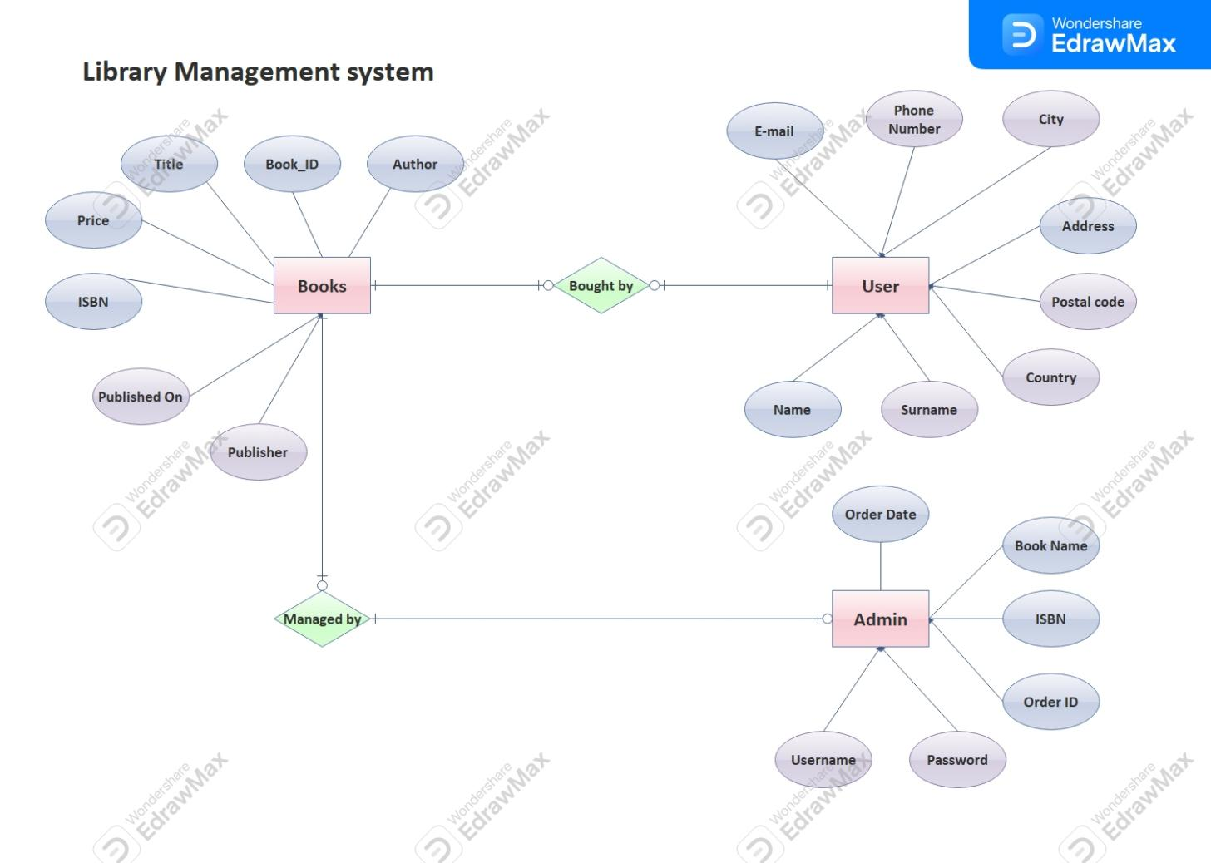

Fig. ER Diagram for BookNest

Use Case Diagram:

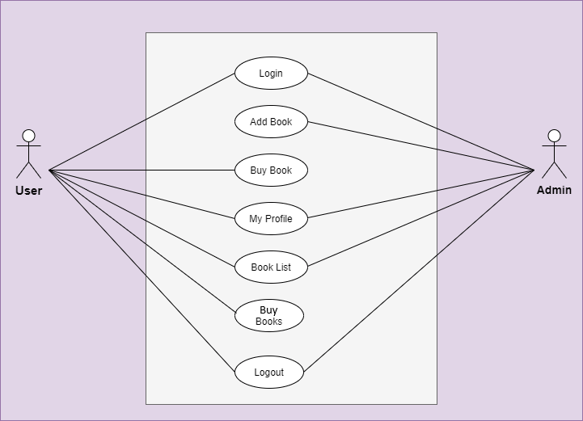

Fig. Use Case Diagram for BookNest

Data Flow Diagram:

DFD Level 0:
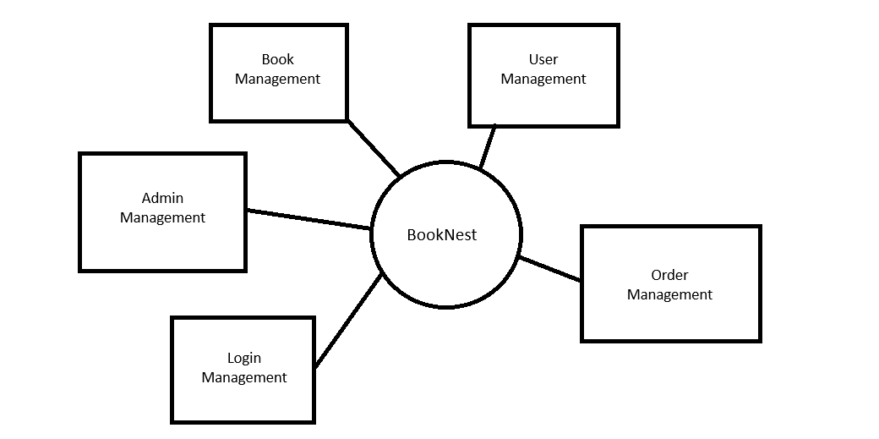

DFD level 1
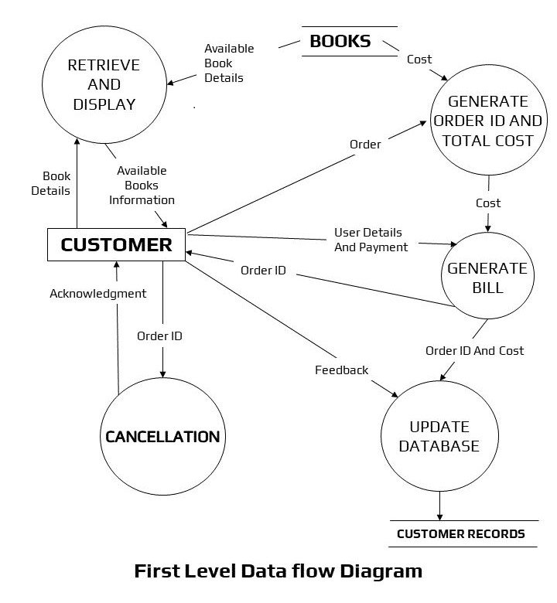

Activity Diagram :

Admin & UserActivity Diagram:

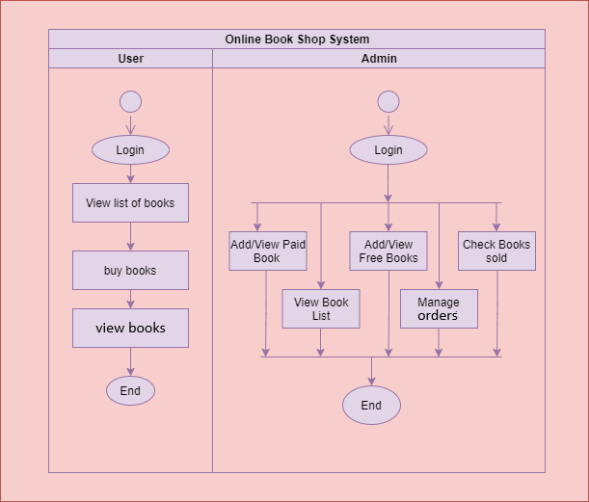

  - Class Diagram:

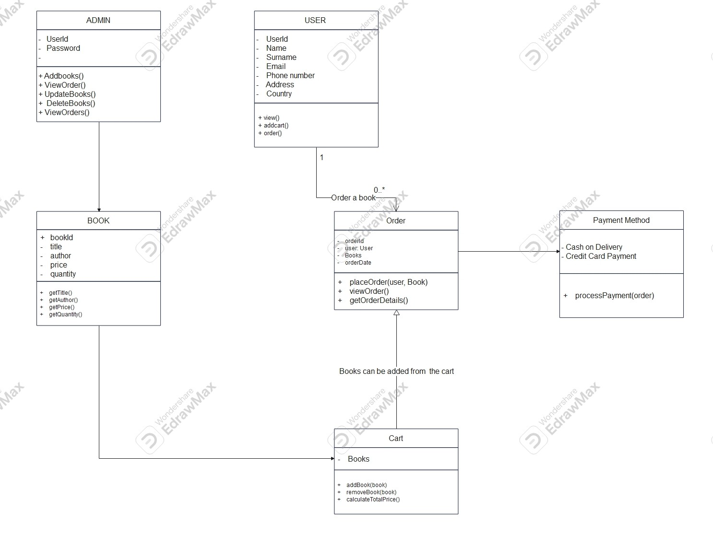

  - Sequence Diagram

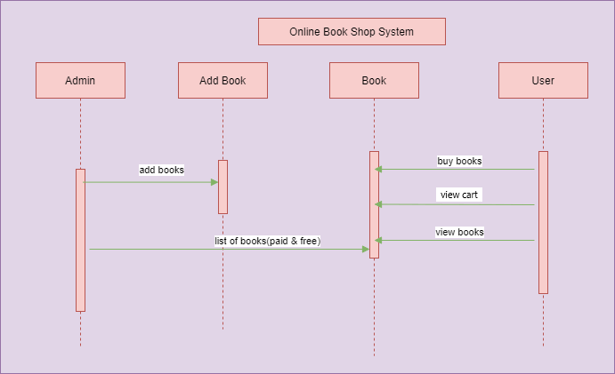

DATABASE DESIGN

  - Tables:
The following table structures depict the database design.

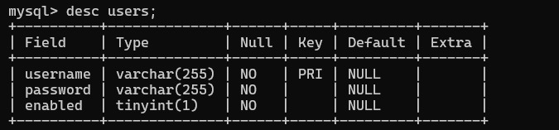

Table 1: user

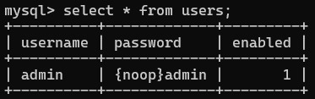

Table 2: admin

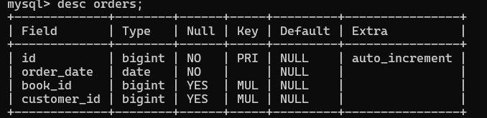

Table 3: order

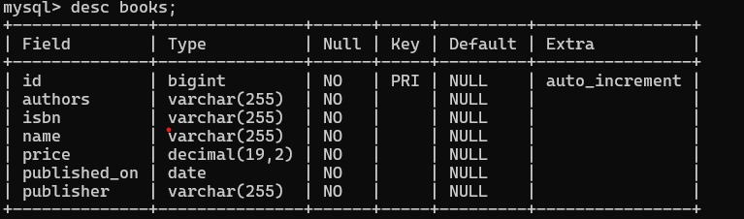

Table 4: Books

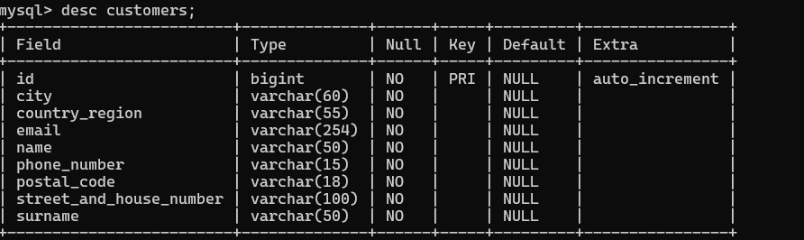

Table 5: Customers

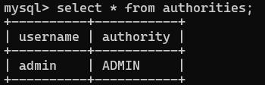

Table 6: Authority

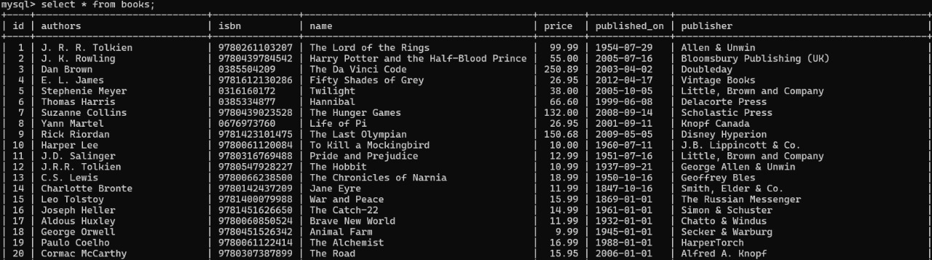

Table 7: Booklist

SNAPSHOTS

Home Page:



Cart:

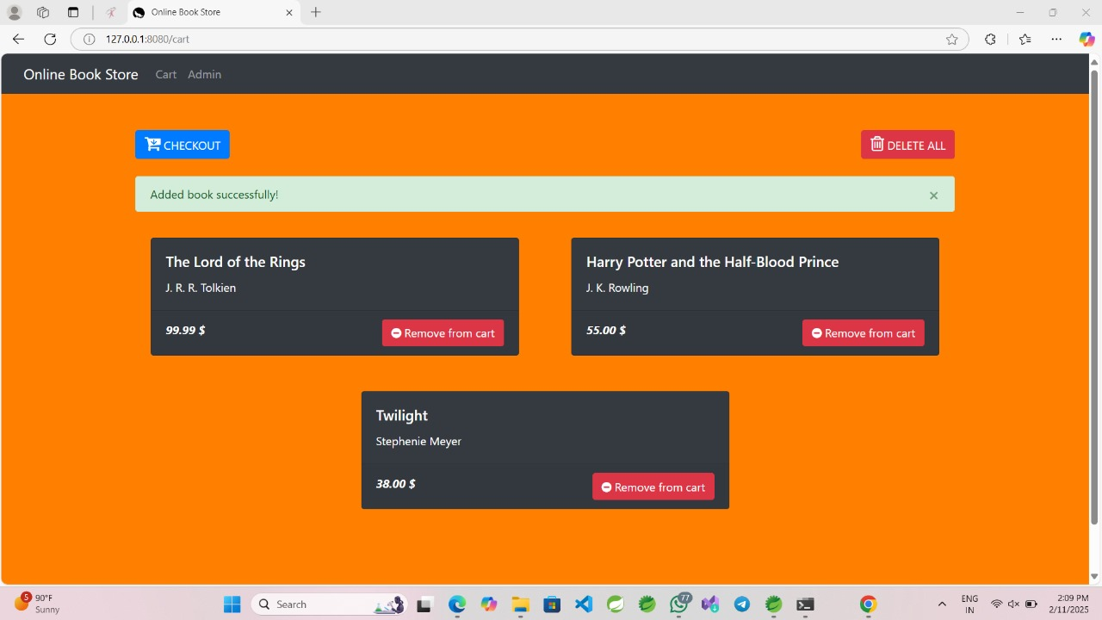

Checkout:

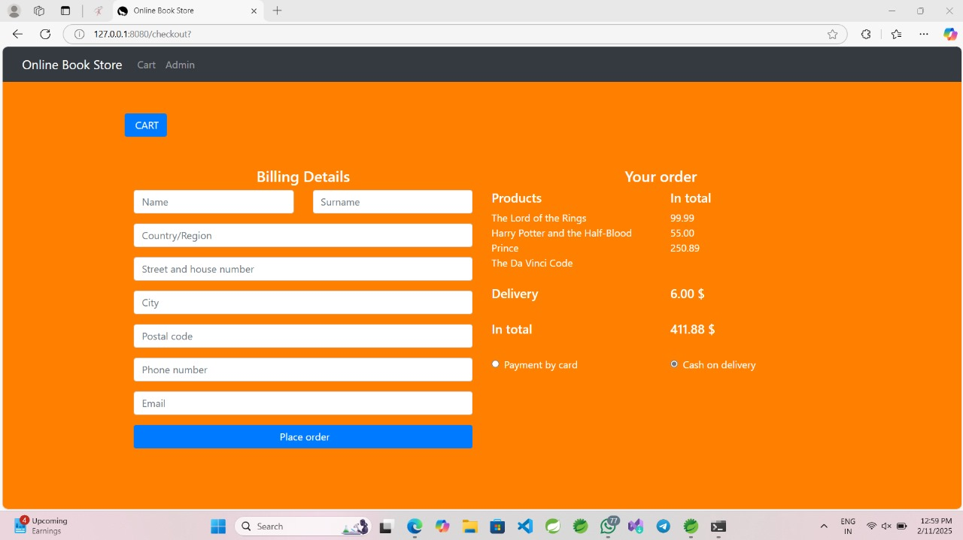

Admin Panel:

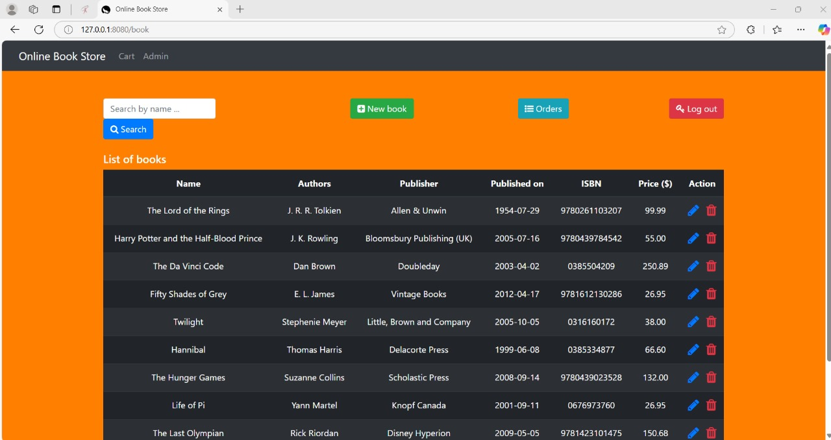

Add Books:

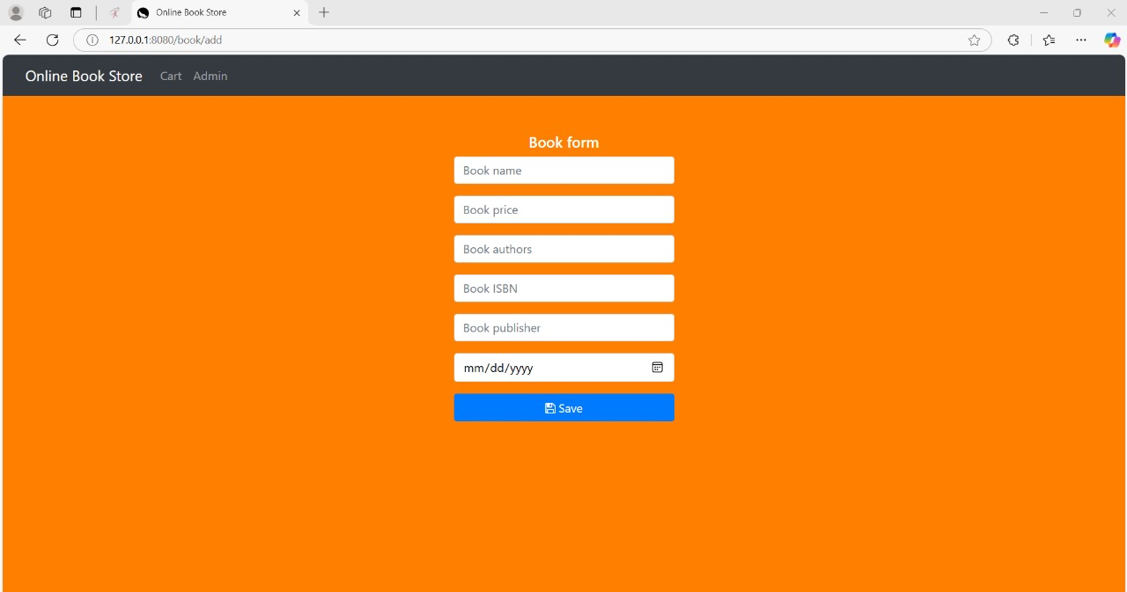

Search Books:

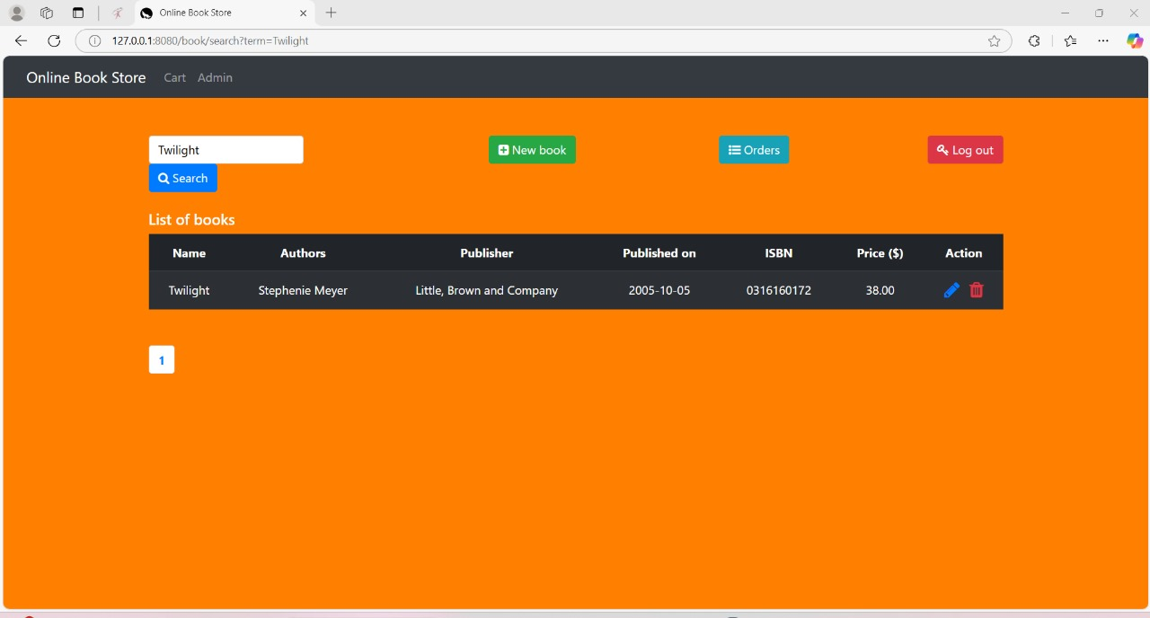

CONCLUSION

In conclusion, the "BookNest" project successfully integrates a range of cutting-edge technologies to deliver a comprehensive platform. Leveraging Spring Boot, Spring Data JPA, Spring MVC ensured robust back-end functionality for user authentication and data retrieval. The BookNest project embodies a comprehensive and user-centric approach to online book retailing. Leveraging technologies like Spring MVC, SpringBoot, Thymeleaf, MySQL database, it provides a robust and scalable e-commerce platform, user-friendly interfaces, and a responsive design, BookNest aims to deliver an immersive book shopping experience. Overall, the BookNest serves as a scalable and efficient solution for book retailers, ensuring seamless operations while catering to the growing demand for digital shopping experiences. The project, poised for growth, showcases a commitment to innovation, user satisfaction, and adaptability in the dynamic landscape of e-commerce.

REFERENCES

- https://docs.spring.io/spring-security/reference/
- https://docs.spring.io/spring-boot/index.html/
- https://mvnrepository.com/.
- https://dev.mysql.com/doc/
- https://www.thymeleaf.org/documentation.html
- https://spring.io/projects/spring-data-jpa

