**GlobalTech Aspire Practise Assignment**

**\*\*\*I have included the db.sql file under file “Database” which contains the DB Structure and test data. Import it before use. \*\*\***

**Setup Environment:**

**Extract Installation.zip file under folder “Backend Setup Steps”. It contains all the steps.**

**To do DB connection use the file application-mysql.properties under /resources folder of the Project.**

**Change the values as needed.**

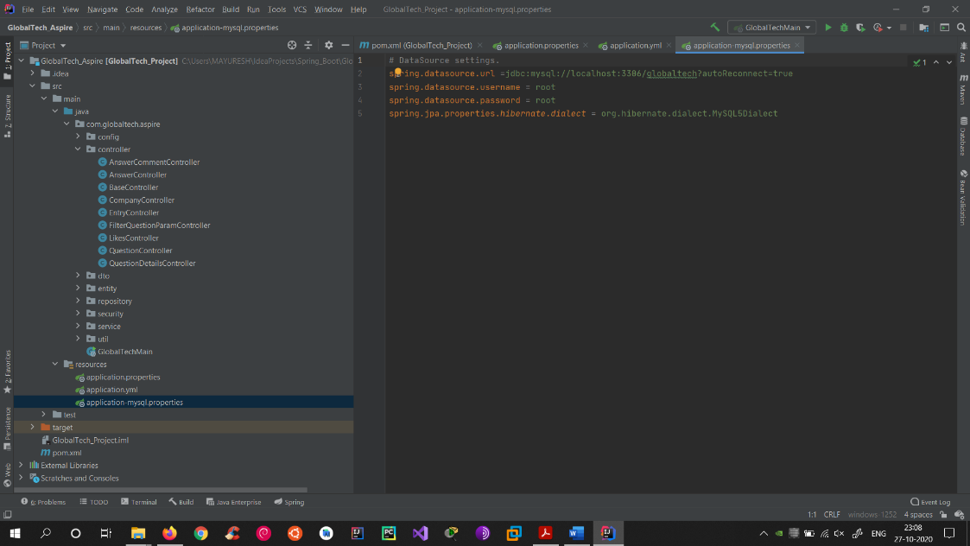

**Controller / API available:**

* Entry Controller: For Creating new Users and getting info
* Company Controller: For creating Company and getting info
* Question Controller: For saving a Question
* Answer Controller: For saving Answer for a Question
* Likes Controller: For giving and checking info for likes to Question & Answer
* AnswerComment Controller: For giving Comments on Answers
* QuestionDetails Controller: For getting all info of a Question
* FilterQuestionParam Controller: Getting List of Questions based upon certain parameters

**Testing full scenario:**

1. **Create User:**

Open Entry Controller and expand Signup. Fill the values and hit “Try it out” button.

If success, then go to Database and check via Query.

1. **Create Company:**

Open Company Controller and expand createCompany. Fill the values and click the button.  
If success, check the Database via Query.

1. **Create Question:**

Open Question Controller and expand saveNewQuestion. Fill the values.

Note: All values should be valid. CompanyName or CompanyId one should be filled. Both can’t be empty. QuestionDescription should be between 50 and 500 characters.

1. **Save Answer for Question:**

Open Answer Controller

Note the Question Id after saving question. User that for saving answer. Answer text should be between 50 to 500 characters.

1. **Likes:**

Open Likes Controller.

Query the Database to find Answer_Id and Question_Id and User_id to give likes. Fill the values.  
Duplicate likes are not allowed.

1. **Comments on Answer:**

Open AnswerComment Controller.  
Insert values and save comment.  
Comment should be between 50 – 500 charatcers.

1. **Question Details:**

To get details of a particular question open Question-detail Controller.

Fill the Question_id.

Note: In the output Question are included in lists. This is because of “Joins”. To eliminate this, we can create a “only question_id in string” column and remove join.

1. **Get Questions based on filter**

Some optimization is preferred because the combinations are increased.

Open the Controller.

Pass all values (Refer Images folder, Image number 12)

Pass anything below but don’t keep first input empty (Company Name)