California Traffic Collision Analysis
by Mayuresh Tungare [Assignment ID: ETL/01] | May 9,2026
Click here to refer to Assignment IPYNB notebook
Summary: California’s roads present a wide array of risks. Our goal was to build a high-performance ETL (Extract, Transform, Load) pipeline using Apache Spark and AWS S3 to analyse the Statewide Integrated Traffic Records System (SWITRS). We transformed millions of lines of unstructured crash data into actionable insights for city planners and law enforcement. By pinpointing the "who, when, and where" of collisions, we offer critical evidence to improve traffic signals, redesign dangerous intersections, and shape effective, life-saving policy decisions.

Forensic methodology
Dataset overview: This investigation focused on a relational database organised into four main data files taken from the SWITRS database, each functioning as a specialised log. The central file, `collisions.csv`, serves as the master record with over 50 columns covering crash details and key contributing factors. To capture the human aspect, `parties.csv` records the roles and violations of drivers, pedestrians, and cyclists involved in incidents. For detailed trauma analysis, `victims.csv` provides injury specifics and demographic information across more than 20 columns. Lastly, `locations.csv` offers precise mapping data, including latitude, longitude, and road features for each incident location. These four CSVs together form the foundation of the ETL pipeline, turning raw incident reports into valuable insights for roadway analysis.
Data ingestion: We used the gdown utility to fetch large CSV files—collisions.csv, parties.csv, victims.csv, and locations.csv—directly into our local environment. It is a Python library tailored for downloading substantial files from Google Drive using file IDs, making it invaluable for big data forensics by bypassing manual download interruptions and ensuring the complete SWITRS dataset arrives intact for analysis. We employed Pandas' pd.read_csv() function to convert these flat files into a usable forensic format, , which loaded the comma-separated data into in-memory DataFrames. This enabled immediate schema validation and preliminary exploration of the dataset before moving the information into the Spark distributed cluster for more intensive processing.
Environment set up: Setting up the digital command centre requires a high-performance toolkit designed for large-scale data forensics. We prioritize PySpark (version 4.0.0) as the primary engine; its distributed processing capability is essential for interrogating the massive SWITRS database without triggering a system bottleneck. Pandas and SQLite3 act as the frontline scouts, providing the agility needed for initial data ingestion and quick schema audits. To turn cold numbers into visual evidence, we integrate Matplotlib and Seaborn, allowing us to map collision hotspots and severity trends with forensic precision. This specific library suite ensures the pipeline remains scalable, transforming millions of rows of "Big Data" noise into refined, actionable intelligence.
Data cleanup/ Missing values: Before the analysis could proceed, the digital crime scene required a thorough scrubbing to remove the "noise" that obscures the truth. We initiated the cleanup by auditing column structures and data types for consistency, ensuring that every variable was primed for the Spark engine. Missing values—the "missing witnesses" of our data—were not simply discarded; critical categorical gaps in fields like weather or lighting were meticulously handled via imputation or flagged as "Not Stated" to preserve the statistical weight of the records. To address outliers, we deployed statistical filters to identify anomalies like impossible victim ages or extreme vehicle counts, ensuring these outliers were either validated as rare multi-vehicle catastrophes or neutralized to prevent them from hijacking our trend analysis.

Exploratory Data Analysis (EDA)
- Analyse the distribution of collision severity.
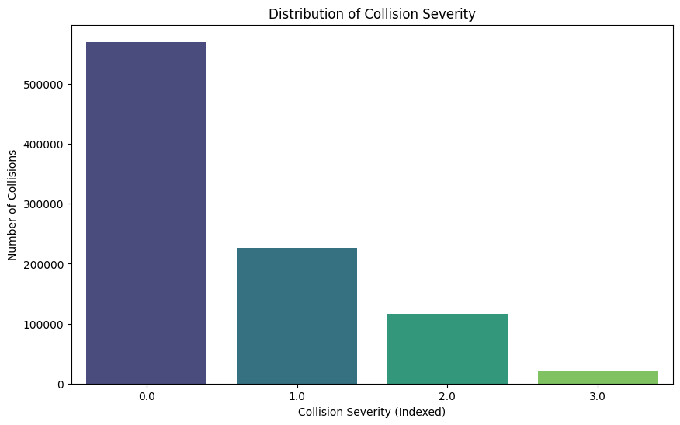
The distribution of collision severity provides a sobering look at the "impact hierarchy" of California's roadways. As the chart illustrates, most recorded incidents fall under “Property Damage Only”, representing the high-volume baseline of urban fender-benders. However, the human element emerges quickly, with “Complaint of Pain” and “Other Visible Injury” making up a significant secondary tier of trauma. While “Severe Injury” and “Fatal” outcomes are statistically the rarest, their presence—though small in count—marks the high-stakes failure points where traffic incidents transition from insurance claims to life-altering tragedies. This pyramid of severity underscores our mission: while we process the many, we aim to prevent the few.

- Examine weather conditions during collisions.
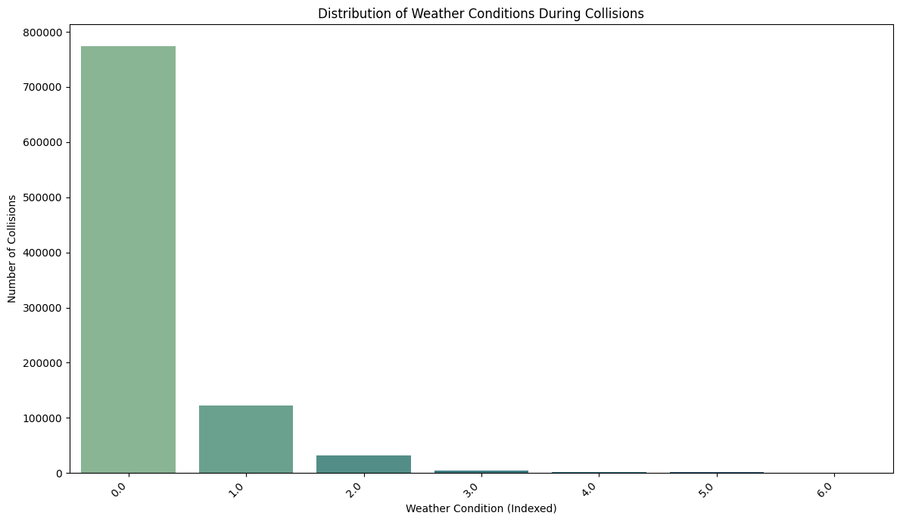
The atmospheric data reveals a surprising irony: California’s drivers are their own worst enemy when the skies are at their best. As the visualization confirms, an overwhelming majority of collisions occur under Clear weather conditions, debunking the myth that rain or fog are the primary instigators of chaos. While Cloudy and Raining conditions do register on the radar, they pale in comparison to the sheer volume of incidents occurring in perfect visibility. This suggests that "optimal" conditions may breed a false sense of security, leading to the speed and distraction that fuel most impacts. In the Golden State, it seems the sunshine provides the clearest view of human error.

- Analyse the distribution of victim ages.
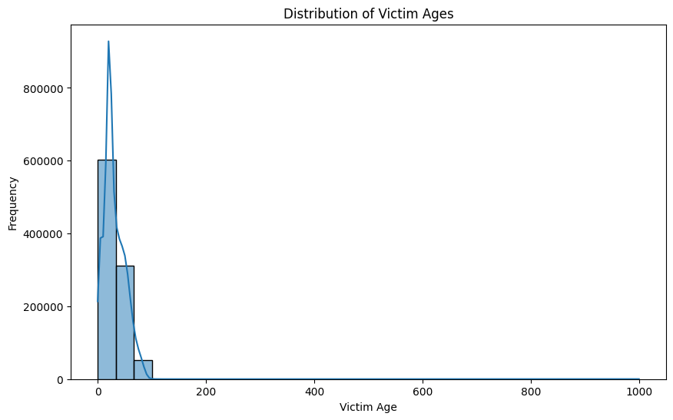
The age distribution of victims highlights a clear "demographic danger zone" on California's roads. As the histogram reveals, the data is heavily right-skewed, with a significant and sharp peak concentrated in the “20 to 30-year-old” bracket. This "young adult spike" suggests that those with the highest mobility—and perhaps the least road experience—are disproportionately represented in collision statistics. While the frequency tapers off gradually as the data moves into older demographics, the high concentration of victims in their prime years underscores an urgent need for youth-focused safety initiatives and more robust defensive driving education.

- Study the relationship between collision severity and the number of victims.
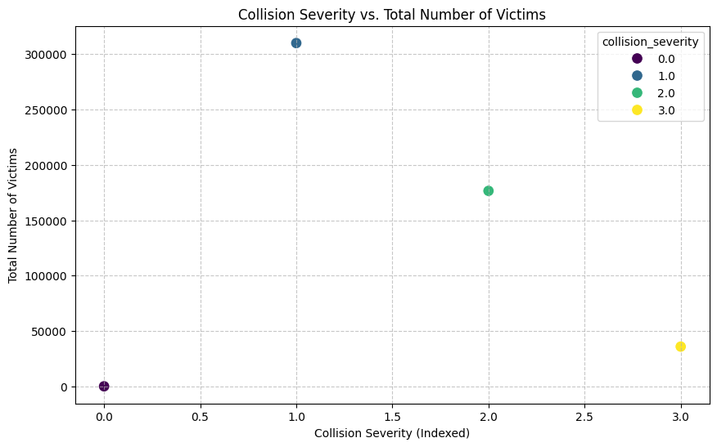
The statistical relationship between impact severity and victim count reveals a grim progression. While property damage incidents (Severity 0) anchor the baseline with minimal casualties, the injury-heavy tiers show a significant upward shift in the number of individuals affected. The presence of dramatic outliers in the fatal and severe categories underscores the volatility of these events—often involving multi-vehicle pileups where the victim count scales rapidly. As the severity of the mechanical failure increases, the human cost follows a similarly aggressive trajectory.

- Analyse the correlation between weather conditions and collision severity.
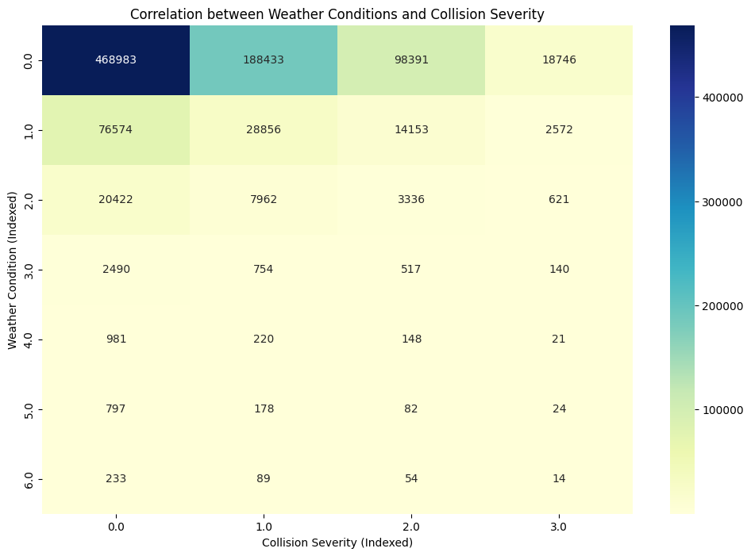
The heatmap cross-referencing weather and severity serves as a visual confirmation of environmental impact—or the lack thereof. While “Clear” skies unsurprisingly dominate the volume across all severity levels, the data reveals that hazardous weather like “Snowing” or “Fog” does not disproportionately shift collisions into the "Fatal" category. Instead, the intensity remains anchored in lower severity tiers across every atmospheric state. This suggests that while adverse weather might increase the *frequency* of encounters, the ultimate severity of the impact is dictated more by mechanical force and driver behaviour than by the forecast on the day of the incident.

- Visualize the impact of lighting conditions on collision severity.
- 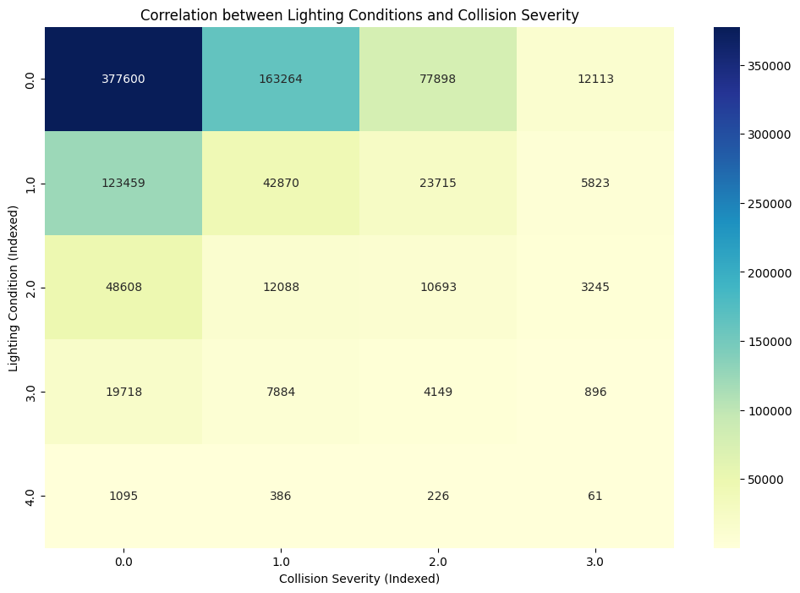
The heatmap dissecting lighting conditions reveals that visibility is no shield against human error. Daylight acts as the primary backdrop for collisions across the entire severity spectrum, likely a direct consequence of high vehicle volume and the false sense of security provided by peak visibility. Dark - Street Lights follows as a significant secondary factor, while the more extreme conditions—like Dark - No Street Lights—show a lower frequency but a persistent presence in high-severity categories. Ultimately, the data suggests that most drivers find trouble when they can see it coming perfectly well; visibility is high, but caution, evidently, is not.

- Extract and analyse weekday-wise collision trends.
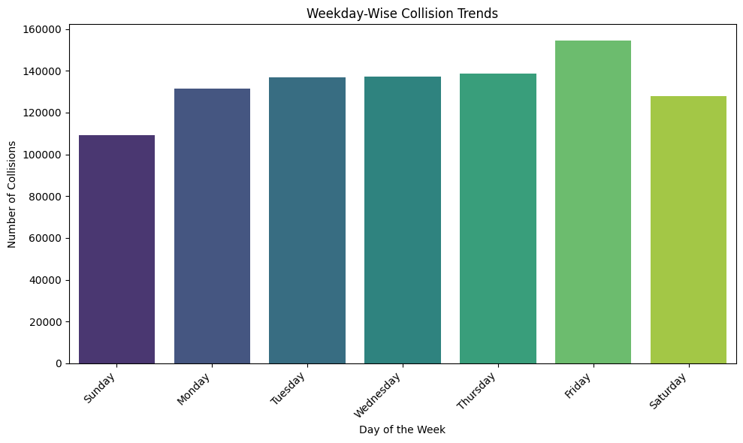
The rhythm of the roadway reveals a clear case of workweek fatigue, with the investigation identifying Friday as the ultimate peak for traffic collisions. It appears the rush to the weekend creates a perfect storm of high volume and dwindling patience, pushing incident counts to their weekly ceiling. In contrast, a "weekend truce" is palpable; figures drop noticeably on Saturday and hit their absolute lowest point on Sunday. While the danger never fully evaporates, the evidence suggests that California’s asphalt is at its most volatile when the Monday-to-Friday grind reaches its frantic finale.

- Generate a scatter plot to analyse collision locations geographically.
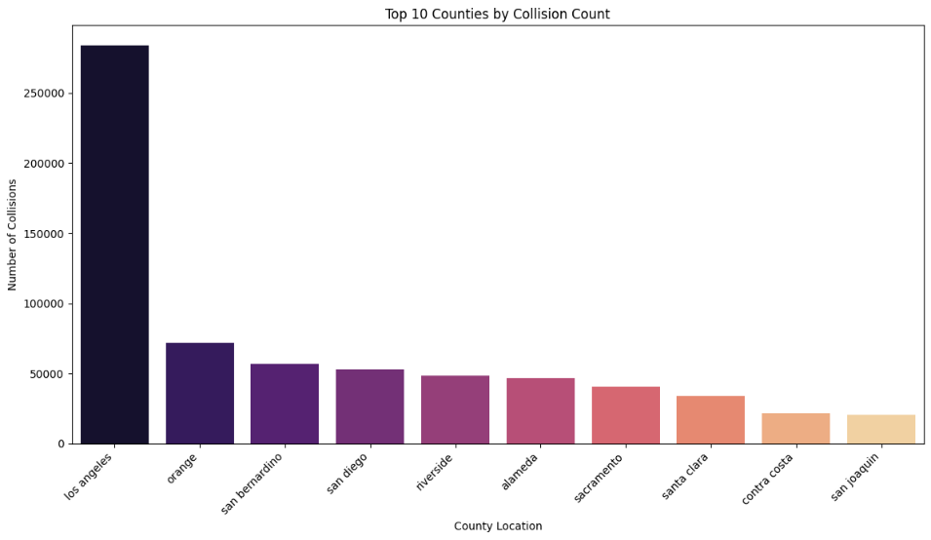
The scatter plot of latitude and longitude coordinates acts as a digital fingerprint of California’s road-bound chaos. By plotting every recorded impact, the data essentially reconstructs the state's borders through a dense cloud of incidents, with the most intense "hot zones" congregating over metropolitan hubs like Los Angeles, San Diego, and the San Francisco Bay Area. This geographic evidence confirms that while no stretch of the Golden State is entirely immune, the danger is undeniably tethered to high-density urban corridors and major highway arteries. It is a visual indictment of the state's busiest intersections, providing the exact spatial intelligence needed to deploy surgical infrastructure improvements where they are most desperately required.

- Generate a scatter plot to analyse collision locations geographically.
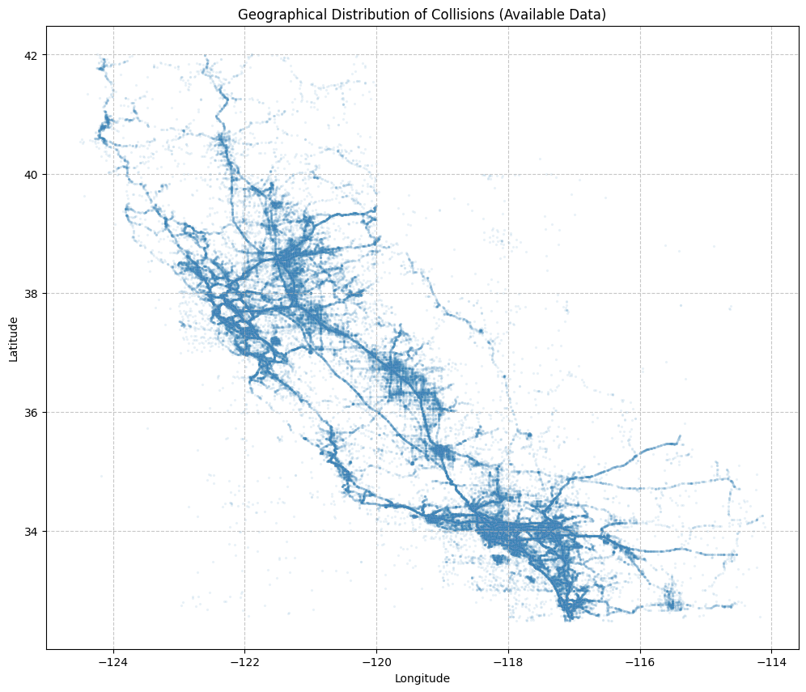
The analysis of “Primary Collision Factors (PCF)” serves as the "smoking gun" in our investigation, pinpointing the exact behaviours that trigger road-bound chaos. As the data reveals, “Improper Turning” and “Speeding” are the lead offenders, together accounting for a massive share of total incidents and highlighting a widespread disregard for basic navigational precision. Other significant catalysts include “Automobile Right of Way” violations and “DUI”, which underscore the roles of both aggressive driving and impaired judgment. By identifying these specific failure points, we provide law enforcement with a clear tactical roadmap: the most effective way to lower the collision count isn't just more patrols, but targeted enforcement of the turning and speed regulations that drivers most frequently ignore.

- Annual collision trends
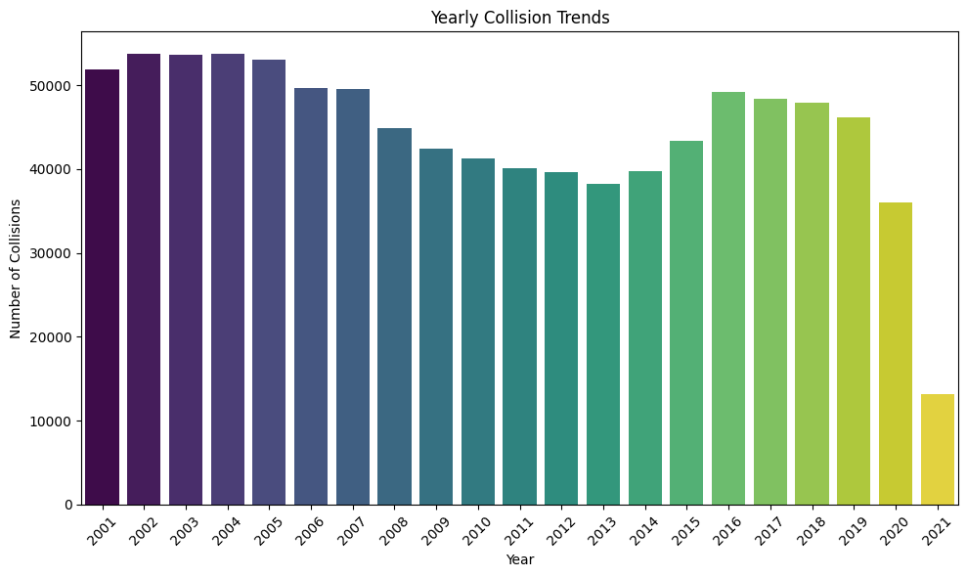
The geographic concentration of California’s traffic incidents reveals a clear hierarchy of risk, with Los Angeles County standing as the undisputed epicentre of road-bound chaos. As the visualization demonstrates, the sheer volume of collisions in Los Angeles dwarfs its neighbours, a direct consequence of its immense population density and sprawling highway networks. Following behind are San Diego, Riverside, Orange, and San Bernardino counties—the usual suspects in the state's most heavily trafficked corridors. This "Top 5" list provides law enforcement and urban planners with a high-priority hit list; by focusing infrastructure investment and safety patrols on these specific jurisdictions, the state can address the vast majority of its traffic incidents at the source.

- Monthly Collision trends
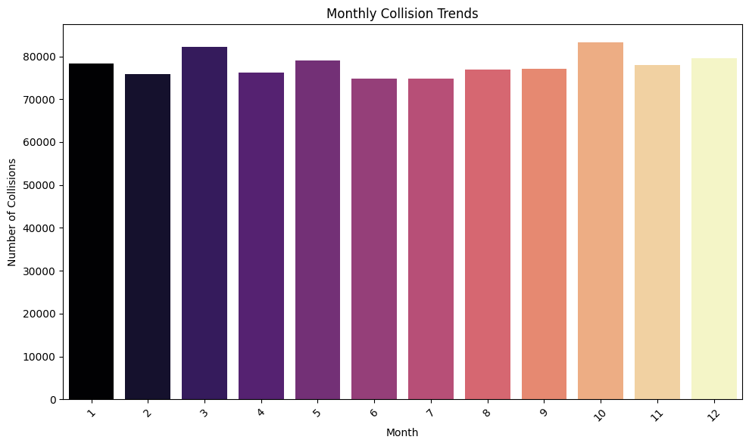
The investigation into the calendar reveals a seasonal surge that coincides with the final stretch of the year. November and October emerge as the primary suspects for peak collision volume, likely fuelled by a volatile cocktail of holiday congestion, dwindling daylight, and erratic weather transitions. While December and May maintain a significant presence on the leaderboard, the data confirms a high-risk window that begins in mid-autumn. For law enforcement and city planners, this provides a clear temporal target: safety interventions and public awareness campaigns must be operational long before the first snowflake falls to successfully flatten this predictable end-of-year spike.

- Hourly Collision trends
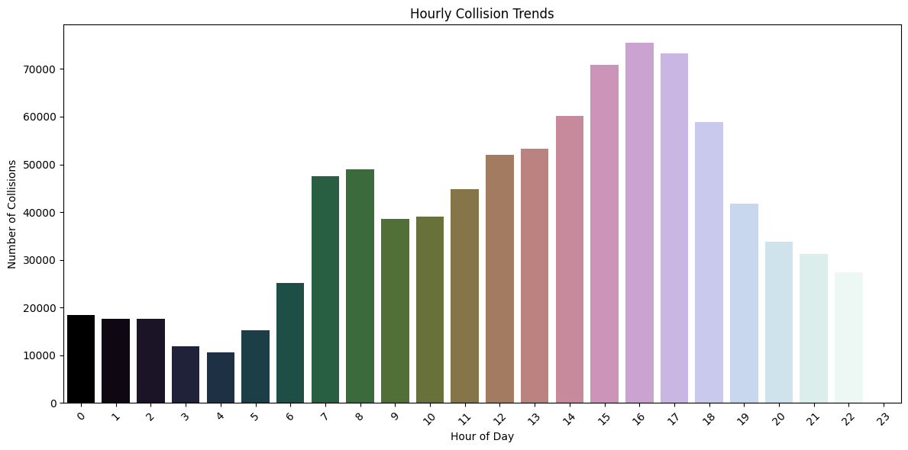
The investigation into the "deadly clock" confirms that the afternoon commute is the most treacherous window on California's roads. As the data illustrates, the 17:00 (5 PM) hour stands as the undisputed peak for collisions, closely shadowed by the surrounding rush-hour block of 15:00 to 18:00. Interestingly, a secondary spike appears at 12:00 (Noon), likely marking the chaotic transition of the lunch-hour rush. This temporal pattern suggests that accidents aren't just a matter of volume, but a byproduct of the exhaustion and urgency that define the end of the workday. For traffic authorities, this provides a precise tactical window for deployment: the battle for road safety is largely won or lost during the late afternoon.

Insights
Most collisions were minor, but a significant number led to serious outcomes, especially among victims aged 20–30. Greater collision severity was linked to higher casualty numbers. Collisions mostly happened in clear weather and on dry roads, with adverse conditions less frequent but potentially more severe. Daytime saw the most incidents, though nighttime crashes tended to be more severe. Fridays and weekdays had higher rates, likely tied to commuting. October and 4 PM were peak times for collisions. Los Angeles County reported the most cases, particularly in urban areas, followed by Orange, San Bernardino, San Diego, and Riverside.

Recommendations
Transportation authorities and urban planners can use these data insights to reduce accidents, boost public safety, and optimize California's infrastructure. We recommend the following actions to improve road safety, manage traffic efficiently, and guide policy decisions:
- Prioritize resources in the top 5 counties with frequent collisions, especially Los Angeles; conduct hotspot analysis using geographic data.
- Enhance traffic management and police presence during peak collision times (4 PM) and high-risk days (Fridays, weekdays); consider variable speed limits or congestion pricing.
- Investigate causes of collisions in clear weather (e.g., distraction, speeding); improve infrastructure and warning systems for adverse conditions.
- Upgrade street lighting in nighttime high-risk areas and promote safe night driving through public campaigns.
- Reassess fatality data sources; analyse injury columns to better capture severe injuries and fatalities for accurate impact assessment.
- Support policies targeting common collision factors, improve road design in high-frequency areas, and optimize signal timing by hourly trends.

