**Steps to make a peanut butter and jam sandwich: -**

1. Collect the required ingredients for the sandwich: Two slices of bread, a jar of peanut butter, a jar of jam. Make sure you check the expiry date of each of the ingredients.
2. Decide the number of butter knives and collect them:
   1. If you are fine with using a single butter knife, collect only one butter knife.
   2. Else, collect 2 separate butter knives for each of the spread.

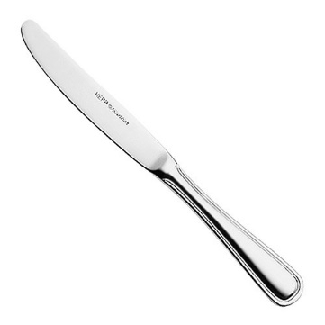

1. Open the peanut butter jar. Pick up a designated butter knife for peanut butter (common or a different one) and insert into the jar.
2. Withdraw some amount of peanut butter from the jar and spread it uniformly on one side of a bread slice. Use a second, third helping if required.

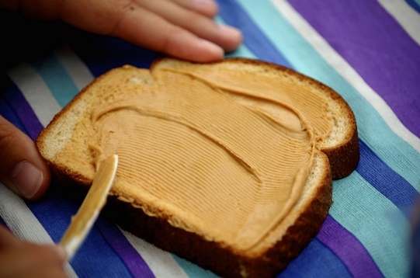

1. Repeat the steps 3 and 4 for jam on the second slice of bread. Use more jam if you feel like having a sweeter sandwich today! Following is the image of how your slices should look like after step 5:

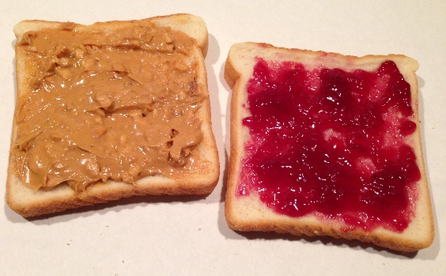

1. Place one slice on the other in such a way that peanut butter and the jam mix. Rub against each other if required.

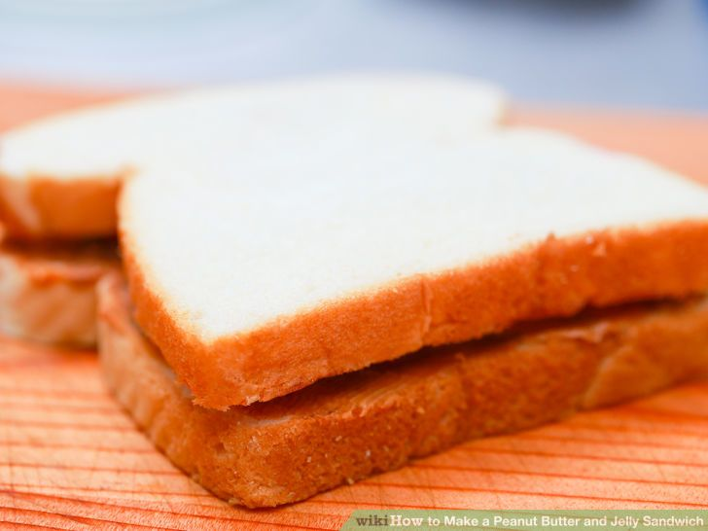

1. Toasting:
   1. If you like a toasted sandwich, toast it.
   2. Else, keep it as it is.
2. Cut the sandwich diagonally:

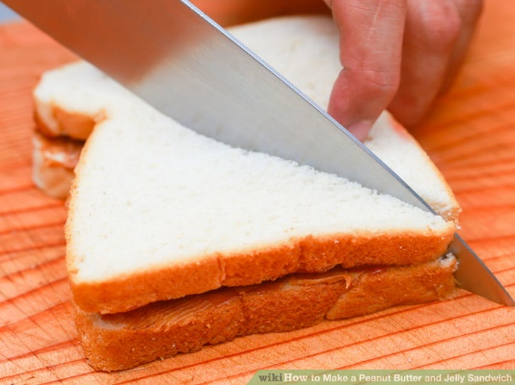

1. Place the two pieces of sandwich in a plate and decorate as required. You can use anything like fruits or dry-fruits!

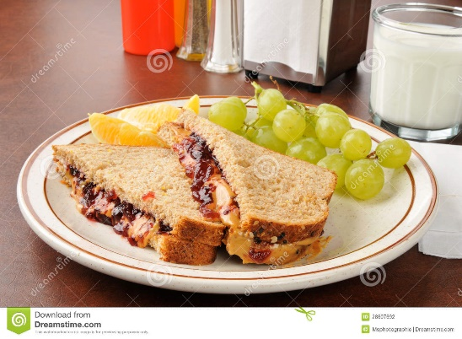

Total Word Count: 248