R Plots and Interpretations

Keen Koalas – Nautical Narwhals

INFM600 - Section 0101

Saba Aldughaither

Mayuresh Amdekar

Eris Mei

Himanshu Sawant

**Introduction**

Our team has created 8 different graphs on various comparisons of pesticides and their residue concentrations in order to answer our research questions.

The outputs of these graphs are included below with their corresponding interpretations. The combined R script file with the code that generated these graphs can be found in the same folder as this document on GitHub (file name: INFM600_0101_KeenKoalas_RPlot.R). PNG images of the graphs are also saved in the “Graphs” subfolder.

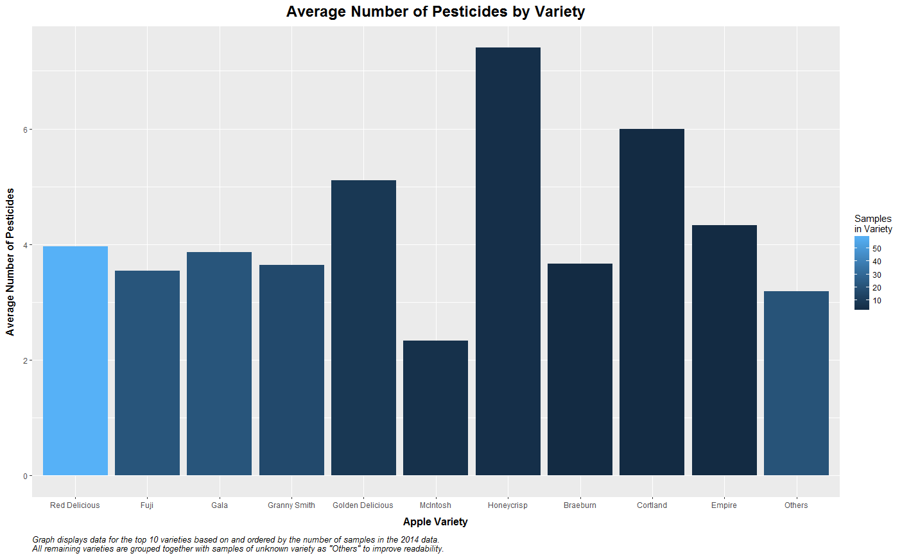

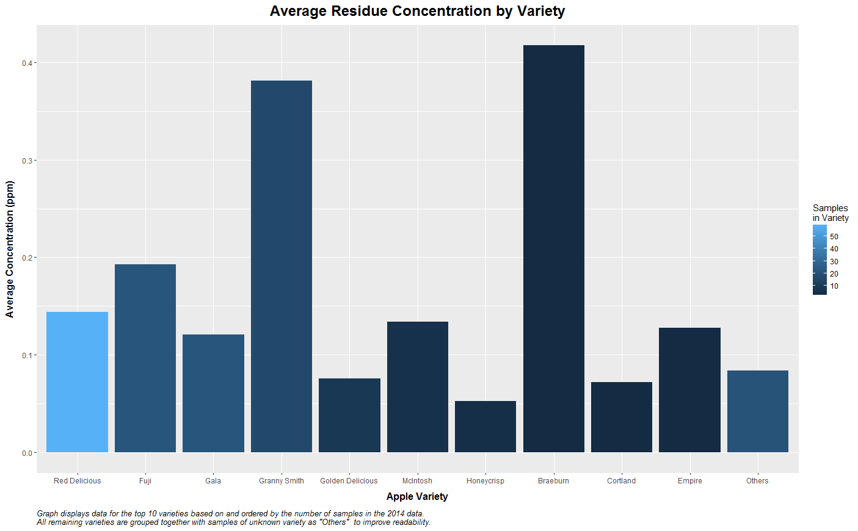

Average Number of Pesticides and Average Residue Concentration by Variety

These are two separate bar graphs showing the average number of types of pesticide found on apple varieties with the most samples in the 2014 conventional apple data and the average residue concentration detected for those varieties. There were a total of 22 different varieties, with some additional samples of unknown varieties. In order to improve readability of the graph, only the top 10 varieties are shown (on the x axis), with the remaining lower frequency and unknown varieties combined into an 11th group labeled as "Others" after obtaining a weighted mean from their data. The varieties are displayed on these graphs in order of their sample frequency from left to right in decreasing order, with the "Others" category added to the end. A color gradient is used to fill the bars in order to provide viewers with approximate sample frequency information on the graph as well. The average number of pesticides and average concentration (unit: ppm, as in parts per million), are put on the y axis of their respective graphs.

The most common apple varieties seem to have an average of around 4 types of pesticide per sample, while Honeycrisp appear to have more per sample (7.4) compared to the other varieties. Due to the wide range of concentration amounts, it is uncertain if a conclusion could be drawn from the average concentration when divided by variety (this point will be mentioned in the presentation if the graph is to be included), but Granny smith and Braeburn had the highest average concentration of the top 10 varieties in 2014. It is interesting to note that the residue concentration average for Honeycrisp appears to be on the low end at 0.053 ppm. So, they appear to have more types of pesticide but of low concentrations in the batches tested in 2014.

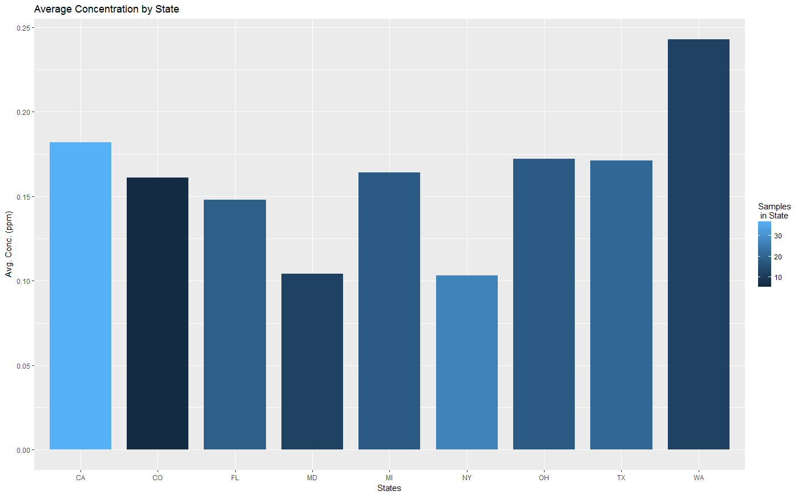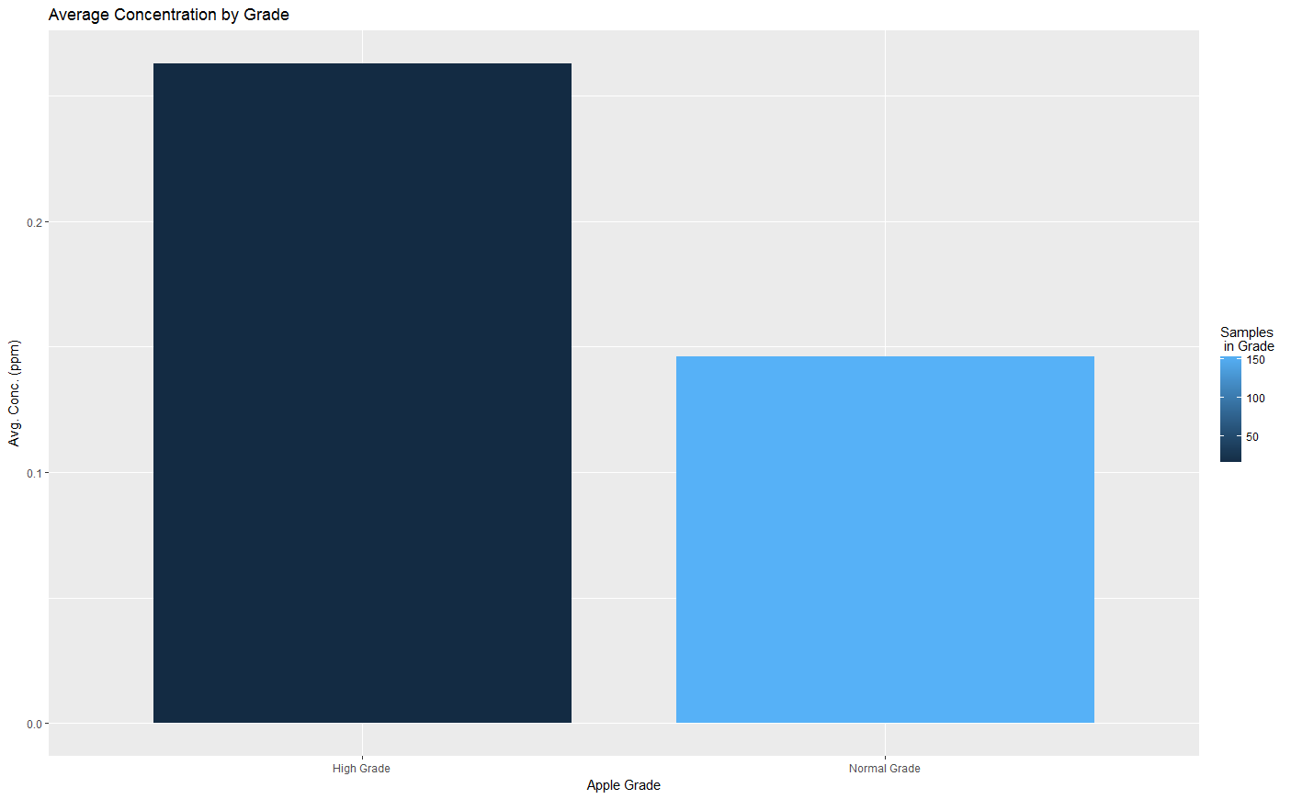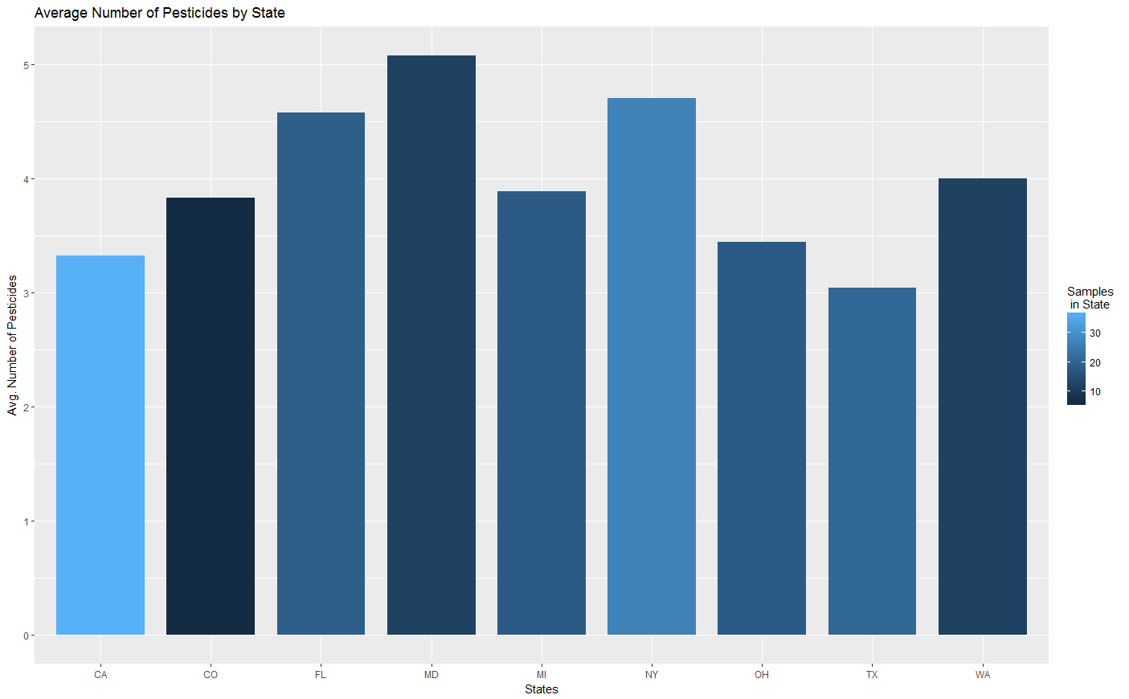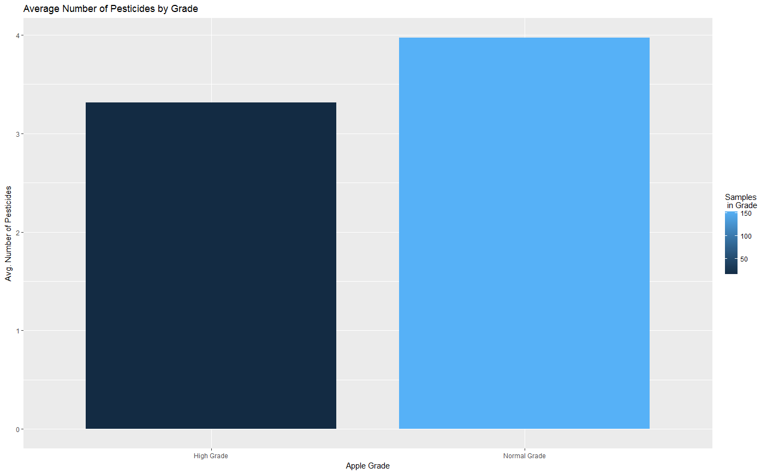

State and Grade Data for Concentration and Number of Pesticides

To visualize how pesticide information varies by state and by apple grade, graphs were plotted to show the average number and concentration of pesticides in each state where samples were collected and by apple grade (normal vs. high grade apples). The plots show that pesticide concentration levels range between 0.103 and 0.263 parts per million. Comparing the two bar plots for apple grade information shows that normal grade apples have on average 0.66 more pesticides than high grade apples, but with a significantly lower average concentration (0.146 compared to 0.263 for high grade apples), showing that high grade apples have a fewer number of pesticides than normal grade apples but in higher concentrations, which challenges the assumption that high grade apples are less chemically treated than normal grade apples.

The state with the lowest average concentration of pesticides was New York (0.103 ppm) and the highest was Washington (0.243 ppm). In terms of number of pesticides, the state with the most on average was Maryland (5.083 pesticides) and the state with the least was Texas (3.048). There seems to be a weak inverse correlation between the number of pesticides found and the average concentration, with states with more pesticides per sample having a lower average concentration of pesticides. This is not true for all states, however.

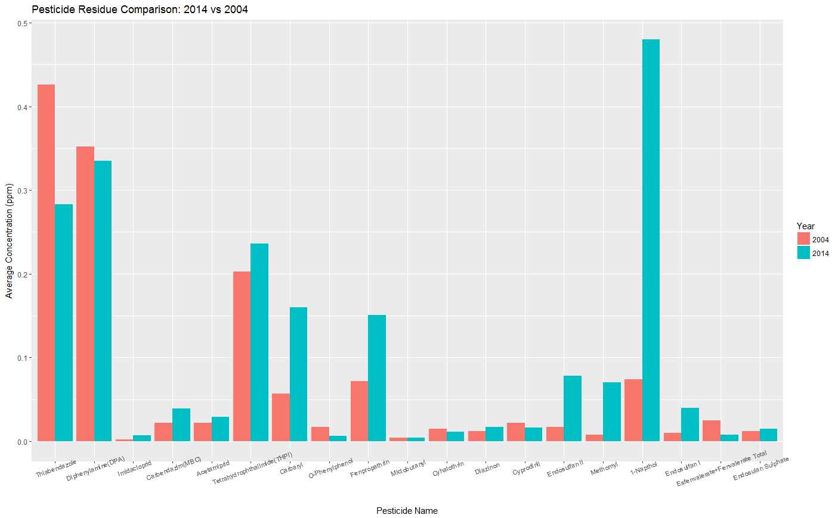

2014 vs 2004 Comparison

The ggplot command plots the grouped bar chart. On the X-axis, we have the names of the various Pesticides which were found in the samples from both 2004 and 2014. The pesticides are arranged by decreasing order of number of times residues of that pesticide were detected in 2004. On the Y-axis we have the average concentration of the pesticides. The grouped bar chart shows that only 5 out of 19 pesticides (Cyhalothrin, Cyphrodinil, Esfenvalerate+Fenvalerate Total, O-Phenylphenol, Thiabendazole) have shown a decline in average concentration from 2004 to 2014. However, all the other pesticides have an average concentration which has increased from 2004 to 2014. This can be seen from the height of the individual bars in the grouped bar chart where red color stands for 2004 samples and blue for 2014 samples. The increase or decrease in the height of the bars represent the increase or decrease in the amount of average concentration of the pesticide found in those samples respectively and thus we can observe the trend from 2004 to 2014.

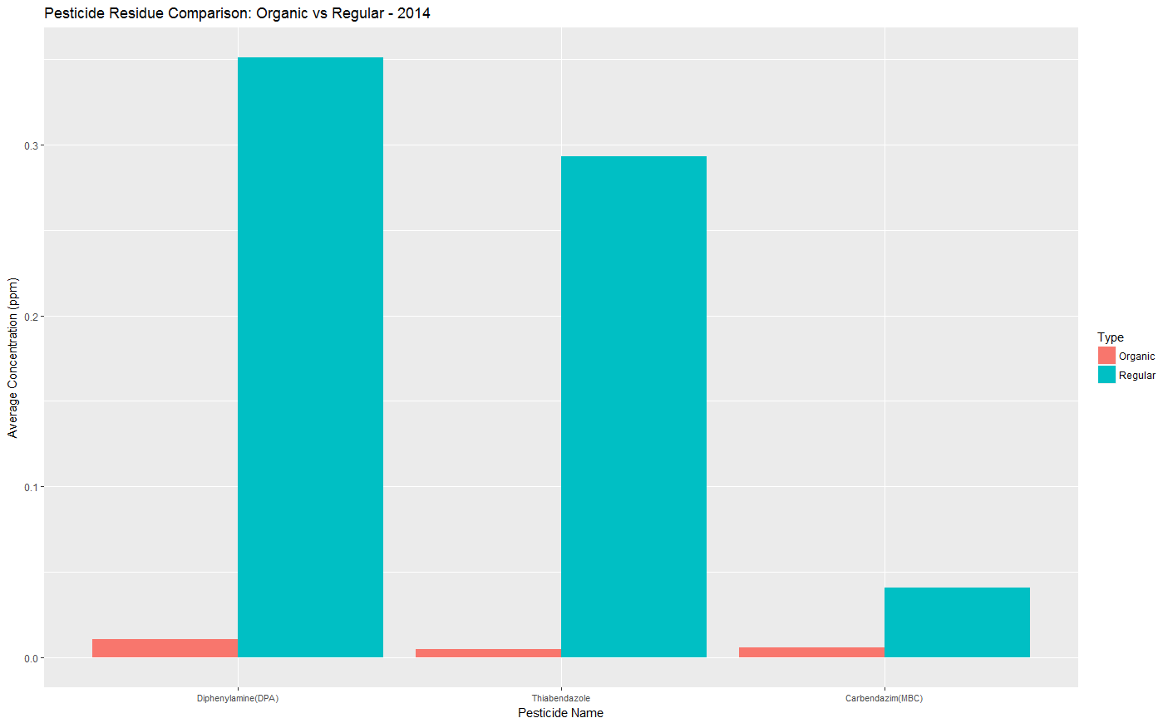

2014 Organic vs Conventional Comparison

The group bar chart plots the average concentrations of the pesticides found common in the regular and the organic samples of apples.

The average concentrations of these pesticides have been plotted in the decreasing order of frequency of residue detection. From the grouped bar chart, it is evident that the regular samples of apples in 2014 have a significantly higher average concentration of the pesticides than their organic counterparts. It can also be interpreted that only 4 kinds of pesticides are actually detected on organic apples (3 of which are also found on conventional apples) whereas for the regular apples, the number of varieties of pesticides found is 43. It can be interpreted that organic apples are definitely a healthier alternative to the regular apples.

Total Word Count: 920