

 | Nutan Maharashtra Vidya Prasarak Mandal’s
NUTAN MAHARASHTRA INSTITUTE OF
ENGINEERING AND TECHNOLOGY
 | Under Administrative Support - Pimpri Chinchwad Education Trust
Approved by AICTE |  | Accredited by NAAC | Affiliated to SPPU
“Samarth Vidya Sankul”, Vishnupuri, Telegaon Dabhade, Taluka Maval, District Pune - 410507
Tel. No. 02114 – 231666, E-mail :nmiettalegaon@gmail.com Web : www.nmiet.edu.in

S.Y. B.Tech (Computer Engineering)
Semester III
Course: Scientific Computing with Python (CE25VSEC-209A)

MINI PROJECT REPORT
on
“Penguin Data Analysis and Visualization Using Python”

Assignment – 12: Data Analysis & Visualization

Submitted by: Mayuresh Ganesh Chaudhary
Roll No.: SECC111 Division: C
Under the guidance of:

Department of Computer Engineering
Nutan Maharashtra Institute Of Engineering And Technology

Academic Year: 2026 – 2027

Index
Sr. No. | Section
1 | Title
2 | Aim
3 | Dataset Description
4 | Tools and Technologies
5 | Data Cleaning
6 | Data Analysis
7 | Data Visualization
8 | Findings / Observations
9 | Result / Screenshots
10 | GitHub Link
11 | Conclusion
12 | References

Note: The yellow-highlighted text in this report (name, roll number, guide, college, GitHub link) is a placeholder and should be replaced with your own details before submission.

1. Title

Penguin Data Analysis and Visualization Using Python

Data Cleaning with Pandas · Numerical Analysis with NumPy · Visualization with Matplotlib and Seaborn

This mini project applies the Python scientific computing stack to the Palmer Penguins dataset, a real-world collection of physical measurements of three penguin species recorded in Antarctica. The project covers the complete workflow of a basic data-science task: loading raw data, detecting and fixing quality problems, computing statistics, creating charts, and drawing conclusions from them.

2. Aim
Aim: To choose a real-world dataset and perform (a) data cleaning using Pandas, (b) numerical analysis using NumPy, (c) data visualization using Matplotlib and Seaborn, and (d) to prepare a brief report of the findings.

2.1 Objectives
- To load a real dataset into a Pandas DataFrame and understand its structure.
- To detect missing values and duplicate records and handle them correctly.
- To compute descriptive statistics such as average, minimum, maximum, total, standard deviation and correlation using NumPy and Pandas.
- To create bar, line, histogram, scatter, heatmap and box plots with proper titles, labels and legends.
- To interpret the plots and report meaningful patterns about the three penguin species.

2.2 Introduction
Data analysis is the process of inspecting, cleaning, transforming and modelling data in order to discover useful information. Python has become one of the most popular languages for this work because of its simple syntax and its powerful libraries: NumPy for fast numerical arrays, Pandas for tabular data handling, and Matplotlib and Seaborn for visualization.
Raw data is rarely perfect. Real datasets usually contain empty cells, repeated rows, inconsistent text and wrong data types. If such data is analysed without cleaning, the results can be misleading. Therefore a standard data-analysis project follows the order: collect data, clean it, analyse it, visualize it, and finally interpret the results.
In this project the Palmer Penguins dataset is used. It describes the bill length, bill depth, flipper length and body mass of penguins belonging to three species (Adelie, Chinstrap and Gentoo) living on three islands of the Palmer Archipelago, Antarctica. The dataset is small enough to understand completely, yet it contains missing values and several numerical and categorical columns, which makes it suitable for demonstrating every step of the syllabus.

2.3 Relation with the Syllabus
The project combines several experiments of the course Scientific Computing with Python (CE25VSEC-209A):
Experiment | Topic | Used in this project
2 – 4 | NumPy arrays, vectorized operations, statistics | np.mean, np.std, np.percentile, np.corrcoef
5 | Series, DataFrame, read/write CSV, head, tail, describe | pd.read_csv, df.head, df.describe, df.to_csv
6 | Missing values, filtering, sorting, groupby | isnull, fillna, dropna, sort_values, groupby
7 – 8 | Matplotlib: line, bar, scatter, histogram, labels, legend, grid | plt.plot, plt.title, plt.legend, plt.grid
9 | Seaborn statistical plots | barplot, histplot, scatterplot, boxplot
10 | Summary statistics, missing values, heatmap | df.describe, sns.heatmap
12 | Mini project | Complete workflow of this report

3. Dataset Description
Property | Details
Dataset name | Palmer Penguins (penguins.csv)
Source | Seaborn data repository on GitHub (github.com/mwaskom/seaborn-data), also available on Kaggle. The original data was collected by Dr. Kristen Gorman and the Palmer Station Long Term Ecological Research (LTER) programme, Antarctica.
Number of records | 344 rows (342 after cleaning)
Number of columns | 7
Domain | Biology / Environmental science
File format | CSV (Comma Separated Values)

The dataset contains physical measurements of adult penguins. Each row represents one penguin. The measurements are used by scientists to understand how body size differs between species and between males and females.

3.1 Attributes (columns)
Column | Data type | Description
species | Categorical | Penguin species: Adelie, Chinstrap or Gentoo
island | Categorical | Island where the penguin was observed: Biscoe, Dream or Torgersen
bill_length_mm | Float | Length of the bill (beak) in millimetres
bill_depth_mm | Float | Depth (thickness) of the bill in millimetres
flipper_length_mm | Float | Length of the flipper in millimetres
body_mass_g | Float | Body weight in grams
sex | Categorical | Male or Female

3.2 Sample of the Raw Data
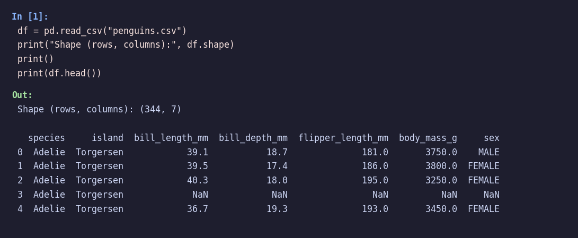
Fig 3.1: Loading the dataset and viewing the first five records
The fourth record (index 3) contains NaN in all four measurement columns and in the sex column. This is the first sign that the data needs cleaning before analysis.

3.3 Structure of the Dataset
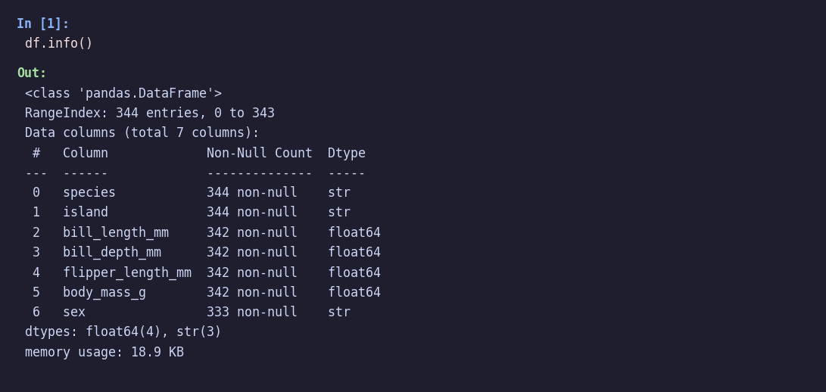
Fig 3.2: Output of df.info()
The output shows 344 entries in total. The four measurement columns have only 342 non-null values and the sex column has only 333, which confirms that some values are missing.

4. Tools and Technologies
Tool | Purpose in this project
Python 3 | General purpose programming language used to write the complete project.
Pandas | Loading the CSV file, finding missing values, filling or dropping them, removing duplicates, grouping and summarising data.
NumPy | Numerical calculations on arrays: mean, minimum, maximum, sum, median, standard deviation, percentiles and correlation coefficient.
Matplotlib | Base plotting library used for figure size, titles, axis labels, legends, grid and saving figures.
Seaborn | High-level statistical graphs built on Matplotlib: bar plot, histogram with KDE, scatter plot, heatmap and box plot.
Jupyter Notebook / Google Colab | Interactive environment in which code, output and charts appear together.

4.1 Brief Description of the Libraries
Pandas provides the DataFrame, a two-dimensional table with labelled rows and columns. Functions such as read_csv(), isnull(), fillna(), dropna(), drop_duplicates() and groupby() make data preparation quick and readable.
NumPy provides the ndarray, a fast multi-dimensional array. Operations are vectorized, which means they are applied to the whole array at once without writing loops. This makes numerical computation efficient.
Matplotlib is the most widely used plotting library in Python. It gives full control over every element of a figure. Seaborn sits on top of Matplotlib and offers attractive default styles and simple functions for statistical graphics.

4.2 Project Workflow
Step 1: Import libraries and load the dataset.
Step 2: Inspect the data (head, info, shape).
Step 3: Detect missing values and duplicates.
Step 4: Clean the data using Pandas.
Step 5: Analyse the cleaned data using NumPy and Pandas.
Step 6: Create visualizations using Matplotlib and Seaborn.
Step 7: Interpret the results and write the report.

4.3 Importing the Libraries
import pandas as pd
import numpy as np
import matplotlib.pyplot as plt
import seaborn as sns

sns.set_theme(style="whitegrid")
pd.set_option("display.width", 200)
pd.set_option("display.max_columns", 20)
print("Pandas:", pd.__version__, "| NumPy:", np.__version__)
Output:
Pandas: 3.0.2 | NumPy: 2.4.4

5. Data Cleaning
Data cleaning prepares the raw data for analysis. The following checks and corrections were performed using Pandas.

5.1 Missing Values Found
print("Missing values per column:")
print(df.isnull().sum())
print()
print("Total duplicate rows:", df.duplicated().sum())
print("Unique values in sex:", df["sex"].unique())
Output:
Missing values per column:
species 0
island 0
bill_length_mm 2
bill_depth_mm 2
flipper_length_mm 2
body_mass_g 2
sex 11
dtype: int64

Total duplicate rows: 0
Unique values in sex: <StringArray>
['MALE', 'FEMALE', nan]
Length: 3, dtype: str

Column | Missing values | Remark
bill_length_mm | 2 | Same two rows are empty in all measurements
bill_depth_mm | 2 | Same two rows
flipper_length_mm | 2 | Same two rows
body_mass_g | 2 | Same two rows
sex | 11 | 2 are the empty rows above; 9 other penguins have unknown sex
species, island | 0 | Complete

Two records were completely empty in all four measurement columns and also in sex. Nine more penguins had valid measurements but their sex was not recorded. No duplicate rows were found.

5.2 Missing Values Handled
Different strategies were applied to different columns:
- Measurements: The two rows with no measurements carry no useful information, so they were removed with dropna(subset=..., how="all"). Filling them with an average would create fake data.
- Sex: The nine rows with only the sex missing still have valid measurements. Deleting them would waste good data, so the missing values were replaced with the label “Unknown” using fillna().

5.3 Duplicate Records, Incorrect Data and Column Selection
- Duplicates: df.duplicated().sum() returned 0, so no records had to be removed. drop_duplicates() was still applied as a safety step.
- Incorrect / inconsistent data: The sex values were written in capital letters (MALE, FEMALE). They were converted to title case (Male, Female) using str.title() to make charts and labels look neat.
- Data types: The species and island columns were converted to the category type, which saves memory and is the correct type for labels.
- Columns selected: All seven columns are useful. The four numeric columns (bill length, bill depth, flipper length and body mass) were selected for statistical analysis and correlation.

5.4 Cleaning Code and Result
# 1. Drop rows where all measurements are missing (2 empty records)
measure_cols = ["bill_length_mm", "bill_depth_mm", "flipper_length_mm", "body_mass_g"]
df = df.dropna(subset=measure_cols, how="all")

# 2. Fill the missing 'sex' values with "UNKNOWN" instead of deleting them
df["sex"] = df["sex"].fillna("UNKNOWN")

# 3. Remove duplicate records
df = df.drop_duplicates()

# 4. Standardise text values (MALE -> Male) and convert to category
df["sex"] = df["sex"].str.title()
df["species"] = df["species"].astype("category")
df["island"] = df["island"].astype("category")

# 5. Reset index and verify
df = df.reset_index(drop=True)
print("Shape after cleaning:", df.shape)
print()
print(df.isnull().sum())
print()
print(df["sex"].value_counts())
Output:
Shape after cleaning: (342, 7)

species 0
island 0
bill_length_mm 0
bill_depth_mm 0
flipper_length_mm 0
body_mass_g 0
sex 0
dtype: int64

sex
Male 168
Female 165
Unknown 9
Name: count, dtype: int64

After cleaning, the dataset has 342 rows and 7 columns, with zero missing values. The sex column now contains 168 Male, 165 Female and 9 Unknown records.
Check | Before cleaning | After cleaning
Total rows | 344 | 342
Total columns | 7 | 7
Missing in measurements | 2 rows | 0
Missing in sex | 11 | 0 (9 labelled Unknown)
Duplicate rows | 0 | 0

6. Data Analysis
Statistical analysis was carried out on the cleaned data using NumPy and Pandas. The target variable for the main calculations is body mass, since it is the most important measure of penguin size.

6.1 Analysis with NumPy
mass = df["body_mass_g"].to_numpy()

print("Body mass (g) analysed with NumPy")
print("Average :", round(np.mean(mass), 2))
print("Minimum :", np.min(mass))
print("Maximum :", np.max(mass))
print("Total :", np.sum(mass))
print("Median :", np.median(mass))
print("Std. Dev. :", round(np.std(mass), 2))
print("25th / 75th percentile:", np.percentile(mass, 25), "/", np.percentile(mass, 75))
Output:
Body mass (g) analysed with NumPy
Average : 4201.75
Minimum : 2700.0
Maximum : 6300.0
Total : 1437000.0
Median : 4050.0
Std. Dev. : 800.78
25th / 75th percentile: 3550.0 / 4750.0

Statistic (body mass) | Value | NumPy function
Average (mean) | 4201.75 g | np.mean()
Minimum | 2700 g | np.min()
Maximum | 6300 g | np.max()
Total | 1,437,000 g | np.sum()
Median | 4050 g | np.median()
Standard deviation | 800.78 g | np.std()
25th percentile | 3550 g | np.percentile()
75th percentile | 4750 g | np.percentile()

The average penguin weighs about 4.2 kg, the lightest weighs 2.7 kg and the heaviest 6.3 kg. The mean (4201.75 g) is higher than the median (4050 g), which indicates that the distribution is slightly skewed towards heavier birds, mainly the large Gentoo penguins.
Note on standard deviation: np.std() calculates the population standard deviation (800.78), whereas Pandas describe() uses the sample standard deviation (801.95). The small difference is expected because the two use different divisors (n and n−1).

6.2 Summary Statistics with Pandas
print(df.describe().round(2))
Output:
bill_length_mm bill_depth_mm flipper_length_mm body_mass_g
count 342.00 342.00 342.00 342.00
mean 43.92 17.15 200.92 4201.75
std 5.46 1.97 14.06 801.95
min 32.10 13.10 172.00 2700.00
25% 39.22 15.60 190.00 3550.00
50% 44.45 17.30 197.00 4050.00
75% 48.50 18.70 213.00 4750.00
max 59.60 21.50 231.00 6300.00

6.3 Group-wise Analysis
print(df.groupby("species", observed=True)[measure_cols].mean().round(2))
print()
print(df.groupby("sex", observed=True)["body_mass_g"].mean().round(2))
print()
print(df["species"].value_counts())
Output:
bill_length_mm bill_depth_mm flipper_length_mm body_mass_g
species
Adelie 38.79 18.35 189.95 3700.66
Chinstrap 48.83 18.42 195.82 3733.09
Gentoo 47.50 14.98 217.19 5076.02

sex
Female 3862.27
Male 4545.68
Unknown 4005.56
Name: body_mass_g, dtype: float64

species
Adelie 151
Gentoo 123
Chinstrap 68
Name: count, dtype: int64

Species | Count | Avg bill length (mm) | Avg flipper (mm) | Avg body mass (g)
Adelie | 151 | 38.79 | 189.95 | 3700.66
Chinstrap | 68 | 48.83 | 195.82 | 3733.09
Gentoo | 123 | 47.50 | 217.19 | 5076.02

Gentoo penguins are clearly the largest, with an average mass of 5076 g and the longest flippers. Adelie and Chinstrap penguins have almost the same average body mass, but Chinstrap penguins have much longer bills. On average, males (4545.68 g) are heavier than females (3862.27 g).

6.4 Correlation Analysis
corr = df[measure_cols].corr().round(2)
print(corr)
print()
r = np.corrcoef(df["flipper_length_mm"], df["body_mass_g"])[0, 1]
print("NumPy correlation (flipper length vs body mass):", round(r, 3))
Output:
bill_length_mm bill_depth_mm flipper_length_mm body_mass_g
bill_length_mm 1.00 -0.24 0.66 0.60
bill_depth_mm -0.24 1.00 -0.58 -0.47
flipper_length_mm 0.66 -0.58 1.00 0.87
body_mass_g 0.60 -0.47 0.87 1.00

NumPy correlation (flipper length vs body mass): 0.871

 | Bill length | Bill depth | Flipper length | Body mass
Bill length | 1.00 | -0.24 | 0.66 | 0.60
Bill depth | -0.24 | 1.00 | -0.58 | -0.47
Flipper length | 0.66 | -0.58 | 1.00 | 0.87
Body mass | 0.60 | -0.47 | 0.87 | 1.00

Flipper length and body mass have a strong positive correlation (r = 0.87): penguins with longer flippers are generally heavier. Bill depth shows a negative correlation with the other measurements. This surprising result is explained in the visualization section, where species are shown separately.

7. Data Visualization
Six graphs were created. Each graph has a title, labelled axes and, where needed, a legend. The code for each plot is shown below the figure.

7.1 Bar Chart – Number of Penguins by Species
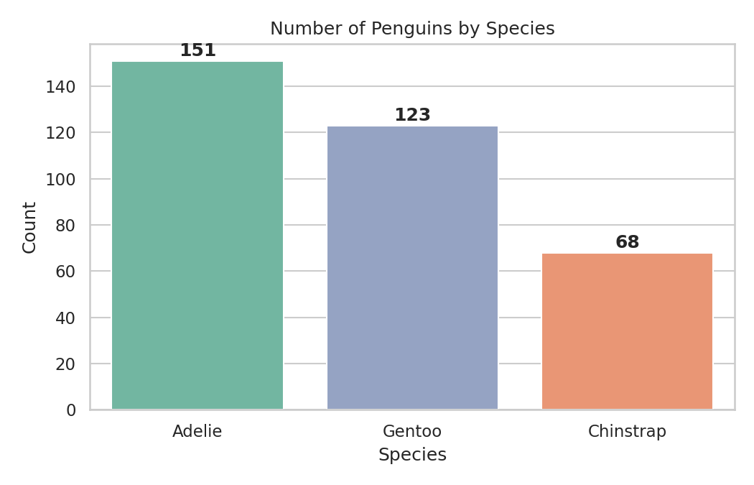
Fig 7.1: Bar chart of penguin count per species

counts = df["species"].value_counts()
plt.figure(figsize=(7, 4.5))
ax = sns.barplot(x=counts.index, y=counts.values, hue=counts.index, palette="Set2", legend=False, dodge=False, order=counts.index)
for i, v in enumerate(counts.values):
ax.text(i, v + 2, str(v), ha="center", fontweight="bold")
plt.title("Number of Penguins by Species")
plt.xlabel("Species")
plt.ylabel("Count")
plt.tight_layout()
plt.savefig("fig1_bar.png", dpi=150)
plt.show()

The bar chart shows that Adelie is the most common species in the dataset (151), followed by Gentoo (123) and Chinstrap (68).

7.2 Line Chart – Body Mass Trend with Flipper Length

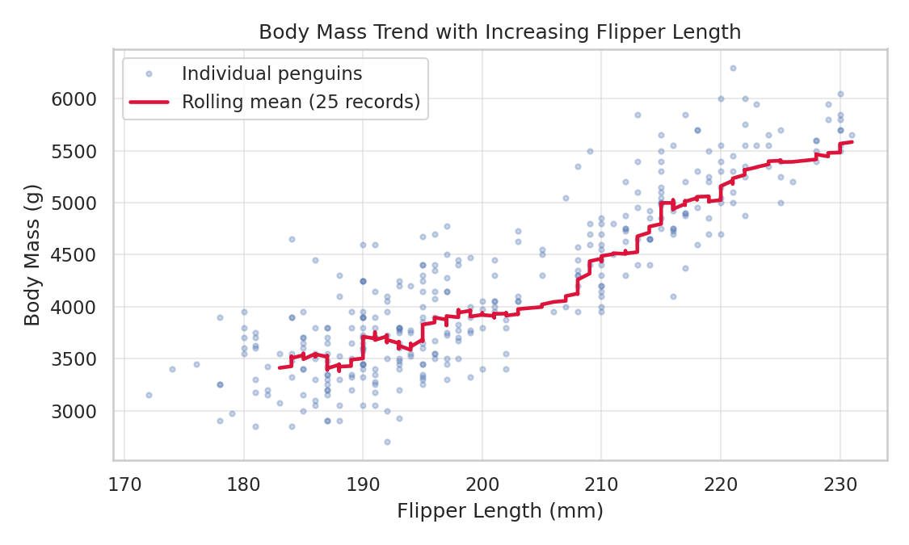
Fig 7.2: Line chart showing rolling mean of body mass against flipper length

avg_mass = df.groupby("species", observed=True)[["bill_length_mm", "flipper_length_mm"]].mean()
sorted_df = df.sort_values("flipper_length_mm").reset_index(drop=True)
rolling = sorted_df["body_mass_g"].rolling(window=25).mean()
plt.figure(figsize=(7.5, 4.5))
plt.plot(sorted_df["flipper_length_mm"], sorted_df["body_mass_g"], ".", alpha=0.3, label="Individual penguins")
plt.plot(sorted_df["flipper_length_mm"], rolling, color="crimson", linewidth=2.2, label="Rolling mean (25 records)")
plt.title("Body Mass Trend with Increasing Flipper Length")
plt.xlabel("Flipper Length (mm)")
plt.ylabel("Body Mass (g)")
plt.legend()
plt.grid(True, alpha=0.4)
plt.tight_layout()
plt.savefig("fig2_line.png", dpi=150)
plt.show()

The red line is the rolling mean of body mass after sorting penguins by flipper length. It rises steadily, showing that body mass increases as flippers get longer.

7.3 Histogram – Distribution of Body Mass
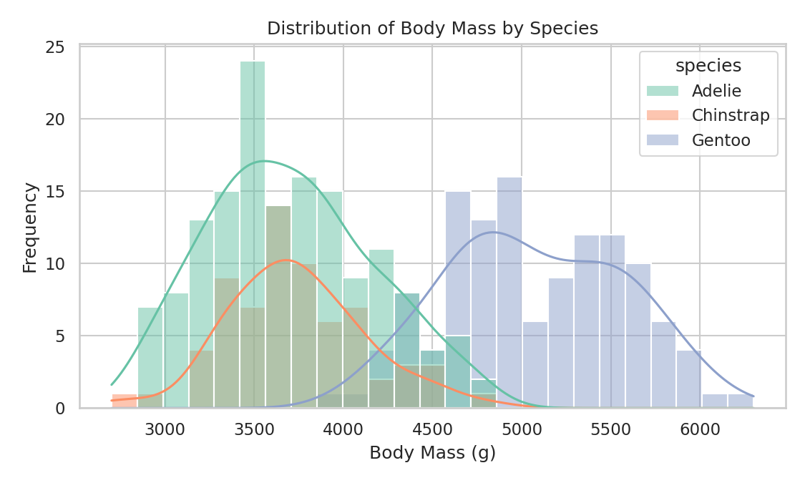
Fig 7.3: Histogram of body mass by species
plt.figure(figsize=(7.5, 4.5))
sns.histplot(data=df, x="body_mass_g", hue="species", bins=25, kde=True, palette="Set2")
plt.title("Distribution of Body Mass by Species")
plt.xlabel("Body Mass (g)")
plt.ylabel("Frequency")
plt.tight_layout()
plt.savefig("fig3_hist.png", dpi=150)
plt.show()
Adelie and Chinstrap penguins overlap around 3500–4000 g, while Gentoo penguins form a separate group centred near 5000 g. This explains why the overall mean is higher than the median.

7.4 Scatter Plot – Flipper Length vs Body Mass
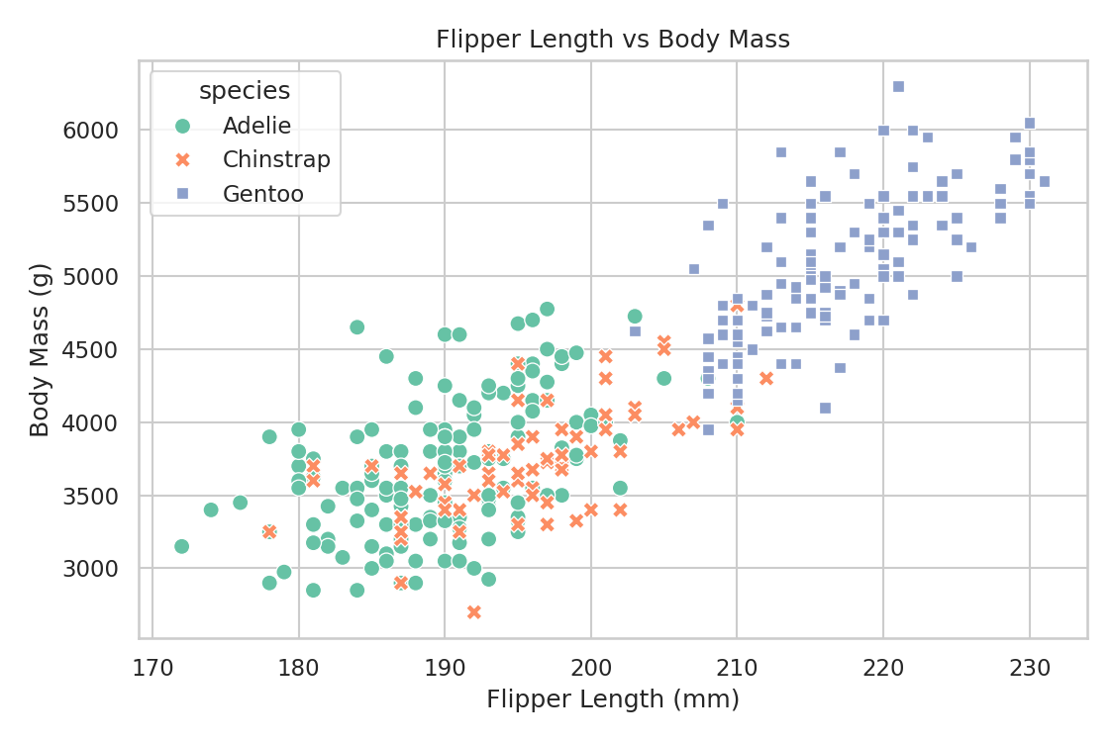
Fig 7.4: Scatter plot of flipper length against body mass
plt.figure(figsize=(7.5, 5))
sns.scatterplot(data=df, x="flipper_length_mm", y="body_mass_g", hue="species", style="species", s=60, palette="Set2")
plt.title("Flipper Length vs Body Mass")
plt.xlabel("Flipper Length (mm)")
plt.ylabel("Body Mass (g)")
plt.tight_layout()
plt.savefig("fig4_scatter.png", dpi=150)
plt.show()
The points form an upward-sloping pattern, confirming the positive relationship. Gentoo penguins (squares) are located in the top-right corner with the longest flippers and highest mass, while Adelie and Chinstrap penguins overlap in the lower-left region.

7.5 Heatmap – Correlation Matrix
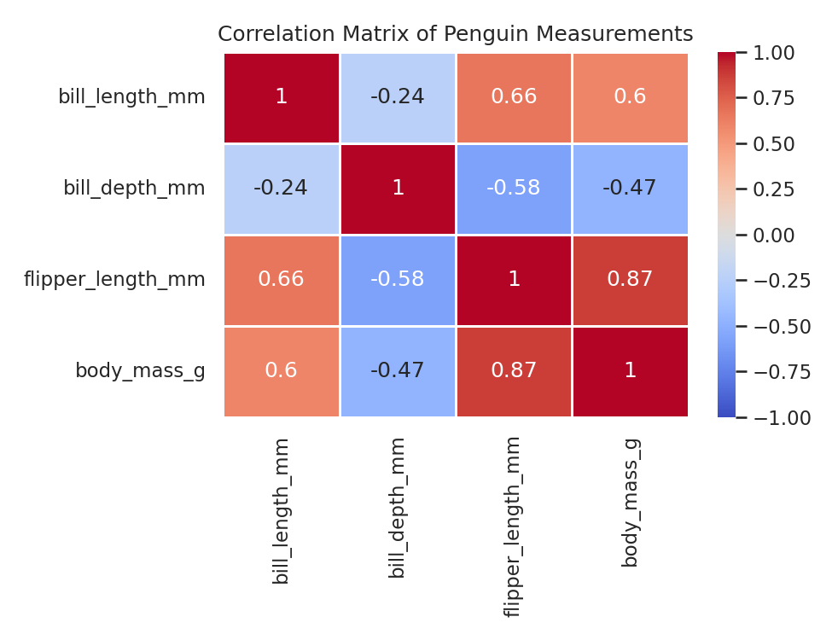
Fig 7.5: Correlation heatmap of the four measurements
plt.figure(figsize=(6.5, 5))
sns.heatmap(corr, annot=True, cmap="coolwarm", vmin=-1, vmax=1, linewidths=0.5)
plt.title("Correlation Matrix of Penguin Measurements")
plt.tight_layout()
plt.savefig("fig5_heatmap.png", dpi=150)
plt.show()
Red cells mean strong positive correlation and blue cells mean negative correlation. The darkest cell outside the diagonal is flipper length vs body mass (0.87). Bill depth is negatively related to flipper length (−0.58).

7.6 Box Plot – Body Mass by Species and Sex
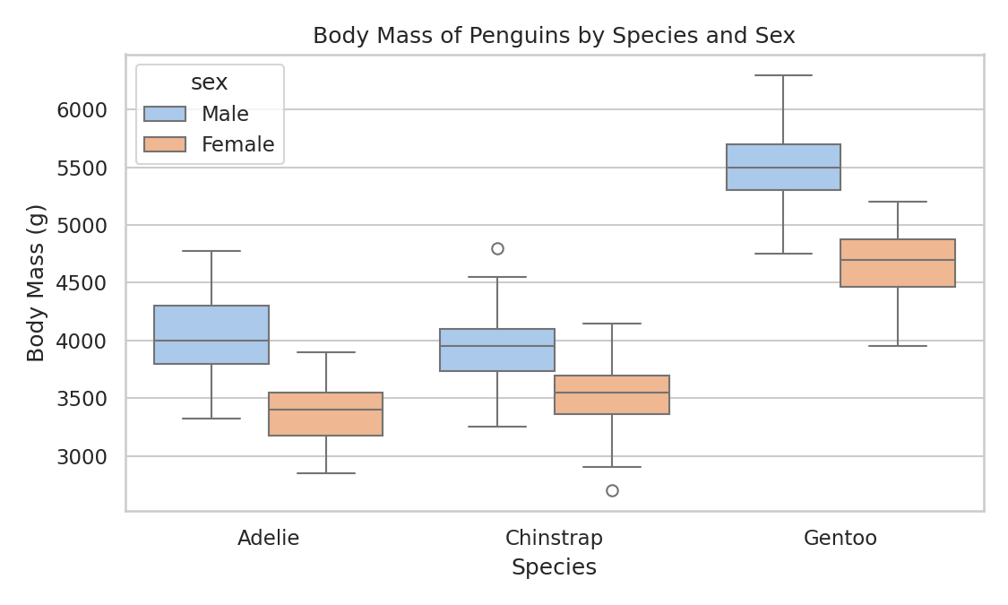
Fig 7.6: Box plot of body mass for each species, split by sex
plt.figure(figsize=(7.5, 4.5))
sns.boxplot(data=df[df["sex"] != "Unknown"], x="species", y="body_mass_g", hue="sex", palette="pastel")
plt.title("Body Mass of Penguins by Species and Sex")
plt.xlabel("Species")
plt.ylabel("Body Mass (g)")
plt.tight_layout()
plt.savefig("fig6_box.png", dpi=150)
plt.show()
In every species the male box lies above the female box, so males are heavier. The Gentoo boxes are far above those of the other two species. The small circles are outliers, i.e. unusually heavy or light individuals.

8. Findings / Observations
The following points were learned from the cleaning, the statistics and the graphs:
- The raw dataset had 344 records. Two records were completely empty and nine had no sex recorded, so data cleaning was necessary before analysis.
- Adelie is the most common species (151 penguins), followed by Gentoo (123) and Chinstrap (68).
- The average body mass of all penguins is about 4201.75 g, with a minimum of 2700 g and a maximum of 6300 g.
- Gentoo penguins are the heaviest (average 5076 g) and have the longest flippers (average 217 mm).
- Adelie and Chinstrap penguins have nearly the same average body mass (about 3700 g), but Chinstrap penguins have longer bills (48.8 mm vs 38.8 mm).
- A strong positive correlation (0.87) exists between flipper length and body mass.
- Males are heavier than females in all three species; the overall average is 4545.68 g for males and 3862.27 g for females.
- Bill depth shows a negative correlation with flipper length across the whole dataset, because the Gentoo species has long flippers but a shallow bill, while Adelie and Chinstrap have the opposite.

8.1 Limitations
- The dataset is small (342 records), so the findings apply only to this sample.
- Correlation does not prove cause and effect; it only shows that two measurements change together.
- The dataset has no date column, so a true time-series trend could not be studied.

8.2 Future Scope
- Build a machine-learning classifier that predicts the species from the four measurements.
- Use a larger multi-year dataset to study changes in penguin size over time.
- Create an interactive dashboard using Plotly or Streamlit.

9. Result / Screenshots
The following screenshots show the output of each cell of the Jupyter Notebook, with a short description of what it does. (You may replace these with screenshots taken from your own notebook run.)
Screenshot 1: Loading the dataset
Reads penguins.csv with pd.read_csv(), prints the shape (344 rows, 7 columns) and shows the first five records with head().
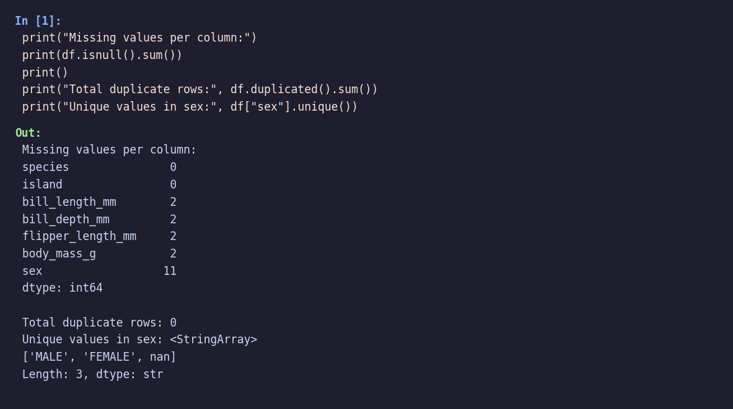
Screenshot 2: Detecting missing values
Uses isnull().sum() to count empty cells in each column and duplicated().sum() to count repeated rows.
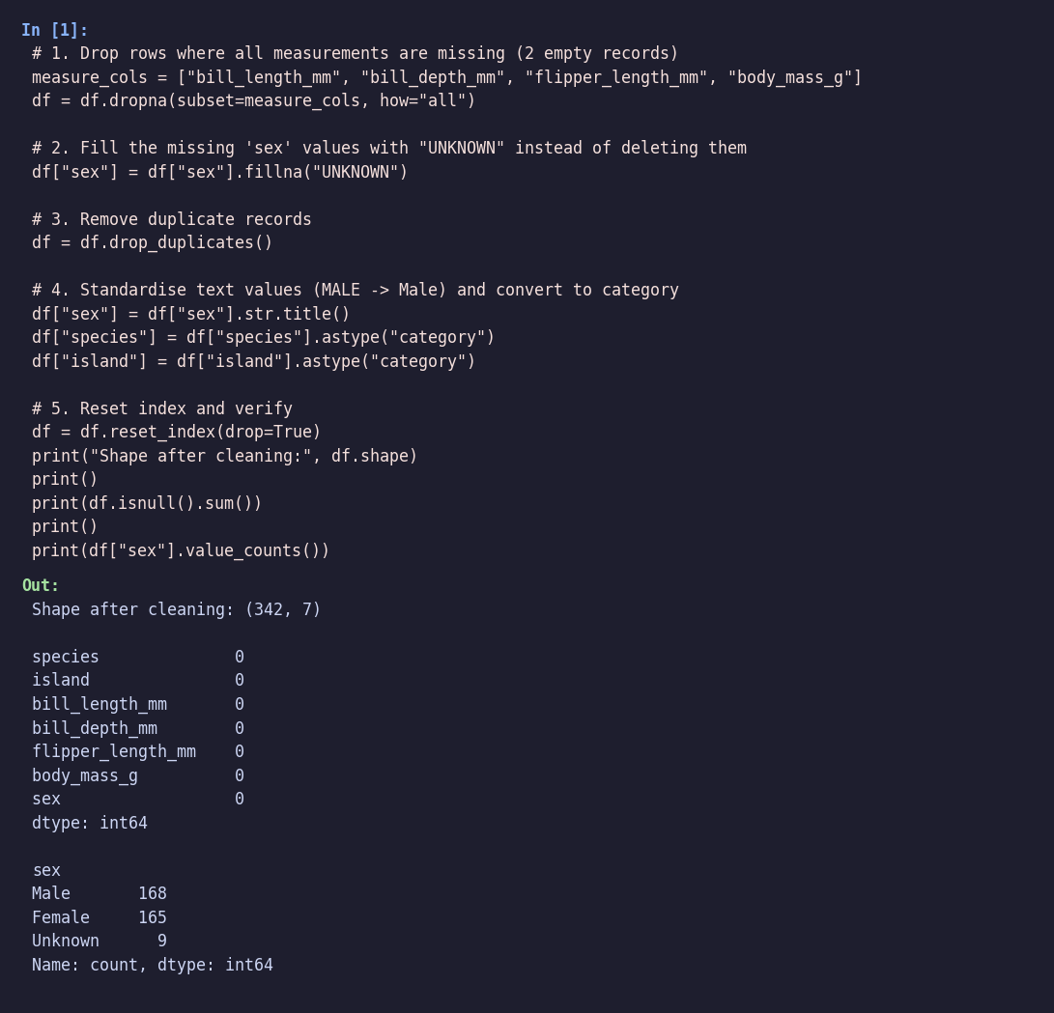
Screenshot 3: Data cleaning
Drops the empty rows, fills missing sex values, removes duplicates, standardises text and verifies that no missing values remain.
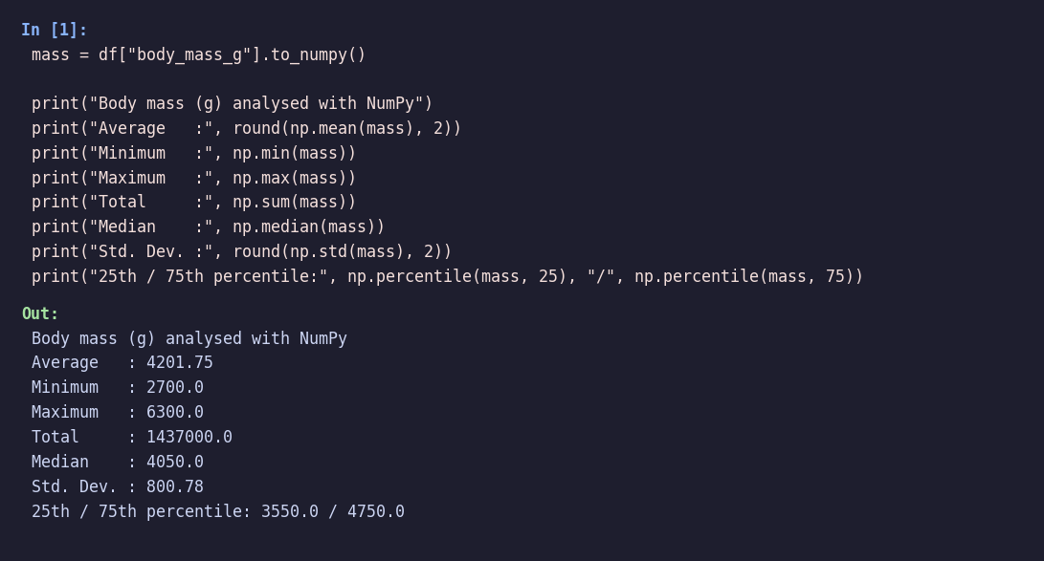
Screenshot 4: NumPy analysis
Converts body mass into a NumPy array and computes mean, minimum, maximum, total, median, standard deviation and percentiles.
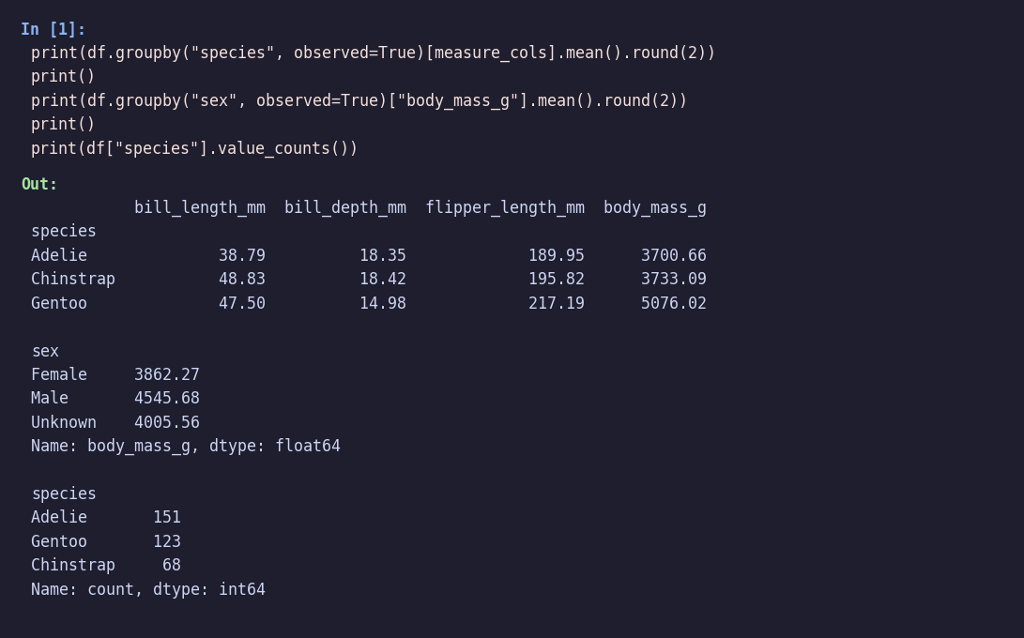
Screenshot 5: Group-wise analysis
groupby() calculates average measurements for each species and each sex, and value_counts() counts penguins per species.
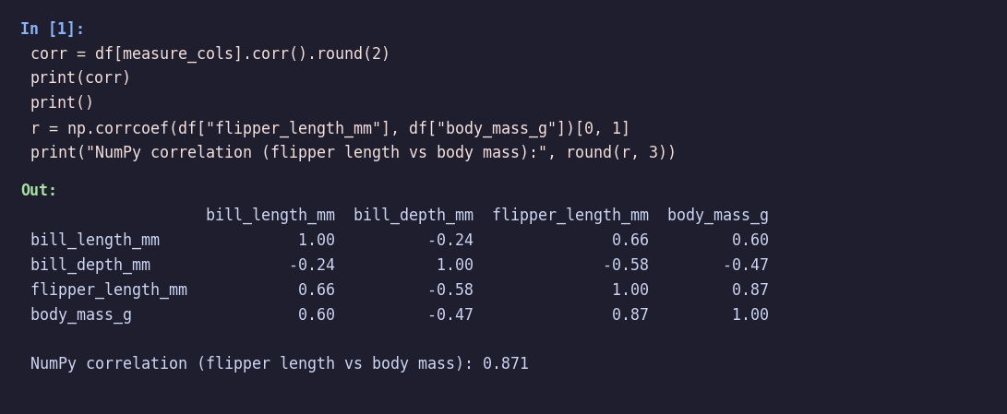
Screenshot 6: Correlation
Creates the correlation matrix with df.corr() and confirms the flipper-mass relationship with np.corrcoef().
Screenshot 7: Bar chart output
Displays the number of penguins in each species with count labels on top of every bar.
Screenshot 8: Histogram output
Shows how body mass is distributed for every species, with a smooth KDE curve over the bars.
Screenshot 9: Scatter plot output
Plots flipper length against body mass, with colours and markers identifying the species.
Screenshot 10: Heatmap output
Colour-coded correlation matrix; the numbers inside the cells show the correlation coefficients.

10. GitHub Link
The complete source code (Jupyter Notebook), the original dataset and the cleaned dataset are uploaded to GitHub:
GitHub Repository: https://github.com/<your-username>/penguin-data-analysis
Repository contents:
- Penguin_Data_Analysis.ipynb – complete notebook
- penguins.csv – original dataset
- penguins_cleaned.csv – dataset after cleaning
- README.md – short description of the project

11. Conclusion
This project demonstrated how Python libraries can be used to clean, analyse and visualize a real-world dataset. Pandas was used to detect and handle missing values, remove duplicates, standardise text and group the data. NumPy was used to calculate the mean, minimum, maximum, total, standard deviation, percentiles and correlation of the measurements. Matplotlib and Seaborn were used to create bar, line, histogram, scatter, heatmap and box plots.
The analysis of 342 cleaned penguin records showed that Gentoo penguins are the largest species, that males are heavier than females in all species, and that flipper length is strongly related to body mass (r = 0.87). The project also showed how important data cleaning is, since two empty records and eleven missing sex values had to be handled before reliable results could be obtained.
Overall, the project gave practical experience of the complete data-analysis workflow and of the Pandas, NumPy, Matplotlib and Seaborn functions listed in the syllabus of Scientific Computing with Python.

12. References
[1] Allen B. Downey, “Think Python: How to Think Like a Computer Scientist”, 2nd Edition, 2020, Green Tea Press.
[2] “Scientific Computing with Python (SciPy Lecture Notes)”, SciPy Community, Online Publication, Latest Edition, 2024.
[3] Robert Johansson, “Numerical Python: A Practical Techniques Approach”, 3rd Edition, 2023, Apress.
[4] Palmer Penguins dataset, Seaborn data repository: https://github.com/mwaskom/seaborn-data
[5] K. B. Gorman, T. D. Williams and W. R. Fraser, “Ecological sexual dimorphism and environmental variability within a community of Antarctic penguins (genus Pygoscelis)”, PLoS ONE, 2014.
[6] Pandas documentation: https://pandas.pydata.org/docs/
[7] NumPy documentation: https://numpy.org/doc/
[8] Matplotlib documentation: https://matplotlib.org/stable/
[9] Seaborn documentation: https://seaborn.pydata.org/

