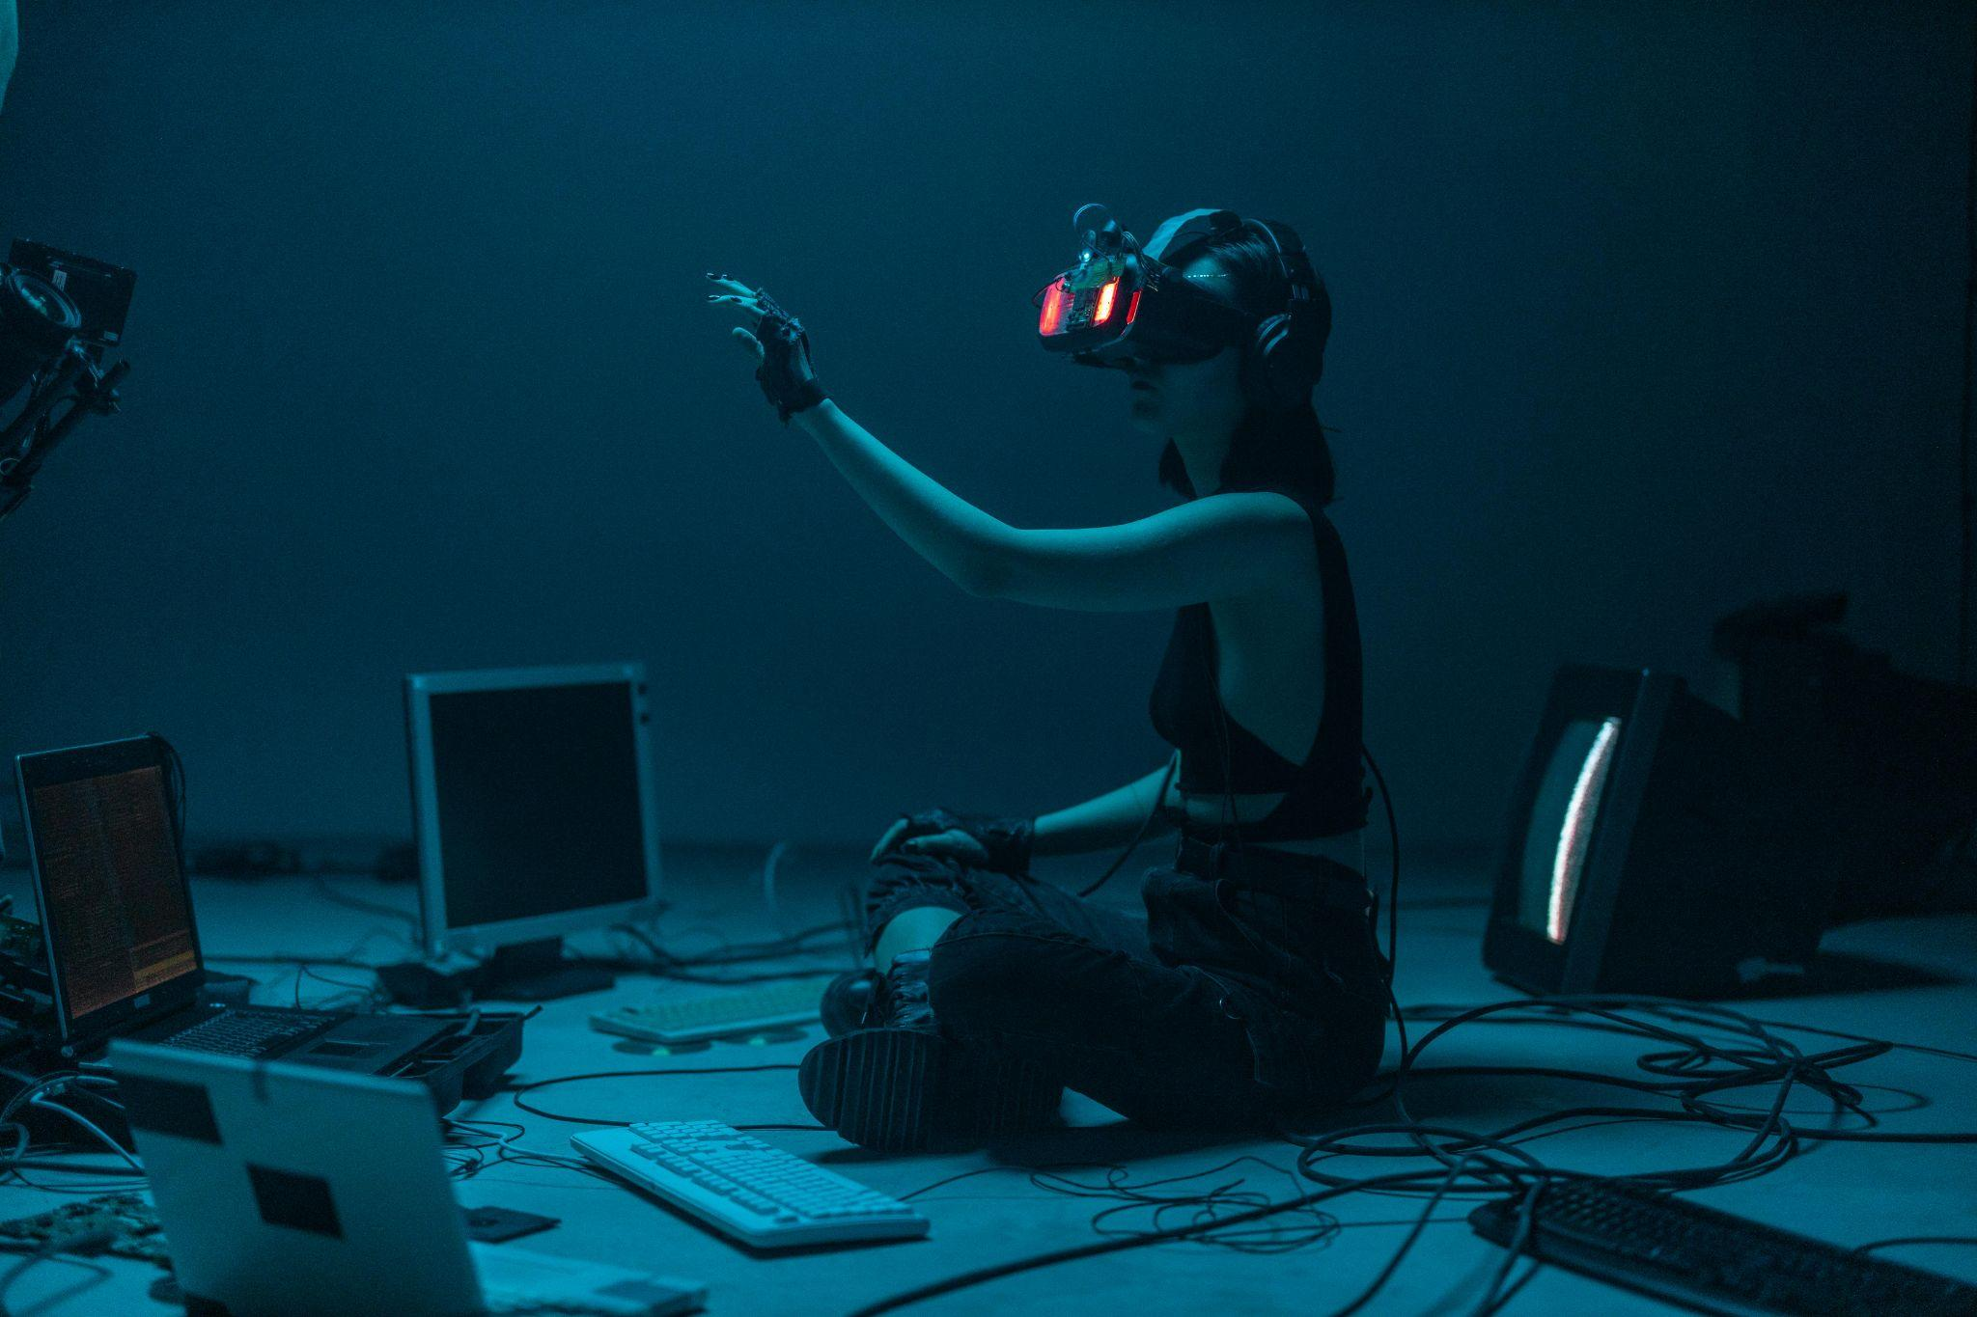
Navigating the AI Revolution: Trends, Image Generation, and Its Human Impact

Key Takeaways
- AI is now mainstream: From students to startups, people everywhere are harnessing AI to create, automate, and innovate.

- Image generation is booming: Tools like DALL-E 3 and Midjourney empower anyone to produce art, though risks like deepfakes and bias loom.

- It’s a societal shift: AI enhances creativity and accessibility, but also challenges ethics, jobs, and trust—demanding thoughtful regulation and human-centered design.

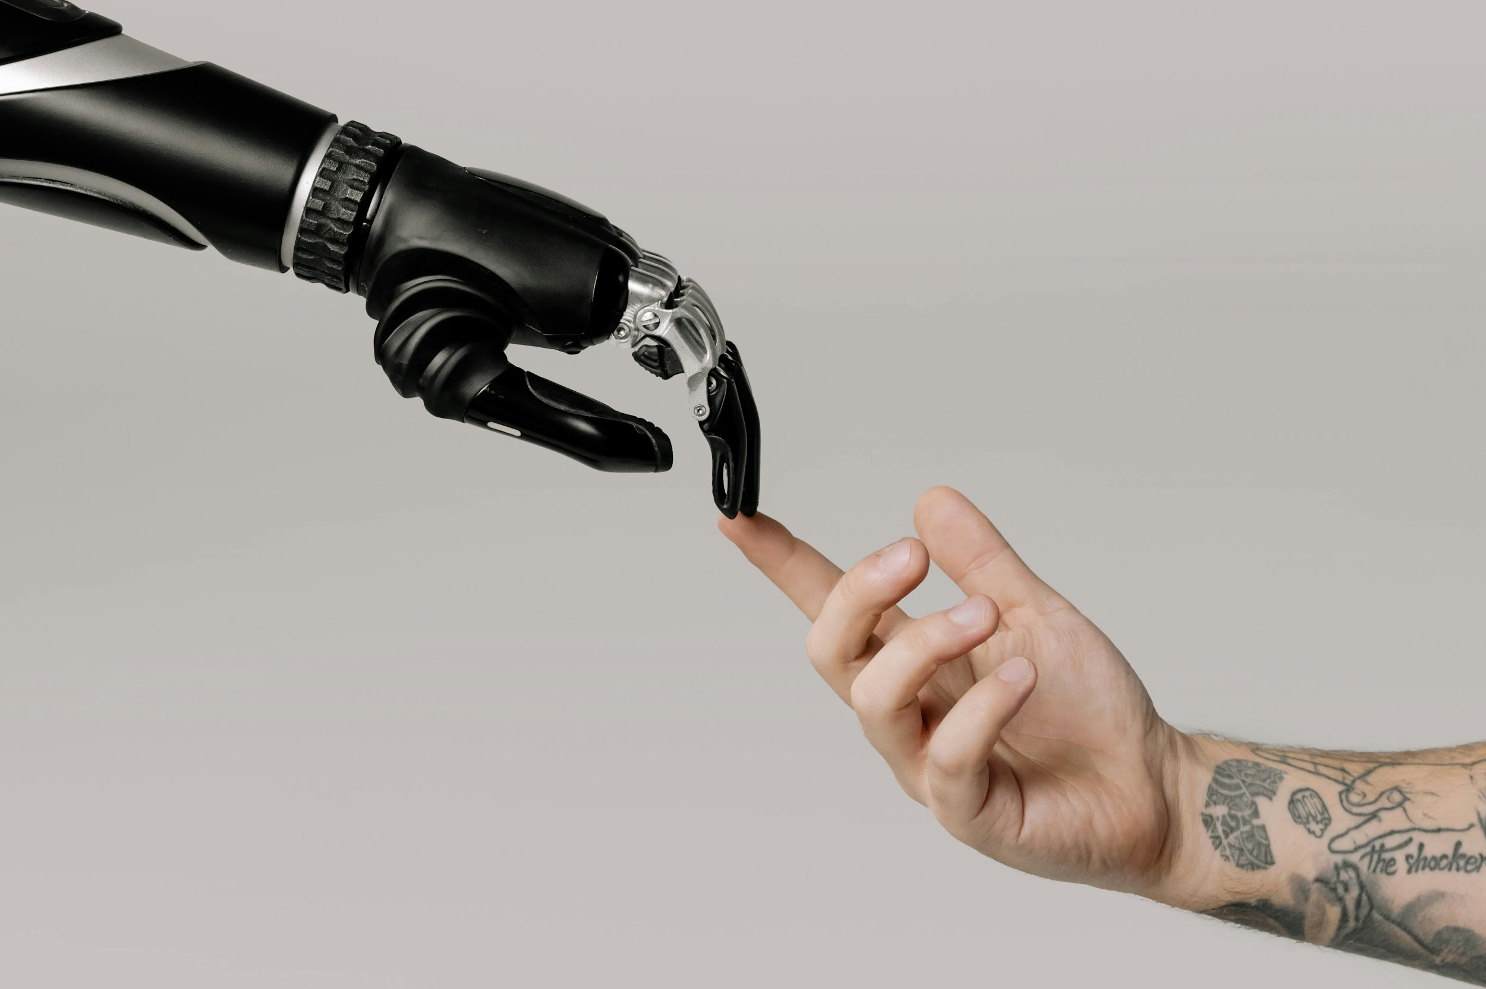
Artificial intelligence impact on humans

Imagine scrolling through your social feed and stumbling on a jaw-dropping landscape that looks like it was painted by a master artist—only to find out it was generated in seconds by AI.
Or picture a small business owner whipping up a professional logo without ever hiring a designer.
This isn’t science fiction. It’s the everyday reality of artificial intelligence in 2025—subtle, powerful, and everywhere.
From chatbots answering support tickets to tools predicting climate patterns with uncanny accuracy, AI is more than a buzzword—it’s transforming how we live, work, and create. But behind the tech wizardry lies a critical conversation: What’s really happening in AI today, how are people using it to create stunning visuals, and what does it all mean for humanity?

📈 Key AI Trends in 2025: From Exclusive to Everyday
In 2025, AI is no longer niche—it’s mainstream. The global market is projected to reach trillions, but what matters most is how it's being used on the ground.

🔹 Smarter, Cheaper, and More Accessible
Gone are the days when you needed a supercomputer to tinker with AI. Today’s models are smaller, faster, and open-source, making experimentation available to students, hobbyists, and small businesses alike.
- IBM highlights the shift to compact, open models that run on everyday devices.
- Farmers use AI to predict crop yields.
- Students build bots in dorm rooms.
- Creators generate polished content without a tech team.

🔹 Multimodal AI Is Exploding
AI now speaks multiple "languages"—text, images, voice, video—all in one go. Think of OpenAI’s GPT-4o: it can chat, draw, and interpret sketches simultaneously. Google’s Gemini does cinematic portraits and abstract fashion visuals with just a few lines of input.

🔹 AI Is Becoming a Partner, Not Just a Tool
Forget clunky assistants. 2025's AI agents book your trips, organize your week, and even troubleshoot your code, autonomously.
Meanwhile, conversational BI tools let anyone—yes, anyone—query big data using plain English, no analytics degree required.
Still, with power comes complexity. Gartner warns of growing regulatory pressures. As AI becomes more integrated, governments are scrambling to catch up, and so should we.

🎨 The Flashiest Frontier: AI Image Generation
Now zoom in on one of AI’s most exciting realms: image generation. It’s not just a trend—it’s an art revolution.
Tools like DALL·E 3, Midjourney, and Stable Diffusion now produce images that rival professional creatives. And it’s happening in seconds.

🔹 Trends to Watch
- Hyper-realism & personalization: AI visuals are almost indistinguishable from real photography.
- Multimodal inputs: Describe an idea using voice, sketch, or keywords—and watch AI bring it to life.
- Style-on-demand: From cyberpunk cities to anime characters to museum-quality landscapes, there's a style for everyone.
These tools are reshaping content creation. As Canva predicts, image generation will soon blend seamlessly with virtual and augmented reality, giving rise to immersive, personalized media.

👩‍💻 How People Are Using AI to Generate Images—Right Now
This isn’t just for tech pros. AI image generation is being used by kids, creatives, CEOs, and educators alike.

🔹 Real-World Use Cases
- A freelance marketer generates product visuals in seconds.
- Teachers build custom illustrations for lessons.
- Indie game devs create character art without hiring artists.
- Therapists help patients visualize emotions and progress.
Platforms like Bing Image Creator and Midjourney are exploding in popularity, empowering hobbyists to design sci-fi book covers, comic panels, and social media content—with no prior art skills.
But professional creators are in the mix too. In film and gaming, AI tools prototype entire scenes or concepts before human artists take over. Some see this as cheating, others as a new form of collaborative creativity.

⚖️ The Double-Edged Sword: Human Impacts of AI
Let’s be real. AI image generation is dazzling, but it’s not without consequences.

✅ The Upside
- Boosted productivity: A PNAS Nexus study found AI increases creative output by 25%.

- Accessibility: People with disabilities can now create visuals they previously couldn’t.

- Democratized creativity: Anyone can generate high-quality content, not just trained professionals.

⚠️ The Dark Side
- Misinformation: Deepfakes and AI-generated hoaxes are on the rise. Think "Pope in a puffer jacket"—amusing, but chilling.

- Bias: AI reflects societal stereotypes, often portraying "attractiveness" as young, white, and Western.

- Job displacement: Artists, designers, and VFX teams face real threats to their careers.

- Privacy & consent issues: Many models are trained on scraped data—often without permission.

- Cultural dilution: With millions of AI-generated images flooding the web, authentic voices risk being drowned out.
Yet, there’s hope. Organizations like the European Commission are pushing for AI ethics, transparency, and accountability. Companies are also training humans for hybrid roles, blending human insight with AI speed.

🌍 The Road Ahead: Humanity at the Center
As of October 2025, one thing is clear: AI isn't going away. It’s evolving faster than we can track, but how we guide it is still up to us.
AI didn’t invent creativity—we did.
Used wisely, it can amplify our imagination, not replace it. From stunning visuals to smart assistants, the tech is ready. But the real question is: Are we ready to steer it responsibly?

