SLE-3: ARCHITECTURAL DESIGN (FULL C4 MODEL)
Course: 02AML204 – Introduction to Artificial Intelligence

PRN: | 26UAM308 | Name:Mayuresh Patil
Division: | A | Name:Mayuresh Patil
GitHub | https://github.com/mayureshpatil7557-ops/SLE3_ArchitectureDesign-C4Models.git

Architecture Design of a Grid-Based Pathfinding System

1. System Title & Short Description
System Title: Architecture Design of a Grid-Based Pathfinding System
The Grid-Based Pathfinding System is an AI-based system designed to find a path between a starting point and a goal point in a grid environment. The grid may contain obstacles that the pathfinding algorithm must avoid. The system uses search algorithms such as Breadth-First Search (BFS) and A* to explore the grid and find a suitable path. A* uses the Manhattan Distance heuristic to guide its search toward the goal. The system can be used to understand and analyze how different search algorithms solve a pathfinding problem.

2. Context Diagram (C4 Level 1)

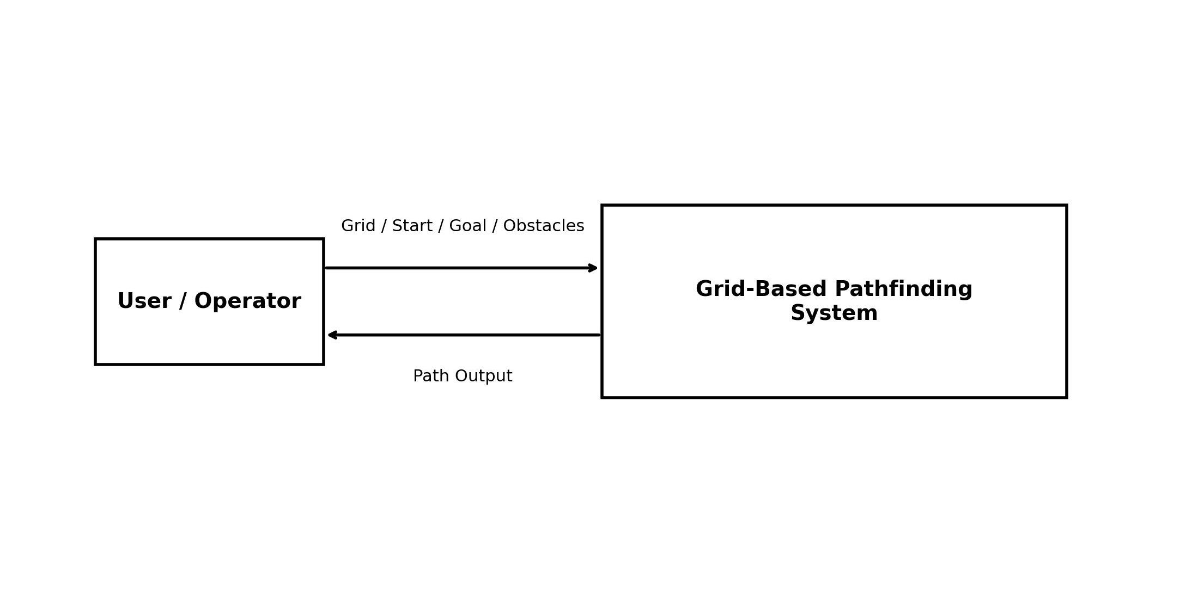
Short Explanation: The Context Diagram shows the Grid-Based Pathfinding System as one main system and the User / Operator as the external actor. The user provides the grid, starting point, goal point, and obstacles. The system processes the input and returns the calculated path as the path output.

3. Container Diagram (C4 Level 2)
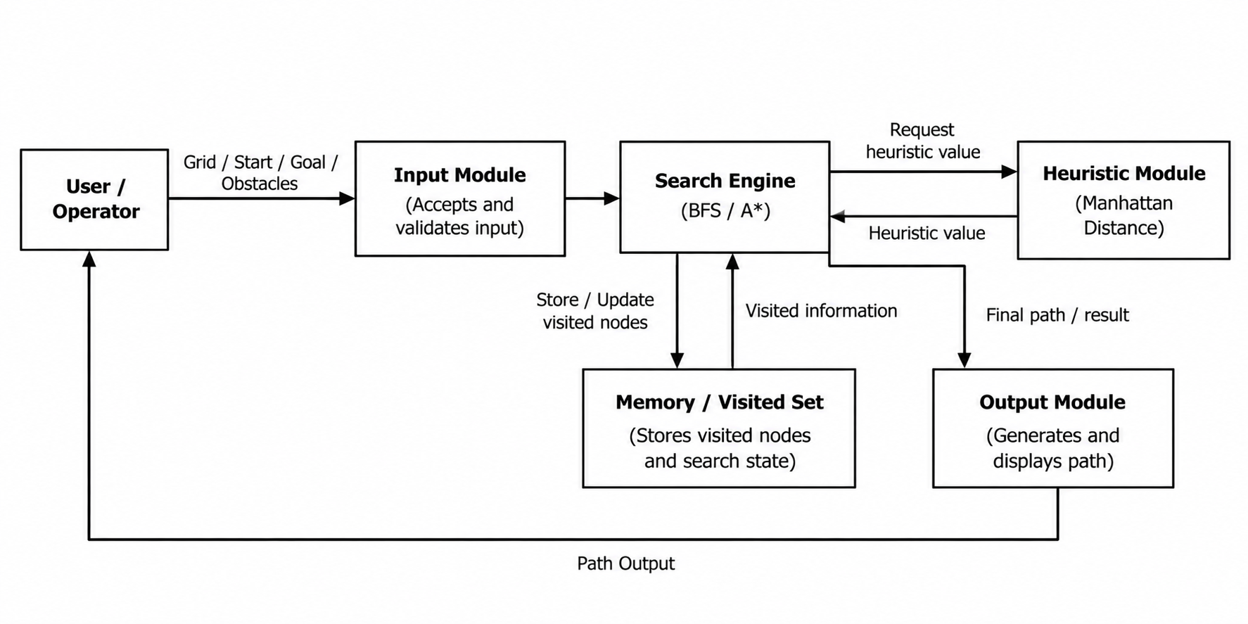
Container Responsibilities:
- Input Module – accepts and validates the grid, start point, goal point, and obstacles.
- Search Engine – performs the path search using BFS or A*.
- Heuristic Module – calculates the Manhattan Distance used by A*.
- Memory / Visited Set – stores visited nodes and search state to avoid unnecessary repeated exploration.
- Output Module – generates and displays the final path or search result.

4. Component Diagram (C4 Level 3)
Selected Container: Search Engine
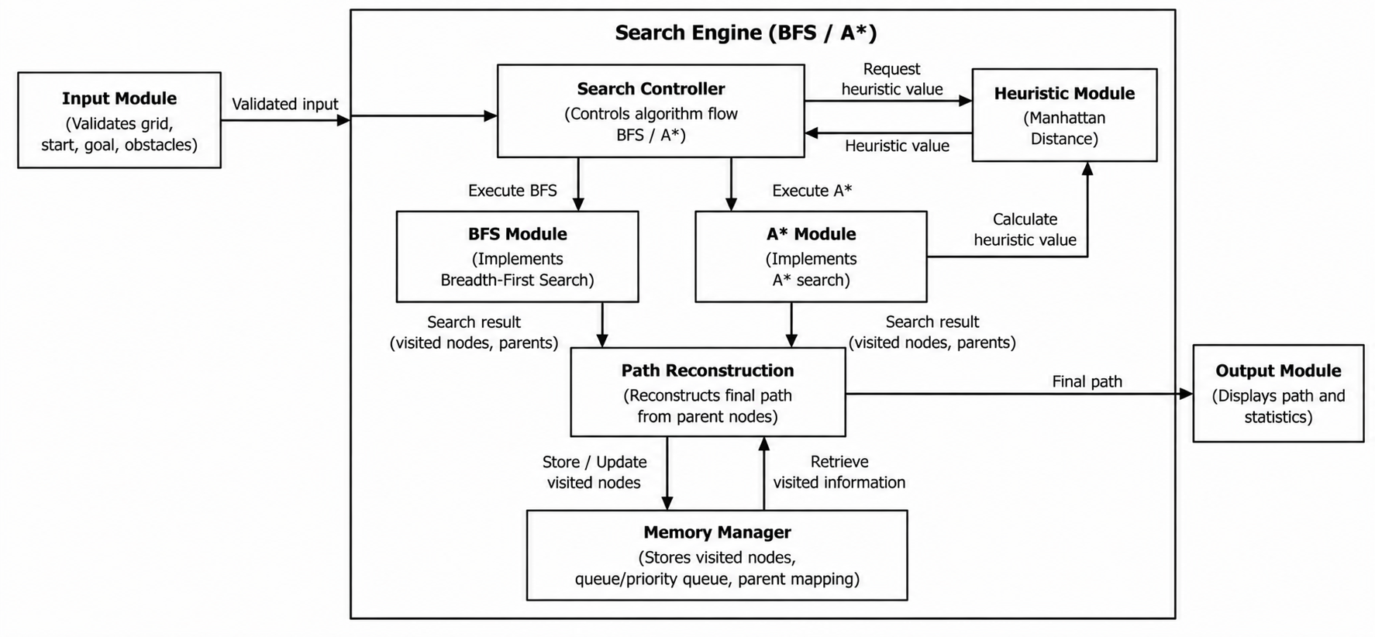

The Search Engine is the main processing container. Its internal components manage the nodes waiting to be explored, track explored nodes, check whether the goal has been reached, and reconstruct the final path. The Frontier / Open List represents the queue used by BFS and the priority-based frontier used by A*. The Explored / Closed Set tracks visited nodes.

5. Code Level Overview (C4 Level 4)
The Code level shows only the main implementation elements and their responsibilities; large source-code listings are not required.
Main Element | Responsibility
Grid / Maze representation | Represents the grid, start point, goal point, and obstacles.
bfs() | Performs Breadth-First Search and explores the grid level by level.
astar() | Performs A* search using path cost and heuristic information.
heuristic() / Manhattan Distance | Estimates the remaining distance from a node to the goal for A*.
reconstruct_path() | Reconstructs the final route after the goal is reached.

6. Design Decisions
- The architecture separates input, search, heuristic calculation, memory, and output responsibilities so each major part has a clear role.
- BFS and A* are kept within the Search Engine because both solve the same pathfinding problem while using different search strategies.
- The Manhattan Distance heuristic is separated from the search process so the A* heuristic calculation is clearly represented.
- The design keeps the architecture small and readable, following the C4 guideline to avoid unnecessary containers or crowded diagrams.

7. AI Contribution Note
The following note clearly separates the use of AI assistance from the work completed and verified by the student.

A. AI Contribution
- AI tools used: ChatGPT was used as an assistance tool during the SLE-3 activity.
- Understanding the C4 Model: AI helped explain the meaning and purpose of the Context, Container, Component, and Code levels in simple terms.
- Architecture planning: AI helped organize the existing grid-based pathfinding system into the four C4 levels without changing the main purpose of the system.
- Diagram planning: AI helped identify appropriate actors, containers, components, interactions, and labels for the diagrams.
- Documentation support: AI helped prepare and improve wording for the system description, diagram explanations, design decisions, and conclusion.
- Presentation support: AI helped provide simple explanations so the architecture and design decisions could be understood and explained during evaluation.

B. My Contribution
- I selected the Grid-Based Pathfinding System from my previous SLE-2 work as the system for SLE-3.
- I worked with the BFS and A* pathfinding algorithms and used the Manhattan Distance heuristic for A* as part of the system design.
- I reviewed and decided the major system containers: Input Module, Search Engine, Heuristic Module, Memory / Visited Set, and Output Module.
- I selected the Search Engine as the main container for the Component-level design and identified its internal responsibilities.
- I created, arranged, and reviewed the C4 diagrams and checked that they represented the pathfinding system.
- I prepared the final Word document, checked all four C4 levels, and verified that the explanations and architecture were consistent with the SLE-3 requirements.
- I am responsible for understanding the final architecture and explaining the system, diagrams, algorithms, and design decisions during evaluation.

8. Conclusion
This SLE-3 activity represents the Grid-Based Pathfinding System using all four levels of the C4 model. The Context level shows the external user interaction, the Container level shows the main system parts, the Component level explains the internal structure of the Search Engine, and the Code level identifies the main implementation elements. The activity helps connect the system design with the BFS and A* pathfinding work completed in the earlier SLEs.

