Zephyr LZ Compression Offload Sub-System
Micro-Architecture Specification (MAS)
Reference SoC Sub-System

Document Type | Micro-Architecture Specification (MAS)
Version | 1.0 (WIP)
Status | Work In Progress (WIP)
Date | September 4, 2026
Author | Mayuresh Piske

Revision History
Version | Date | Author | Description
0.1 | 2026-09-04 | M. Piske | Initial WIP draft for Hackathon 2026 submission.

Table of Contents
Revision History 1
Table of Contents 1
1 Introduction 1
1.1 Purpose 1
1.2 Scope 1
1.3 References 1
1.4 Abbreviations 1
2 Micro-Architecture Overview 1
3 Block Micro-Architecture 1
3.1 AXI Interconnect and Arbiter 1
3.2 L2 Cache 1
3.3 Memory Controller 1
3.4 LZ Compression Accelerator (Master M2) 1
3.4.1 Pipeline Stages 1
3.4.2 Match / Effort Level 1
3.5 Input / Output DMA (Masters M0 / M1) 1
3.6 CSR / Register File 1
3.7 Control Module 1
4 Register Map 1
4.1 CTRL Bit-fields (0x000) 1
4.2 CFG Bit-fields (0x004) 1
5 Control Module FSM 1
6 Datapath Flows 1
6.1 Job Fetch 1
6.2 Input Load 1
6.3 Compress 1
6.4 Output Write 1
6.5 Cache Miss / Write-back 1
7 Arbitration Detail 1
8 Performance Numbers 1
9 Error Handling 1
9.1 Detection and Response 1
9.2 ERROR Register Bit-fields (0x040) 1
9.3 Recovery 1
10 Debug and Observability 1
10.1 DBG_CTRL Bit-fields (0x060) 1
10.2 Trace and Observation 1
11 Clock and Reset Domains 1
12 Parameters and Configurability 1
13 Verification and Debug Hooks 1

1 Introduction

1.1 Purpose
This Micro-Architecture Specification (MAS) details the internal implementation of the Zephyr LZ Compression Offload Sub-System (COSS): block micro-architecture, the compression pipeline, datapaths, the complete firmware register map, the control finite-state machine, arbitration, cache organization, and the performance, error-handling, and debug facilities. It is the implementation companion to the COSS HAS.

1.2 Scope
The MAS is the authoritative source for RTL and verification. Where the HAS states what the sub-system does, the MAS specifies how each block is built and how firmware interacts with it at the register and signal level.

1.3 References
- Zephyr COSS High-level Architecture Specification (HAS), v0.1.
- ARM AMBA AXI and ACE Protocol Specification (AXI4, AXI4-Lite).
- RFC 1951 – DEFLATE Compressed Data Format (informative).

1.4 Abbreviations
Term | Definition
AXI | Advanced eXtensible Interface (AMBA AXI4)
AXI4-Lite | Lightweight, single-beat AXI variant used for register access
COSS | Compression Offload Sub-System (this IP)
LZ / LZ77 | Lempel-Ziv sliding-window compression algorithm family
DEFLATE | LZ77 + Huffman entropy coding (RFC 1951)
CSR | Control/Status Register (firmware-visible register space)
DMA | Direct Memory Access engine
FSM | Finite State Machine
QoS | Quality of Service (arbitration priority)
RR | Round-Robin (arbitration policy)
LRU | Least Recently Used (cache replacement policy)
WB | Write-Back (cache write policy)
W1C | Write-1-to-Clear register semantics
CRC | Cyclic Redundancy Check (integrity)
ECC | Error-Correcting Code (SRAM protection)
IRQ | Interrupt Request
HAS | High-level Architecture Specification
MAS | Micro-Architecture Specification

2 Micro-Architecture Overview
Three masters (Input DMA, Output DMA, LZ accelerator) drive an AXI interconnect containing the address decoder and read/write arbiters. The interconnect targets a single memory subordinate fronted by a write-back L2 cache and a memory controller. The control plane — an AXI4-Lite CSR register file and a job-sequencer FSM — consumes job descriptors, drives the datapath, and reports results, performance, errors, and debug state to firmware.
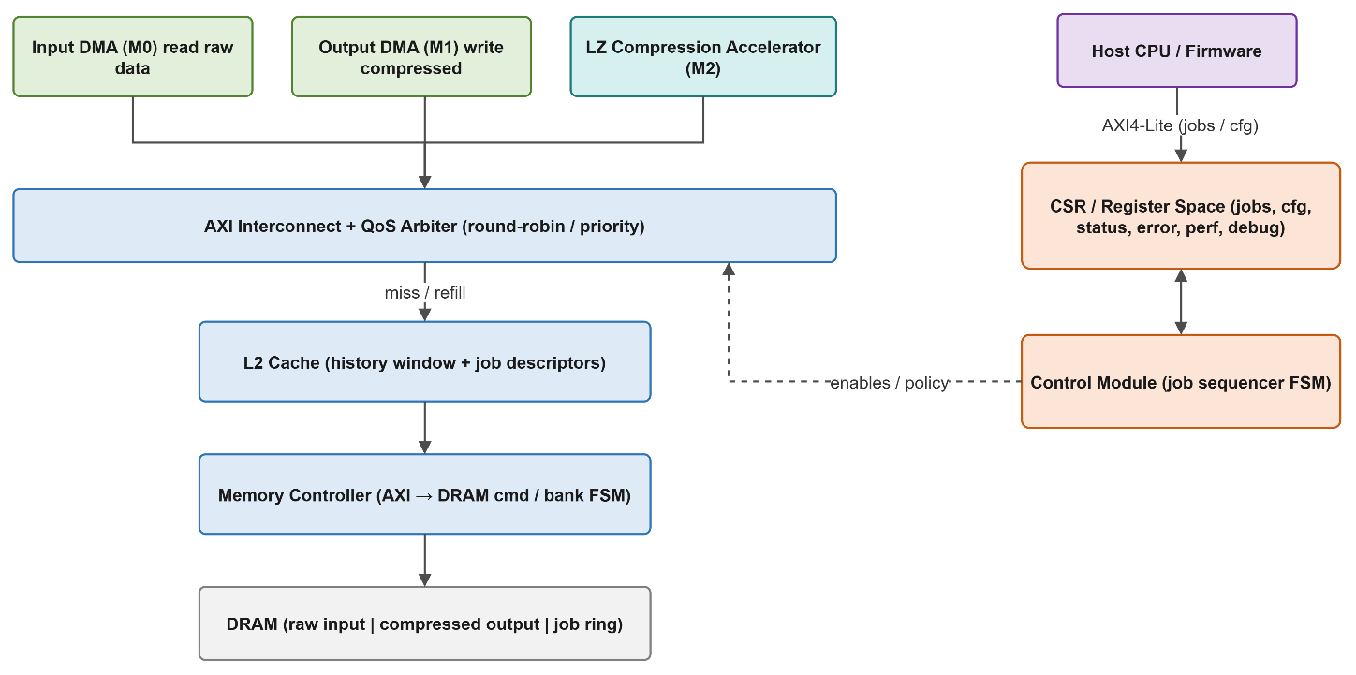
Figure 1 – COSS top-level datapath and control plane.

3 Block Micro-Architecture

3.1 AXI Interconnect and Arbiter
Implements address decoding, master-to-subordinate routing, and independent write- and read-channel arbitration. Masters expose the full AXI4 channel set (AW, W, B, AR, R); outstanding transactions are tracked by AXI ID for out-of-order responses.
- Policies: round-robin (default) and fixed-priority (Output DMA highest, to drain compressed data and avoid back-pressure), selectable via CFG.ARB_MODE.
- Anti-starvation: a starvation counter promotes a long-waiting master. Per-master grant counts are exported to ARB_GRANTS.

3.2 L2 Cache
A 2-way set-associative, write-back, write-allocate cache holds the LZ history window and job descriptors — the most frequently re-read structures. Streaming input/output data may be marked non-cacheable to avoid pollution.
Parameter | Value (reference)
Total size | 64 KB
Associativity | 2-way set-associative
Line size | 64 bytes
Sets | 512
Write policy | Write-back, write-allocate
Replacement | LRU (1 bit/set)
Metadata | Valid + Dirty per line (optional ECC)
Primary tenants | History window (32 KB) + job descriptors
Address decomposition (32-bit): [31:15] tag | [14:6] index (512 sets) | [5:0] offset (64B line).

3.3 Memory Controller
Converts cache refill/write-back and streaming DMA bursts into DRAM commands via a bank/row command FSM with a fixed-latency timing model. Separate refill and write-back buffers decouple the datapath from DRAM latency.

3.4 LZ Compression Accelerator (Master M2)
The accelerator is the application engine. Its internal pipeline is shown in Figure 2.
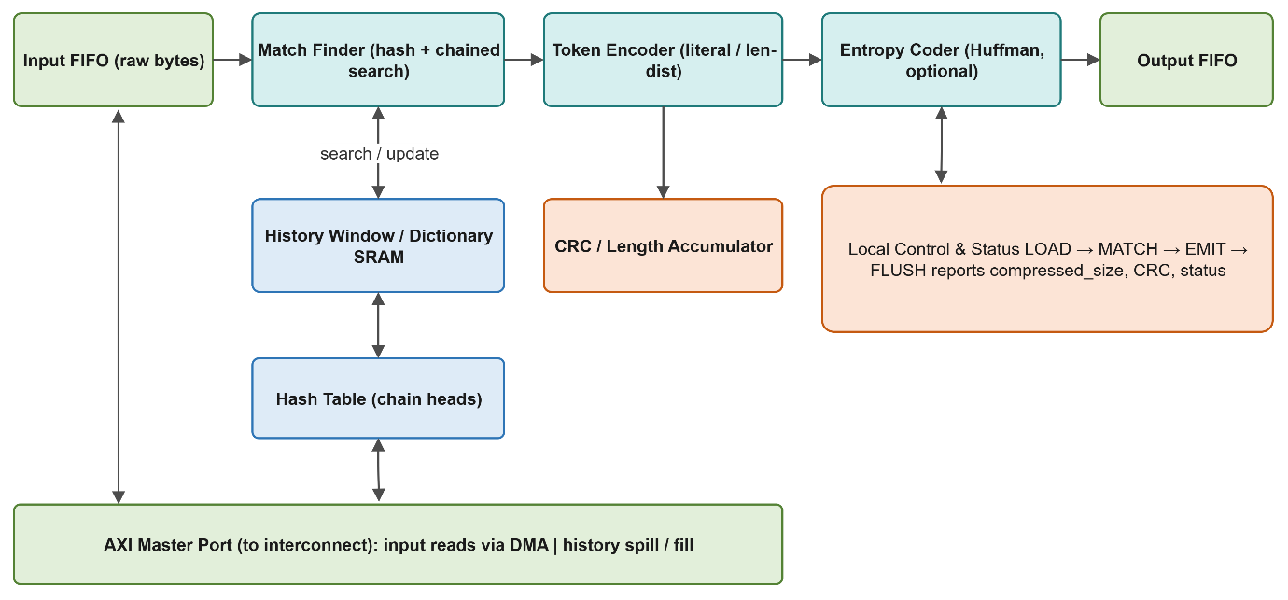
Figure 2 – LZ compression accelerator internal pipeline.

3.4.1 Pipeline Stages
Stage | Function
Input FIFO | Buffers raw bytes streamed in by the Input DMA; decouples DMA bursts from the match rate.
Match Finder | Hashes the next few bytes, walks the chained hash-table entries into the history window, and returns the longest match (offset, length).
History Window / Dictionary SRAM | Sliding window of recently seen bytes; searched every step and updated as bytes advance (spilled to/filled from cache/DRAM).
Hash Table | Head-of-chain pointers per hash bucket for candidate match positions.
Token Encoder | Emits a literal token or a (length, distance) copy token based on the match result and effort level.
Entropy Coder (optional) | Static/dynamic Huffman coding of the token stream for a DEFLATE-class higher ratio; bypassable in LZ-only mode.
CRC / Length Accumulator | Accumulates output CRC and compressed byte count as tokens are emitted.
Output FIFO | Buffers the compressed byte stream for the Output DMA.
Local Control & Status | Sub-FSM (LOAD → MATCH → EMIT → FLUSH); reports comp_size, CRC, and status to the Control Module.

3.4.2 Match / Effort Level
CFG.LEVEL bounds the chained-search depth: low level = shorter search (higher throughput, lower ratio); high level = deeper search (higher ratio, lower throughput). A minimum-match-length threshold avoids emitting unprofitable short copies.

3.5 Input / Output DMA (Masters M0 / M1)
- Input DMA (M0): reads src_len bytes from src_addr in bursts into the input FIFO; sequential, bandwidth-oriented.
- Output DMA (M1): drains the output FIFO to dst_addr in bursts; favored by priority arbitration; enforces dst_cap and flags ERR_DST_OVFL.

3.6 CSR / Register File
An AXI4-Lite subordinate implementing the register map in §4. All registers are 32-bit, word-addressed, with defined reset values and access types; reserved bits read zero.

3.7 Control Module
The job sequencer decodes control/config, fetches descriptors, orchestrates the DMAs and accelerator, writes back results, aggregates errors and performance events, and generates interrupts. Its FSM is specified in §5.

4 Register Map
Offsets are byte offsets from the COSS CSR base. Access: RW, RO, W1C (write-1-to-clear).
Offset | Name | Access | Reset | Description
0x000 | CTRL | RW | 0x0 | START/doorbell, STOP, SOFT_RESET, CACHE_FLUSH.
0x004 | CFG | RW | 0x0 | MODE, ALGO, LEVEL, WINDOW, ARB_MODE, CACHE_EN, HALT_ON_ERR.
0x008 | STATUS | RO | 0x1 | BUSY, IDLE, ERROR, RING_EMPTY/FULL, active job_id.
0x010 | RING_BASE | RW | 0x0 | Base address of the job descriptor ring in DRAM.
0x014 | RING_HEAD | RO | 0x0 | Consumer index (hardware-updated).
0x018 | RING_TAIL | RW | 0x0 | Producer index (firmware doorbell).
0x01C | RING_SIZE | RW | 0x0 | Number of descriptor entries.
0x020 | PERF_BYTES_IN | RO | 0x0 | Total uncompressed bytes consumed.
0x024 | PERF_BYTES_OUT | RO | 0x0 | Total compressed bytes produced.
0x028 | PERF_JOBS | RO | 0x0 | Completed job count.
0x02C | PERF_CYCLES | RO | 0x0 | Active compression cycles (for throughput).
0x030 | PERF_HITS | RO | 0x0 | Cache hits (history/descriptor).
0x034 | PERF_MISS | RO | 0x0 | Cache misses.
0x038 | ARB_GRANTS | RO | 0x0 | Packed per-master grant counters.
0x040 | ERROR | W1C | 0x0 | Latched error code bits (see §9.2 / §10).
0x044 | ERR_ADDR | RO | 0x0 | Faulting AXI address captured on error.
0x048 | ERR_INFO | RO | 0x0 | Faulting job_id and context.
0x050 | INT_EN | RW | 0x0 | Interrupt enable mask (DONE, ERR, THRESH).
0x054 | INT_STATUS | W1C | 0x0 | Pending interrupts; write 1 to clear.
0x060 | DBG_CTRL | RW | 0x0 | HALT, STEP, BREAK_ON_ERR, FREEZE_CTRS.
0x064 | DBG_STATE | RO | 0x0 | Control FSM state, accelerator sub-state, active job_id.
0x068 | DBG_OBS_SEL | RW | 0x0 | Observation-bus signal-group select.
0x06C | DBG_TRACE | RO | 0x0 | Job trace-buffer read port (pops one entry).

4.1 CTRL Bit-fields (0x000)
Bits | Field | Description
[0] | START | Doorbell: begin consuming the job ring.
[1] | STOP | Quiesce after the in-flight job.
[2] | SOFT_RESET | Self-clearing datapath/FSM reset (CSR config preserved).
[3] | CACHE_FLUSH | Flush + invalidate L2; self-clears on completion.
[31:4] | Reserved | Reads 0.

4.2 CFG Bit-fields (0x004)
Bits | Field | Description
[1:0] | MODE | 0=LZ-only, 1=LZ+Huffman, 2=store, 3=reserved.
[3:2] | ALGO | LZ variant / token format select.
[6:4] | LEVEL | Effort level 0–7 (match search depth).
[9:7] | WINDOW | History-window size select (e.g. 4/8/16/32 KB).
[10] | ARB_MODE | 0=round-robin, 1=fixed priority.
[11] | CACHE_EN | 1=cache enabled, 0=bypass.
[12] | HALT_ON_ERR | 1=halt on error, 0=skip job and continue.
[31:13] | Reserved | Reads 0.

5 Control Module FSM
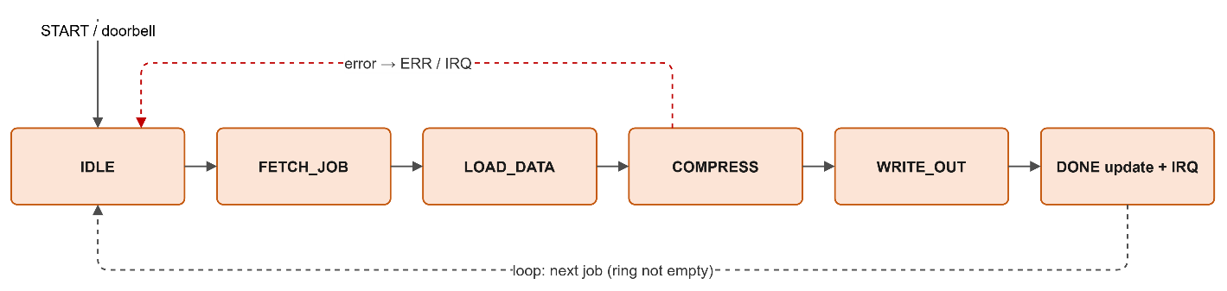
Figure 3 – Job sequencer states.
State | Action / Transition
IDLE | Wait for CTRL.START / doorbell. If ring non-empty → FETCH_JOB.
FETCH_JOB | Read next descriptor (via cache); validate fields. Bad → ERR; else → LOAD_DATA.
LOAD_DATA | Program Input DMA (src_addr, src_len); stream bytes to the accelerator input FIFO. → COMPRESS.
COMPRESS | Accelerator runs match/encode; Output DMA drains compressed bytes to dst_addr. On overflow → store fallback / ERR. → WRITE_OUT.
WRITE_OUT | Finish output drain and CRC; write comp_size / crc / status into the descriptor. → DONE.
DONE | Advance RING_HEAD, update PERF_* counters, push a trace entry, raise DONE/THRESH IRQ. → FETCH_JOB (loop) or IDLE on STOP.
An error in any state transitions to an error path that aborts the job, latches the ERROR register, and (per CFG.HALT_ON_ERR) halts or advances to the next job.

6 Datapath Flows

6.1 Job Fetch
Control Module reads the descriptor at RING_HEAD (cache hit expected after warm-up) and validates pointers, length, and flags.

6.2 Input Load
Input DMA issues AXI read bursts from src_addr → interconnect arbiter → cache/memory controller → input FIFO. The accelerator consumes bytes as they arrive.

6.3 Compress
The match finder searches the history window (resident in cache) for the longest match; the token encoder emits literals or (length, distance) copies; the optional Huffman stage codes the tokens; the CRC/length unit accumulates output stats. Compressed bytes flow to the output FIFO.

6.4 Output Write
Output DMA drains the output FIFO to dst_addr with priority arbitration, checking dst_cap. On completion the descriptor result fields are written back.

6.5 Cache Miss / Write-back
A history/descriptor miss allocates an LRU way; a dirty victim is drained to the write-back buffer while the refill completes, minimizing stall.

7 Arbitration Detail
- Separate write-path (AW/W) and read-path (AR) arbiters, each with its own policy instance.
- Round-robin: rotating grant pointer, bounded wait.
- Fixed-priority: Output DMA > Accelerator (history) > Input DMA, with starvation promotion after a programmable threshold.
- Grant events increment ARB_GRANTS for the fairness demo.

8 Performance Numbers
Reference clock 500 MHz, 32 KB window. Throughput ≈ f × bytes-advanced-per-cycle; ratio and rate are derived from PERF counters at runtime.
Metric | Reference target | Derivation
Sustained throughput | ~0.5 GB/s | 1 B/cycle × 500 MHz (LZ-only, level low).
Peak throughput (stretch) | ~2 GB/s | 4 parallel comparators (4 B/cycle).
Compression ratio (text) | 2.5–3.5× | PERF_BYTES_IN / PERF_BYTES_OUT.
Per-job latency (4 KB) | ~8–10 µs | fill(~64) + ~4096 compress + DMA cycles.
Cache hit-rate | > 95% | PERF_HITS / (HITS+MISS).
Huffman stage cost | ~10–25% throughput | Mode-dependent (LZ+Huffman vs LZ-only).
Instrumentation: PERF_BYTES_IN/OUT, PERF_JOBS, PERF_CYCLES, PERF_HITS/MISS, and ARB_GRANTS are free-running (clear via CTRL / snapshot via DBG_CTRL.FREEZE_CTRS). Firmware computes GB/s = PERF_BYTES_IN / (PERF_CYCLES / f) and ratio = BYTES_IN / BYTES_OUT.

9 Error Handling

9.1 Detection and Response
Each block reports faults to the Control Module, which latches the first error code, captures context (ERR_ADDR, ERR_INFO), sets STATUS.ERROR, writes the error code into the job result, and raises the ERR interrupt (if enabled). CFG.HALT_ON_ERR chooses halt vs. skip-and-continue.

9.2 ERROR Register Bit-fields (0x040)
Bits | Field | Condition
[0] | ERR_DESC | Malformed job descriptor.
[1] | ERR_SRC_LEN | Zero or oversized source length.
[2] | ERR_DST_OVFL | Output exceeded dst_cap (after store fallback).
[3] | ERR_AXI | AXI SLVERR/DECERR on read/write.
[4] | ERR_ALIGN | Address/length alignment violation.
[5] | ERR_TIMEOUT | Watchdog expiry (no forward progress).
[6] | ERR_ECC | Uncorrectable ECC in history/FIFO SRAM.
[31:7] | Reserved | Reads 0.

9.3 Recovery
- Firmware clears ERROR/INT_STATUS via W1C after reading ERR_ADDR/ERR_INFO.
- For fatal faults (ECC, timeout) firmware issues CTRL.SOFT_RESET before resuming.
- A watchdog guarantees a stuck job cannot hang the sub-system indefinitely.

10 Debug and Observability

10.1 DBG_CTRL Bit-fields (0x060)
Bits | Field | Description
[0] | HALT | Freeze the control FSM at the next job boundary.
[1] | STEP | Advance exactly one job while halted.
[2] | BREAK_ON_ERR | Auto-halt on any latched error.
[3] | FREEZE_CTRS | Atomically freeze performance counters for a consistent snapshot.
[31:4] | Reserved | Reads 0.

10.2 Trace and Observation
- Job trace buffer: circular buffer of the last N jobs (job_id, in/out size, cycles, status), read one entry per DBG_TRACE access.
- DBG_STATE: live control-FSM state, accelerator sub-state, and active job_id.
- Observation bus: DBG_OBS_SEL routes a selected signal group (arbiter grants, cache hit/miss, FIFO levels, DMA state) to the optional debug port.
- DFT: scan-enable and per-SRAM MBIST provisions (history window, hash table, FIFOs) at integration level.

11 Clock and Reset Domains
- Single functional clock domain (datapath, control, CSR) in the reference design.
- Asynchronous-assert / synchronous-release reset; cache invalidate and FIFO clear before leaving reset.
- SOFT_RESET (CTRL[2]) resets datapath and FSM while preserving CSR configuration.

12 Parameters and Configurability
Parameter | Default | Notes
NUM_MASTERS | 3 | Input DMA, Output DMA, Accelerator.
WINDOW_BYTES | 32 KB | History-window size (CFG.WINDOW selectable).
MIN_MATCH | 3 | Minimum profitable match length.
MAX_MATCH | 258 | Maximum copy length (DEFLATE-class).
HASH_BITS | 15 | Hash-table index width.
CACHE_SIZE | 64 KB | sets × ways × line.
LINE_BYTES | 64 | Cache line / burst length.
RING_DEPTH | 256 | Job descriptor ring entries.
ADDR_WIDTH / DATA_WIDTH | 32 / 64 | AXI address / data width.

13 Verification and Debug Hooks
- Round-trip self-check: hardware output decompressed by a reference model must match the input bit-exactly; CRC cross-checked.
- All PERF_*, ERROR, and DBG_* registers are runtime-readable for self-checking and the live dashboard.
- Directed error-injection per ERR_* class; randomized corpora for ratio/throughput stress.
- Assertions: AXI protocol per master, FIFO overflow/underflow, ring pointer monotonicity, history-window coherence, no-overflow-past-dst_cap.

