ENTERPRISE HQ
NETWORK SIMULATION
Cisco Packet Tracer
TECHNICAL PROJECT REPORT
PREPARED BY | PLATFORM | REPORT
Mayuresh Mhatre | Cisco Packet Tracer | Project documentation

Portfolio

Document Information
Field | Details
Project title | Enterprise HQ Network Simulation — Cisco Packet Tracer
Prepared by | Mayuresh Mhatre
Simulation environment | Cisco Packet Tracer
Report date | 31 October 2026

Executive Summary
This project documents a simulated enterprise headquarters LAN built in Cisco Packet Tracer. The supplied evidence shows four departmental VLANs—HR, IT, ADMIN and SERVER—gateway subinterfaces on a Cisco 2911 router, an IEEE 802.1Q switch trunk, DHCP pools and bindings, a server-side DNS A record, an internal HTTP page, SSH version 2 status and switch port-security output.
The report records the visible configuration and verification results while distinguishing confirmed evidence from details that are not legible or not shown in the source PDF.

1. Project Objectives
- Create a simulated headquarters LAN in Cisco Packet Tracer.
- Segment departments using VLANs 10, 20, 30 and 40.
- Provide VLAN gateway addresses through router subinterfaces.
- Configure and verify switch VLAN membership and 802.1Q trunking.
- Configure DHCP pools for client addressing.
- Configure internal DNS and HTTP services on the server.
- Enable SSH version 2 for secure remote management.
- Apply and verify switch port security.

2. Topology and Components
The logical workspace shows a central router/switch arrangement with multiple end devices. The router CLI identifies the device as Cisco 2911 and labels it R1_HQ. Switch CLI evidence is labelled SW1_HQ. HR_PC_1, HR_PC_2, ADMIN_PC_1 and SRV_1 are visible in the supplied screens. The screenshots do not provide a fully readable inventory of all endpoint models and cable-port mappings.
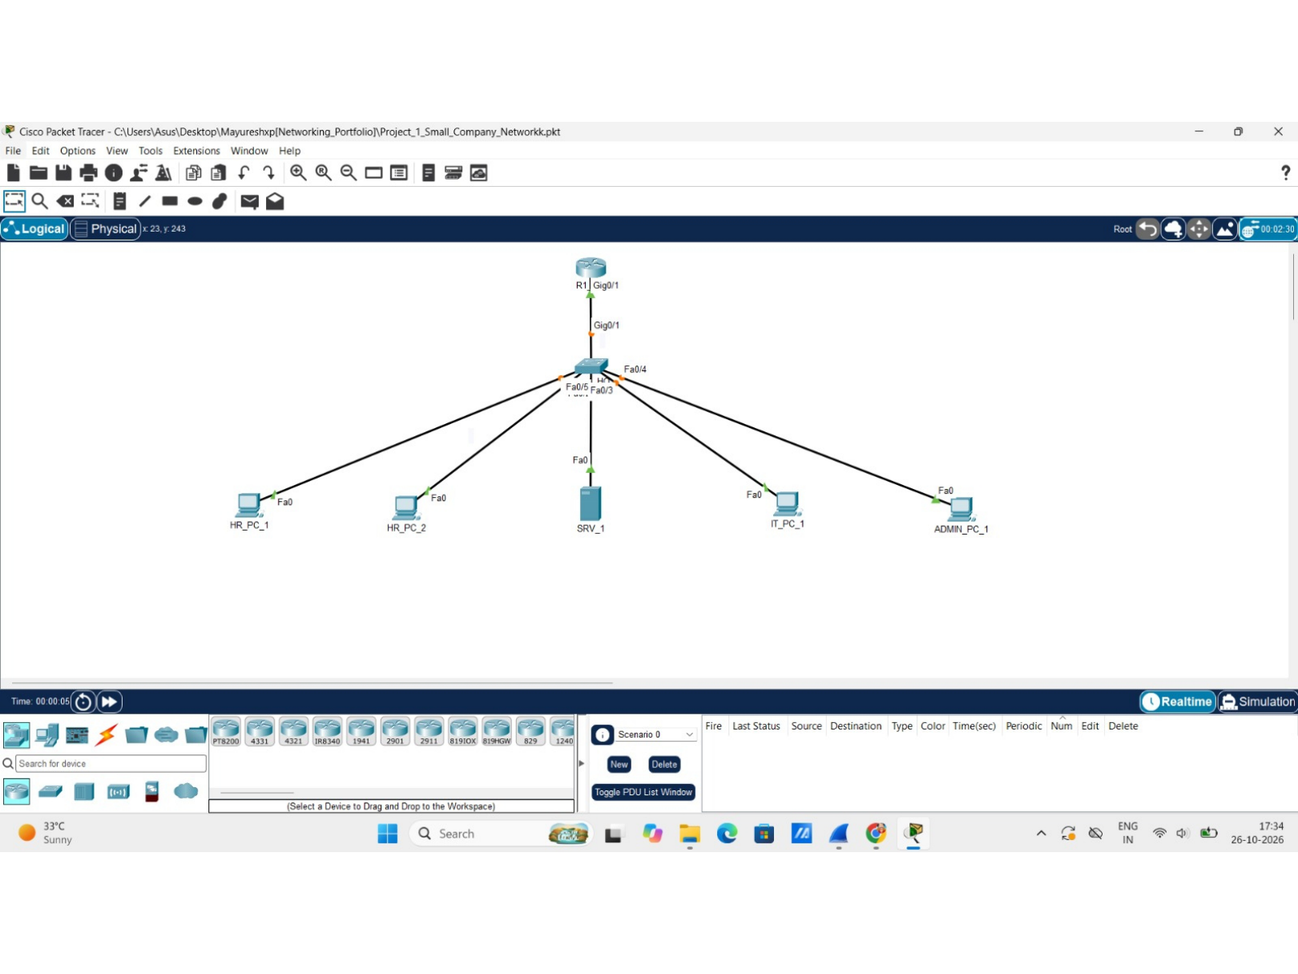
Figure 1. Overall Enterprise HQ topology in Cisco Packet Tracer.
Component | Evidence-supported description
R1_HQ | Cisco 2911 router; VLAN gateway subinterfaces on GigabitEthernet0/1.
SW1_HQ | Switch with VLAN, trunk and port-security verification output.
HR endpoints | HR_PC_1 and HR_PC_2 are visible.
ADMIN endpoint | ADMIN_PC_1 is visible.
SRV_1 | Server device; default gateway shown as 192.168.40.1.

3. IPv4 Addressing and VLAN Plan
The router interface output confirms four logical interfaces with .1 gateway addresses in four 192.168.x.0 networks. The switch output identifies the corresponding VLAN IDs and names.
VLAN ID | VLAN name | Subnet | Gateway | Department / role
10 | HR | 192.168.10.0/24 | 192.168.10.1 | Human Resources
20 | IT | 192.168.20.0/24 | 192.168.20.1 | Information Technology
30 | ADMIN | 192.168.30.0/24 | 192.168.30.1 | Administration
40 | SERVER | 192.168.40.0/24 | 192.168.40.1 | Server network

The /24 notation is consistent with the displayed DHCP pool ranges and network layout. The screenshots show gateway IPs but do not show a complete subnet-mask table.

4. Switch VLAN Configuration and Trunking
The `show vlan brief` output shows the following access-port assignments:
VLAN | Name | Ports shown
10 | HR | Fa0/1, Fa0/2
20 | IT | Fa0/3
30 | ADMIN | Fa0/4
40 | SERVER | Fa0/5

The `show interfaces trunk` output identifies GigabitEthernet0/1 as an 802.1Q trunk in the trunking state. The native VLAN is 1. The output lists VLANs 1, 10, 20, 30 and 40 as allowed and active in the management domain and as forwarding/not pruned.
Verification field | Observed value
Trunk port | GigabitEthernet0/1
Mode / encapsulation | On / 802.1Q
Status | Trunking
Native VLAN | 1
Allowed VLANs | 1–1005
Allowed and active | 1, 10, 20, 30, 40
Forwarding and not pruned | 1, 10, 20, 30, 40

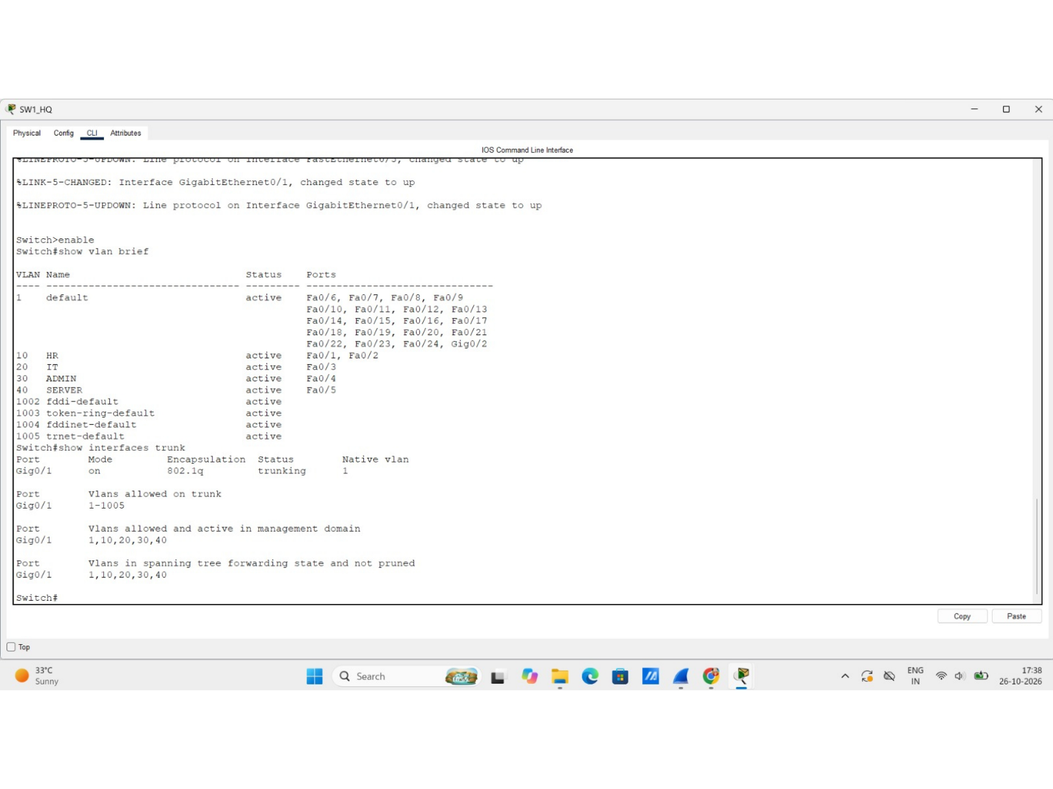
Figure 2. VLAN membership and trunk verification output.

5. Router-on-a-Stick Gateway Interfaces
The `show ip interface brief` output shows four subinterfaces on GigabitEthernet0/1. All four subinterfaces and the parent GigabitEthernet0/1 interface are shown up/up.
Router interface | IPv4 address | Status | Protocol
GigabitEthernet0/1.10 | 192.168.10.1 | Up | Up
GigabitEthernet0/1.20 | 192.168.20.1 | Up | Up
GigabitEthernet0/1.30 | 192.168.30.1 | Up | Up
GigabitEthernet0/1.40 | 192.168.40.1 | Up | Up

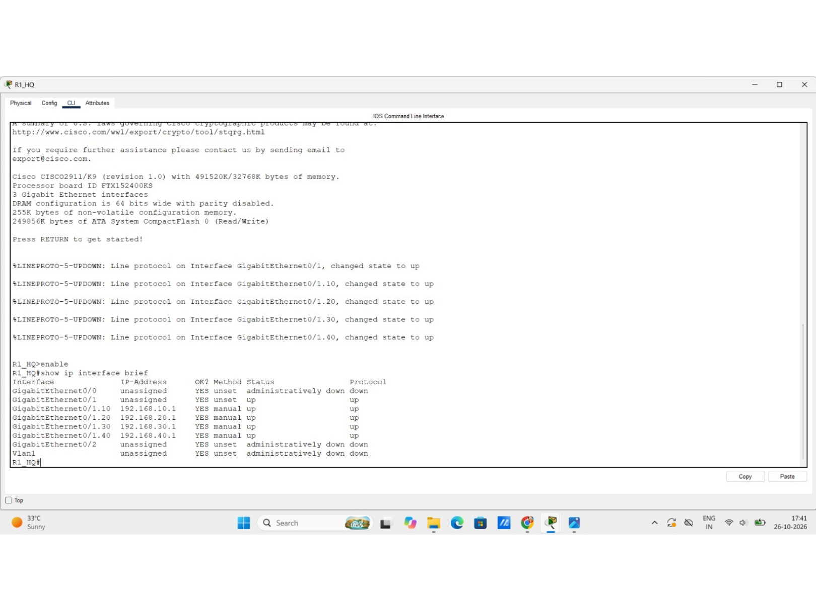
Figure 3. R1_HQ interface summary and VLAN gateway sub-interfaces.
The screenshot verifies operational interface status and IP addresses. It does not show the complete router configuration commands, so command syntax is not presented as independently verified.

6. DHCP Configuration and Evidence
The router CLI displays DHCP pools named HR, IT and ADMIN. Each shown pool has a range covering 192.168.x.1 through 192.168.x.254. The pool output also shows excluded-address counts and lease counts.
Pool | Displayed range | Evidence notes
HR | 192.168.10.1–192.168.10.254 | 3 excluded addresses; 0 leases shown in pool summary.
IT | 192.168.20.1–192.168.20.254 | 3 excluded addresses; 2 leases shown in pool summary.
ADMIN | 192.168.30.1–192.168.30.254 | 23 excluded addresses; 0 leases shown in pool summary.

The DHCP binding output includes client addresses 192.168.10.10 and 192.168.20.10. The complete client identifiers are not reproduced.
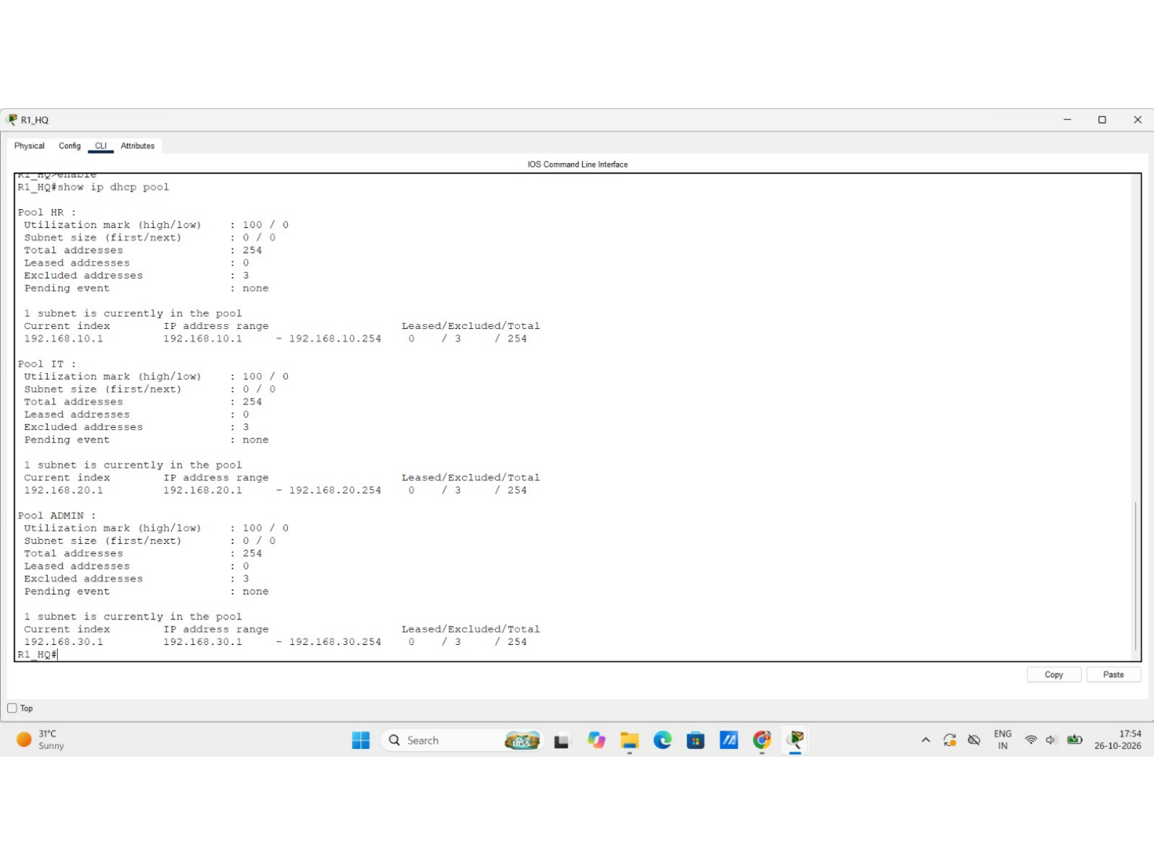
Figure 4. DHCP pool status for HR, IT and ADMIN.
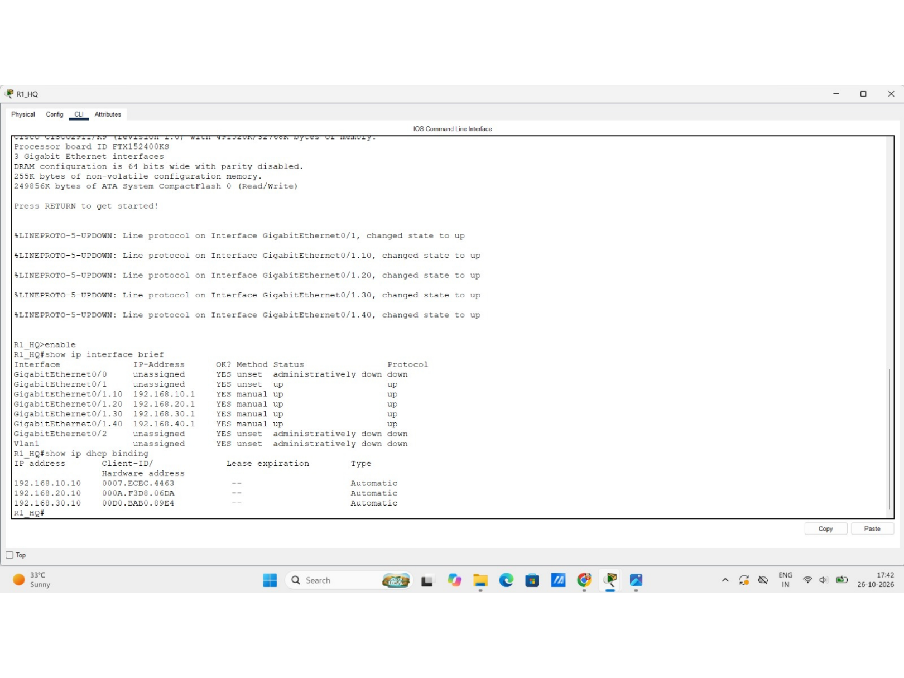
Figure 5. Router interface and DHCP binding output.
Verification note: the supplied screenshots do not clearly show complete DHCP pool commands or a DHCP lease for every VLAN. The DHCP method for the SERVER VLAN should be confirmed against the final Packet Tracer file.

7. Server Configuration and Network Services

7.1 Server addressing
The SRV_1 device screen shows its default gateway as 192.168.40.1. The DNS A record points to 192.168.40.10, identifying that address as the server host used by the DNS record.
Server field | Value visible
Device name | SRV_1
Address used by DNS A record | 192.168.40.10
Default gateway | 192.168.40.1
DNS server field | Not legible / not confirmed

7.2 DNS
The DNS service screen displays an A record with address 192.168.40.10. The browser test uses the hostname `dhappa.local`.
DNS detail | Observed value
Record type | A
Record address | 192.168.40.10
Hostname used in browser | dhappa.local

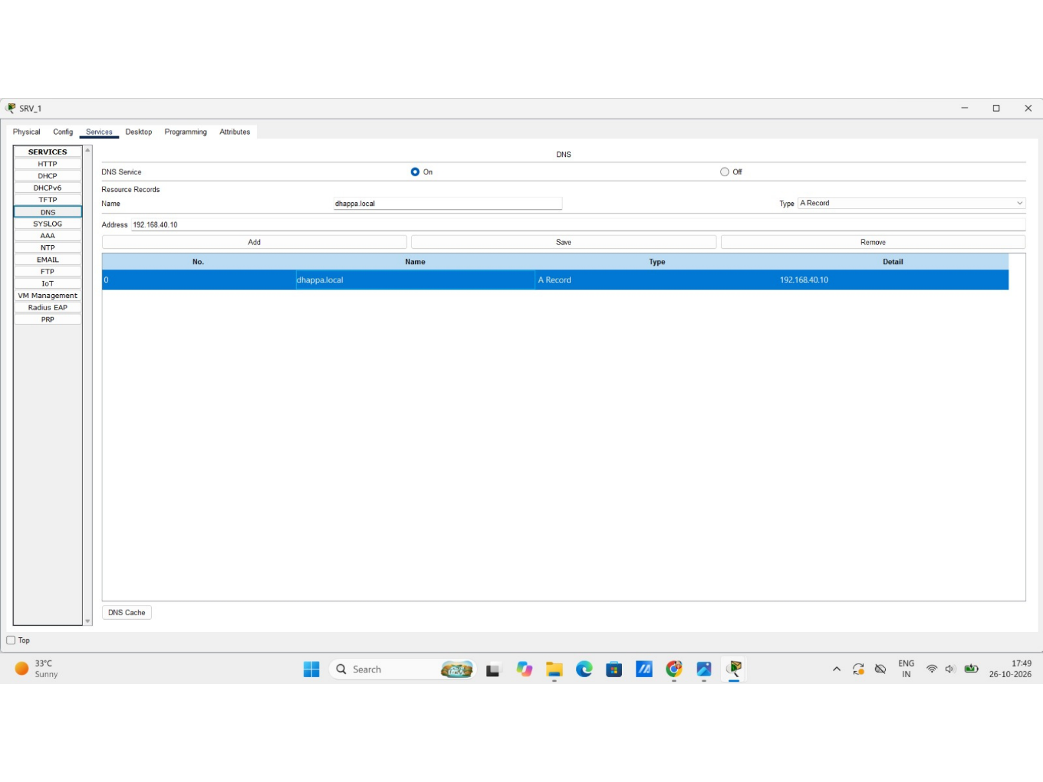
Figure 6. DNS resource-record screen.

7.3 HTTP
The browser screenshot shows `http://dhappa.local` and a page headed “DHAPPA - HQ Network”, providing visual evidence of the internal web page.
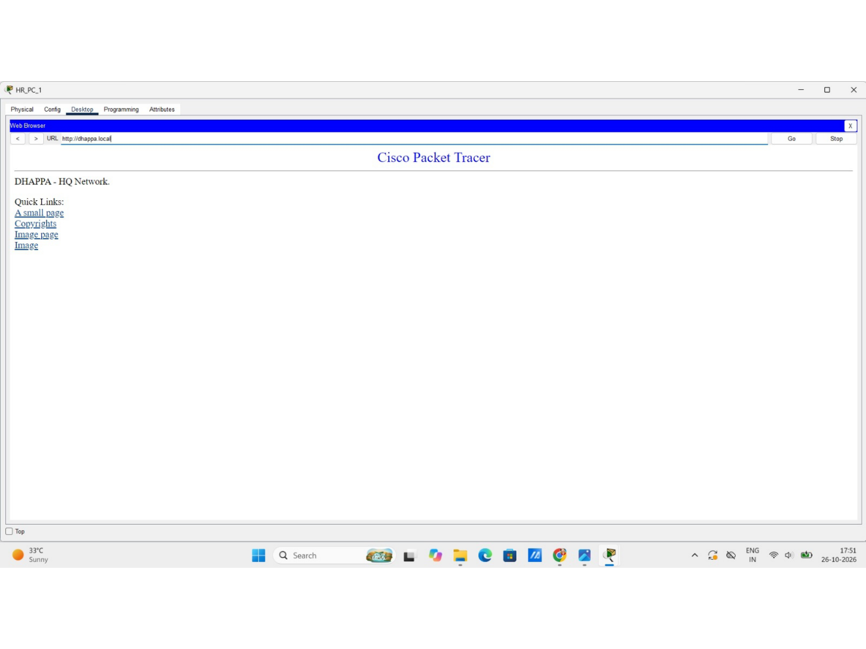
Figure 7. Internal HTTP page opened at http://dhappa.local

8. Security Configuration

8.1 Switch port security
The switch CLI displays port-security status and detailed output for FastEthernet0/1. Port security is enabled, the port state is Secure-up, and the violation mode is Shutdown. The maximum secure MAC address count shown for Fa0/1 is one.
Fa0/1 parameter | Observed value
Port security | Enabled
Port status | Secure-up
Violation mode | Shutdown
Maximum secure MAC addresses | 1
Aging time | 0 minutes
Secure static address aging | Disabled
Security violation count | 0 shown

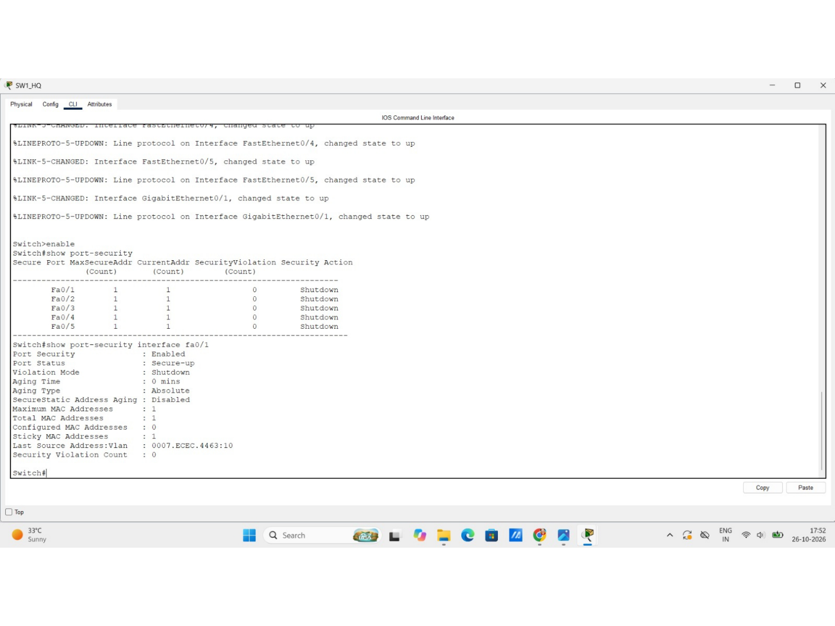
Figure 8. Port-security summary and Fa0/1 details.

8.2 SSH remote management
The router `show ip ssh` output reports SSH enabled, version 2.0, an authentication timeout of 120 seconds and three authentication retries.
SSH parameter | Observed value
Status | Enabled
Version | 2.0
Authentication timeout | 120 seconds
Authentication retries | 3

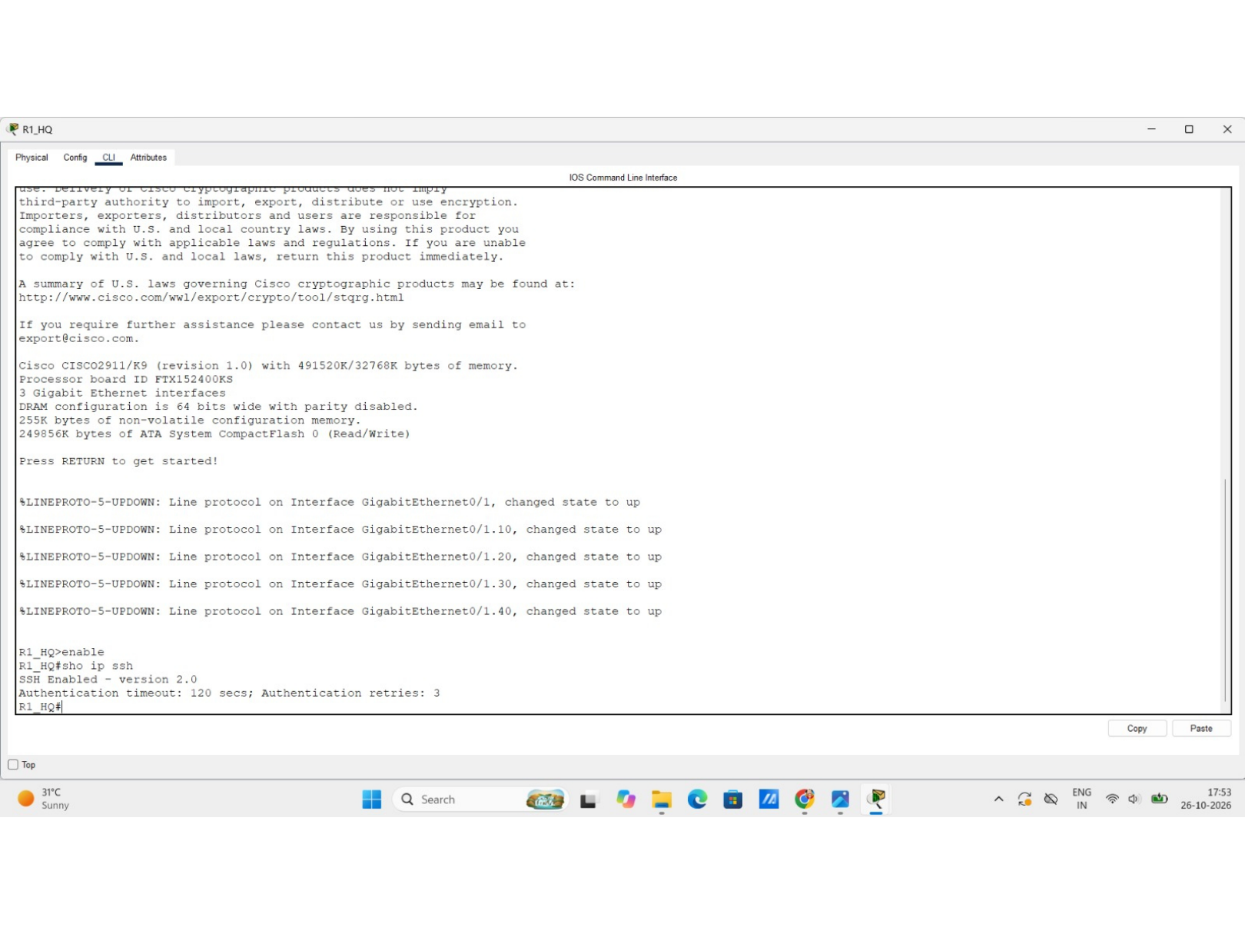
Figure 9. Router SSH status output.

9. Verification Summary
Area | Evidence shown | Supported result
Topology | Packet Tracer workspace | HQ topology and connected devices visible.
VLANs | `show vlan brief` | VLANs 10, 20, 30 and 40 active; access-port assignments displayed.
Trunk | `show interfaces trunk` | Gi0/1 trunking with 802.1Q; VLANs 1,10,20,30,40 active and forwarding.
Gateway interfaces | `show ip interface brief` | Gi0/1.10 through Gi0/1.40 are up/up with the listed gateway IPs.
DHCP | `show ip dhcp binding`; `show ip dhcp pool` | Pools and some lease/binding information displayed.
DNS | DNS resource-record screen | A record points to 192.168.40.10.
HTTP | Browser at `http://dhappa.local` | Internal page headed “DHAPPA - HQ Network” displayed.
Port security | `show port-security` and interface detail | Fa0/1 enabled, Secure-up, Shutdown violation mode.
SSH | `show ip ssh` | SSH version 2.0 enabled.

Two endpoint command-prompt screenshots (source PDF pages 8–9) are included in the appendix. Their text is not sufficiently legible to accurately transcribe, so no ping destination, packet-loss percentage or latency claim is made.

10. Conclusion
The supplied evidence documents an enterprise headquarters LAN simulation with four departmental VLANs, operational router gateway subinterfaces, an active 802.1Q trunk, DHCP pool evidence, DNS and HTTP service screens, SSH version 2 status and switch port-security output. The internal web page is shown opening through the hostname `dhappa.local`.
The clearest verified outcomes are the VLAN and trunk state, router subinterface status, DNS A-record target, internal HTTP page, SSH status and port-security state on Fa0/1. Before final submission or handover, confirm endpoint connectivity results and ensure DHCP/server addressing matches the final saved Packet Tracer project.

11. Final Validation Checklist
- Confirm the final topology inventory and saved .pkt filename.
- Verify each endpoint's IPv4 address, subnet mask, gateway and DNS settings.
- Ping each VLAN gateway and SRV_1 (192.168.40.10) from representative clients.
- Verify that `dhappa.local` resolves from client devices.
- Verify the internal HTTP page loads from intended client VLANs.
- Test SSH from an authorized management endpoint and confirm access restrictions.
- Verify port-security settings on every intended access port.
- Save all device configurations and the final Packet Tracer project file.

12. Author and Project Details
Item | Details
Author | Mayuresh Mhatre
Project | Enterprise HQ Network Simulation — Cisco Packet Tracer
Portfolio | Operation Dhappa
Institution / course | [Add if required]
Final completion date | [Add if different from report date]
Final Packet Tracer filename | [Insert exact .pkt filename]

Appendix A — Original Evidence Screenshots
The following images reproduce the 14 pages supplied by the author. They are retained as supporting evidence. The report does not alter the underlying technical screenshots.

Evidence A01
Original topology view.

Evidence A02
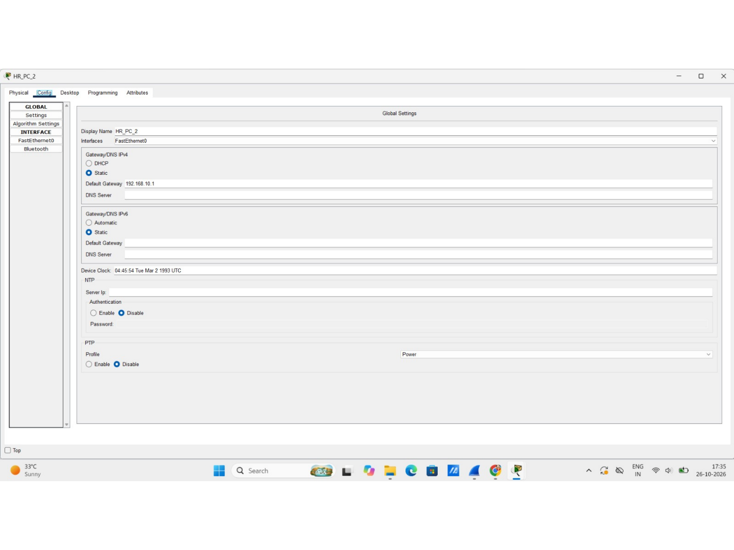
HR_PC_2 device addressing screen.

Evidence A03
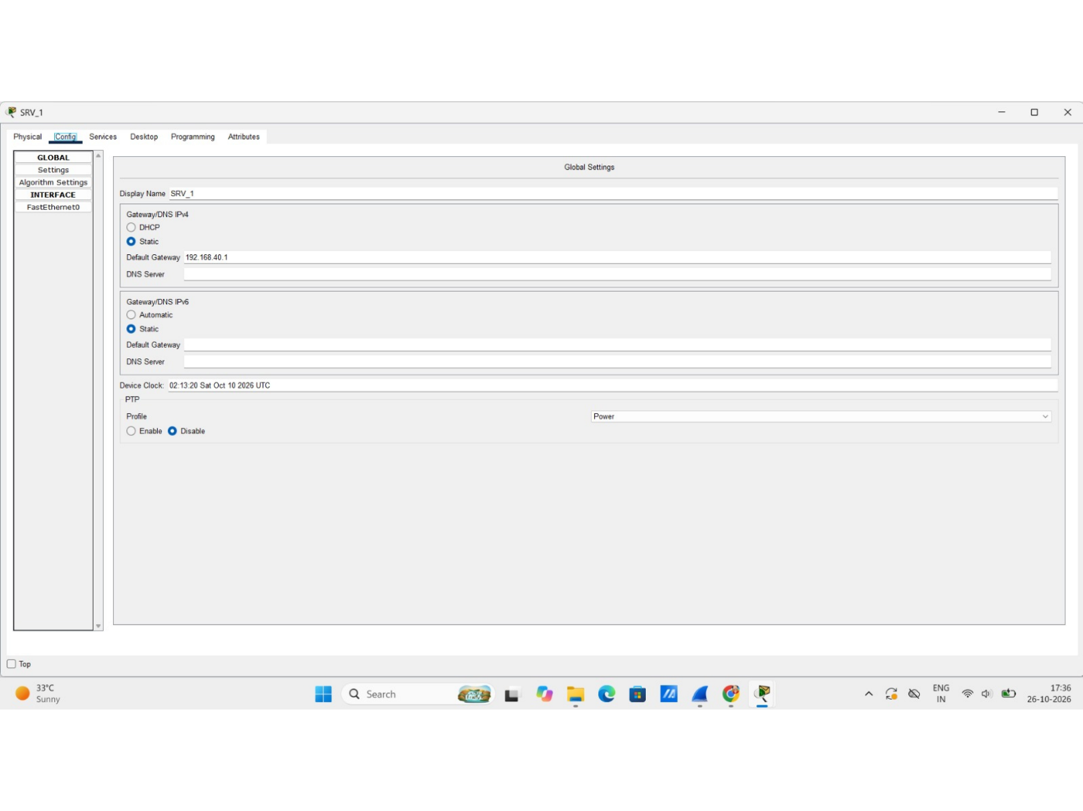
SRV_1 device addressing screen.

Evidence A04
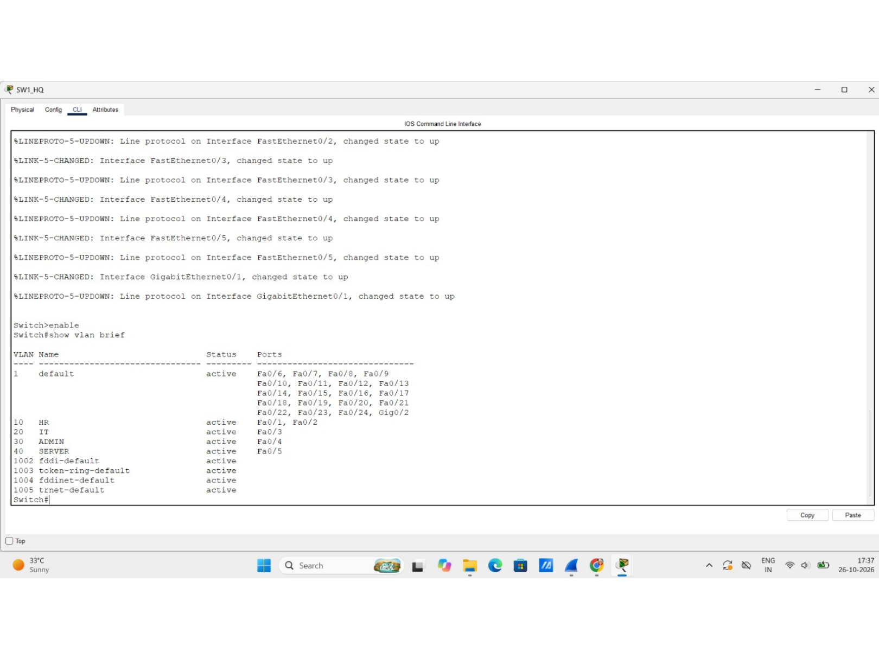
Switch VLAN output.

Evidence A05
Switch VLAN and trunk verification output.

Evidence A06
R1_HQ interface status output.

Evidence A07
R1_HQ interface and DHCP binding output.

Evidence A08
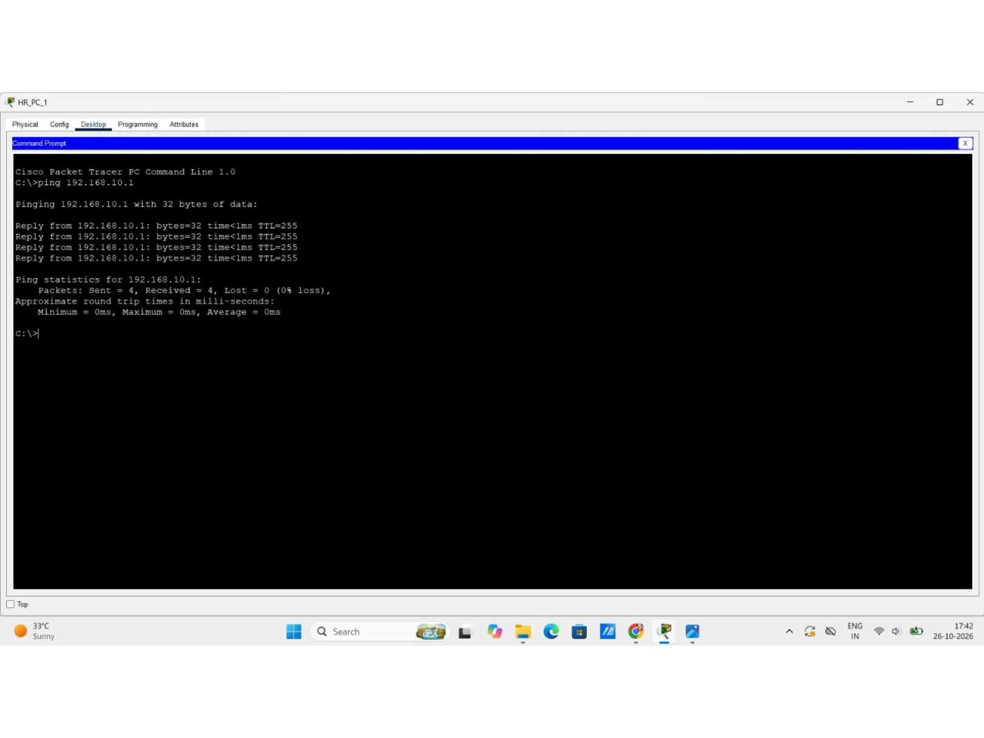
Endpoint command-prompt evidence; text not transcribed.

Evidence A09
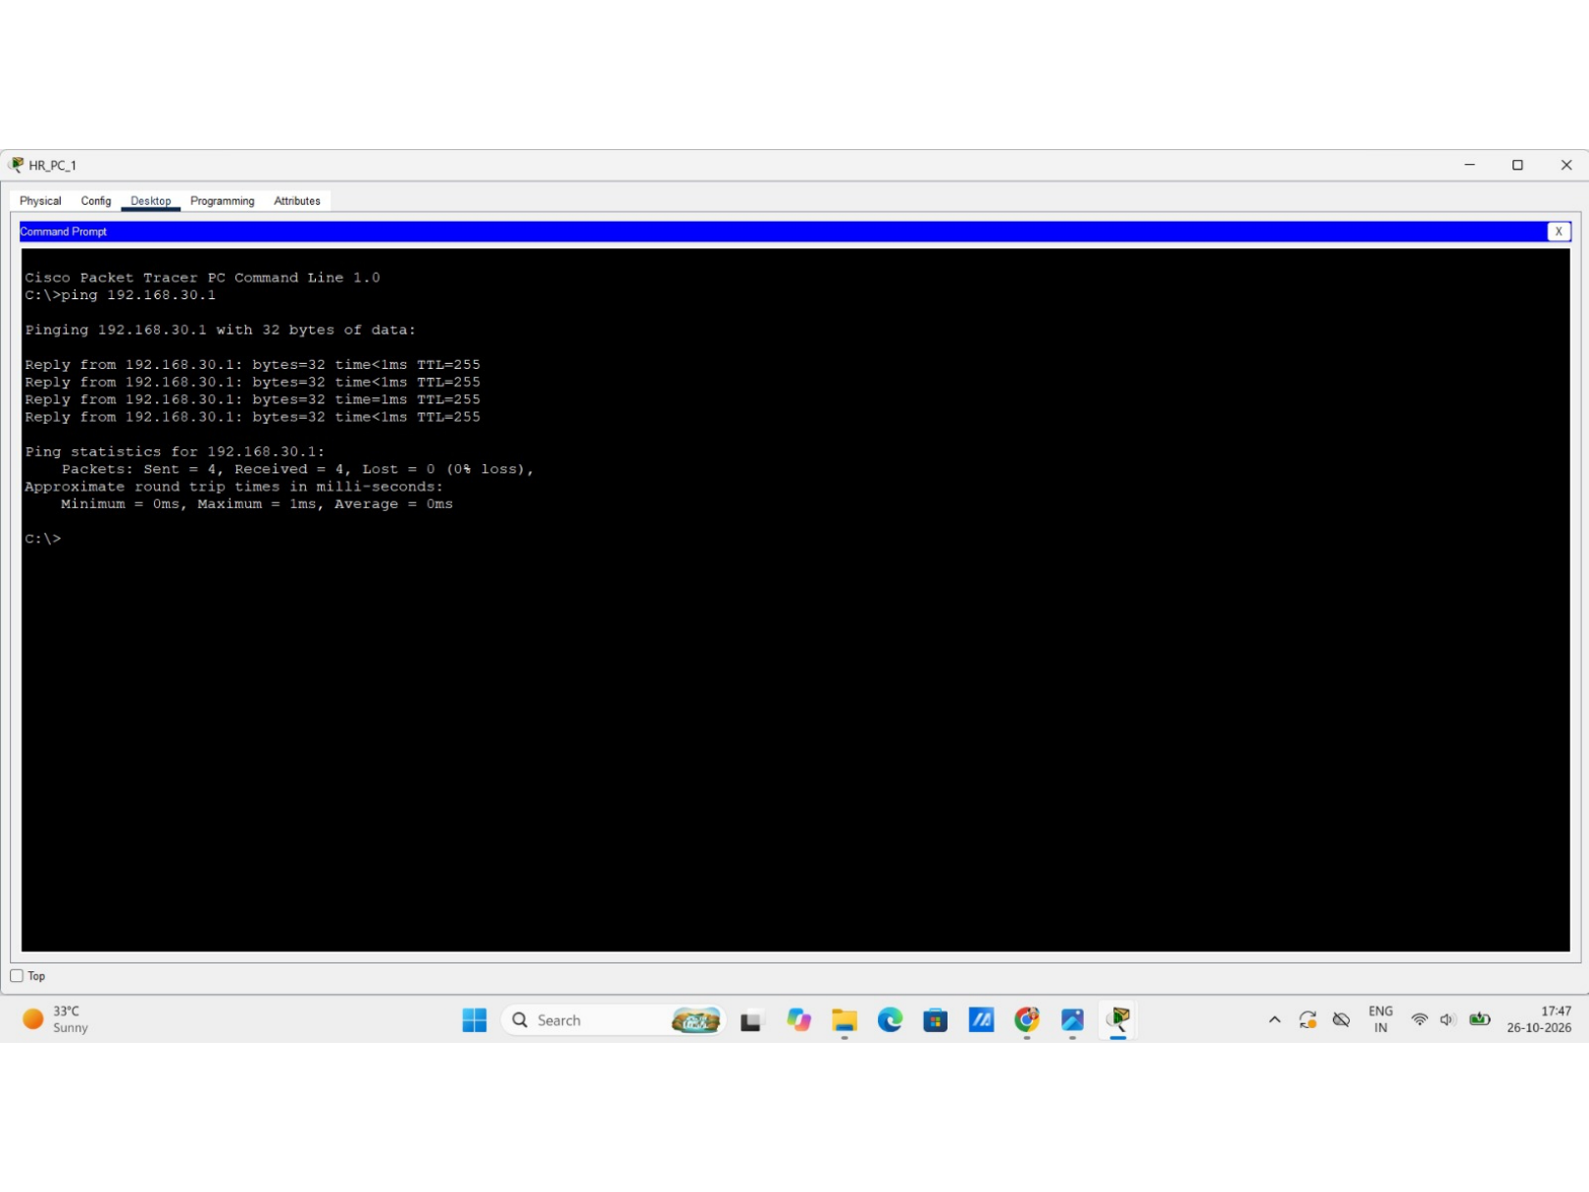
Endpoint command-prompt evidence; text not transcribed.

Evidence A10
DNS service resource-record screen.

Evidence A11
Internal HTTP page.

Evidence A12
Switch port-security output.

Evidence A13
Router SSH status output.

Evidence A14
DHCP pool status output.

