**Insurance Claim Fraud Detection: A Machine Learning Approach**

**1. Problem Definition**

In today's digital world, the prevalence of fraud in the insurance industry has surged, making fraud detection systems essential for companies to safeguard their profits. **Insurance claim fraud** can range from exaggerated claims to entirely fabricated incidents, costing the industry billions of dollars annually. To combat these malicious activities, data-driven solutions, specifically machine learning models, offer an intelligent approach by identifying patterns in fraudulent claims with remarkable accuracy.

This project aims to build a machine learning-based fraud detection system that can accurately classify insurance claims as either fraudulent or legitimate. The dataset used includes features such as the claimant’s information, details of the claim, and the outcome, providing a comprehensive base for modeling. The objective is to create a robust system that can minimize false positives and detect fraud early, reducing financial loss.

**2. Data Analysis**

Before we dive into modeling, it is important to understand the dataset and perform preliminary analysis. In this dataset, various attributes, including categorical and numerical features, describe the claims. These include:

* Claim amount
* Type of claim (e.g., theft, accident)
* The claimant's history with the insurance provider
* Time-related variables

Initial steps in **data analysis** involved:

1. **Loading the data**: The data was loaded into a pandas DataFrame for ease of manipulation.

2. **Understanding the target variable**: The target variable in this case is binary, where `1` represents fraudulent claims and `0` represents legitimate claims.

3. **Distribution of fraud cases**: Fraudulent claims are often rare compared to legitimate ones, creating an imbalanced dataset, which we need to account for in the model-building phase.

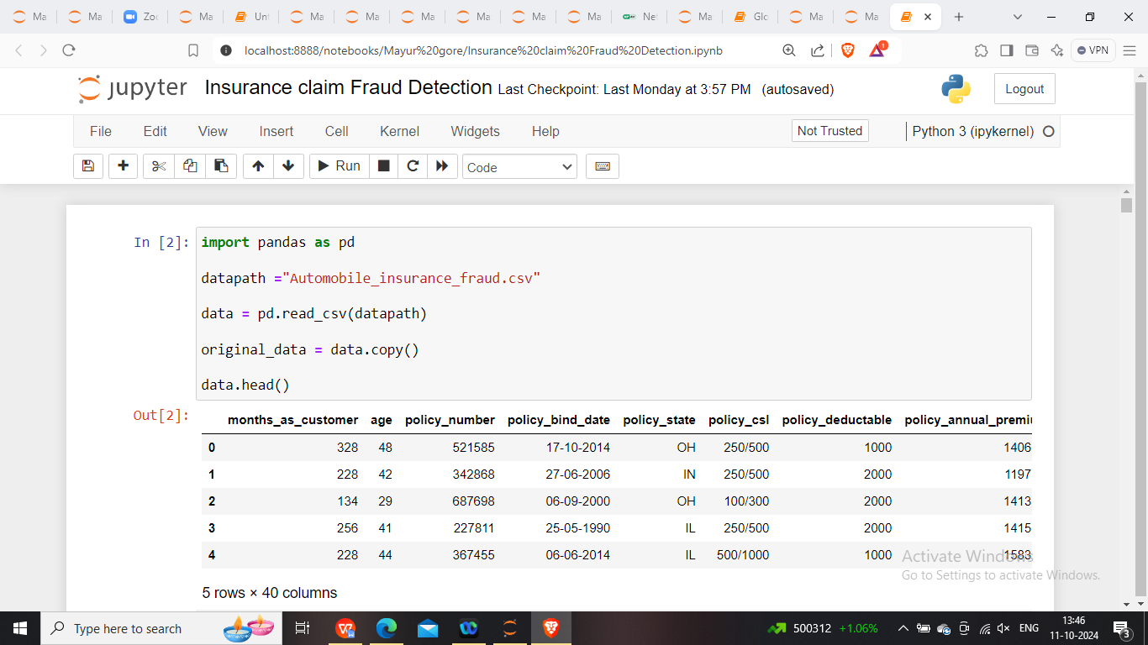

The preliminary data analysis revealed:

* A significant imbalance between fraudulent and non-fraudulent claims.
* Numerical features such as claim amounts had large variances, which could affect the performance of some models.
* Categorical variables needed to be transformed using encoding techniques.

---

**3. EDA Concluding Remarks**

**Exploratory Data Analysis (EDA)** plays a critical role in understanding the relationships between variables and the distribution of the data. Here are some insights from the EDA process:

1. **Correlation analysis**: By plotting correlation heatmaps, it was found that some features were highly correlated with the target variable. For example, claim amounts for fraudulent cases tend to be higher than legitimate ones.

2. **Class distribution**: As expected, the number of fraudulent claims was much smaller compared to legitimate claims, emphasizing the need for careful treatment of class imbalance during model training.

3. **Visualization**: Box plots and histograms were used to inspect the distribution of key features. For instance, some claim types were more likely to be fraudulent, which provided valuable insights for feature engineering.



These findings laid the groundwork for the next steps in the modeling pipeline, particularly regarding feature selection and data pre-processing.

**4. Pre-processing Pipeline**

A well-structured pre-processing pipeline ensures that the data is prepared effectively for model training. This step is crucial, especially when dealing with real-world data that often contains missing values, inconsistencies, and varying scales.

Key steps in the pre-processing pipeline:

1.**Handling missing values**: Several strategies were employed depending on the feature type:

* For numerical features, missing values were imputed with the median or mean.
* Categorical features were filled with the most frequent category or labeled as "unknown".

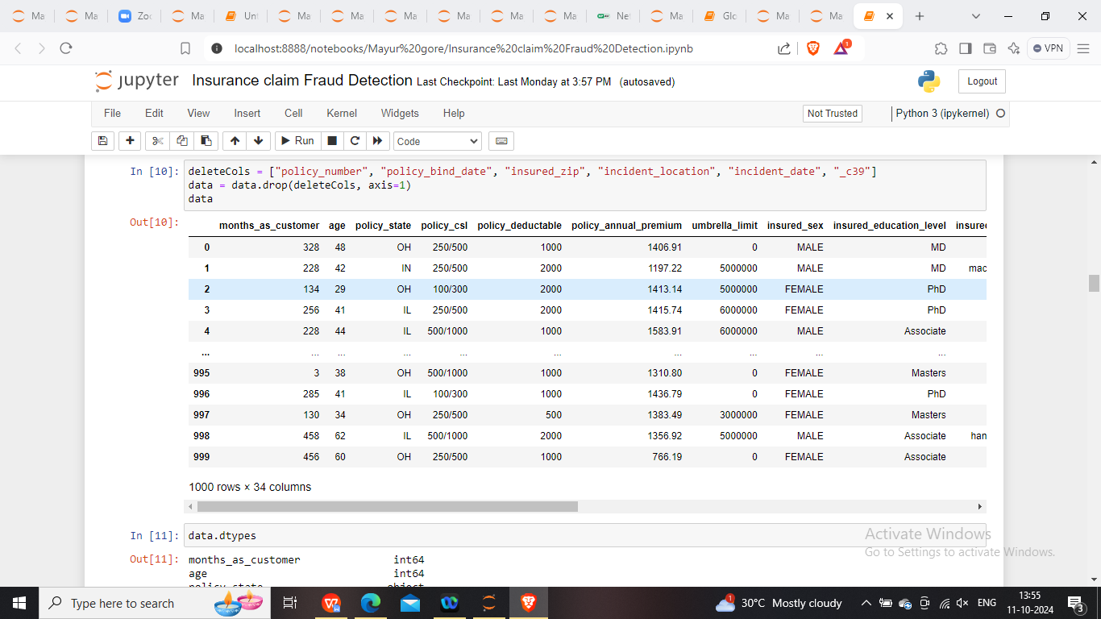

2. **Encoding categorical variable**s: Since many machine learning algorithms require numerical inputs, categorical features such as claim type and customer history were encoded using:

* One-hot encoding for nominal variables.
* Label encoding for ordinal variables.

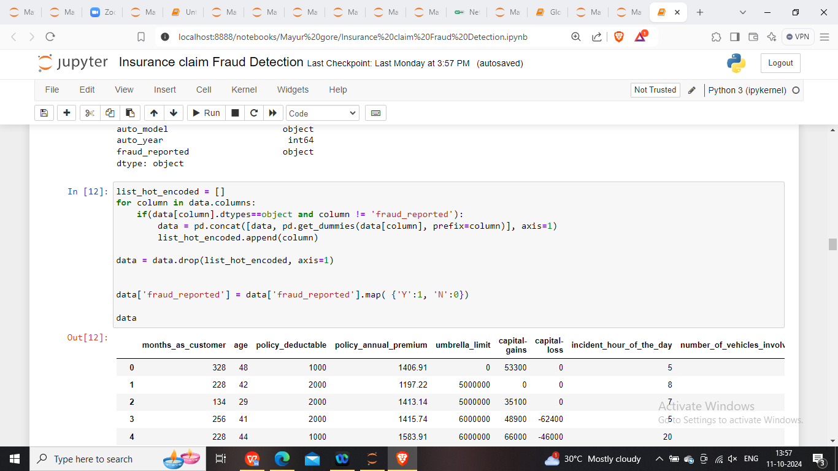

**3. Feature scaling**: Some models, like logistic regression and neural networks, are sensitive to the scale of input features. Hence, features were standardized using MinMax scaling to transform them into a range between 0 and 1.

**4. Class imbalance handling**: Due to the imbalanced nature of the data, techniques like **SMOTE (Synthetic Minority Over-sampling Technique)** were applied to balance the distribution of the target variable. This approach generated synthetic samples for the minority class (fraud cases) to improve model performance.

**5. Building Machine Learning Models**

Once the data was cleaned and pre-processed, multiple machine learning algorithms were employed to classify fraudulent and non-fraudulent claims. These models included:

**1. Random Forest**

* A robust ensemble learning method that operates by constructing multiple decision trees during training.
* ROC-AUC scores were used to evaluate performance. A well-tuned random forest model showed a strong AUC score of around 0.74, indicating good classification capabilities.
* The random forest was selected for its ability to handle both categorical and numerical features effectively, while also providing feature importance rankings.

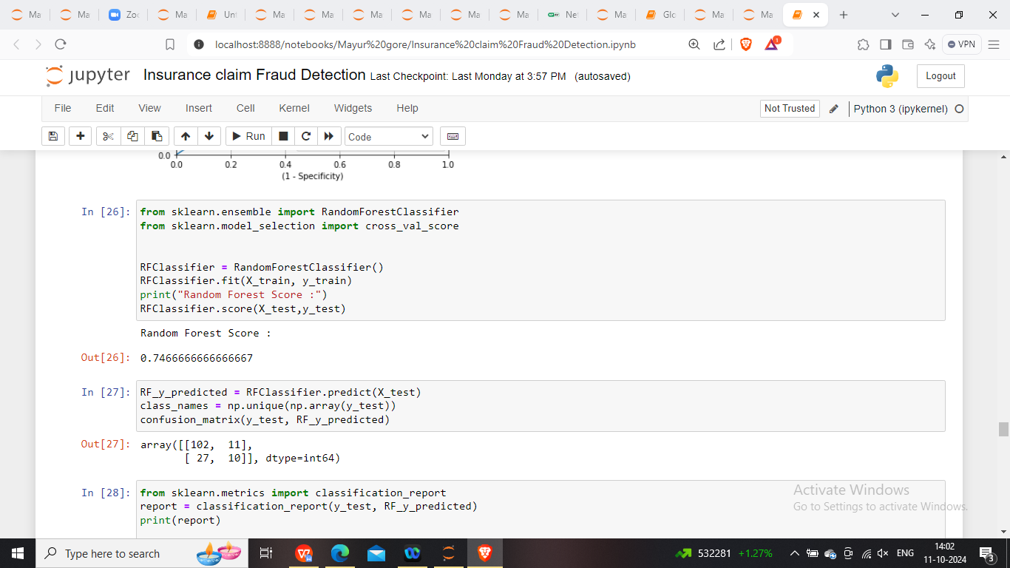

**2. Linear Discriminant Analysis (LDA)**

* LDA is a classification method that assumes Gaussian distributions for each class. It works well for linear separability.
* LDA achieved an accuracy score of 82.67% on the test set. Despite its simplicity, it provided competitive results and proved effective in this fraud detection task.

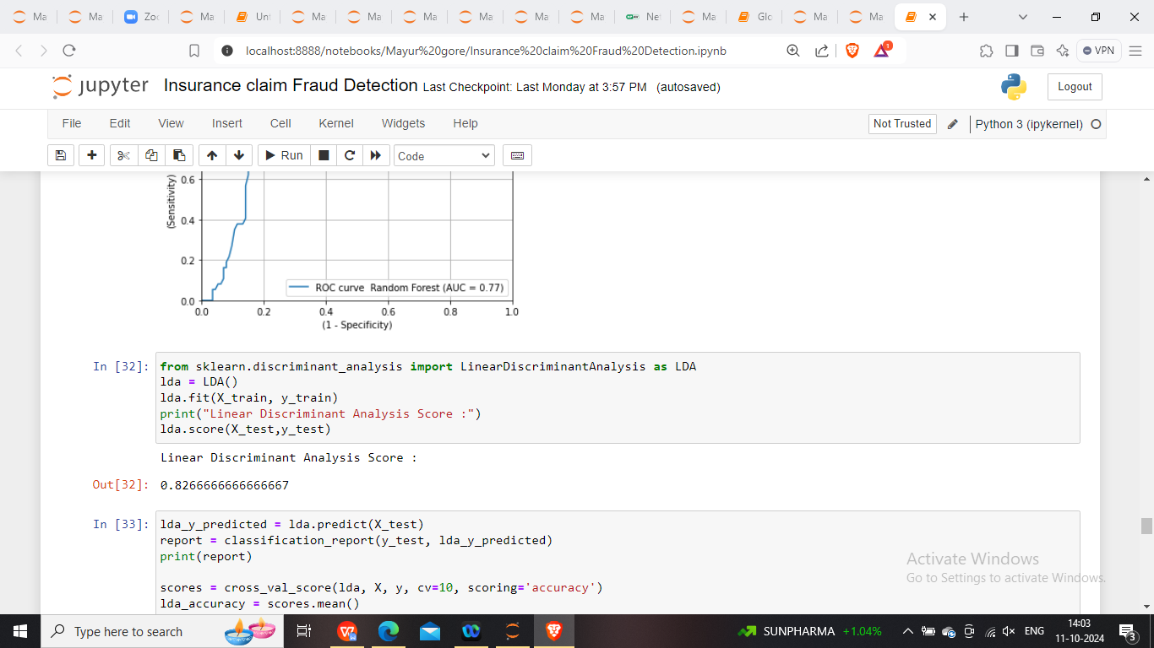

**3. Naive Bayes**

* A probabilistic classifier based on Bayes' Theorem. Despite its simplicity, Naive Bayes often performs surprisingly well on complex datasets.
* In this case, it achieved a cross-validated accuracy of 80%, though it struggled with precision for the minority class, as expected.

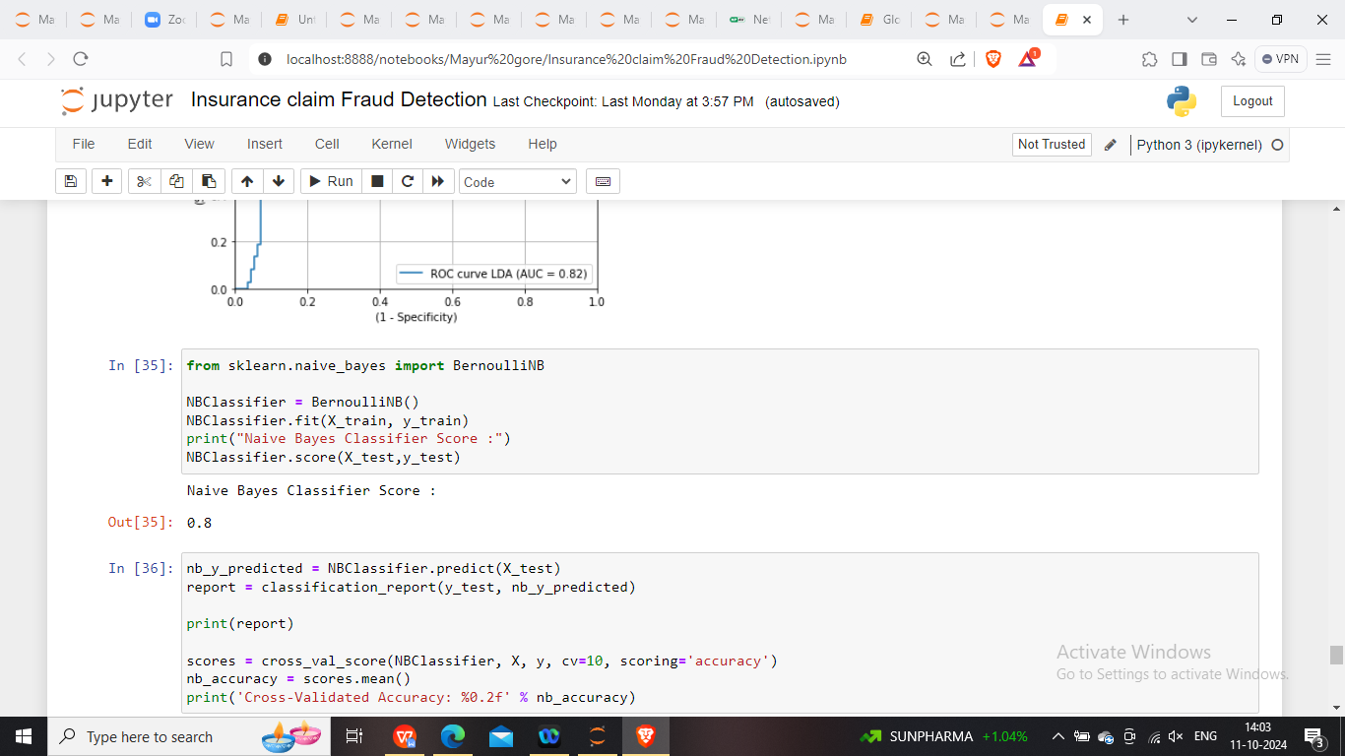

**4. MLPClassifier (Neural Network)**

* A neural network-based approach was used to capture non-linear relationships in the data.
* The MLPClassifier, with a single hidden layer, yielded a lower accuracy (62%) compared to the other models, likely due to over-fitting or a need for hyper-parameter tuning.

**Model Performance Comparison:**

* LDA emerged as the best-performing model based on AUC and precision-recall metrics, making it the most reliable classifier for fraud detection in this dataset.
* Naive Bayes and Random Forest provided solid results, but their performance was slightly hindered by the class imbalance.
* Neural Network struggled, possibly due to the small size of the dataset, making it prone to over-fitting.

**6. Concluding Remarks**

Fraud detection in insurance is a complex challenge that requires sophisticated approaches. In this project, we demonstrated the use of various machine learning algorithms to tackle the problem. The results show that:

* LDA was the best-performing model, providing high accuracy and strong AUC scores.
* Data pre-processing, especially handling missing values, feature encoding, and class imbalance, played a crucial role in improving model performance.
* Class imbalance was a major challenge, but techniques like SMOTE helped mitigate its impact.

Future improvements could include:

* Applying more advanced techniques such as XGBoost or LightGBM, which often outperform traditional algorithms.
* Implementing more extensive hyper-parameter tuning to improve the performance of neural networks.
* Gathering more data to further enhance the model's generalization capabilities.

This project underscores the importance of combining domain knowledge with data science techniques to build effective fraud detection systems. As fraudsters evolve their methods, so too must our models and strategies to protect against financial loss in the insurance sector.

This comprehensive article, based on the project, touches on each crucial step of the machine learning process, from data exploration and pre-processing to building and evaluating various models.