Savitribai Phule Pune University

**MASTER OF COMPUTER APPLICATION**



**Jayawant Shikshan Prasarak Mandal Group of Institute**

## Jayawantrao Sawant College of Engineering, Hadapsar

A

**Project Report**

On

“Bike Rental System”

**SUBMITTED BY-**

**Name: Mayur Bhaskar Hase**

**Roll No.:22**

**MCA FY**

UNDER THE GUIDANCE OF

**Prof. Swayam Shah**

**MCA Department**

Semester -II

For Academic Year 2021-22

**Jayawant Shikshan Prasarak Mandal Group of Institute**

## Jayawantrao Sawant College of Engineering, Hadapsar

**CERTIFICATE**

This is to certify that, **Mr. Mayur Bhaskar Hase** has satisfactorily carried out project work entitled **“Bike Rental System”**  for Jayawantrao Sawant College of Engineering , Hadapsar as partial fulfillment of the course Masters of Computer Application, sem-II under Savitribai Phule Pune University, Pune for academic year 2021 – 2022.

Place : Hadapsar

Date :

Prof. Swayam Shah Prof. Swayam Shah Dr. R.D. Kanphade

Project Guide H.O.D. Principle

**Jayawant Shikshan Prasarak Mandal Group of Institute**

## Jayawantrao Sawant College of Engineering, Hadapsar

ACKNOWLEDGEMENT

# ****This report has been made through direct & indirect cooperation of various person for whom we wish to express our appreciation & gratitude.****

I am very thankful to **Prof. Swayam Shah** for guiding throughout our project & exceeding useful cooperation during the period with discussion & guidance to success our project works.

Words are insufficient to express our appreciation for the valuable advice & continuous motivation **provided** by M.C.A. Department of Jayawantrao Sawant College of Engineering, Hadapsar.

Thanking you

**Mr. Mayur Bhaskar Hase**

**M.C.A. -I Sem-II**

**Jayawant Shikshan Prasarak Mandal Group of Institute**

## Jayawantrao Sawant College of Engineering, Hadapsar

### DECLARATION

### Me undersigned here by declare that this project entitled **“Bikr Rental System”** is original work prepared by me under the guidance of **Prof. Swayam Shah** the empirical findings in this report are based on data collected by us the matter presented in this report is not copied from any source.

This work has not been submitted to the award for any degree or diploma either to Jayawantrao Sawant College of Engineering, Pune or any other university . If our works is found to be copied, then I will be Liable to punished under the rule.

Date:

Place: Hadapsar

**Mr. Mayur Bhaskar Hase**

**Roll No.:22**

**INDEX**

|  |  |  |
| --- | --- | --- |
| **Sr.No.** | **CONTENTS** | **Page no.** |
| **1** | **INTRODUCTION TO PROJECT**   * 1. **INTRODUCTION**   **1.2 EXISTING SYSTEM**  **1.3 SCOPE OF SYSTEM**  **1.4 HARDWARE & SOFTWARE DETAILS** | **6**  **7**  **8**  **9** |
| **2** | **PROPOSED SYSTEM**  **2.1 OBJECTIVE OF PROPOSED SYSTEM**  **2.2 USER REQUIREMENT** | **10**  **10**  **10** |
| **3**  **3.1** | **ANALYSIS AND DESIGN**  **UML DIAGRAMS**  **3.1.1 USE CASE DIAGRAM**  **3.1.2 USE CASE DIAGRAM**  **3.1.3 CLASS DIAGRAM**  **3.1.4 ENTITY RELATIONSHIP DIAGRAM**  **3.1.5 ACTIVITY DIAGRAM FOR USER**  **3.1.6 ACTIVITY DIAGRAM FOR ADMIN**  **3.1.7 SEQUENCE DIAGRAM**  **3.1.8 WEBSITE MAP DIAGRAM** | **11-18**  **11-18**  **11**  **12**  **13**  **14**  **15**  **16**  **17**  **18** |
| **4** | **INPUT AND OUTPUT SCREENS** | **19-23** |
| **5** | **TESTING PHASE** | **24-26** |
| **6** | **FUTURE ENHANCEMENTS** | **27** |
| **7** | **CONCLUSION** | **28** |
| **8** | **BIBLIOGRAPHY** | **29** |

## Introduction of Bike Rental System

* 1. **Introduction:**

This system is named as Bike on Rent Management System. This system is designed to help the customers to take bikes or two-wheelers for rent. When we go on any trip outside the town or country, we want to be free of time so instead of going through metros and taxis, we prefer to have our own vehicle for rent.

Using this system vehicle owners can register as sellers and customers who want to take bikes on rent can register themselves as renters and can take any bike on rent. Address of the both are required as the customer can only take bike by going to the address provided and the vehicle owners can know the address that a customer is verified or not. The customer also has to upload some proofs to take the bike on rent.

Proofs like license, pan card, and identity card are compulsory so that no one could run taking the bike. Any customer whose proofs are not uploaded and are not valid will not be allowed to take any bike on rent. This has one admin account that verifies the registering user and two types of user account. One for bike sellers and one for customers who take the bike on rent.

A bike rental is a rented vehicle that can be used temporarily for a fee during a specified period. Getting a rental bike helps people get around despite the fact they do not have access to their own personal vehicle or don't own a vehicle at all. The individual who needs a bike must contact a rental bike company and contract out for a vehicle. This system increases customer retention and simplify vehicle and staff management.

This system has only one admin account and cannot have more than one admin account. Admin can verify and register the user who is registering. If the admin does not verify, the user cannot register. All other features are explained further in detail.

## Existing System and Need for System

* The Bike Rental System reduces time of taking manual Browsing of bikes for rents.
* This system will work efficiently and correctly as far as computer technology is concerned.
* This system will provide better security and transparency.
* Less User Friendly and Limited to Single System.
* This System Save the time of user for searching bikes all over the city.

## 1.3 Scope of System

This project was designed to investigate and related different functional, operational and technical requirement of a dedicated web application for online bike rental system.

The system equipped to answer customer’s inquiries about the availability and rental fee of various types of bikes for certain dates in the future.

The system process a bike pick up. Customer walks in and supplies either the confirmation number or name. The system should pull up all the reservation information about this customer. The customer is then asked to supply a driver’s license.

Bike rental system gives bike rental service for both foreign as well as local customers. This organization carries out its daily work by providing; their service to the customer using manually system

## 1.4 Operating Environment - Hardware and Software Detail Description of Technology Used :

The Software Requirement deal with defining software resource requirements and prerequisites that needs to be installed on a computer to provide optimal functioning of an application.

Front End

* + User interface : HTML/CSS/JavaScript
  + Operating System : Microsoft Windows 7 or above
  + Web Browser : Chrome, Internet Explorer

Back End

* + Database : My SQL
  + Application Server : XAMPP server(v3.2.2) for Apache server(localhost)
  + PHP (v7.2.10) for server side scripting
  + Sublime3 (Source Code Editor)

1. **PROPOSED SYSTEM:**
   * + Our proposed system helps to maintain all records using database system, and the new feature that we are going to implement is maintain in this
     + application by offline.
     + As we are introducing the solution to existing problem it reduces time and it reduces lot of paper work and all the calculation and maintenance of the data is much easy compare to the manual system.

## 2.1 Objectives of System:

* To produce a web-based system that allow customer to register and reserve a bike online and for the company to effectively manage their bike rental business.
* To ease customer’s task whenever they need to rent a bike.
* Availability of vehicle round the clock.
* Wide range of vehicles.
* Maintaining record of each booking history.
* Online payment option
* Login and account generation

## 2.2 User Requirements:

* Registration and login
* Android phone, Desktop, Laptop
* User have to book bike

1. **ANALYSIS AND DESIGN:**

**3.1 UML DIAGRAMS:**

**3.1.1** **Module Hierarchy Diagram:**

Manage Order Confirmation

Manage Bikes

Login

Admin

User

Give Feedback

Book Bike

Login

Register

**Online Bike Rental Website**

## 3.1.2 Use Case Diagram:

Register

Login

Add bike

**User**

View Bike

Check Bike Price

Book bike

View Booking List

**Admin**

Confirm Booking

Give Feedback

## 3.1.3 Class Diagram:

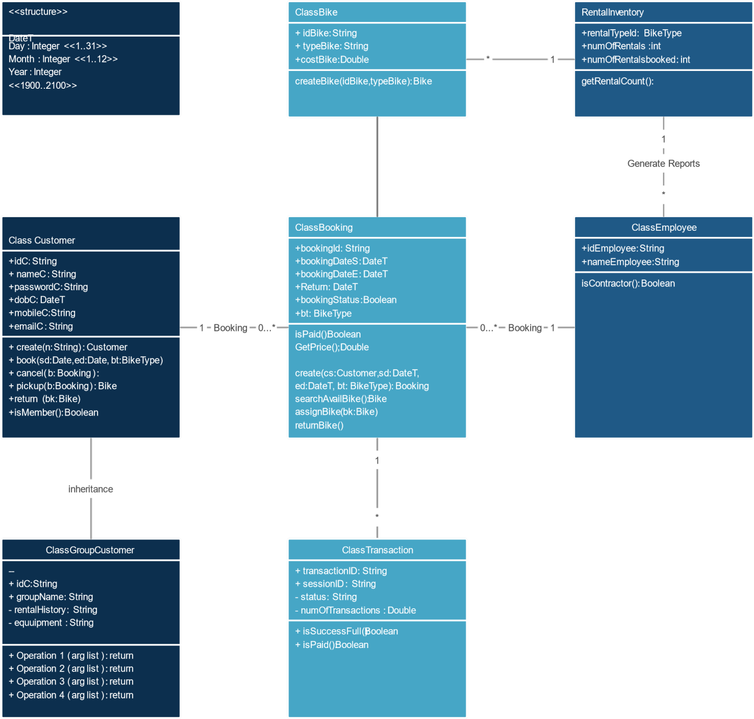

**3.1.4 Entity – Relationship Diagram**

An Entity Relationship model, also called as Entity – Relationship (ER) Diagram, is a graphical representation of entities and their relationship to each other, typically used in computing in regard to the organization of data within databases or information systems.

Testinonial

Views

Admin_name

User

Admin

UserAdd

Submit

A_email

Password

Confirm

Request

U_id

User Name

Booking

B_No Book_date

Manage

V_No Year

Check

has

Vehicle

B_No

Brand_Type

Brands

P_No

Contacts

**3.1.5 Activity Diagram for User:**



User

Registration

Login

Book Bike

Give feedback

**3.1.6 Activity Diagram for Admin: -**



Login

Add/Remove Bike

View users

Confirm Booking

View Bookings

**3.1.7 Sequence Diagram:**

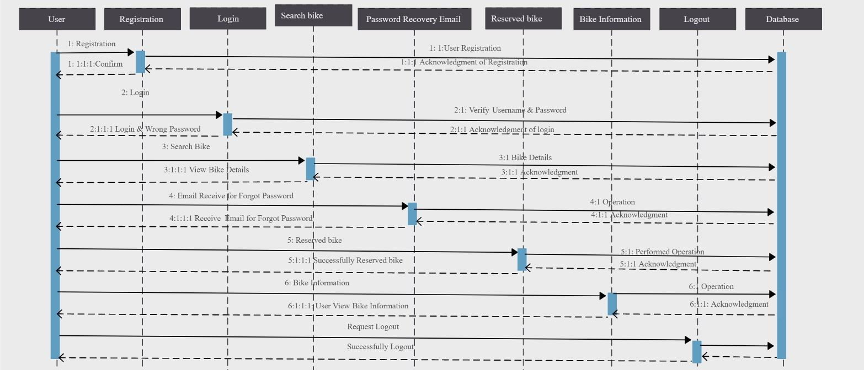

## Website Map Diagram:



**ONLINE BIKE RENTAL**

HOME

ABOUT

LOGIN

SIGNUP

ADMIN

ADMIN

USER

USER

1. **INPUT AND OUTPUT SCREEN:**

**HOME PAGE:-**

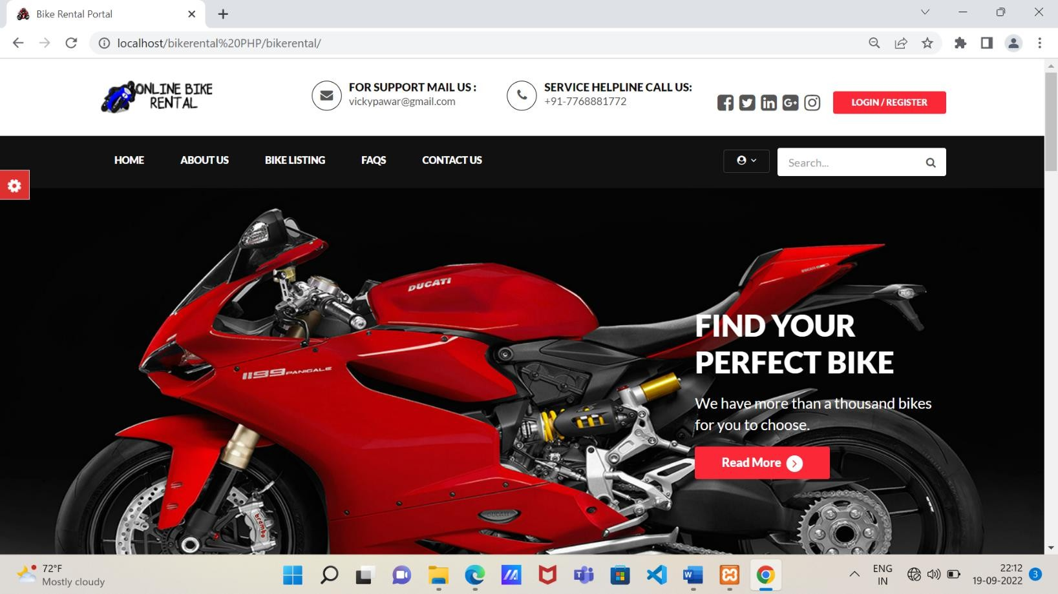

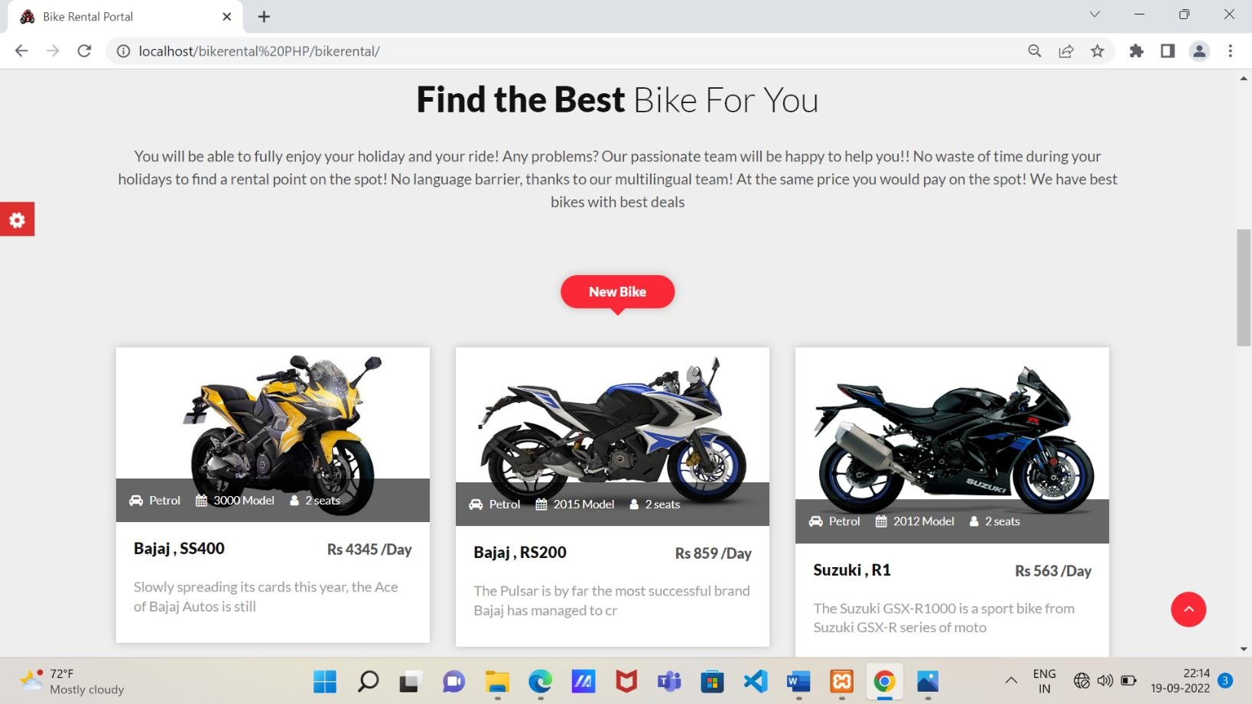

## LOGIN SCREEN:-

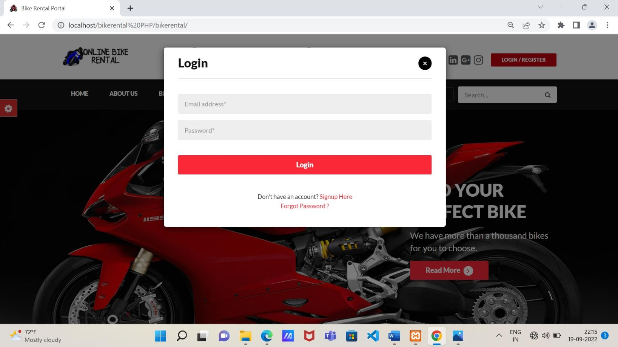

**REGISTRATION:-**

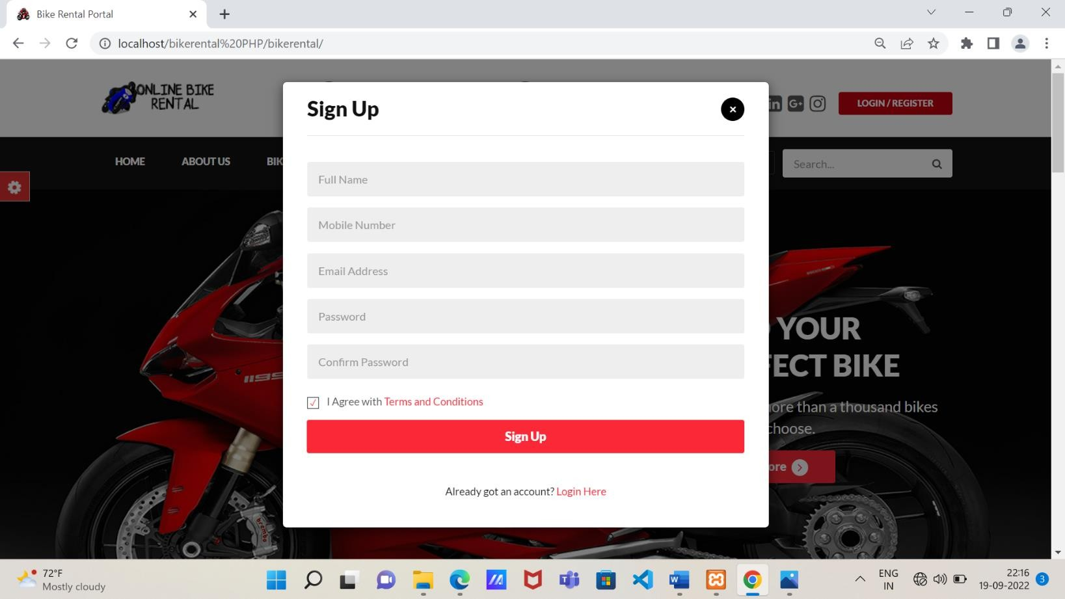

## ADMIN:-

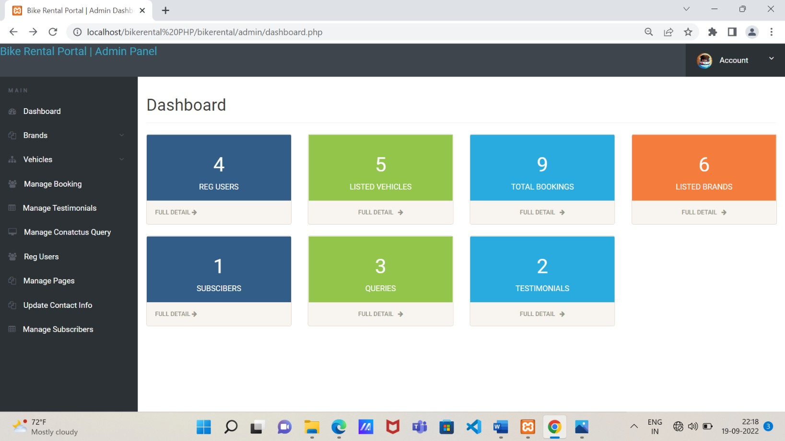

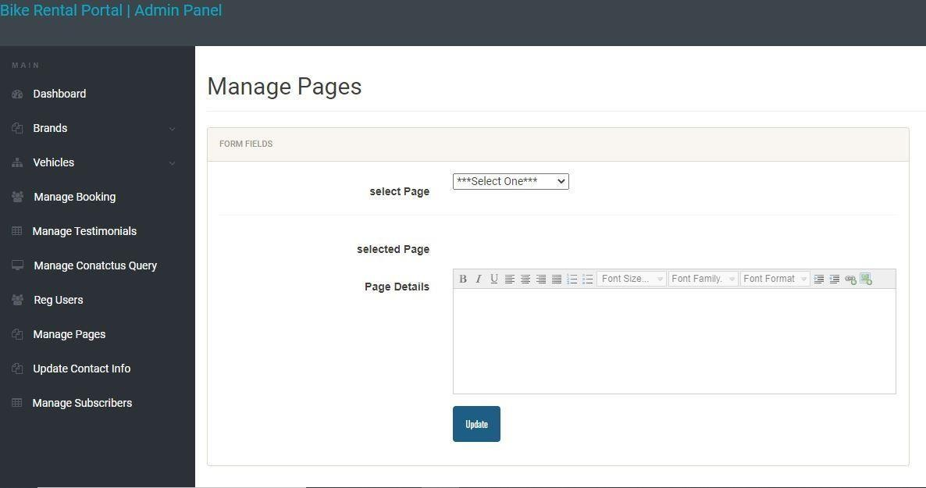

**ABOUT US:-**

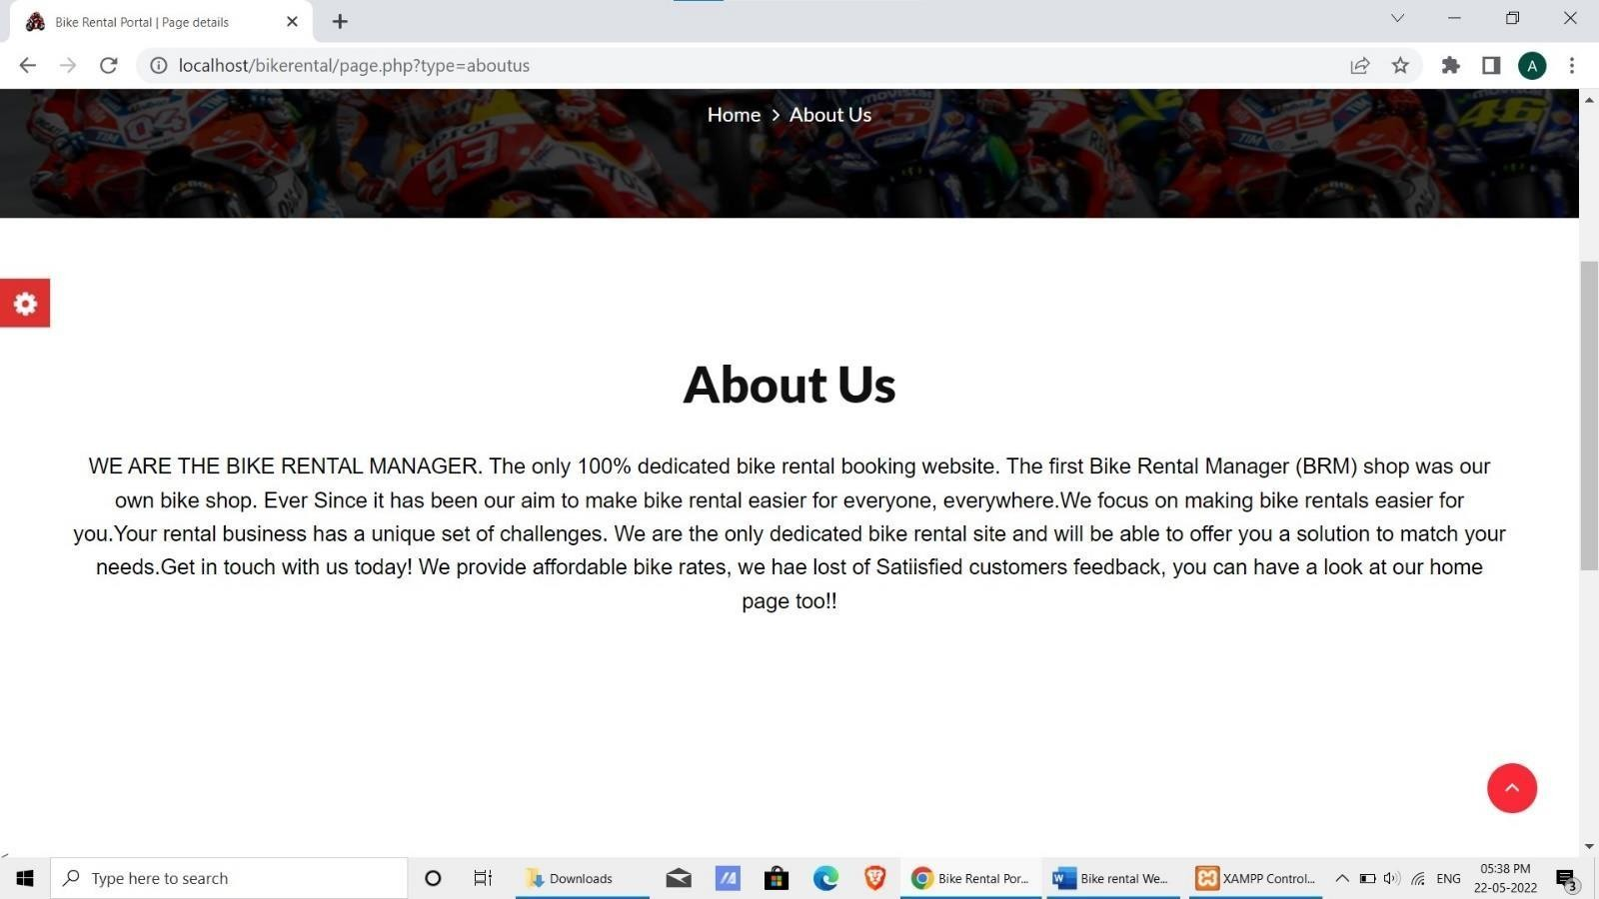

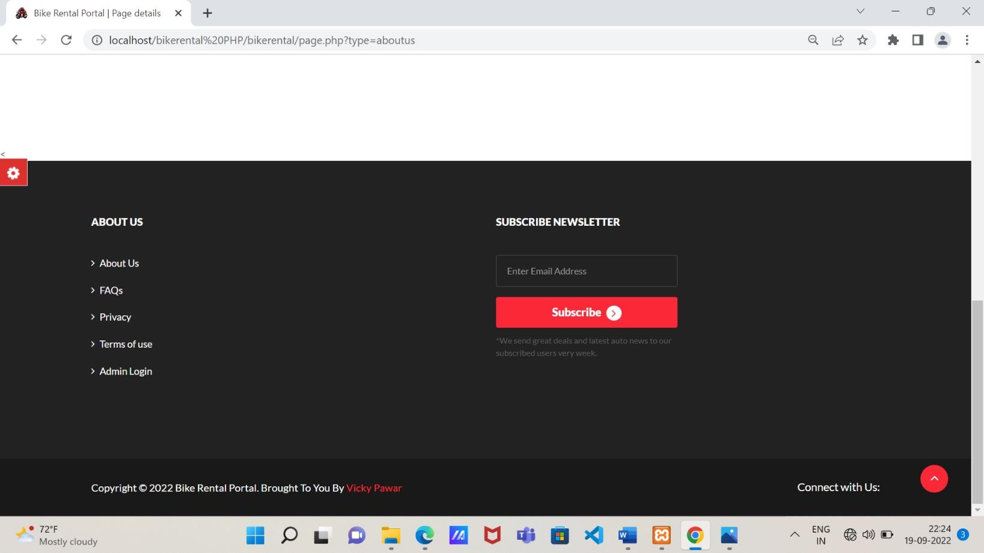

## Description of Tables:-

**ADMIN:-**



**USER:-**

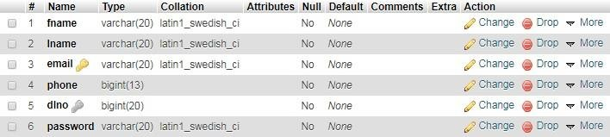

**BIKE:-**

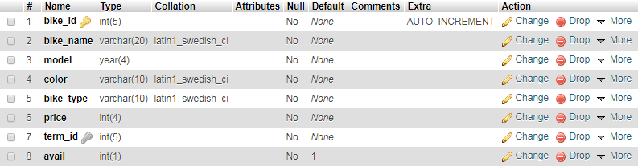

**PAYMENT:-**

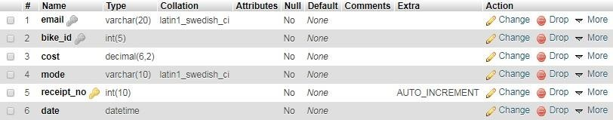

**5. TESTING PHASE**

**5.1 Introduction:**

Testing is a process of executing a program with the indent of finding an error. Testing is a crucial element of software quality assurance and presents ultimate review of specification, design and coding.System Testing is an important phase. Testing represents an interesting anomaly for the software. Thus a series of testing are performed for the proposed system before the system is ready for user acceptance testing.The code is tested at various levels in software testing. Unit, system and user acceptance testing’s are often performed. This is a grey area as many different opinions exist as to what the stages of testing aree and how much if any iteration occurs.

**5.2 Testing Objectives:**

* Testing is a process of executing a program with the intent of finding an error
* A good test case is one that has a probability of finding an as yet undiscovered error
* A successful test is one that uncovers an undiscovered error

**5.3 Testing Principles:**

* All tests should be traceable to end user requirements
* Tests should be planned long before testing begins
* Testing should begin on a small scale and progress towards testing in large
* Exhaustive testing is not possible
* To be most effective testing should be conducted by a independent third party

The primary objective for test case design is to derive a set of tests that has the highest livelihood for uncovering defects in software. To accomplish this objective two different categories of test case design techniques are used. They are

* White box testing.
* Black box testing.

**5.3.1 White Box Testing:**

White box testing focus on the program control structure. Test cases are derived to ensure that all statements in the program have been executed at least once during testing and that all logical conditions have been executed.

**5.3.2 Black Box Testing:**

# Black box testing is designed to validate functional requirements without regard to the internal workings of a program. Black box testing mainly focuses on the information domain of the software, deriving test cases by partitioning input and output in a manner that provides through test coverage. Incorrect and missing functions, interface errors, errors in data structures, error in functional logic are the errors falling in this category.

**5.4 Testing Strategies:**

A strategy for software testing must accommodate low-level tests that are necessary to verify that all small source code segment has been correctly implemented as well as high-level tests that validate major system functions against customer requirements.

There are two general strategies for testing software. These are as follows:

**5.4.1 Code Testing:**

This examines the logic of the program. To follow this test, cases are developed such that every path of program is tested.

**5.4.2 Specification Testing:**

Specification Testing examines the specification starting what the program should do and how it should perform under various conditions. Then test cases are developed for each condition and combinations of conditions and to be submitted for processing.

**6. CONCLUSION**

The project entitled “Bike Rental System” is developed using HTML, CSS, PHP as front end and MySQL Server for database in back end to computerize the process of Vehicle Renting System. This project covers only the basic features required. There is lot to learn in renting of vehicle process. More improvement in renting procedure can be done to achieve highest rental system satisfaction. There are many problems while renting a vehicle for which we have to go beyond engineering application and prescribed method. In order to accommodate additional features it will take longer time and effort to understand the requirement and converting it into working system.

Bike Rental System is a web application and it is restricted to only limited type of users. In this application, Admin have been given access rights and are restricted up to certain functionalities, so that the data is maintained securely and redundant data is prevented. As the Data is stored electronically, it is necessary to have a Computer and Network connection to access the Application. It is a software which helps the user to rent bike base on their need. This software reduces the amount of manual data entry and gives greater efficiency. The User Interface of it is very friendly and can be easily used by anyone. It also decreases the amount of time taken to write details and other modules. At the end, this software can perform all the tasks accurately and can do the work for which it is made.

## FUTURE ENHANCEMENTS:-

Once the final Bike Rental System is built, business students will become involved with an economic and marketing analysis. The engineering programs will pay for the construction of the bike system from funds budgeted for the capstone class. An initial thought is for local business to sponsor each of the bikes. As an incentive, they will be allowed to put an advertisement for their business on the bike they sponsor. Asmall monthly fee will then be charged to continue the sponsorship. The fees collected will be used to contract with a local bike shop to maintain the condition bikes. The implementation of the final bike rental system is truly the final step in maintaining the community relations link.

Further Enhancement can also be done by providing access permissions to the employees, Try to Implement the GPS System in Bikes.

To maximize the use of Bike Renting System, the lead agency needs to have the support of stakeholders and partners. These stakeholders may be including Local municipality (funding and space), Public transit operators, User association and other groups (e.g. vehicle sharing companies).

## BIBLIOGRAPHY:-

* + 1. Object Oriented Databases and their applications.
    2. Software Engineering.
    3. PHP & MYSQL Web Development.
* **REFERENCES:**

1. [www.wikipedia.com](http://www.wikipedia.com/)
2. [www.phppoint.com](http://www.phppoint.com/)
3. [www.slideshare.com](http://www.slideshare.com/)
4. [www.w3school.com](http://www.w3school.com/)