NPM ASSIGNMENT

1] UPDATE COMMAND - sudo apt update

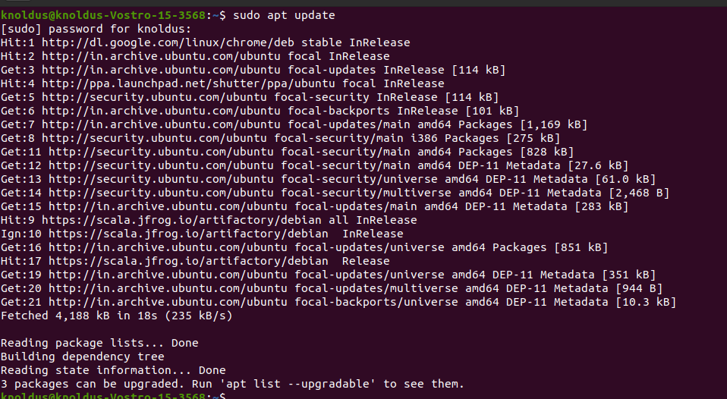

2] INSTALL NODEJS COMMAND- sudo apt install nodejs

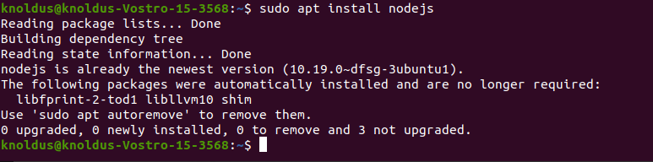

3] NODEJS CLI COMMAND- node -v

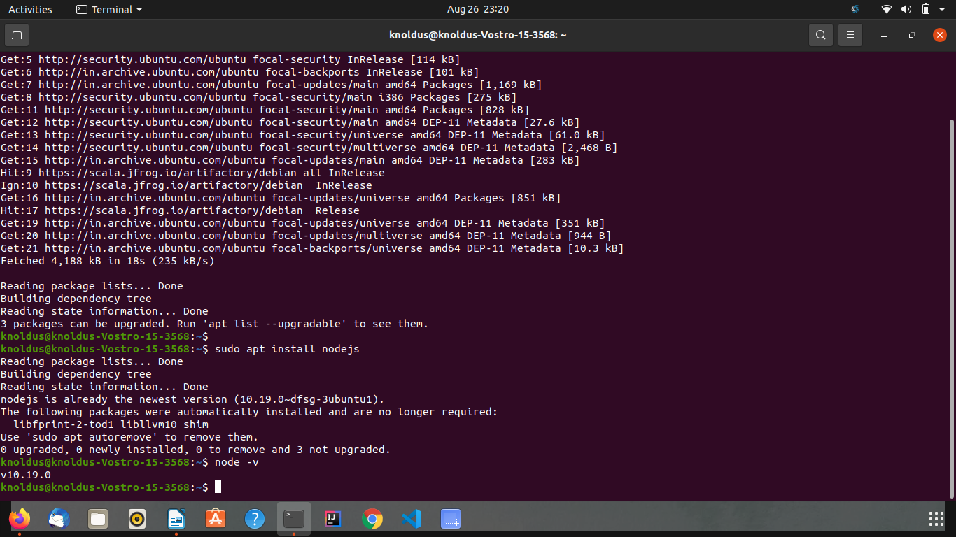

4] INSTALL NPM COMMAND- sudo apt install npm

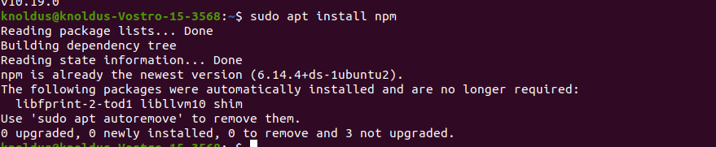

5] INSTALL ANGULAR COMMAND- sudo npm install -g @angular/

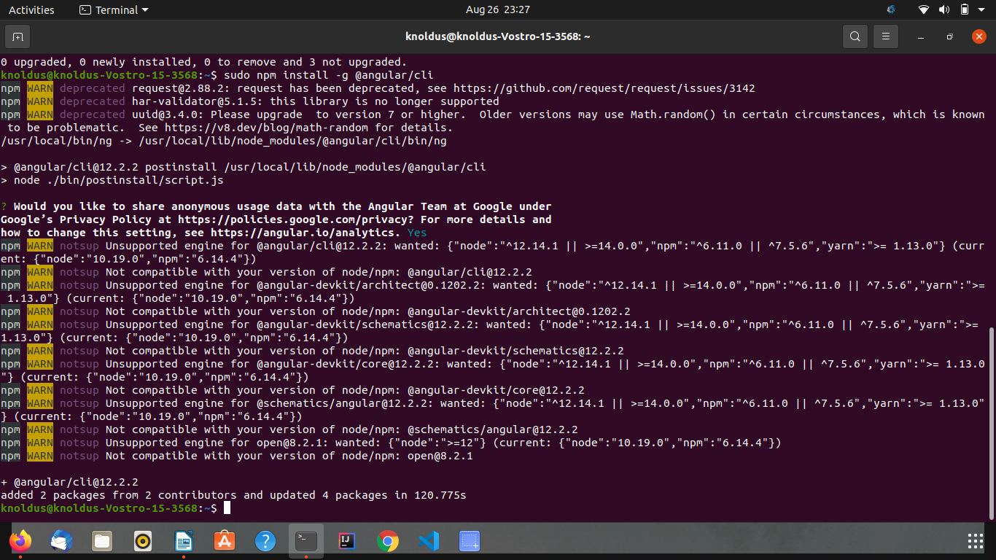

6] ANGULAR CLI COMMAND- ng –version

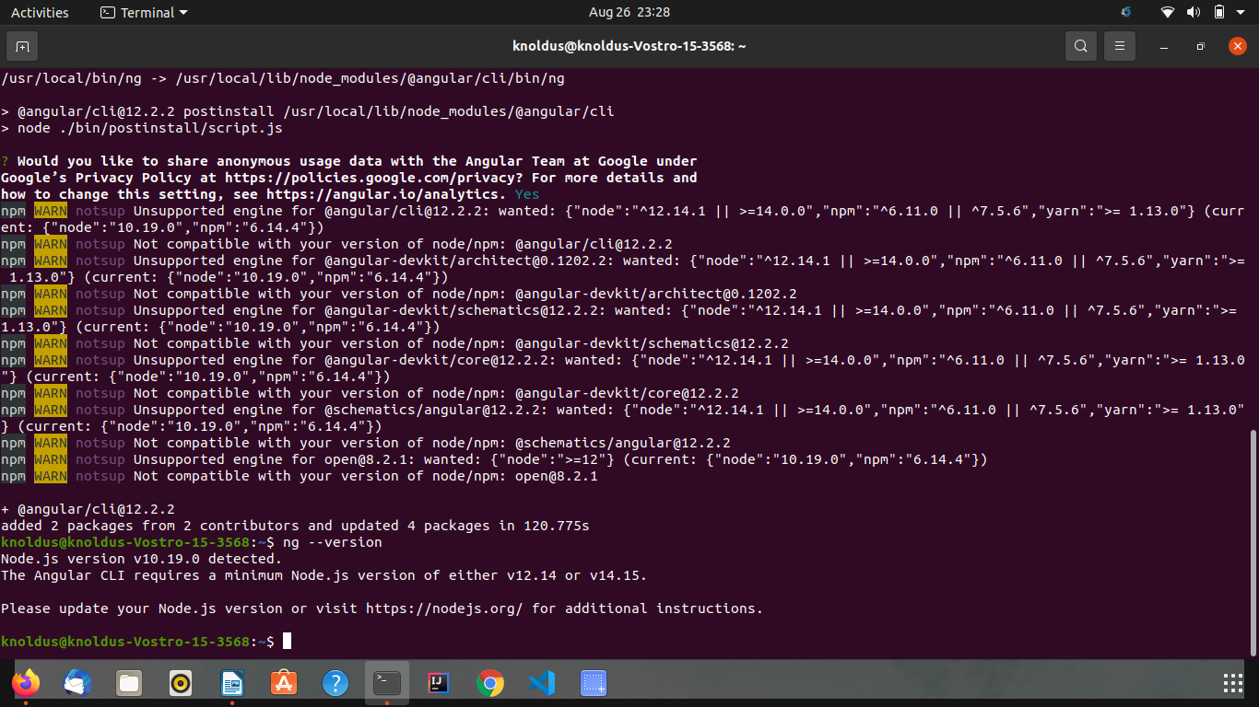

7] IONIC INSTALL COMMAND- sudo npm i -g @ionic/cli

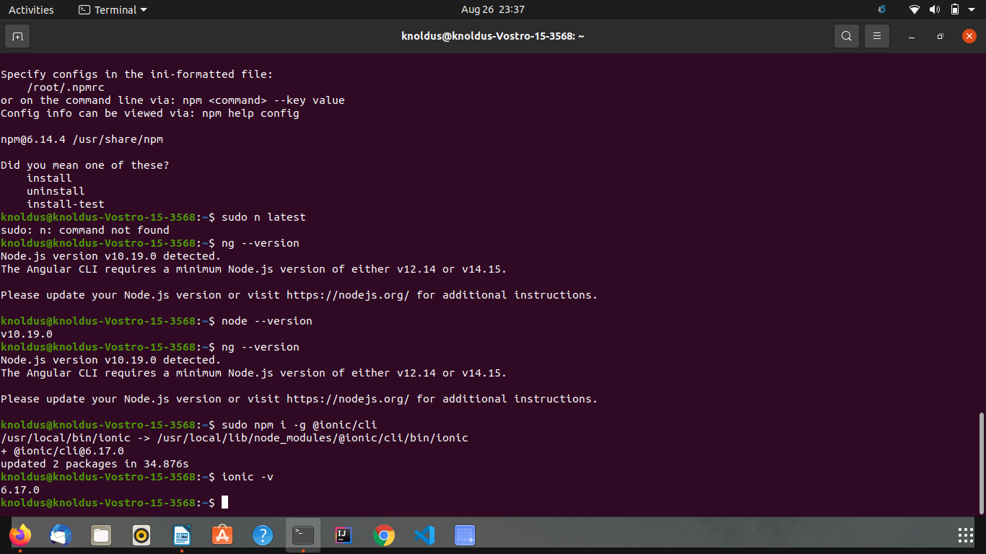

8] IONIC CLI COMMAND- ionic –v

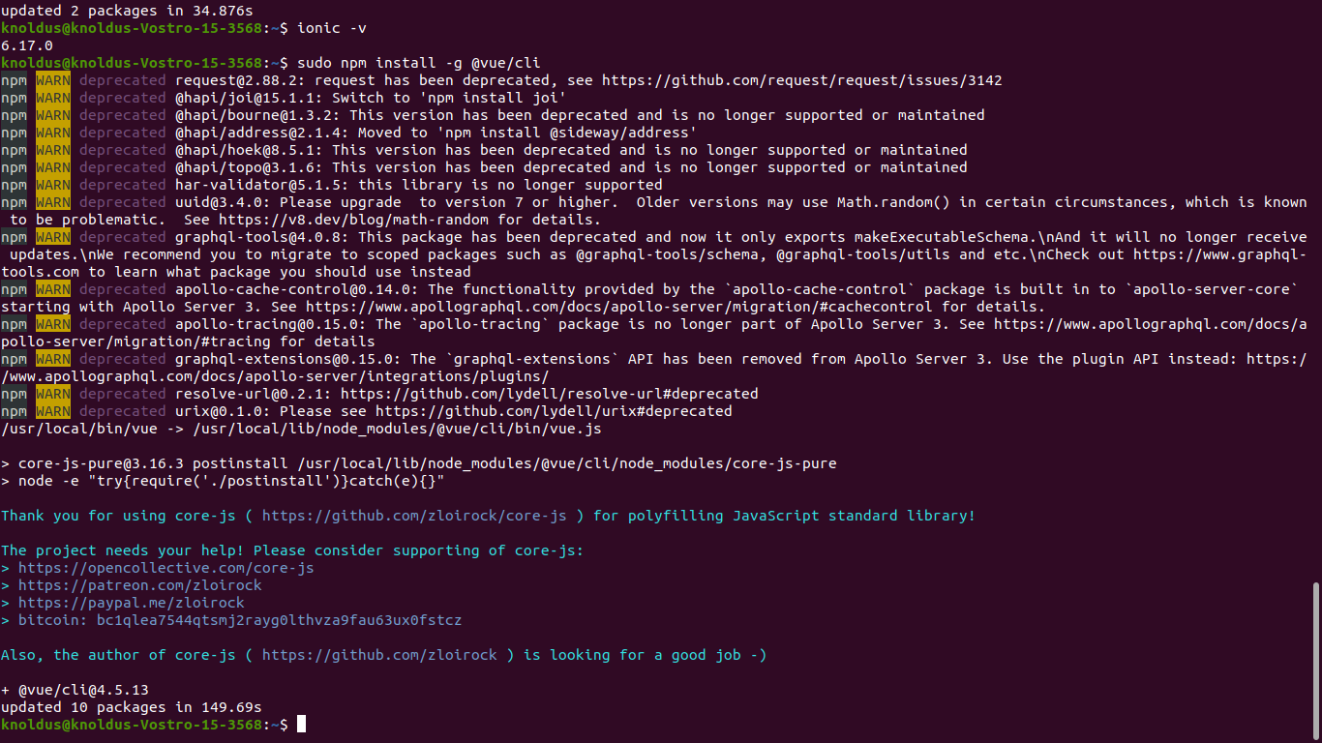

9] INSTALL VUE COMMAND- sudo npm install -g @vue/cli

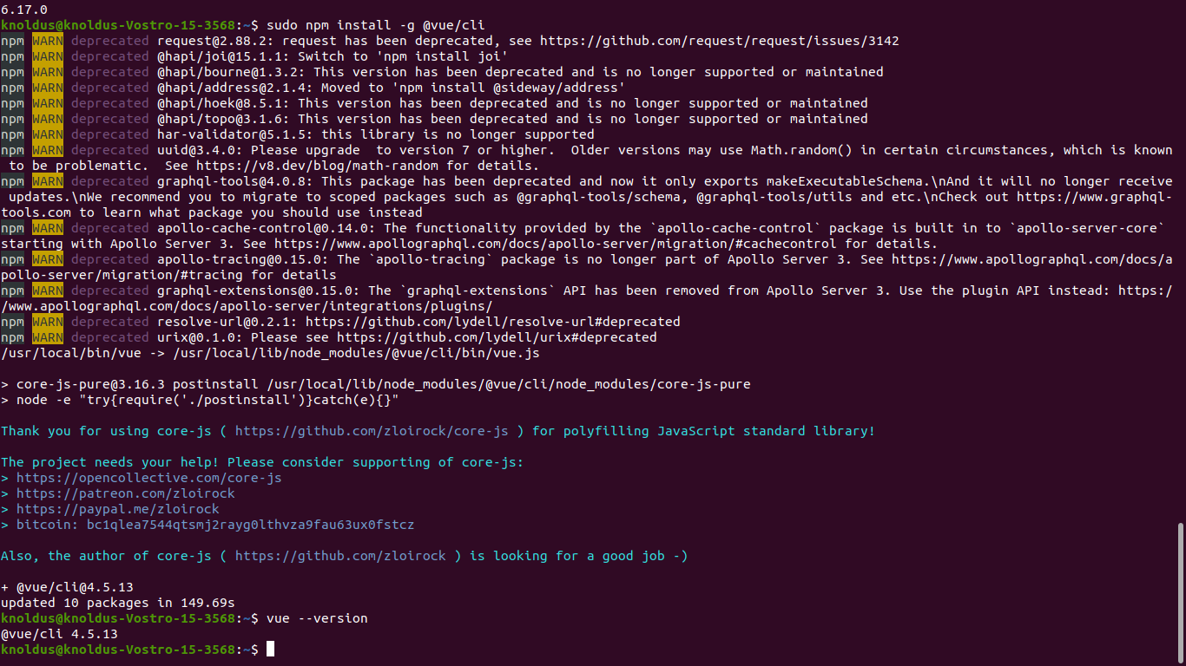
10] VUE CLI COMMAND- vue –version

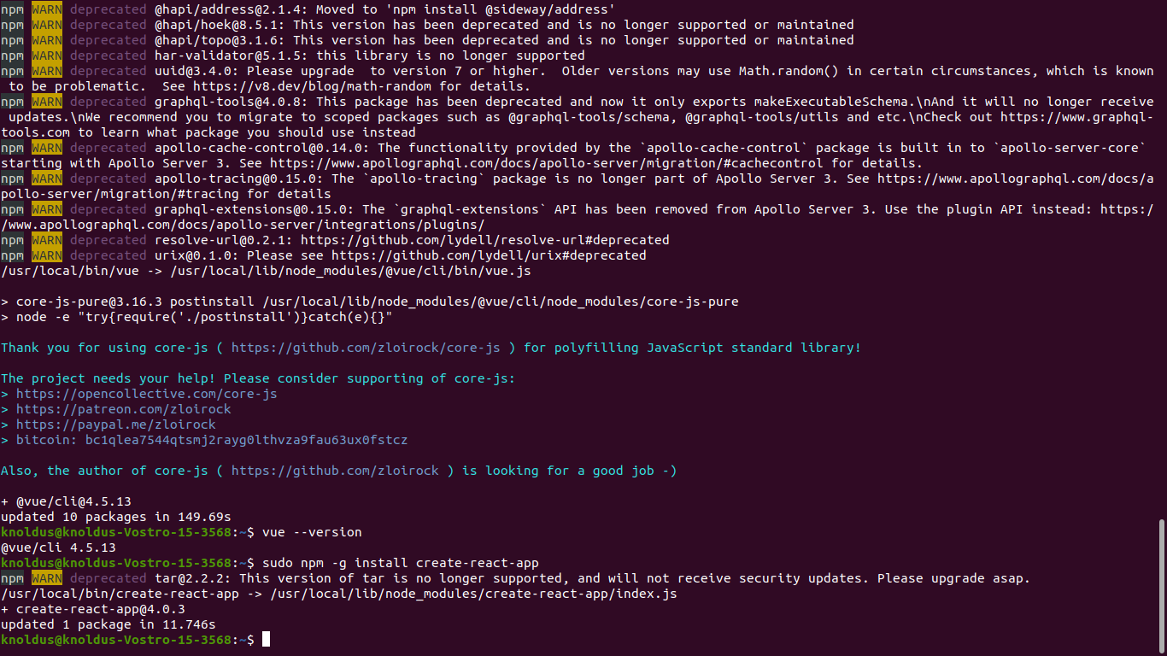

11] INSTALL CREATE REACT COMMAND- sudo npm -g install create-react-app

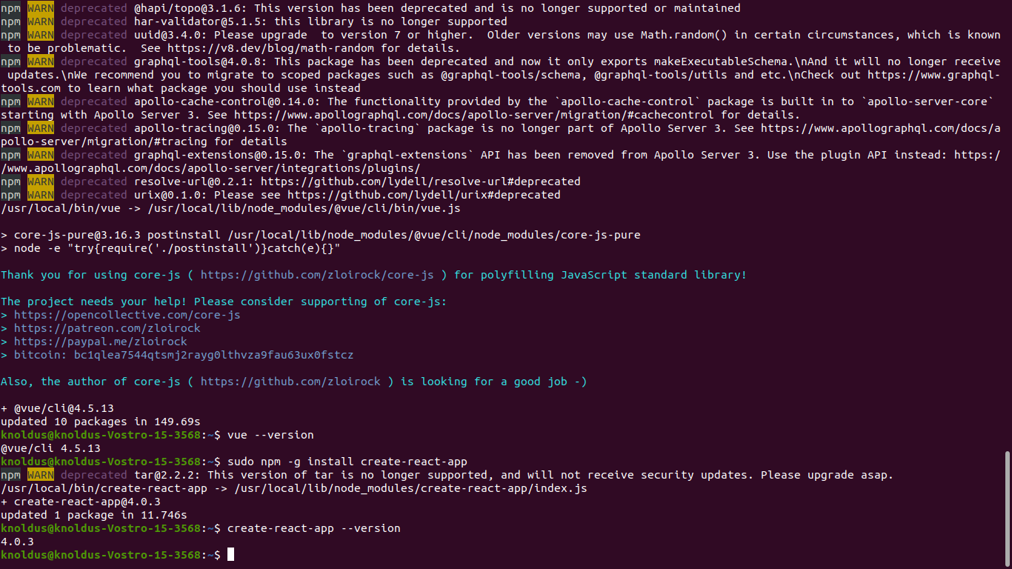

12] CREATE REACT CLI COMMAND- create-react-app --version

13] COMMAND FOR ANGULAR CLI LATEST VERSION –

sudo npm cache clean –f
sudo npm install –g n
sudo n latest

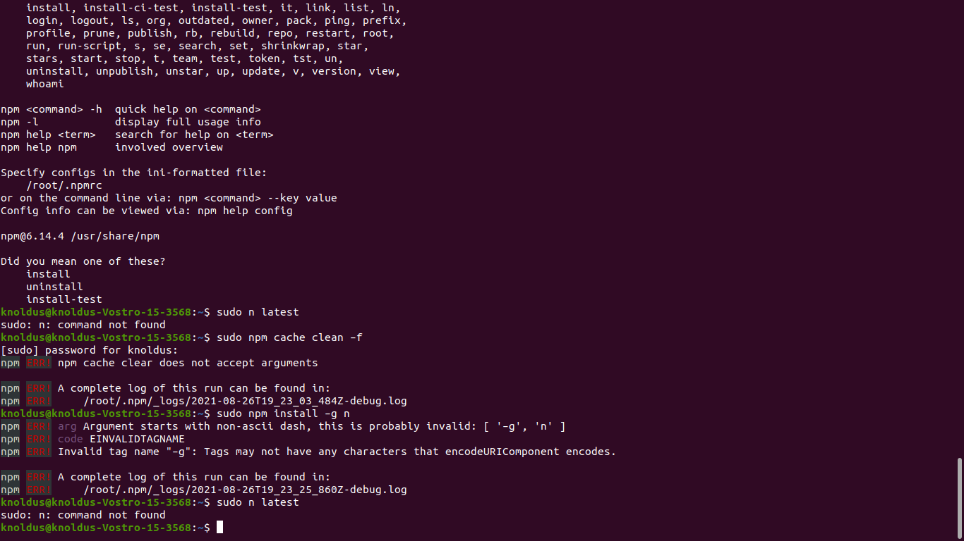

BY: MAYURI DHOTE.

