USER MANUAL
ClassiCrypt
An Interactive Classical Cryptography Toolkit
This manual explains how to use every feature of the ClassiCrypt web application, from logging in to encrypting text, comparing algorithms, and processing files. It is written for first-time users and assumes no technical background.

1. Introduction
ClassiCrypt is a web-based educational toolkit for exploring classical cryptographic algorithms. It runs entirely in your web browser and lets you encrypt and decrypt text using eight different classical ciphers, compare them side by side, process whole text files, and view a step-by-step breakdown of how each algorithm works.
This manual covers every user-facing feature of the application: logging in, navigating between sections, encrypting and decrypting text, the automatic encryption-to-decryption flow, comparing algorithms, working with files, and using the built-in reference and help sections.

2. Getting Started
ClassiCrypt requires no installation. It can be used in either of two ways:
- Online: open the deployed GitHub Pages link in any modern web browser (Chrome, Edge, Firefox, or Safari).
- Offline: download the project files (index.html, styles.css, script.js) and open index.html in a browser, keeping all three files in the same folder.
JavaScript must be enabled in the browser, as all calculations are performed locally on your device. No data is uploaded to any server.

3. Logging In
When the application is opened, a login screen appears before the toolkit becomes accessible.
- Locate the password field on the login screen.
- Enter the required password.
- Click the Unlock button.
- If the password is correct, the login screen disappears and the Home page is displayed.
- If the password is incorrect, an error message appears showing how many attempts remain. After 5 incorrect attempts, the login form is locked and the page must be reloaded to try again.
LOGIN SCREEN

Note: This login screen is a simple access gate intended for demonstration purposes as part of an educational project. It is not a substitute for secure, server-based authentication.
Note: Once unlocked, the application remains accessible for the rest of the browser tab's session. There is no separate logout button; closing the browser tab ends the session.

4. Application Layout and Navigation
After logging in, a navigation bar is visible at the top of every page. It remains available at all times, allowing you to move freely between sections without following a fixed sequence.
Menu Item | What it opens
Home | The landing page with a project overview and quick links.
Encrypt / Decrypt | The main workspace for encrypting or decrypting text.
Compare | Runs the same plaintext through all 8 ciphers at once.
File Tools | Encrypts or decrypts the contents of a .txt file.
Algorithm Info | A reference guide describing all 8 ciphers.
Help | An in-app usage guide and FAQ.

On smaller screens (such as mobile phones), the navigation bar collapses into a menu icon (☰). Tap this icon to reveal the same navigation options. Clicking the ClassiCrypt logo in the top-left corner always returns you to the Home page.

5. Home Page
The Home page provides a brief overview of the project and quick access to its main features:
- Two buttons — “Open the workbench” and “Read the algorithms” — that take you directly to the Encrypt/Decrypt workspace or the Algorithm Information page.
- A summary strip showing the number of ciphers implemented and other project statistics.
- Three quick-link cards for Encrypt & Decrypt, Compare Algorithms, and Algorithm Info, which can also be clicked to jump to that section.
HOME PAGE


6. Text Encryption and Decryption
The Encrypt / Decrypt workspace is where individual pieces of text are encrypted or decrypted. The steps below use the Caesar Cipher as a representative example.

Encrypting Text — Example: Caesar Cipher
- Open the “Encrypt / Decrypt” section from the navigation bar.
- Ensure the mode toggle at the top of the panel is set to Encrypt.
- Select “Caesar Cipher” from the Cipher dropdown.
- Enter a numeric key in the Key field (for example, 3).
- Enter the plaintext to be encrypted in the Text box.
- Click the Run button.
- The encrypted result (ciphertext) appears in the output panel, along with the execution time, character count, and the key used.
- Click “Show encryption process” to expand a step-by-step table showing exactly how each character was shifted to produce the ciphertext.
ENCRYPTION EXAMPLE WITH PROCESS EXPANDED
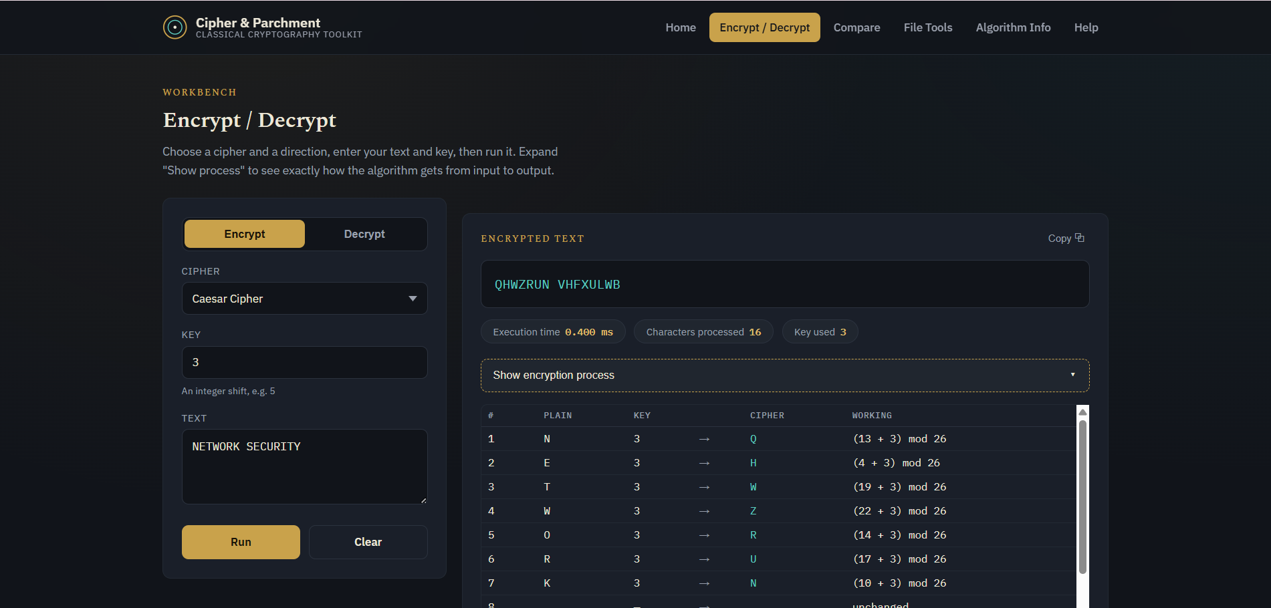

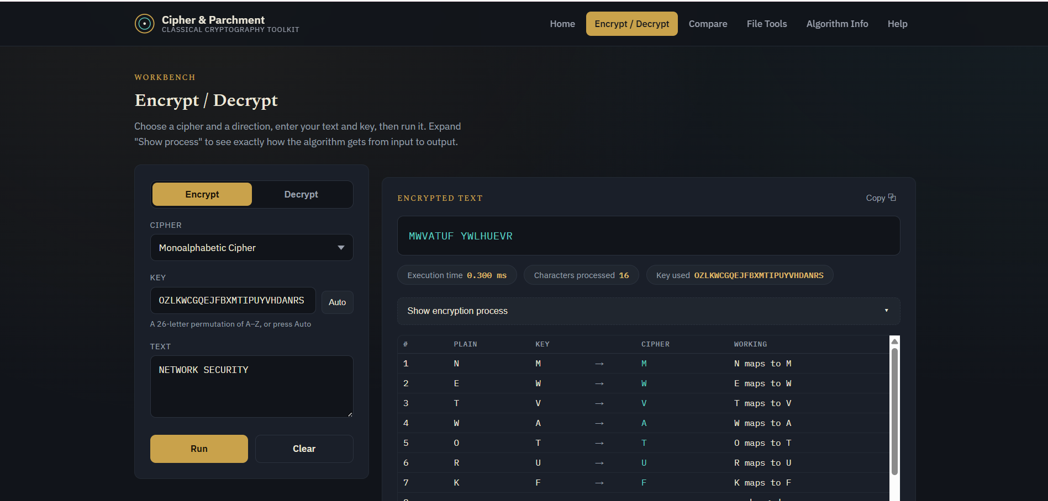
Note: The general workflow is similar for all eight ciphers. However, the required key format differs by algorithm — for example, Rail Fence expects a number, Playfair and Vigenère expect a keyword, and Hill Cipher requires exactly 4 letters. The correct format for the selected cipher is always shown as hint text below the Key field, and full details are available in the Algorithm Information section (Section 11).
Note: For the Monoalphabetic Cipher and One-Time Pad, an Auto button appears next to the Key field. Clicking it automatically generates a valid random key, so these two ciphers do not require you to devise a key manually.

Decrypting Text
Decryption follows the same layout, using the Decrypt mode instead of Encrypt:
- Set the mode toggle to Decrypt.
- Select the same cipher that was used to encrypt the text.
- Enter the matching key.
- Enter the ciphertext in the Text box.
- Click Run to reveal the original plaintext.
- Click “Show decryption process” to view the step-by-step breakdown of the decryption.
Other workspace controls include the Copy button (copies the result to the clipboard) and the Clear button (resets the text, key, and output).

7. The Complete Encryption-to-Decryption Flow
ClassiCrypt is designed to demonstrate the full cryptographic cycle in a single, guided sequence:
Plaintext → Encrypt → Ciphertext → Automatically transferred to the Decrypt input → User clicks Decrypt → Original Plaintext
When you successfully encrypt a piece of text, the resulting ciphertext is automatically placed into the same text field, and the workspace switches itself into Decrypt mode:
- The ciphertext is transferred automatically — you do not need to copy and paste it.
- The selected cipher and the key remain exactly as they were, so both are already in place for decryption.
- Decryption does not happen automatically. You must click the Run button yourself to complete the cycle.
- If you switch back to the Encrypt tab afterward, your original plaintext and key reappear exactly as you entered them, so you can compare the two steps side by side.
AUTO-TRANSFERRED CIPHERTEXT IN DECRYPT MODE
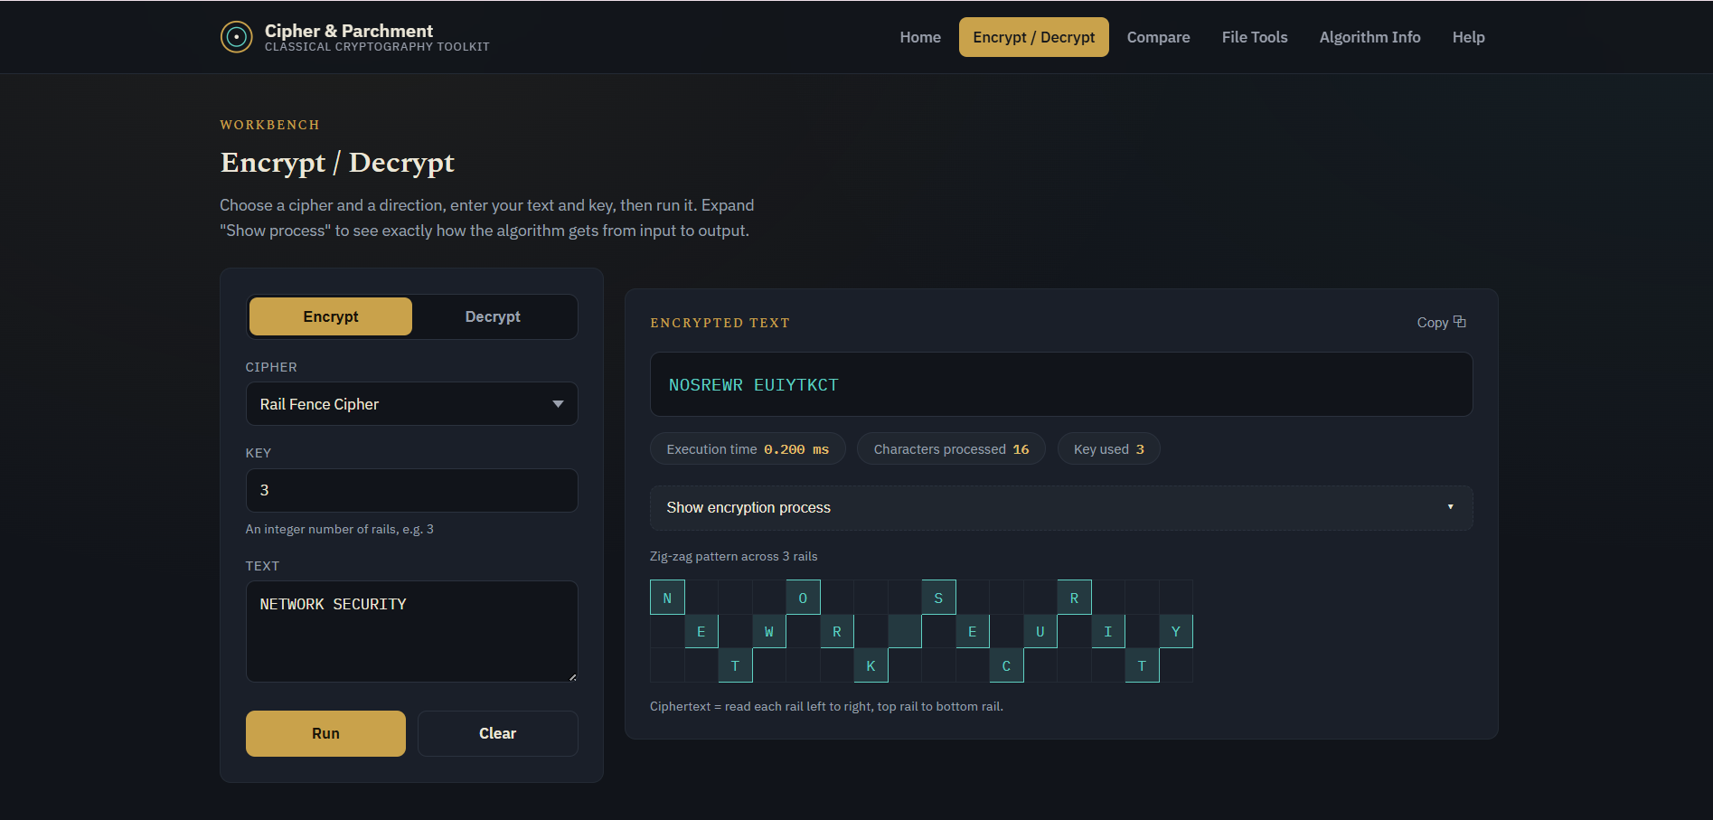
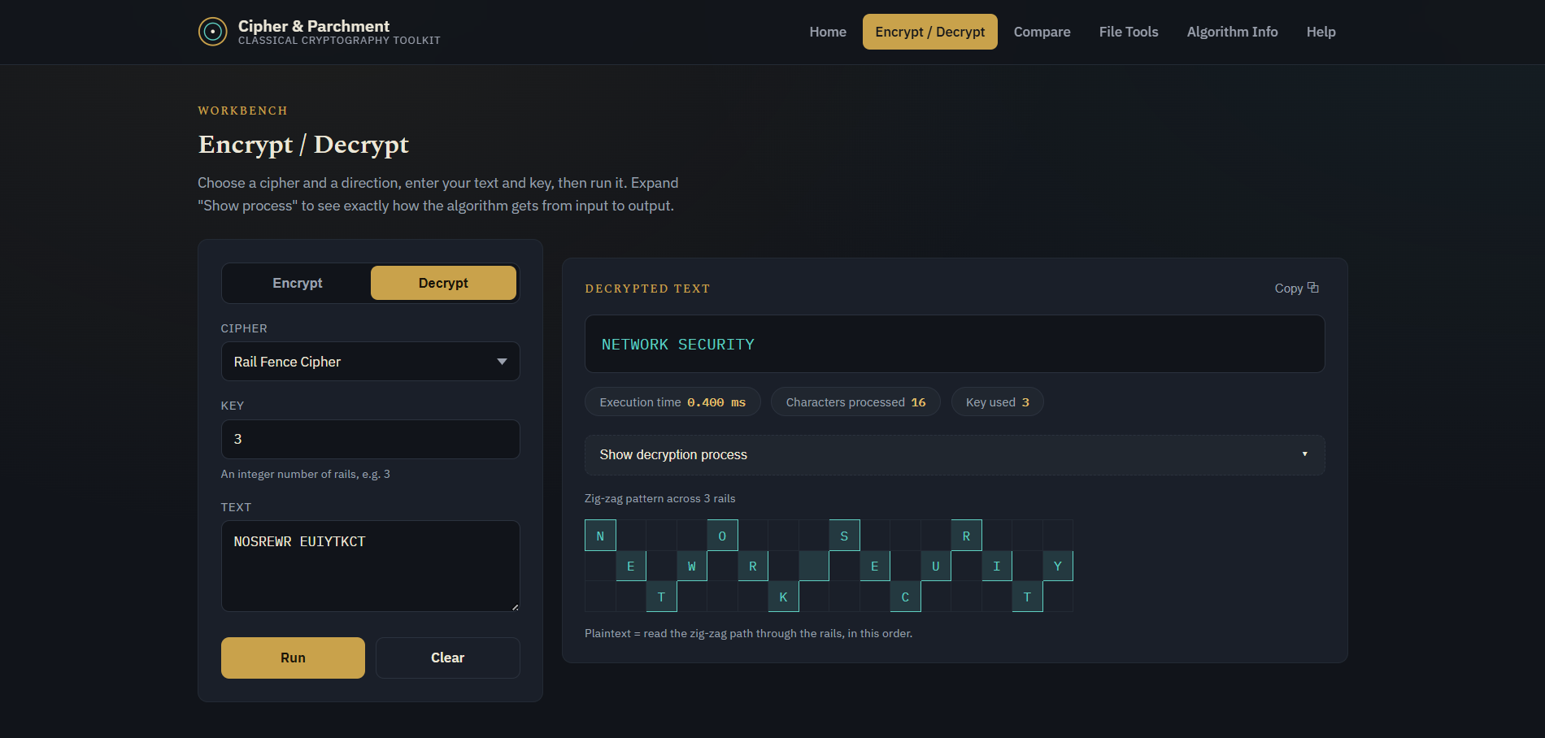

8. Independent Decryption
You are not required to encrypt something before decrypting. ClassiCrypt also supports testing decryption on its own:
- Open the Encrypt / Decrypt workspace.
- Set the mode toggle to Decrypt.
- Select the appropriate cipher.
- Type or paste a ciphertext directly into the Text box, together with the matching key.
- Click Run to view the resulting plaintext.
This is useful for testing a known ciphertext, or for practicing decryption without needing to perform an encryption first.

9. Comparing All Algorithms
The Compare section runs a single piece of plaintext through all eight ciphers at the same time, making it easy to see how differently each algorithm transforms the same input.
- Open the “Compare” section from the navigation bar.
- Enter the plaintext you want to test in the input box.
- Click “Compare all ciphers.”
- A results table appears, listing every cipher along with the key that was used (generated automatically for this comparison), the resulting ciphertext, and the execution time.
The execution time column includes a small bar alongside each value, giving a quick visual sense of the relative speed of each algorithm; in practice, all eight typically complete in a fraction of a millisecond.

ALGORITHM COMPARISON RESULTS
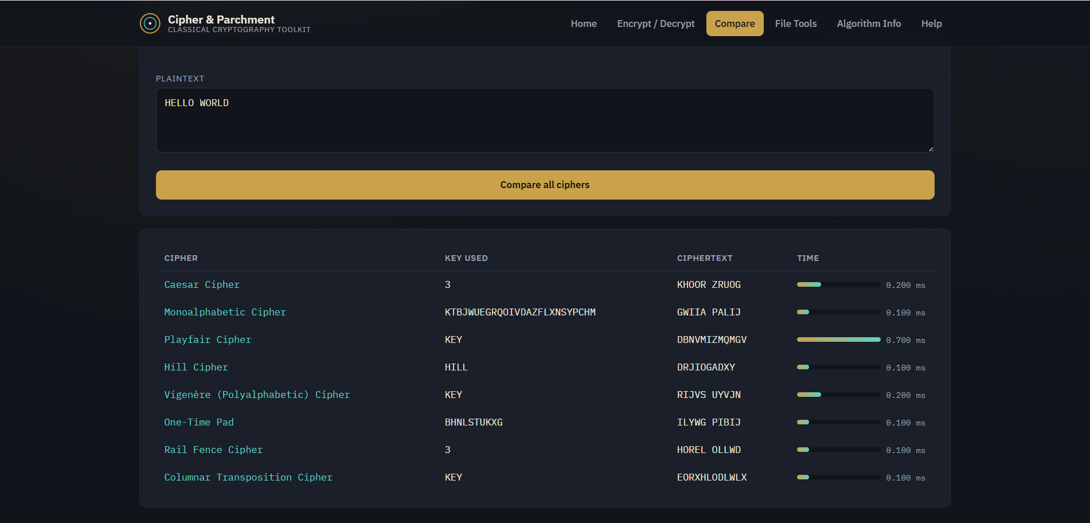

10. Encrypting and Decrypting Files
The File Tools section applies the same ciphers to the contents of a text file, instead of text typed directly into the browser.
- Open the “File Tools” section from the navigation bar.
- Choose “Encrypt file” or “Decrypt file” using the mode toggle.
- Click the upload area to choose a file, or drag a file directly onto it.
- Select the desired cipher from the dropdown.
- Enter the key, or click Auto if the selected cipher supports automatic key generation.
- Click “Process file.”
- A preview of the resulting text is displayed, along with the execution time.
- Click “Download result (.txt)” to save the processed file to your device.
[ INSERT SCREENSHOT: FILE ENCRYPTION / DECRYPTION SCREEN ]
Note: Only plain text files with a .txt extension are supported. Other file formats, such as .pdf or .docx, cannot be processed.

11. Algorithm Information Reference
The Algorithm Info section is a reference guide, not an interactive tool — it does not perform any encryption or decryption itself.
- Open the “Algorithm Info” section from the navigation bar.
- Click on any cipher's name to expand its entry.
- Each entry shows the cipher's category (Substitution or Transposition), a short description of how it works, its key format, and a worked example.
Use this section to check the correct key format for a cipher before using it in the Encrypt/Decrypt workspace or File Tools.
ALGORITHM INFORMATION PAGE
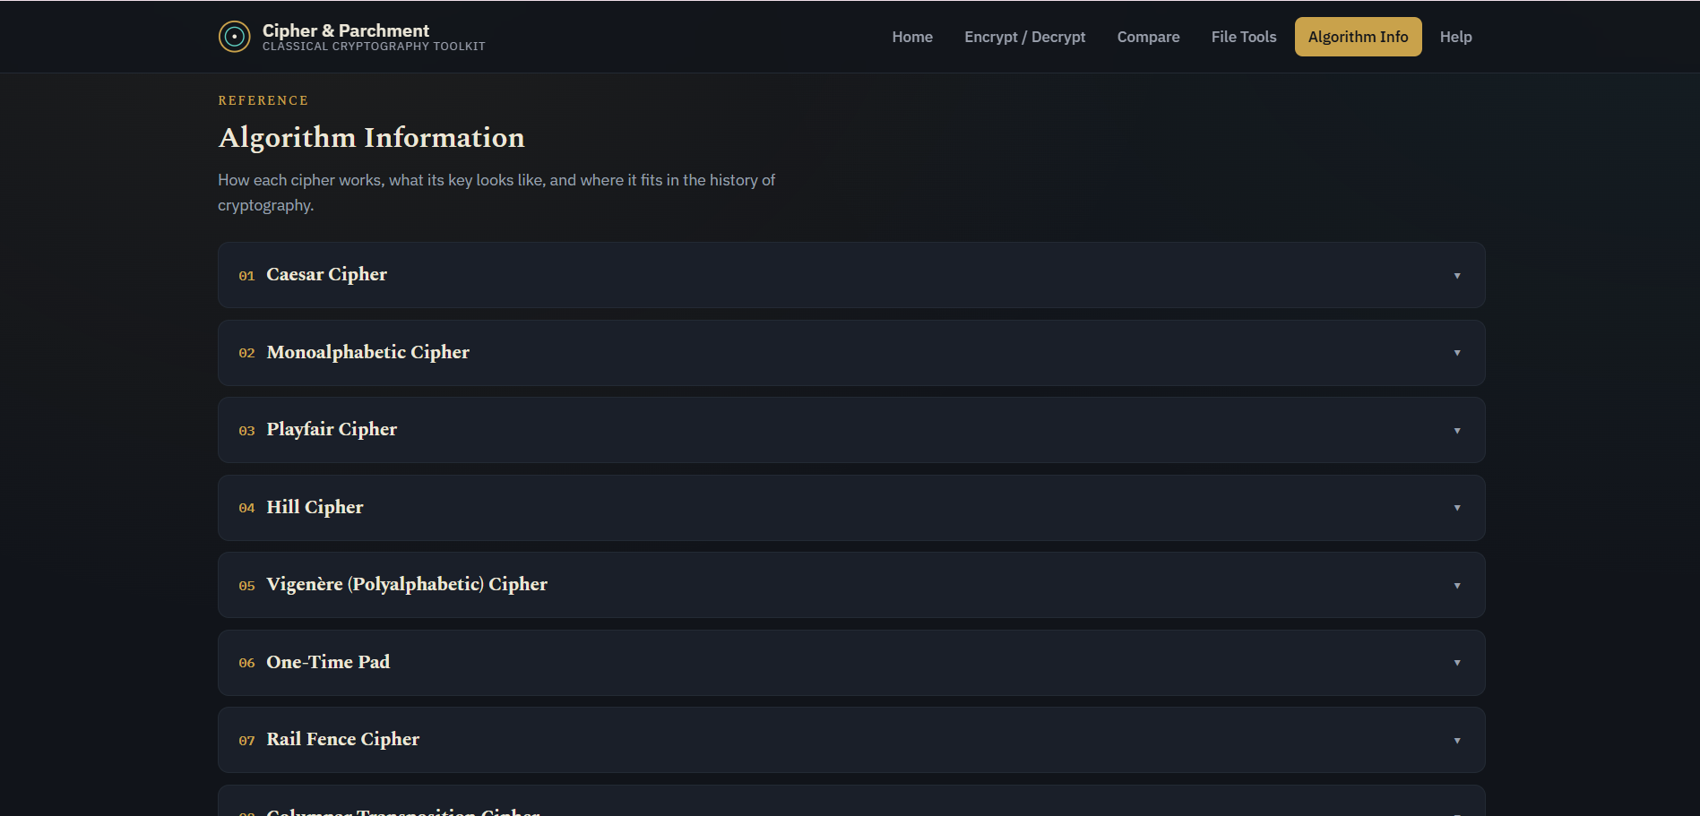
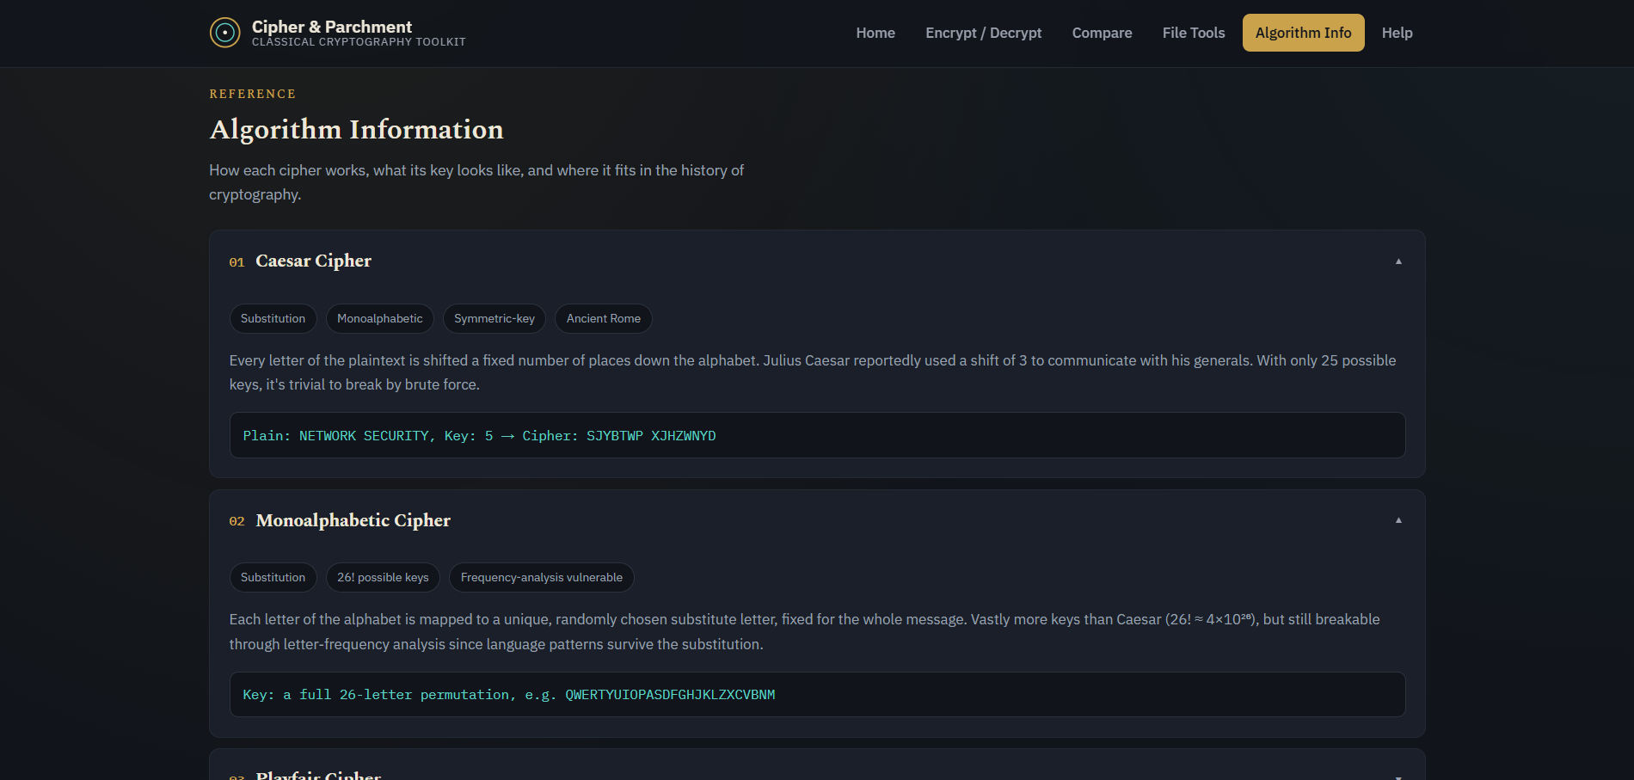

12. Help and FAQ
The Help section, accessible from the navigation bar, contains two parts:
- A short numbered guide summarising how to use the Encrypt/Decrypt workspace.
- A list of frequently asked questions covering common issues, such as why decryption might fail, what happens to spaces and punctuation, and whether the ciphers implemented here are secure for real-world use (they are not — see Section 13).

13. Troubleshooting
The table below lists common issues and how to resolve them:
Problem | Likely Cause / Solution
“Please enter a key” error | The Key field was left empty. Enter a key, or use the Auto button if it is available for the selected cipher.
Decryption produces gibberish | The key, or the selected cipher, does not match what was used to encrypt. Re-check both.
Hill Cipher key is rejected | A Hill Cipher key must form a mathematically invertible matrix. Try a different 4-letter key, such as HILL or RSAX.
File will not upload | Only plain .txt files are supported. Other formats such as .pdf or .docx are not accepted.
Locked out of the login screen | Too many incorrect password attempts were made. Reload the page to try again.

14. Conclusion
ClassiCrypt provides a complete, hands-on way to explore classical cryptographic algorithms — from single-text encryption and decryption, through the full encryption-to-decryption learning cycle, to comparing algorithms and processing whole files. All processing takes place locally in the browser, and no data is transmitted anywhere.
The ciphers implemented in this application are classical algorithms intended for learning purposes only. They are not secure by modern standards and should not be used to protect real, sensitive information.

