**Insights and Key Points of Sales Dashboard**



**[Coffee Shop Sales Excel Dashboard Insights**]

**Coffee Shop Sale Excel Dashboard Insights**

**This is visual representation of Excel Dashboard of Coffee shop sales:**

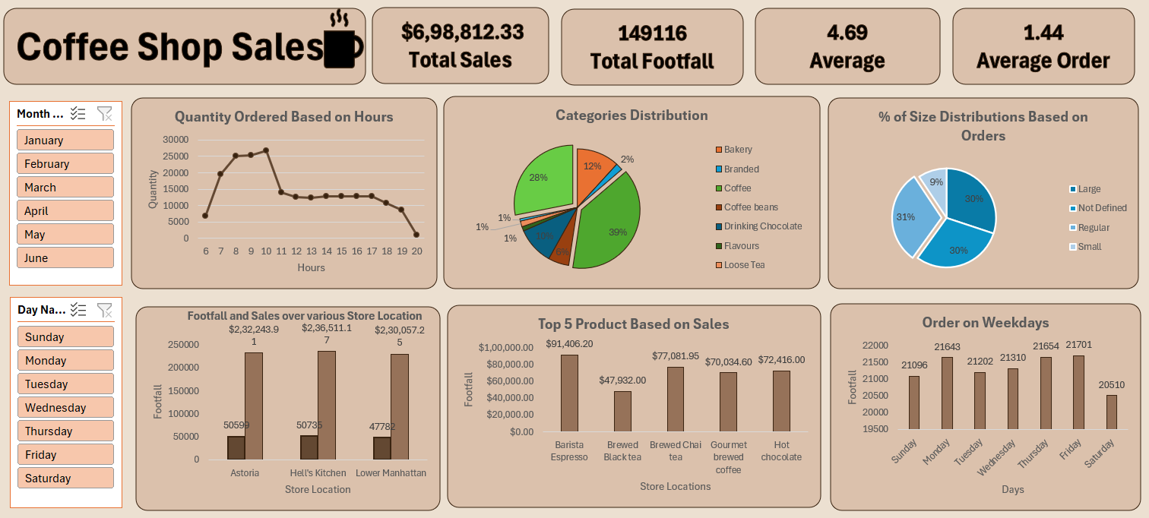

**Here are some key insights and report based on the Coffee Shop Sales dashboard:**

### **1. Total Sales and Footfall**

* **Total Sales:** $698,812.33, which indicates the coffee shop's revenue over the analyzed period.
* **Total Footfall:** 149,116, representing the total number of customers visiting the coffee shop.

### **2. Average Metrics**

* **Average Sales per Customer (Order Average):** 1.44, suggesting a relatively low spend per visit.
* **Average Items per Order:** 4.69, showing an average purchase quantity per customer.

### **3. Peak Order Hours**

* **High Demand Time:** Orders peak between 8 AM and 11 AM, suggesting this is the coffee shop's busiest time, likely due to morning coffee rush.
* **Drop in Orders:** Noticeable decrease in orders after 11 AM, with steady low levels throughout the afternoon and evening.

### **4. Product Category Distribution**

* **Top Categories:** Coffee (39%), Loose Tea (28%), and Drinking Chocolate (10%) are the most popular categories.
* **Other Products:** Bakery, branded items, coffee beans, and other flavors make up smaller portions, indicating areas for potential growth or targeted promotions.

### **5. Order Size Distribution**

* **Popular Sizes:** Orders are evenly split across sizes: Large (30%), Regular (31%), and Small (30%), with a small percentage of undefined sizes (9%).
* **Implication:** Customers have diverse preferences in order sizes, which could be leveraged for tailored marketing or pricing strategies.

### **6. Footfall and Sales by Location**

* **Top Locations:** Hell's Kitchen leads in both footfall and sales, followed by Astoria. Lower Manhattan sees the lowest footfall and revenue, suggesting it might need additional promotions or improvements.
* **Sales per Footfall:** Locations vary in terms of sales per footfall, indicating some stores may perform better despite lower foot traffic.

### **7. Top-Selling Products**

* **Highest Revenue Products:** Barista Espresso ($91,406.20) and Brewed Black Tea ($47,932.00) are the top sellers.
* **Key Items for Focus:** Products with high sales can be prioritized in promotions or bundled with other items to maximize profits.

### **8. Weekday Trends**

* **Peak Days:** Friday shows the highest footfall, followed by Thursday, while Saturday sees the lowest.
* **Potential for Marketing:** Focusing marketing efforts or discounts on low-footfall days (e.g., weekends) could help boost sales.

### **Summary and Recommendations:**

* **Focus on High-Demand Hours:** Optimize staffing and inventory during peak hours (8-11 AM) to enhance service and customer experience.
* **Product Promotion:** Promote high-revenue products like Barista Espresso and Brewed Black Tea.
* **Location-Specific Strategy:** Implement targeted promotions for lower-performing locations like Lower Manhattan to increase footfall and sales.
* **Day-Based Offers:** Introduce weekend-specific promotions to boost Saturday footfall.
* **Size Preferences:** Consider creating combo offers that cater to size preferences (Large, Regular, Small) to appeal to varying customer orders.