LABHCHAR

Templates Link:

<http://themestarz.net/html/zoner/>

<http://themeforest.net/item/sunhouse-real-estate-html-template/full_screen_preview/14310028>

<http://templates.crelegant.com/wedoor/property_listing.html>

[http://mariusn.com/themes/reales/index.html#](http://mariusn.com/themes/reales/index.html)

Requirements

* Commercial
* Rent / Lease (New / Old)
* Lease / Sell (New / Old) (Under construction, Ready to move)
* Residential
* Rent / Lease (New / Old)
* Lease / Sell (New / Old) (Under construction / Ready to move)
* Ongoing Projects
* Investment Opportunities. (Under construction, Future projects, Lunching Shortly)
* Featured property by city, area, type.
* Multiple admin (With limited Rights) capability for this system is required.
* Only Super admin have rights to see the transaction.
* Multiple admin with different capability is required.
* We have to implement commission system for the admins (Agents for each property they sell/rent)
* We should use on-off button to enable and disable the properties, Projects, Users and admins.
* Before any one book for an appointment he/she have to be a premium member of the site else he/she can only visit the site and check property but he/she can’t make an appointment with the Admin. (property dealer)
* Appointments scheduler.
* Appointment with the agent of particular agent can be set dynamically. (Suggested Feature)
* When Super Admin approves the appointment / Reject / Make changes to the appointment or make changes in the appointment a notification should be given to the user/admin
* Appointments need to be categorized in the two category

1. Appointment for the Property
2. Appointment for the project Investment.

* If user is premium member of the website, he/she can place an appointment request for the properties listed for Investment / Sell / Rent from the property group of residential and commercial.
* There should be a system to verify the user mobile number and email address.
* User cannot make an appointment without verifying mobile number and email address.
* Whenever user open the website the geo location of the user should be tracked automatically and city selected automatically, as well as the properties and projects related to that city should be displayed.
* User can add a property in the follow list and also can add any property as a favorite property. (For getting notification)
* If any listed property is sold or rented by someone it should display the name of buyer / renter in the list view for that property.
* User can send inquiry to the builder.
* If user rents any property it should be displayed as the rented for the property added for rent. (same for the property listed for sell.)
* User can apply for loan request and can calculate the loan eligibility. (Suggested Feature)
* User can download the brochure for the new added project (It must be in uploaded in PDF format if uploaded by the construction company for a project.)
* If project or property price is not given, in place of price there a text “ASK FOR PRICE” Should Be Displayed.
* If any changes are made in the property details / User details / Admin, then an entry should be made in separate database to keep the track of who has made changes in which record at what time using which IP address. (Suggested Feature.)
* SMS Notification of an appointment should be sent to the user and the Admin / Super Admin with whom the appointment is scheduled before an Hour or 2 Hour of the appointment.
* The sold properties and rented properties should display with the “Sold” and “Rented” Ribbon on the property image.
* Whenever rent period for property comes to an end a notification and a email should be sent to the super admin and the person who have rented that property.

Roles

* Super Admin
* Admin (Agent) (With limited rights)
* User

Super Admin Rights

* Categories for the buy/rent of residential/ commercial should be dynamic.
* Geographical expansion should be Dynamic.
* Manage properties
* Manage agent
* Adjust appointments
* Manage approvals.
* Manage users.
* Manages for the payment of rent/Sell.

Super Admin

* Super Admin dashboard should display Total Sells, Total Profit, Total Active Admins, Total property Available for rent, Total Property available for Sell, Total Available Project for investment, Appointments List (Todays appointment should be displayed first)
* Header should display the Super admin image and name in the header after login.
* Notification should be included in the header for various pending approval requests (Property, Transaction, Project, Status changed appointment)
* A Notification should be displayed whenever a rent period for a rented property comes to an end.
* Super admin can view the requested Properties list by customers
* **Manages the admin (Add/Edit/Delete/List/Filter)**
* **Filter List:** By Name, By City, By Status, By Type, By Sell/Rent
* Super admin can view list of all the properties available for Ren/Lease/Sell of type Commercial/Residential and can refine the result by applying various filters.
* Super admin can add a new property and all of related details to the property.
* Super admin can edit the existing property and make the required changed in the property details.
* Super admin can Delete the listed property is Super Admin found anything wrong with the listed property.
* Super admin can change the status for the property “Sold” when the listed property sold, can change the status to “rented” when listed property become rented by someone.
* Super admin can find or refine the result of the listed property by applying various filter.
* **Manages the User (Add/Edit/Delete/List/Filter/Approve/Unapproved/Reject)**
* **Filter List:** By Name, By City, By Status
* Whenever a user registers, first his request for the become member received by the Super admin. Then the Super admin decides whether to approve or not the received become member request.
* Super admin can view the list of all the available user records and can refine the result by applying various filters.
* Super admin can revoke the approval of the previously approved User.
* Super admin can add a new user with all the required details.
* Super admin can edit the existing user record and make required changes in the user record.
* Super admin can delete any user if Super admin want to delete the user.
* Suggested Feature Whenever Super admin deletes the user; the user should be marked as the deactivated user but its’ entry should be kept in the user table or if the user is deleted than all related entries made for the user in the system should be deleted as soon as the user is deleted by super admin.
* Super admin can filter the list of user or can search the user record by using various filters available.
* **Manages Properties (Add/Edit/Delete/List/Filter/Approve/Unapproved/Reject)**
* **Filter List:** BY ID, By Builder, By Admin name, By City, BY Price range, BY Date, BY Status
* Admin can post a property, but the posted property request is first received by the super admin and then super admin decides whether to approve or not the property request.
* Super admin can filter the properties on the basis of the whether the property rented / Sold.
* Property added by the admin (Agent) should be displayed as in the disabled mode.
* Super admin can view the list of properties and can filter the properties list using available filter options.
* Super admin can add a new property and all the required details of the property.
* Super admin can Edit existing property.
* Super admin can Delete the existing property from the list of property.
* Super admin can approve or reject the posted property.
* Super admin can Revoke the approval of the previously approved property.
* **Manages the Project. (Add/Edit/Delete/List/View/Filter/Enable/Disable)**
* **Filter List:** By Project name, By Builder name, By State, By City, By Area
* Admin can decide whether to display or not the new project by changing the project status to enabled or disabled.
* Super admin can view the list of available project records and can filter the list of available project record by applying various filters.
* Super admin can add a new project with all the required details of the project.
* Super admin can Edit the existing project and changes the values for the various fields of the project.
* Super admin can delete any project record.
* Super admin can revoke the approval of the previously approved project record.
* **Manages Transactions (For sold and rented properties/List/Filter/Add/Edit/Delete)**

This module is only available to SUPER ADMIN no other role has access to this module.

* **Filter List:** By Transaction ID, By Transaction status, By Transaction Type, By date, By amount, By Payer Name.
* Only Admin have right to create the transaction.
* If the transaction is related to user / Builder / Admin than the User/ Builder / Admin should be able to see the transaction on their account.
* Super Admin creates the Transaction with the type Rent / Sell and Investments.
* Transaction page should consist of a drop down which can be helpful to differentiate the transactions made for property (Sell/Rent) or for the project.
* Suggested service whenever a transaction occurs mail should be sent to super admin, related admin and to the payer (Payer can be a builder/User/Admin).
* Super admin can view the list of all the transactions created and can filter the list of transactions using the available filter.
* Super admin can add a new transaction.
* Super admin can Edit the existing transaction can make changes to the values of the transaction.
* Super admin can delete a transaction, Suggested Feature however when the Super Admin deletes the transaction the deleted transaction should be added to the garbage table / database with the transaction ID generated for it in the transaction table (Which keeps all the deleted transaction.) this database needs to be created.
* **Manages Appointment for the User and Admin (List/Add/Edit/Delete/Filter/Reschedule/Assign)**
* **Filter List:** By Date, By Time, By Admin, By Property(optional), By Status
* By Default, today’s appointment should be displayed on the top with the assigned time in ascending order
* Whenever appointment request is made by user a notification should be given to Super admin/Admin.
* On the reschedule of appointment a mail should be sent to the super admin notifying a user has requested for the appointment reschedule.
* Whenever appointment is rescheduled a notification should be displayed to the admin and a mail should be sent to the admin and user when the approval for the approval of the appointment is confirmed by the super admin.
* When Super Admin approves the appointment / Unapproved the appointment or make changes in the appointment a notification should be given to the user/admin
* Super Admin can view the list of all the appointment and apply various available filters to refine the appointment record list.
* Super admin can add a new appointment with the user or with the admin.
* Super admin can edit the already existing Appointment.
* Super admin has right to reschedule the appointment.
* Super admin has right to assign appointment of the user to specific admin.
* Super admin can delete the appointment.
* **Manages Settings regarding system:**
* Notifications Settings.
* SMS Settings.
* Email Settings.
* SMS template Settings.
* Email Template Settings.
* General Settings (Website name / Company tag line / Theme / Email Address.)
* Manage Approvals:
* User Approvals. (Approve / Reject)
* Projects Approvals. (Approve / Reject)
* Property Approvals. (Approve / Reject)
* Manage Properties:
* Categories.
* Sub Categories.
* Manage Geographical Location:
* State.
* City.
* Area.
* Manage Amenities:
* Pages (Add/Edit/Delete/Edit content for the pages)
* Super admin can Add new pages like About us / Contact us / FAQ and Terms and Condition.
* Super admin can Edit these new Created pages.
* Super admin can delete these pages as per the required.
* Super Admin can generate reports.
* Sales Report
* Investment report
* Profit Report
* Commercial Properties
* Rent (This report should also display total available property for rent excluding the rented Properties)

This reports should have filter like

1. On the basis of period: By Date Range, Last month, Last week, Year
2. On the basis of Status: Rent period completed, New added, Ranted

* Sold (This report should also display total available property for sale excluding the rented Properties)

This reports should have filter like

1. On the basis of period: By Date Range, Last month, Last week, Year
2. On the basis of Status: Sold, New added

* Commercial Project Report

1. On the basis of period: By Date Range, Last month, Last week, Year
2. On the basis of Status: New added

* Residential Properties
* Rental Report (This report should also display total available property for rent excluding the rented Properties)

This reports should have filter like

1. On the basis of period: By Date Range, Last month, Last week, Year
2. On the basis of Status: Rent period completed, New added, Ranted

* Sold Report (This report should also display total available property for sale excluding the rented Properties)

This reports should have filter like

1. On the basis of period: By Date Range, Last month, Last week, Year
2. On the basis of Status: Sold, New added

* Residential Project Report

1. On the basis of period: By Date Range, Last month, Last week, Year
2. On the basis of Status: New added

* Account Setting
* Change Password.
* Edit profile

Admin

* **Manages Appointment for the User Assigned to him.** (List/Add/Edit/Delete/Filter/Reschedule/Assign)
* **Filter List:** By Date, By Time, By Property, By Status
* By Default, today’s appointment should be displayed on the top with the assigned time in ascending order.
* Whenever appointment is assigned to the admin a notification should be displayed.
* Whenever admin makes changes in the appointment the notification should be sent the Super admin and the user who have made request for an appointment.
* In the same manner SMS should be sent to the user.
* Admin can view the list of appointments assigned to him.
* Admin can refine the list of appointments by applying various available filters.
* Admin can reschedule the appointment.
* Admin can Assign the appointment request if he/she is not available.
* Admin can set the status of the appointment assigned to him.

++++++++++++++===========================================++++++++++++++++++

* **Manages Transactions (For sold and rented properties/List/Filter)**
* Filter List: By Transaction ID, By Transaction status, By date, By amount, By Payer Name.
* Transaction will be first selected by admin whether it is for the rent or sell or investment. Status for the transaction need to be saved to keep track of the transaction and the transaction status.

++++++++++++++===========================================++++++++++++++++++

* **View users list and details. He should be also able to see the package bought by the user. (Can only view approved users)**
* **Filter List:** By First Name, By Last Name, By City, By Purchased Package.
* Admin can view all the approved user.
* Admin search or refine the result of the user list by using available all the filters of the system.
* Admin can view the details of the user of the system.
* **View Property list and Details(Add/Edit/List/Filter)**
* **Filter List:** By Property Type, By Property Age, By Property Price Filter, By Property Sell / rent, By city
* Admin can add a new property but whenever a property is added by the admin it is set as disabled. To display this property in the list of property it must be approved by the Super admin.
* Whenever a new property is added by the admin a notification should be sent to the Super admin for its approval.
* Without admin approval property added by the admin do not get displayed in the property list to the user.
* After Approval of the property by Super Admin a notification gets displayed to the admin who has made request.
* Admin can view the list of all the available property and can refine the property list result using the available various filter.
* Admin can add a new property.
* Admin cab edit any existing property
* Admin can view the details of the property.
* **View new projects list and details(Add/Edit/List/Filter)**
* **Filter List:** By ID, By Builder, By Admin name, By City, BY Date, BY Status.
* Admin can add a new project, But the project request is sent to the super admin for the approval.
* Till the super admin Approval, the project does not get displayed to the user.
* Whenever a new project is added by the admin a notification should be displayed to the super admin.
* After Approval of the Project by Super Admin a notification gets displayed to the admin who has made request.
* Admin can view all the projects list and can refine the list result by applying various available filters.
* Admin can view details of the project
* Admin can add a new project request.
* **Account settings (Editing Profile)**
* Admin can edit his Profile.
* Can change his password.
* Can change his Profile picture.
* Can change other related information.

User

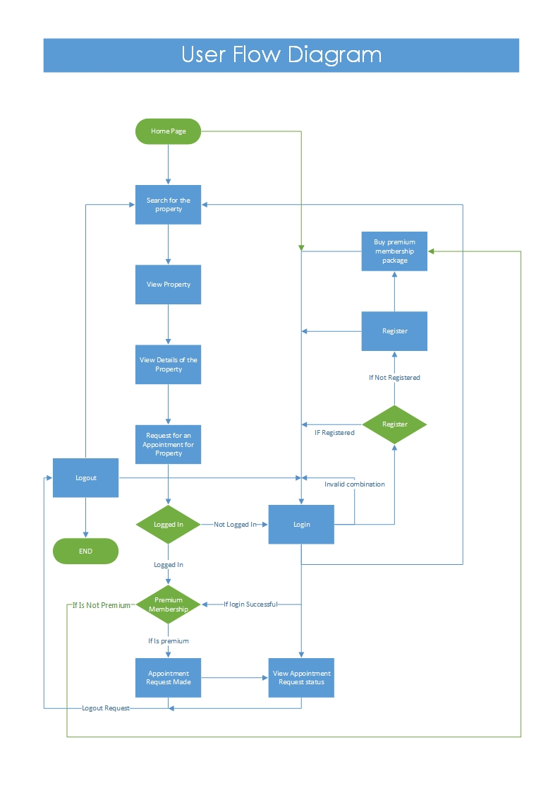

* User Can Register on the site and on the registration He / She have to buy the premium user package or can skip it and buy later.
* User cannot make appointment without buying premium user pack
* User should be able to Login to the system using valid login credential. (Valid username/Password combination)
* User should be able to retrieve his password using either his email or Mobile number if He / She Forgot password. (If and if the password request for the email address is found in user database than the mail with the user password should be sent to the valid email address and in the same manner user should be able to retrieve his password using the valid mobile number)
* If User do not buy a Premium user package at the time of registration, He / She have to buy the premium user package while making an appointment.
* User have to verify mobile number and email address.

1. Mobile number can be verified using the OTP and
2. Email address can be verified by sending account activation link to the user on the enter email address during registration.

* User can later verify his cell number.
* User Can Search property using various filter criteria or can simply view the list of all listed properties (Properties list can also be sorted in order if user want to by the price of the property in ascending and descending manner.)
* User should also be able to search the properties using following filter:

(By Price range, By Property Type, By city, By area, By Property age, By Sell / Rent).

* There should be a Follow / Unfollow Button on the Properties Details page.
* It Should Display “Followed” caption if the property is already being followed by the user if not then the “Start Following” text should be displayed.
* If user want to remove a property from his follow list, he just has to click on the same button on which he/she has clicked to start following the property.
* Make an appointment to have a look of. (Appointment need to be confirmed by the super admin or admin) User can select a date and time slot from the available time slot and the appointment request is made than the super admin/admin can approve or make a change and approve the appointment request
* Whenever a request is made by the user the it automatically should fetch the agent who belongs to the area of the property for which the appointment is requested. If the agent is not found the appointment should be assigned to the super admin.
* User can view his previous appointments details and status of the appointments.
* There should be a restriction for make an appointment. User should not be able to make appointment for the same, the day when user is sending the appointment request.
* User cannot request an appointment for already sold / rented Property.
* User can view list of properties and can apply various filters in the list of properties (Filter List: By Price range, By Property type, By State, By city, By area, By Sell/rent, By Property age)
* User can view the related properties when he opens any property from the list or searched result.
* User can add a property to his followed properties list. (By creating this list a user can view list of properties of his/her interest and keep track of price change or any other changes.)
* User can make a request for a property of his own requirement. If available, he will be notified by the Super Admin.
* When Super Admin approves the appointment / Unapproved the appointment or make changes in the appointment a notification should be given to the user/admin.
* User can reschedule the appointment and if the user changes the appointment status to reschedule the user must have to select new data and time and request for the reschedule of appointment.
* User can register his/her self as an investor.
* User can edit his / Her profile and can change the profile image, email address, Mobile number, Personal information.

Home page:

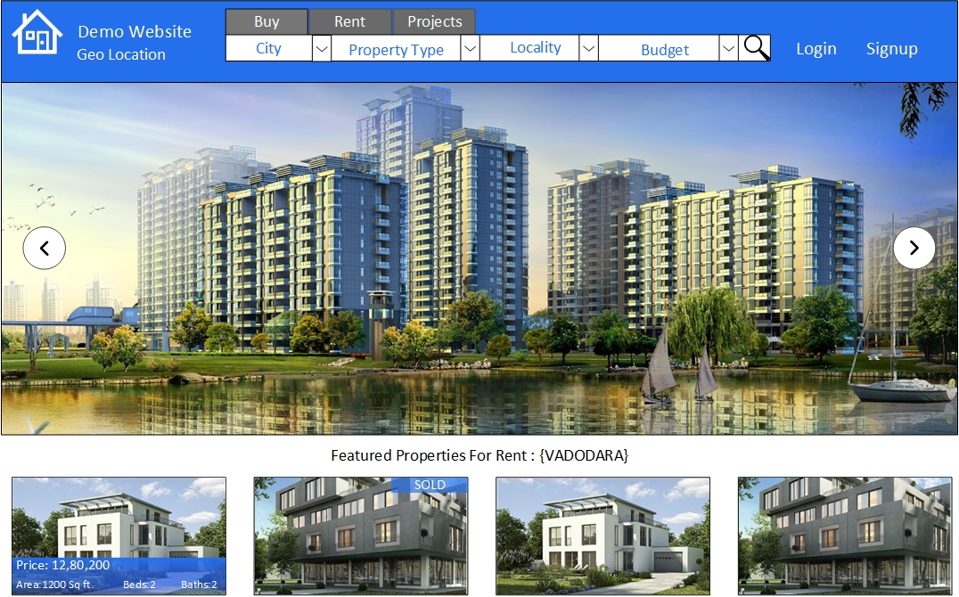

* Home page contains a search bar with various filter to search for the property
* Home page should display the featured properties
* By Property Type
* Residential
* Rent
* Sell
* Commercial
* Rent
* Sell
* Featured Projects
* Commercial Projects.
* Residential Projects.
* Projects.

Home page Search:

* First select city.
* Select type of property.
* Select sub type of the property.
* Then select area.
* Then select price range of which property you are looking for.

Sorting:

* Sorting by Lower Prize to Higher Prize.
* Sorting by Higher Prize to Lower Prize

Filters:

* BY Sell / Rent
* By City
* By Area
* By Type
* By Sub Type (For Example Commercial -> Shop or office, For Residential -> Flat, Bungalow, Paint house).
* By the price range

Types of Residential Property:

* Flat
* House/villa
* Plot
* Studio Apartment
* Farm House
* Other

Types of Commercial Property:

* Office Space
* Shop / Showroom
* Commercial Land
* Warehouse / Godown
* Industrial Building
* Industrial Shed

Types of ongoing project

* This will be the combination of the types of residential property and types of commercial property
* Commercial Projects
* Residential Projects.

Property Age:

* Under Construction
* New
* Combination of Number and “Year” string.

Ongoing Projects:

* Project Name.
* Project location.
* Project Details.
* Project Plan.
* Project Estimated cost.
* Estimated Project Completion date.
* Builder Details
* Projects can be filter:
* By city.
* By area.
* By State.
* By Estimated Date of completion.
* By Estimated cost
* By Estimated revenue generation.

Project status:

* Future Project
* Launching Shortly
* Ongoing (Under Construction)

Amenities:

Table column:

Amenities ID

Property ID

Amenity name

Amenity Icon

Amenities

-Club House

-Jogging and Strolling Track

-Cycling and Jogging Track

-Power Backup

-Garage

-Swimming Pool

-Lift

-Service and Goods Lift

-Visitors Parking

-Maintenance Staff

-Television Facility

-Flower Garden

-Library and Business center

-Water Storage

-Retails Shop

-Waste Disposal

-Early Learning Center

-Event Space and Amphitheater

-Intercom facility

-Recreational Pool

-Bank and ATM

-Kids Club

-Indoor Squash and Badminton Court

-Multipurpose Courts

-Outdoor tennis court

-Activity Deck 4

-Fire Fighting Equipment

-Security

-Park

-Reserved Parking

-Gymnasium

-Indoor Games Room

-Kids Play Area

-Rain Water Harvesting