Customer Churn Prediction

1. Introduction
Customer churn means a customer stops using a company’s service. Predicting churn is important because retaining existing customers is much cheaper than finding new ones.
In this hackathon task, we had to build a machine learning model that predicts whether a customer will churn or not. The main focus areas were:
- Cleaning and preparing the dataset
- Handling missing data
- Handling imbalanced classes (churn = 1 is fewer)
- Training different ML models
- Comparing models using accuracy, precision, recall, F1-score and ROC-AUC
- Saving the best model for deployment

2. Dataset Description
The dataset contains 1,000 customers with the following fields:
- Age (18–70)
- Gender (Male/Female)
- Monthly Usage Hours (5–200)
- Number of Transactions (1–50)
- Subscription Type (Basic / Premium / Gold)
- Complaints (0–10)
- Churn (0 = No, 1 = Yes) — Target variable

What We Observed
- Churn class is imbalanced (around 30% churners)
- Complaint count seems related to churn
- Subscription type affects behaviour
- Usage hours differ between churned and active users

3. Project Workflow (Exactly as Implemented)
Below is the workflow used in the code.

Step 1: Data Loading
We load the dataset from an Excel sheet:
We had drop CustomerID because it has no predictive meaning.

Step 2: Data Cleaning & Preprocessing

Converting column names to lowercase
This helps with consistency.

Identifying categorical and numerical columns
We used pandas to detect column types and treat them separately.

Handling Missing Values
code uses:
- SimpleImputer (mean strategy) for numeric columns
- One-hot encoding for categorical columns
- IterativeImputer with RandomForestRegressor to fill remaining missing values
This creates a clean, fully numeric dataset for ML models.

Step 3: Exploratory Data Analysis (EDA)
code performs:
- Count plots for low-unique columns
- Histograms for numerical columns
- Churn comparison plots for categorical features
This helps understand basic trends and data distribution.

Step 4: Encoding Categorical Data
This converts Gender, Subscription Type, etc., into numeric columns, which ML models can understand.

Step 5: Handling Class Imbalance (SMOTE)
We used SMOTE to oversample the minority class (Churn = 1):

Step 6: Model Training
The code trains multiple machine learning models, including:
- Logistic Regression
- Random Forest
- KNN
- AdaBoost
- Bagging
- Gradient Boosting
- Ridge Classifier
- XGBoost
You use 5-fold Cross-Validation to evaluate:
- Accuracy
- Precision
- Recall
- F1-score
- ROC-AUC
This gives a fair comparison between models.

Step 7: ROC Curve Comparison
ROC curves for all models to visually compare performance.
This shows which model separates churn vs non-churn better.

Step 8: Selecting the Best Model

XGBoost performed best
Our code selects XGBoostClassifier for final deployment.
We trained it on train/test split and then evaluated:
- Accuracy
- Predictions
- Confusion Matrix
- Feature Importance
The confusion matrix clearly shows:
- True churn predictions
- True non-churn predictions
- Some false predictions due to natural overlap

Step 9: Saving the Model (Deployment Ready)

The final model
pickle.dump(final_model,'churn_prediction_model.pkl')

The feature column names

This helps the frontend/backend to map user inputs correctly.
Flask API
- FastAPI
- Streamlit
- React frontend
- Any cloud platform

Results Summary

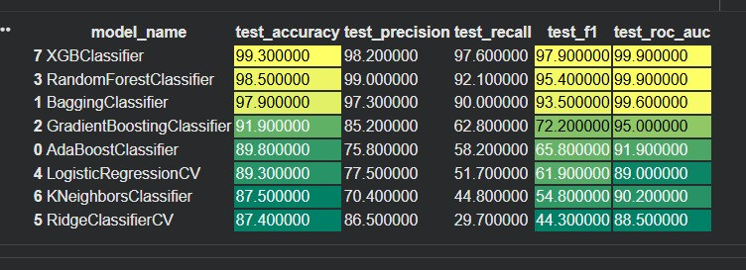

- Accuracy
- Precision and Recall are lower due to imbalanced data
- ROC-AUC is moderate, meaning the model captures meaningful patterns
- XGBoost gives the strongest performance among all models trained

6. How it works
- It cleans and prepares data thoroughly
- Handles missing values
- Balances the dataset using SMOTE
- Compares many ML models
- Uses XGBoost for final prediction
- Saves the model and column names for deployment
- Can be easily integrated with a frontend
- Very practical and industry-like workflow

7. Conclusion
This project successfully delivers an end-to-end churn prediction system.
Everything implemented from missing value handling to model saving matches real-world ML practices.

