Hello Team!

This is Mayuri Baikerikar, and following are my screenshots for the work done for the day.

1. Flask Hello world application.

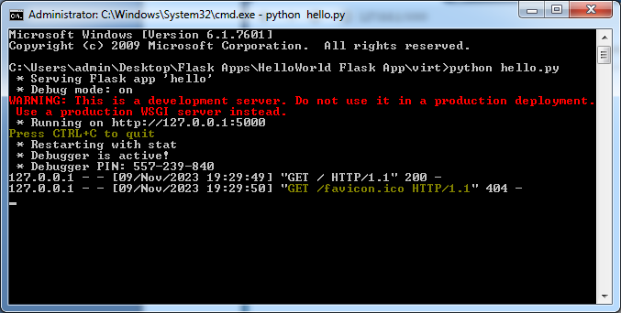

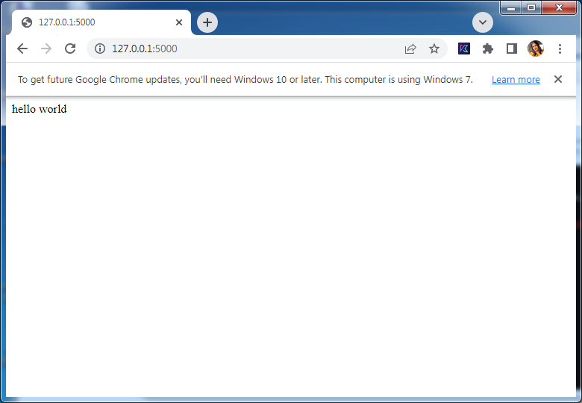

1. Pattern forming

