Mini Project Report

On

**Railway Management System**

By

**Ms.Mayuri Godse Seat No.T190554255**

**Mr. Kshitij Bhosale Seat No. T190554214**

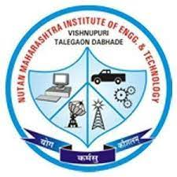

**Department of Computer Engineering**

**PCET-NMVPM’s**

**NUTAN MAHARASHTRA INSTITUTE OF ENGINEERING AND TECHNOLOGY**

**TALEGAON-DABHADE,**

**Vishnupuri, Talegaon Station-410507**

**SAVITRIBAI PHULE PUNE UNIVERSITY**

**2022-2023**

G

**OBJECTIVES**

Railway is a very important part of India’s transportation system. Proper management of it is equally important. There are so many trains and so many passengers as well, along with different ticket fares based on compartments. Different trains have different timings and different routes as well. If they are not managed properly, there would be absolute chaos. The main objective of this project is to provide solution to this problem by providing a system which would reduce the manual work and help in the management. This project is totally built at administrative level and thus only the administrator is guaranteed the access. This project is focused on a single railway station.

**INTRODUCTION**

In this railway management system, the user will be able to search all the trains passing through the station along with train timings. The user will be shown ticket fares on selecting a particular train according to compartments. The user will be able to book tickets. The user will be required to enter the passenger details while doing so. The data will be able to stored in a database. The user will also be able to view the details of all the passengers who have booked the tickets.

**Technology Used:**

• C++ / OOPS

• File Handling

**Expected Output:**

• Search trains at a particular station

• View Train Timings

• Able to view ticket fares

• Book tickets by entering number of passengers and passenger details in

a single PNR.

• Get total fare details the passenger need to pay.

• Get Tickets

• View the details of already booked tickets.

• Add travel companions

**Output:**

