TASK 2: Robotic Arm Simulation

Objective
To design a 2D/3D model of a robotic arm, define its degrees of freedom (DOF) and perform a basic
pick-and-place motion simulation. An object (cube, 40 mm) is picked from point P, lifted, carried by rotating the base through 90 degrees and placed at point Q.

Design of the arm
The arm is an articulated (anthropomorphic-type) manipulator. A rotating base (J1) turns the whole arm about the vertical axis, while the shoulder (J2) and elbow (J3) move the arm in a vertical plane. A parallel-jaw gripper is fitted at the wrist as the end-effector.
Part | Specification
Base column height H0 | 200 mm (shoulder axis height above table)
Link 1 (upper arm) L1 | 280 mm
Link 2 (forearm) L2 | 260 mm
Maximum reach | L1 + L2 = 540 mm from shoulder axis
Gripper | Parallel jaw, 20-36 mm opening, finger length 60 mm
Payload (assumed) | Light object up to 0.5 kg
Actuators (assumed) | Servo / stepper motors at J1, J2, J3; small servo for gripper

Degrees of freedom (DOF)
DOF = number of independent joint motions that position the end-effector. The arm has 3 revolute joints = 3 DOF (positions the wrist anywhere in cylindrical coordinates r, z, theta). The gripper open/close action is an extra end-effector function and is not counted as a positioning DOF (total 4 actuated axes including gripper).
Joint | Type | Axis of rotation | Motion | Used range in simulation
J1 - Base | Revolute | Vertical (Z) | Swing left/right | 0 to 90 deg
J2 - Shoulder | Revolute | Horizontal (Y) | Raise / lower upper arm | 23 to 86 deg
J3 - Elbow | Revolute | Horizontal (Y) | Bend forearm | -114 to -85 deg
Gripper | Prismatic (jaws) | Horizontal | Open / close | 20 to 36 mm

Kinematics used (for simulation)
Forward kinematics (side plane): wrist r = L1 cos(q1) + L2 cos(q1+q2); wrist z = H0 + L1 sin(q1) + L2 sin(q1+q2). Inverse kinematics: cos(q2) = (d2 - L12 - L22) / (2 L1 L2), with d = sqrt(r2 + (z - H0)2); q1 = atan2(z - H0, r) - atan2(L2 sin q2, L1 + L2 cos q2). The elbow-up solution is chosen (q2 negative). Base angle theta = rotation of the plane about Z.

Joint i | theta (variable) | d (mm) | a (mm) | alpha
1 | theta1 = base angle | 200 | 0 | 90 deg
2 | theta2 = q1 | 0 | 280 | 0
3 | theta3 = q2 | 0 | 260 | 0
Table: Denavit-Hartenberg parameters of the arm.

2D and 3D model

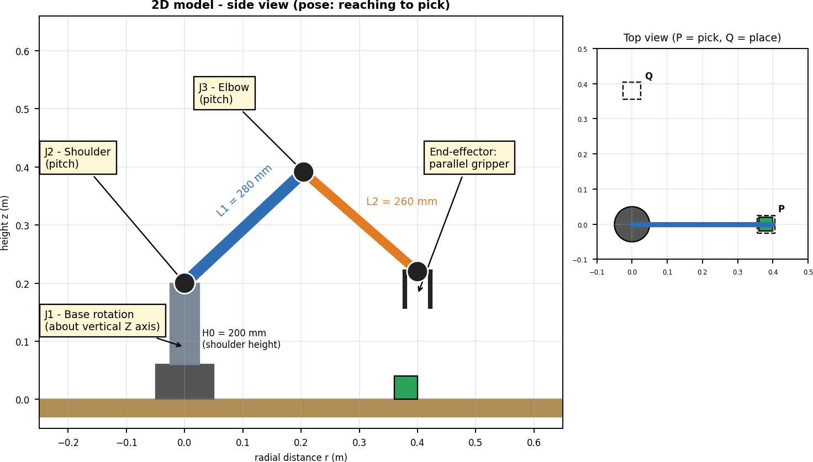

Figure 1: 2D model with joints, link lengths and top view.

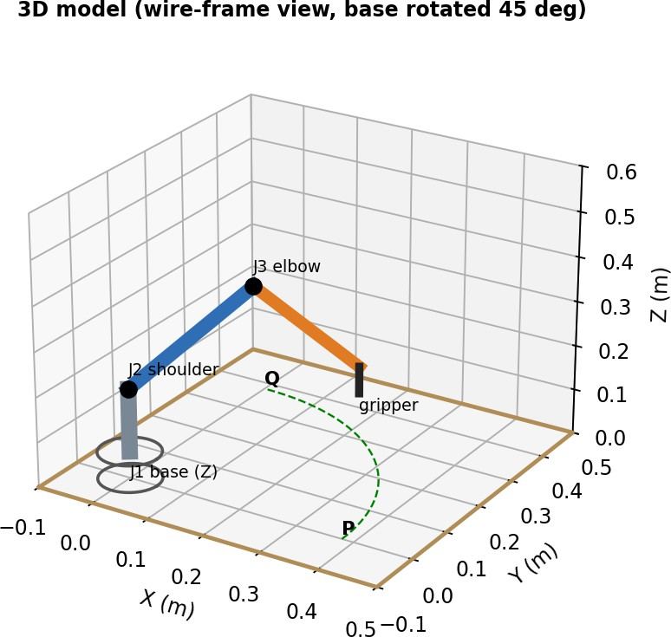

Figure 2: 3D wire-frame model of the same arm (base rotated 45 degrees).

Pick-and-place motion simulation
The arm moves through 8 key poses (screenshots below). Between poses the wrist moves in a straight line with smooth acceleration; inverse kinematics gives the joint angles at every instant. Each pose takes 1 second (total cycle time = 7 s). The small inset in every screenshot is the top view showing the pick point P and place point Q.
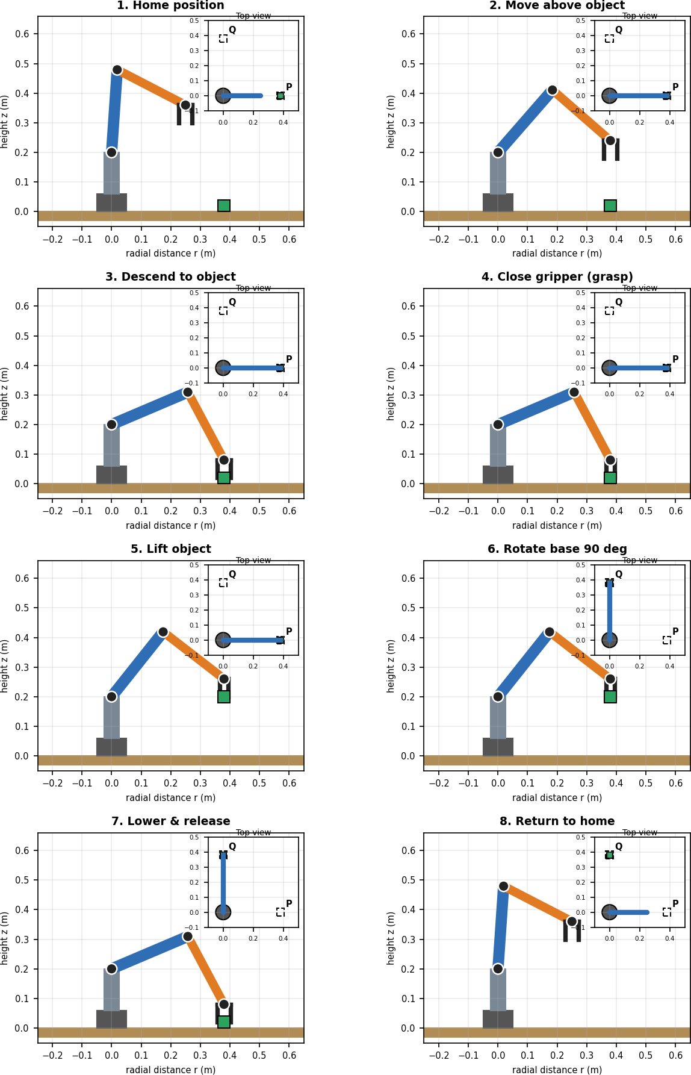
Figure 3: Simulation screenshots, steps 1 to 8.

Joint motion graph and sequence
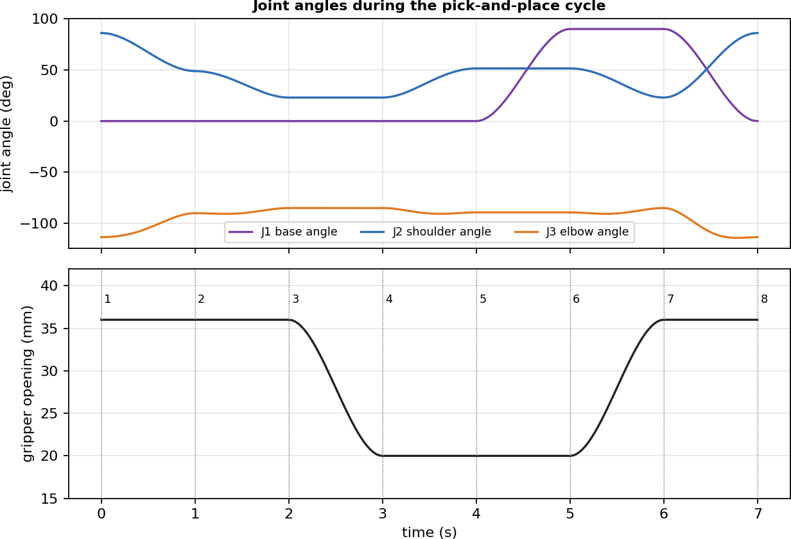

Figure 4: Joint angles and gripper opening against time (numbers 1-8 = poses of Figure 3).

Step | Action | Joint motion | Gripper
1 | Home position | Start pose | Open
2 | Move above object | J2, J3 move arm over P | Open
3 | Descend | J2, J3 lower the wrist to 80 mm | Open
4 | Grasp | No joint motion | Closes on cube
5 | Lift | J2, J3 raise the wrist to 260 mm | Closed
6 | Rotate base | J1 rotates 0 to 90 deg | Closed
7 | Lower & release | J2, J3 lower to table at Q | Opens
8 | Return home | J1 back to 0 deg, arm to home | Open

Conclusion
A 3-DOF articulated robotic arm with a gripper was modelled in 2D and 3D, its degrees of freedom and kinematics were defined, and a complete pick-and-place cycle was simulated. All target points lie inside the 540 mm workspace, so the inverse-kinematics solution exists at every step. The model can be extended with a wrist rotation (4th DOF), collision checking or a CAD model in SolidWorks/AutoCAD using the same link dimensions.

