High-Level Design (HLD)
RAG-Based Customer Support Assistant using LangGraph & HITL

Prepared By:
Mayuri Rathod

Technology Stack:
Python, LangChain, ChromaDB, HuggingFace, LangGraph

1. System Overview
The RAG-Based Customer Support Assistant is an AI-powered system designed to answer customer queries using information retrieved from PDF documents. The system uses Retrieval-Augmented Generation (RAG) to retrieve relevant content from a knowledge base and generate contextual responses.
The project integrates LangGraph for workflow orchestration and conditional routing. It also supports Human-in-the-Loop (HITL) escalation for handling low-confidence or complex queries.

2. Scope of the System
The scope of the system includes:

- Loading and processing PDF documents
- Splitting documents into chunks
- Generating embeddings for semantic search
- Storing embeddings in ChromaDB
- Retrieving relevant information based on user queries
- Generating contextual answers using an LLM
- Workflow orchestration using LangGraph
- Human escalation for uncertain responses
3. System Architecture Diagram
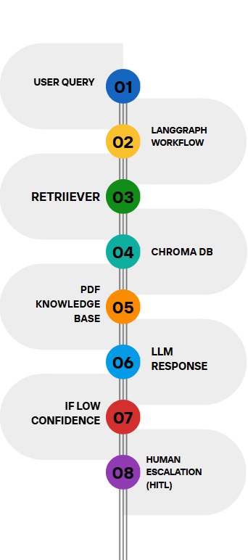

4. Component Description
4.1 Document Loader
The document loader is responsible for loading PDF documents into the system. PyPDFLoader from LangChain is used to extract text from the PDF knowledge base.

4.2 Chunking Strategy
The extracted document text is divided into smaller chunks using RecursiveCharacterTextSplitter. Chunking improves retrieval efficiency and provides better contextual understanding for the language model.
4.3 Embedding Model
HuggingFace embeddings are used to convert text chunks into vector representations. These embeddings enable semantic similarity search.

4.4 Vector Store
ChromaDB is used as the vector database to store document embeddings. It supports fast similarity search and efficient retrieval operations.

4.5 Retriever
The retriever searches the vector database and retrieves the most relevant document chunks based on the user query.

4.6 Large Language Model (LLM)
The GPT-2 model from HuggingFace is used to generate contextual responses using the retrieved information.

4.7 LangGraph Workflow Engine
LangGraph manages the workflow execution and routing logic between different processing nodes.

4.8 Routing Layer
The routing layer checks whether the generated response is sufficient or if escalation is required.

4.9 HITL Module
The Human-in-the-Loop (HITL) module handles escalation for low-confidence responses by forwarding the query to a human support agent.

5. Data Flow
The system follows the following data flow:

1. The PDF knowledge base is loaded into the system.
2. The document text is split into smaller chunks.
3. Embeddings are generated for each chunk.
4. The embeddings are stored in ChromaDB.
5. The user submits a query.
6. The retriever searches for relevant chunks from the vector database.
7. The retrieved context is passed to the language model.
8. The LLM generates a contextual response.
9. LangGraph manages workflow execution and routing.
10. If the response confidence is low, the query is escalated to a human agent through the HITL module.

6. Technology Choices
- Python
Python is used as the primary programming language because of its simplicity and extensive AI ecosystem.

- LangChain
LangChain is used for document loading, chunking, embeddings, retrieval, and LLM integration.

- ChromaDB
ChromaDB is selected as the vector database because it is lightweight, fast, and easy to integrate with LangChain.

- HuggingFace
HuggingFace models are used for generating embeddings and text responses.

- LangGraph
LangGraph is used for workflow orchestration, state management, and conditional routing.

- Jupyter Notebook
Jupyter Notebook is used for development, testing, and experimentation.

7. Scalability Considerations
The system can be scaled by:

- Using distributed vector databases for large-scale document storage
- Implementing caching mechanisms for frequent queries
- Using more advanced LLMs for improved response quality
- Supporting multiple PDF knowledge bases
- Deploying the application as a web service
- Optimizing chunk sizes and retrieval strategies for lower latency

