A DISSERTATION PHASE-II REPORT ON

GENE2FACE: DNA-BASED FACIAL MODELLING USING AI

IN THE COMPLETE FULFILLMENT FOR THE AWARD OF THE DEGREE

OF

MASTER OF TECHNOLOGY

IN

ARTIFICIAL INTELLIGENCE AND DATA SCIENCE

BY

SIDDHI DESHMUKH PRN: 124M1K012

UNDER THE GUIDANCE OF

DR. RAJESH PHURSULE

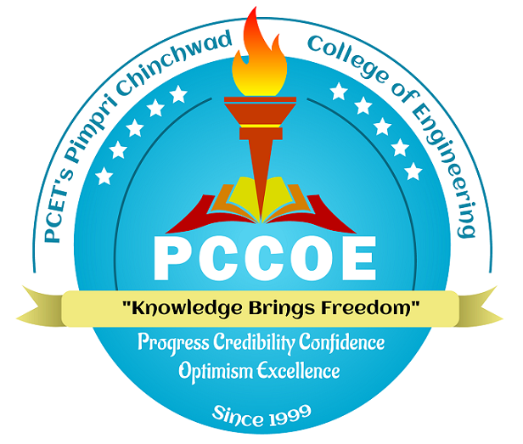
DEPARTMENT OF INFORMATION TECHNOLOGY
PIMPRI CHINCHWAD COLLEGE OF ENGINEERING, NIGDI, PUNE -411044
An Autonomous Institute Affiliated to Savitribai Phule Pune University

2025-26

CERTIFICATE

This is to certify that the dissertation phase-II report entitled

GENE2FACE: DNA-BASED FACIAL MODELLING USING AI

Submitted by

Siddhi Deshmukh PRN: 124M1K012

is a Bonafide work carried out by them under the supervision of Dr. Rajesh Phursule and it is approved for the complete fulfillment of the requirement of Savitribai Phule Pune University for the award of the Degree of Master of Technology in Artificial Intelligence and Data Science, Department of Information Technology.

This project report has not been earlier submitted to any other Institute or University for the award of any degree or diploma.

Dr. Rajesh Phursule Dr. Jayashree V. Katti
Internal Guide Head of Department
Department of Information Technology Department of Information Technology

Dr. Govind N. Kulkarni
External Examiner Director
PCCoE, Pune

Place: Date:

