
FPT-aptech computer education
eProject Document
Leave Management System
Group 1
Group Member | Nguyen Manh Hung – A04211 – 691  Nguyen Duc Phuong –A04210 – 694  Le Quang Hung – A04209 – 708
Instructor | TuNN
Batch | C0810L
Semester | <2|4>

- Hanoi, 6/2010-

Content

1. Problem Definition 4
1.1. Problem Abstraction 4
1.2. The Current System 4
1.3. The Proposed System 4
1.4. Boundaries of the System 5
1.5. Development Environment 5
2. Requirements and Business Flow 7
2.1. Customer Requirement Specification 7
2.2. Activity Diagram 7
2.3. Use Case Diagram 8
2.4. Use Case Specification 8
3. Design 14
3.1. System Architecture 14
3.2. Class Diagram 14
3.3. Class Diagram Explanation 14
3.4. Data Flow Diagram 14
3.5. Entity Relationship Diagram 16
3.6. Database Design 16
4. System Prototype 26
5. Management and Project Planning 26
5.1. Management Approach 26
5.2. Project Plan 26
5.3. Task Sheet 26
6. Checklists 27
6.1. Check List of Validation 27
6.2. Submission Checklist 27
7. Screenshots 27
8. Coding Convention 27
Appendix 28

Introduction

This project is aimed at developing a leave management system that is of importance to any organization. The Leave Management System (LMS) is an application that can be accessed by all the employees of the organization. This system can be used to automate the workflow of leave applications and their approvals. The periodic crediting of leave is also automated. There are features like cancellation of leave, report generators, etc… in this system.

Problem Definition

Problem Abstraction
In most of the organizations, each employee has been provided with the leave card at the time of appointment. Leave card shows the leaves credited to the employee’s account. Each time employee wants to go on leave, he will have to mention the details on the card, get it approved from the superior and submit it to the human resources staff person for updating in the company records. At the end of the year the leave balance is updated. However this paper based process is very time consuming and also causes discrepancies in the records.

The Current System
Currently, system only uses paper to apply and decide a leave. So, this is very inconvenient and takes so much time for a staff to get a leave because of complex administrative procedures.

The Proposed System
Due to the inconvenience in managing the data using leave cards, it is required to have a computer based system where an employee can login and apply for the leave. He can even see the records of the previous leaves taken as well check the balance leaves.
Each person should have the functions below:
- Login to the system through the first page of the application
- Change the password after logging into the system
- See his/her leave details (how many days of leave
he/she is eligible for, leave balance, leave history , etc…)
- Apply for leave, specifying the dates, reason for taking leave, address for communication while on leave.
- See his/her current leave applications and the leave applications that are submitted to him/her for approval or cancellation (if he/she is a superior)
- Approve/reject the leave applications that are submitted to him/her (if he/she is a superior)
- Withdraw his/her leave application (which has not been approved)
- Cancel his/her leave (which has been already approved). This will need to be approved by his/her Superior.
- Get help about the leave system on how to use the different features of the system.

After each staff activity, system will create a log to save the details of the action for the superior giving detail.
The report of leave details will be sent to their manager periodically.
Also, managing director creates a policy of the number of days that a staff can leave in a period time and mark the public holidays in calendar.

Boundaries of the System
As the content above, system can be applied to everyone in the company

Development Environment
Hardware:
- A minimum computer system that will help you access all the tools in the courses is a Pentium 166 or better.
- 128 Megabytes of RAM or better
Software:
- Visual Studio .Net / ASP / Visual Studio 6.0
- IIS server
- .Net Framework
- Java Virtual Machine/ J2EE server
- Notepad/Java editor
- j2sdk1.4.1_02 (or later).
- EJB Dev Kit
- Java enabled web server
- JSP / Servlets Dev. Kit

Requirements and Business Flow

Customer Requirement Specification
Customer requires an IT system that can control and operate every activity about leave management by computer to replace the current manual system.

Activity Diagram
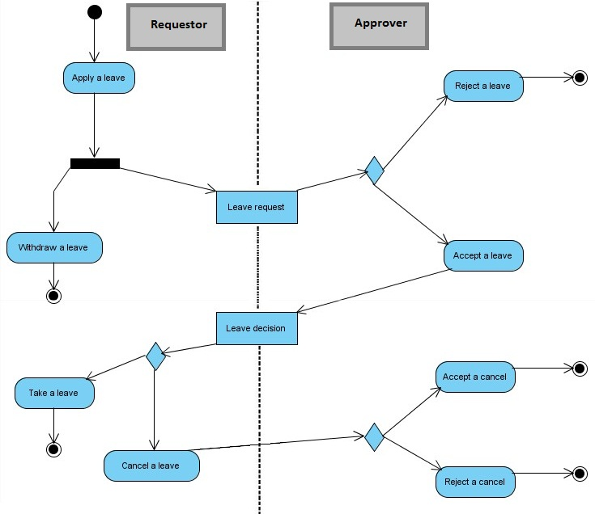

Use Case Diagram
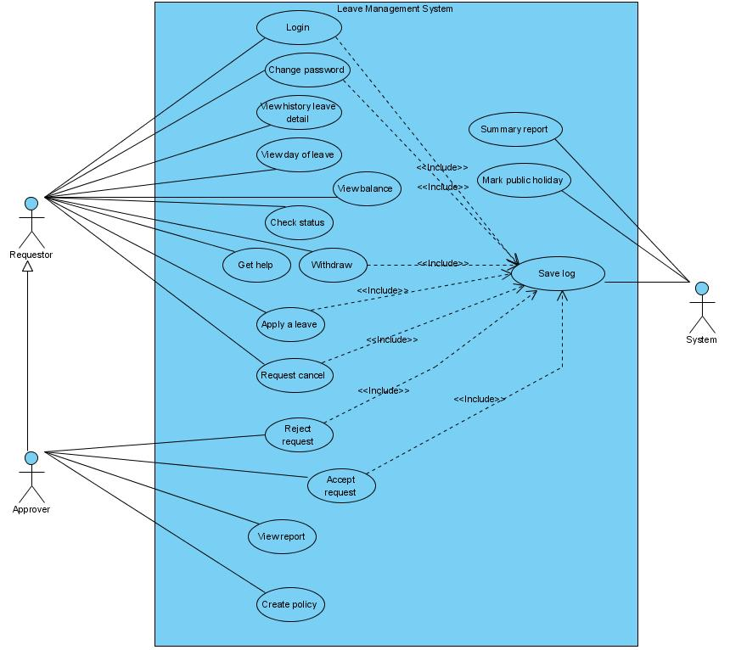

Use Case Specification
Use-case No. | UC01 | Use-case Version |  | 1.0
Use-case Name | Login
Author | Hungnm
Date | 15/06/2010 | Priority | High
Actor:
Requestor/Approver

Summary:
Requestor login to the leave management system
Goal:
Login to the system to use it’s function

Triggers
N/A
Preconditions:
N/A
Post Conditions:
N/A
Main Success Scenario:
Step | Actor | System
1 | User enter username and password then click into button Login
2 |  | If proper the conditions BR01 ,will take users to the system on the main interface else will be forwarded to AS01
3 | End use case

Alternative Scenario:
Step | Actor | System
1 |  | Display message “Wrong username or password. Please try again”
2 |  | Back to step 1 of main scenario
3 | End use case

Exceptions:
N/A
Relationships:
N/A
Business Rules:
- BR1 : Username and password correctly

Use-case No. | UC02 | Use-case Version |  | 1.0
Use-case Name | Change password
Author | Hungnm
Date | 15/06/2010 | Priority | Normal
Actor:
Requestor/Approver

Summary:
Users want to change their password
Goal:
Change password

Triggers
N/A
Preconditions:
After login
Post Conditions:
N/A
Main Success Scenario:
Step | Actor | System
1 | User click button Change your password
2 |  | System displays the password change interface
3 | User enter old password , new password and confirm password then click button OK
4 |  | If proper the conditions BR01 , system will show the message “password successfully changed ” else will be forwarded to AS01
5 | End use case

Alternative Scenario:

Step | Actor | System
1 |  | Display message “Wrong old password or newpass and confirm pass must be identical”
2 |  | Back to step 3 of main scenario
3 | End use case

Exceptions:
N/A
Relationships:
N/A
Business Rules:
- BR1 : Old password correctly, new password and confirm password must be identical

Use-case No. | UC03 | Use-case Version |  | 1.0
Use-case Name | View history leave detail
Author | Hungnm
Date | 15/06/2010 | Priority | Normal
Actor:
Requestor/Approver

Summary:
Users want to view their own history leave
Goal:
Know their own history leave

Triggers
N/A
Preconditions:
After login
Post Conditions:
N/A
Main Success Scenario:
Step | Actor | System
1 | User click button View history leave
2 |  | System displays the history leave interface
3 | End use case

Alternative Scenario:
N/A

Exceptions:
N/A
Relationships:
N/A
Business Rules:
- N/A

Use-case No. | UC04 | Use-case Version |  | 1.0
Use-case Name | View day of leave
Author | Hungnm
Date | 15/06/2010 | Priority | Normal
Actor:
Requestor/Approver

Summary:
Users want to view their own day of leave
Goal:
Know their own day of leave

Triggers
N/A
Preconditions:
After login
Post Conditions:
N/A
Main Success Scenario:
Step | Actor | System
1 | User click button View day of leave
2 |  | System displays the day of leave interface
3 | End use case

Alternative Scenario:
N/A

Exceptions:
N/A
Relationships:
N/A
Business Rules:
- N/A

Use-case No. | UC05 | Use-case Version |  | 1.0
Use-case Name | View balance
Author | Hungnm
Date | 15/06/2010 | Priority | Normal
Actor:
Requestor/Approver

Summary:
Users want to view their own balance
Goal:
Know their own balance

Triggers
N/A
Preconditions:
After login
Post Conditions:
N/A
Main Success Scenario:
Step | Actor | System
1 | User click button View balance
2 |  | System displays the balance interface
3 | End use case

Alternative Scenario:
N/A

Exceptions:
N/A
Relationships:
N/A
Business Rules:
- N/A

Design

System Architecture

Class Diagram

Class Diagram Explanation

Data Flow Diagram
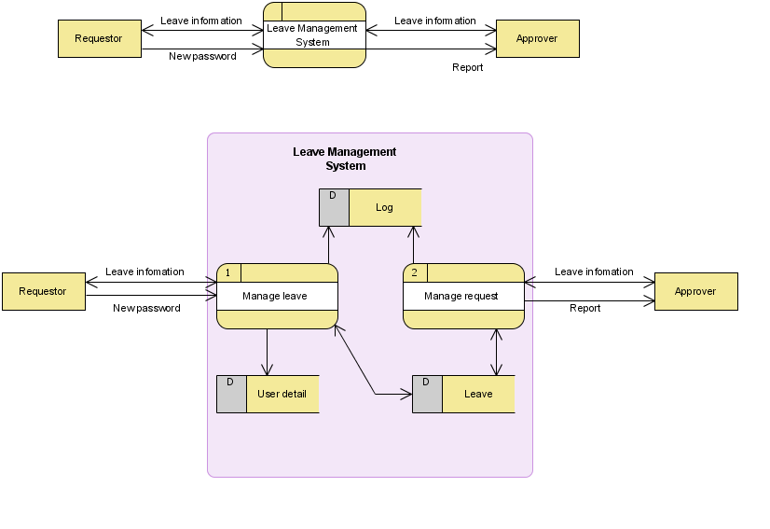
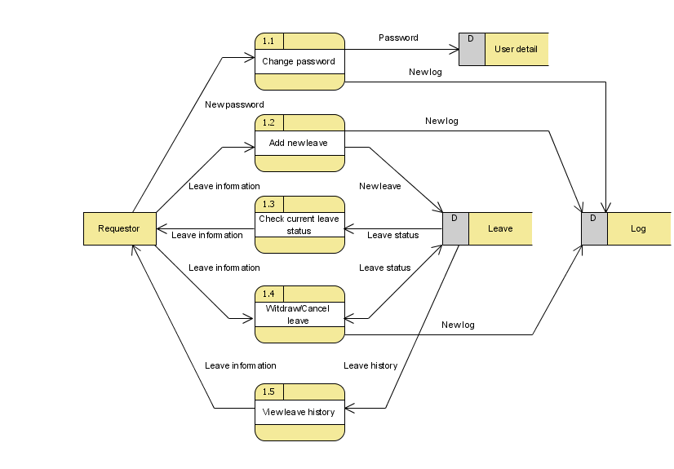

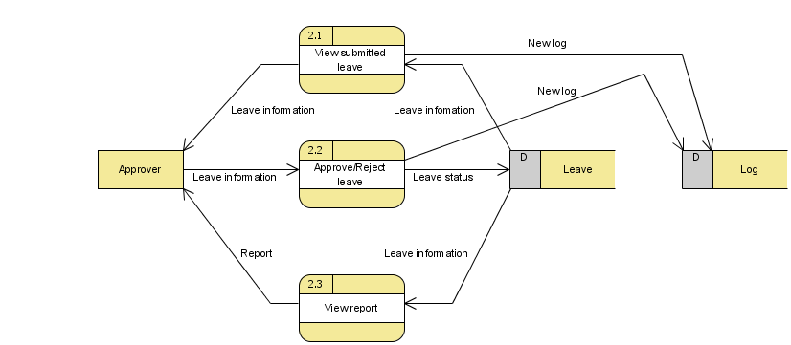

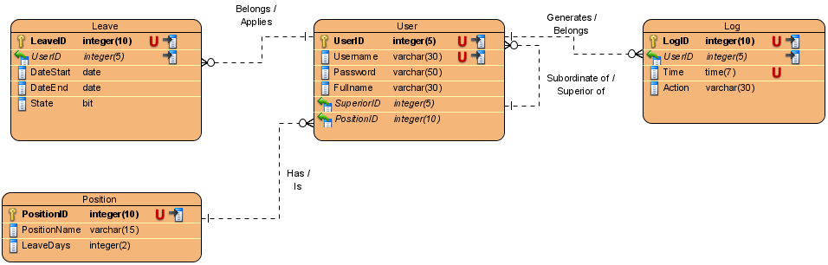
Entity Relationship Diagram

Database Design

Name | Value
Name | Leave Management System
Data Model | Physical

Summary
Name | Documentation
Leave
User
Log
Position

Details
Leave
Name | Value
Data Model | Physical

Columns Summary
Name | DataType | Constraints | Nullable | Documentation
LeaveID | integer(10) | PKUnique | No
UserID | integer(5) | FK (User.UserID) | No
DateStart | date |  | No
DateEnd | date |  | No
State | bit |  | No

Columns
LeaveID
Type | integer
Nullable | false
Unique | true
Primary Key | true
Index | true
Type Name | integer
Length | 10
Scale | 0
Id Generator | increment
Generated | Always
Sync To Attribute | Yes
UserID
Type | integer
Nullable | false
Unique | false
Primary Key | false
Index | true
Type Name | integer
Length | 5
Scale | 0
Id Generator | native
Generated | Unspecified
Sync To Attribute | Yes
DateStart
Type | date
Nullable | false
Unique | false
Primary Key | false
Index | false
Type Name | integer
Length | 0
Scale | 0
Generated | Unspecified
Sync To Attribute | Yes
DateEnd
Type | date
Nullable | false
Unique | false
Primary Key | false
Index | false
Type Name | integer
Length | 0
Scale | 0
Generated | Unspecified
Sync To Attribute | Yes
State
Default Value | 0
Type | bit
Nullable | false
Unique | false
Primary Key | false
Index | false
Type Name | integer
Length | 0
Scale | 0
Generated | Unspecified
Sync To Attribute | Yes

Relationships
Belongs /
Applies : Relationship
From | User
Identifying | false
To Multiplicity | 0..*
From Multiplicity | 1
Sync To Association | Yes
Data Model | Physical

User
Name | Value
Data Model | Physical

Columns Summary
Name | DataType | Constraints | Nullable | Documentation
UserID | integer(5) | PKUnique | No
Username | varchar(30) | Unique | No
Password | varchar(50) |  | No
Fullname | varchar(30) |  | No
SuperiorID | integer(5) | FK (User.UserID) | No
PositionID | integer(10) | FK (Position.PositionID) | No

Columns
UserID
Type | integer
Nullable | false
Unique | true
Primary Key | true
Index | true
Type Name | integer
Length | 5
Scale | 0
Id Generator | identity
Generated | Always
Sync To Attribute | Yes
Username
Type | varchar
Nullable | false
Unique | true
Primary Key | false
Index | true
Type Name | integer
Length | 30
Scale | 0
Generated | Unspecified
Sync To Attribute | Yes
Password
Type | varchar
Nullable | false
Unique | false
Primary Key | false
Index | false
Type Name | integer
Length | 50
Scale | 0
Id Generator | native
Generated | Unspecified
Sync To Attribute | Yes
Fullname
Type | varchar
Nullable | false
Unique | false
Primary Key | false
Index | false
Type Name | integer
Length | 30
Scale | 0
Generated | Unspecified
Sync To Attribute | Yes
SuperiorID
Type | integer
Nullable | false
Unique | false
Primary Key | false
Index | false
Type Name | integer
Length | 5
Scale | 0
Generated | Unspecified
Sync To Attribute | Yes
PositionID
Type | integer
Nullable | false
Unique | false
Primary Key | false
Index | false
Type Name | integer
Length | 10
Scale | 0
Id Generator | native
Generated | Unspecified
Sync To Attribute | Yes

Relationships
Generates /
Belongs : Relationship
To | Log
Identifying | false
To Multiplicity | 0..*
From Multiplicity | 1
Sync To Association | Yes
Data Model | Physical

Subordinate of /
Superior of : Relationship
To | User
Identifying | false
To Multiplicity | 0..*
From Multiplicity | 1
Sync To Association | Yes
Data Model | Physical

Belongs /
Applies : Relationship
To | Leave
Identifying | false
To Multiplicity | 0..*
From Multiplicity | 1
Sync To Association | Yes
Data Model | Physical

Has /
Is : Relationship
From | Position
Identifying | false
To Multiplicity | 0..*
From Multiplicity | 1
Sync To Association | Yes
Data Model | Physical

Log
Name | Value
Data Model | Physical

Columns Summary
Name | DataType | Constraints | Nullable | Documentation
LogID | integer(10) | PKUnique | No
UserID | integer(5) | FK (User.UserID) | No
Time | time(7) | Unique | No
Action | varchar(30) |  | No

Columns
LogID
Type | integer
Nullable | false
Unique | true
Primary Key | true
Index | true
Type Name | integer
Length | 10
Scale | 0
Id Generator | increment
Generated | Always
Sync To Attribute | Yes
UserID
Type | integer
Nullable | false
Unique | false
Primary Key | false
Index | true
Type Name | integer
Length | 5
Scale | 0
Id Generator | native
Generated | Unspecified
Sync To Attribute | Yes
Time
Type | time
Nullable | false
Unique | true
Primary Key | false
Index | false
Type Name | integer
Length | 7
Scale | 0
Generated | Unspecified
Sync To Attribute | Yes
Action
Type | varchar
Nullable | false
Unique | false
Primary Key | false
Index | false
Type Name | integer
Length | 30
Scale | 0
Id Generator | native
Generated | Unspecified
Sync To Attribute | Yes

Relationships
Generates /
Belongs : Relationship
From | User
Identifying | false
To Multiplicity | 0..*
From Multiplicity | 1
Sync To Association | Yes
Data Model | Physical

Position
Name | Value
Data Model | Physical

Columns Summary
Name | DataType | Constraints | Nullable | Documentation
PositionID | integer(10) | PKUnique | No
PositionName | varchar(15) |  | No
LeaveDays | integer(2) |  | No

Columns
PositionID
Type | integer
Nullable | false
Unique | true
Primary Key | true
Index | true
Type Name | integer
Length | 10
Scale | 0
Id Generator | identity
Generated | Always
Sync To Attribute | Yes
PositionName
Type | varchar
Nullable | false
Unique | false
Primary Key | false
Index | false
Type Name | integer
Length | 15
Scale | 0
Id Generator | native
Generated | Unspecified
Sync To Attribute | Yes
LeaveDays
Type | integer
Nullable | false
Unique | false
Primary Key | false
Index | false
Type Name | integer
Length | 2
Scale | 0
Id Generator | native
Generated | Unspecified
Sync To Attribute | Yes

Relationships
Has /
Is : Relationship
To | User
Identifying | false
To Multiplicity | 0..*
From Multiplicity | 1
Sync To Association | Yes
Data Model | Physical

System Prototype

Management and Project Planning

Management Approach

Project Plan

Task Sheet

Checklists

Check List of Validation

Submission Checklist

Screenshots

Coding Convention

Appendix

